Ks7581

Kirti Sharma

**Report**

Ping.py:

Python implementation of the ping utility, designed to test the reachability of a host on an Internet Protocol (IP) network and measure the round-trip time for messages sent from the originating host to a destination computer.

1. The basic usage of ping.py allows users to ping a specified host.

python ping.py example.com

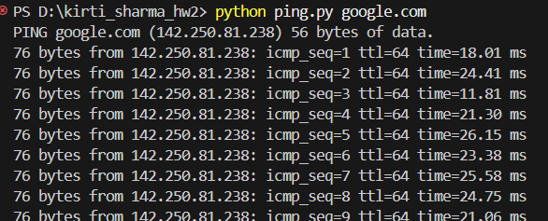

1. The count option allows users to specify the number of ping requests to send.

python ping.py -c 5 example.com

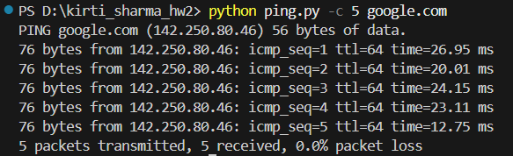

1. The Interval option sets the time interval between ping requests.

python my_ping.py -i 2 example.com

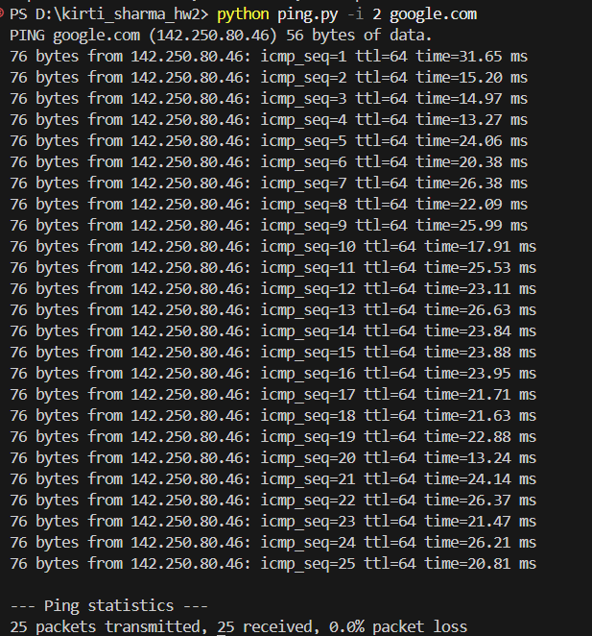

1. Users can specify the size of the ping packet with -s option.

python my_ping.py -s 100 example.com

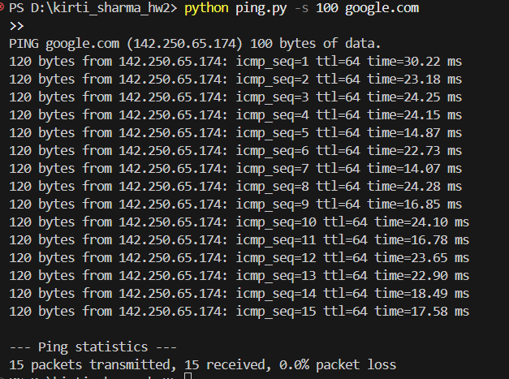

1. The timeout option -t sets the maximum time to wait for a response.

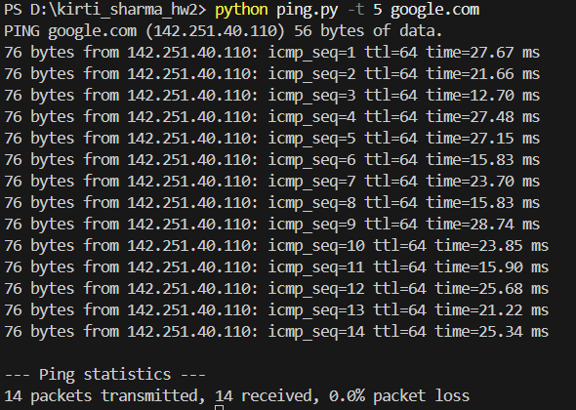

Traceroute.py:

Traceroute is a network diagnostic tool used to trace the route taken by packets from one host to a destination. The Python implementation allows for customizable options to explore network paths.

1. Basic Usage:

python traceroute.py example.com