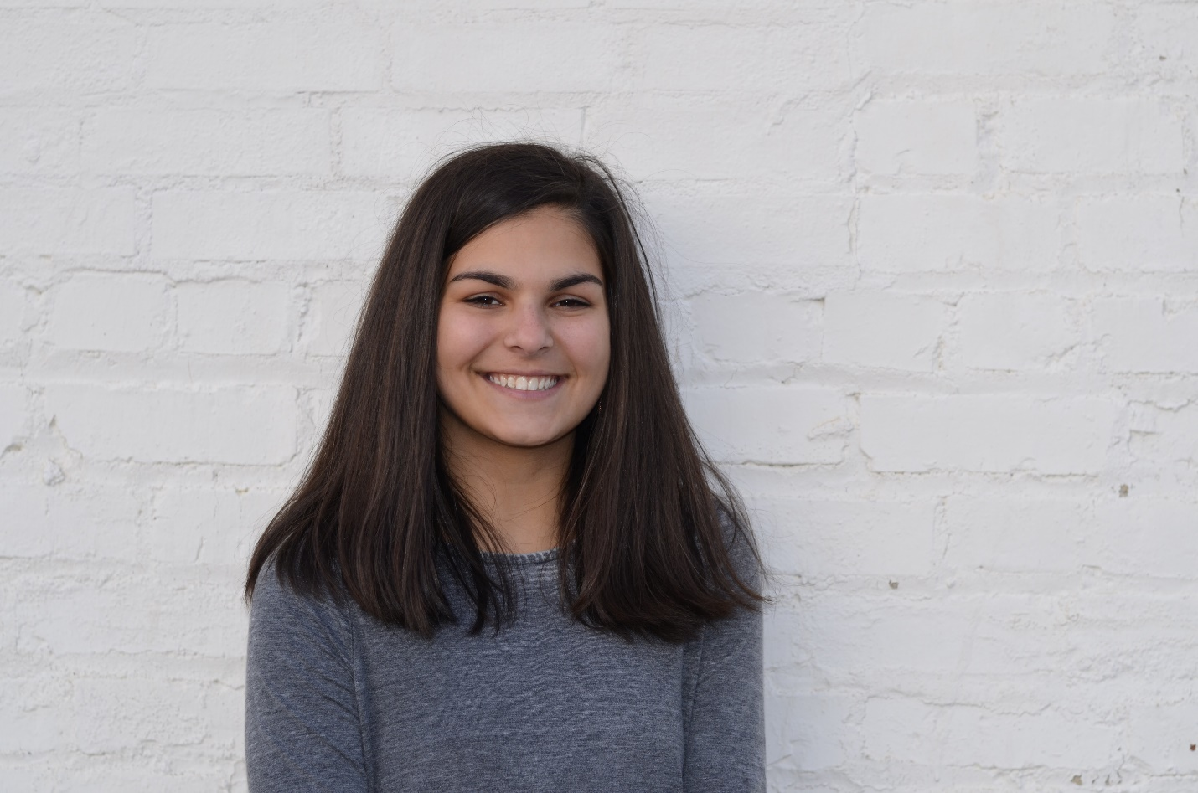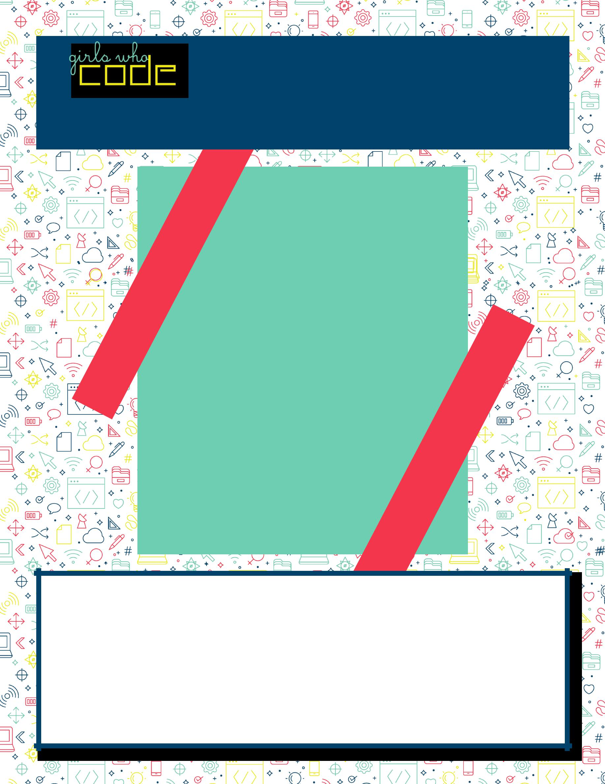

* Rising senior at Apex High School
* Manali, Elizabeth, and I worked together to create an Ubbi Dubbi translator, a pirate mad lib, a personality quiz, and a research triangle LGBTQ+ friendly restaurant finder.
* I hope to be able to attend UNC Chapel Hill or NC State University to study computer science.
* With the help of my teammates and google, I learned the basis of HTML, CSS, and JavaScript. I also learned cooperation by being able to combine everything each member wanted in our final project.
* I would definitely tell girls to pursue what they are passionate about even if the degree is male dominated. Come into each project or task with confidence and the ability to make mistakes because there will always be debugging, but it is all worth it when you are able to see the final project.

**Kiran Ruff**

**Woman In Tech Spotlight:**