VIETNAM GENERAL CONFERDERATION OF LABOR

**TON DUC THANG UNIVERSITY**

**FACULTY OF INFORMATION TECHNOLOGY**



**NGUYỄN CHÍ ANH - 520H0335**

**HỒ LÊ TRUNG TÍN – 520H0585**

**FINAL-TERM REPORT OF**

**REQUIREMENT ANALYSIS AND DESIGN**

**IMPLEMENT AN INFORMATION SYSTEM FOR A DISTRIBUTOR SELLING ELECTRONIC PRODUCTS**

**HO CHI MINH CITY, YEAR 2023**

VIETNAM GENERAL CONFERDERATION OF LABOR

**TON DUC THANG UNIVERSITY**

**FACULTY OF INFORMATION TECHNOLOGY**



**NGUYỄN CHÍ ANH – 520H0335**

**HỒ LÊ TRUNG TÍN – 520H0585**

**FINAL-TERM REPORT OF**

**REQUIREMENT ANALYSIS AND DESIGN**

**IMPLEMENT AN INFORMATION SYSTEM FOR A DISTRIBUTOR SELLING ELECTRONIC PRODUCTS**

Instructor

**Mr. Phạm Thái Kỳ Trung**

**HO CHI MINH CITY, YEAR 2023**

ACKNOWLEDGEMENT

We would like to express our sincere gratitude to Mr. Phạm Thái Kỳ Trung for his assistance in requirement analysis and design and guiding us through the completion of this report during the course.

We sincerely thank you!

*Ho Chi Minh City, May 6th , 2023*

*Authors*

*Nguyễn Chí Anh*

*Hồ Lê Trung Tín*

THIS REPORT IS COMPLETED  
 AT TON DUC THANG UNIVERSITY

I hereby declare that the report is our work and is under the scientific guidance of Mr. Phạm Thái Kỳ Trung. The research contents and results in this topic are honest and have not been published in any form before. The data in the tables for analysis, comments and evaluation are collected by the author himself from different sources, clearly stated in the reference section.

In addition, in the report, a number of comments, assessments as well as data from other authors, other agencies and organizations are also used, with original citations and annotations.

If any fraud is detected, we would like to take full responsibility for the content of our report. Ton Duc Thang University is not related to copyright and copyright violations caused by me during the implementation process (if any).

Ho Chi Minh City, May 6th, 2023

*Authors*

*Nguyễn Chí Anh*

*Hồ Lê Trung Tín*

TABLE OF CONTENTS

ACKNOWLEDGEMENT 3

TABLE OF FIGURES 1

CHAPTER 1 – BUSSINESS REQUIREMENTS 2

1.1 Organization Chart 2

1.2 Business Modelling/Requirements 2

1.3 Business process 3

1.4 Activity Diagram 4

CHAPTER 2 – THEORECTICAL BASIS 4

2.1 Translate from Business Use Case 4

*2.1.1. System Narrative* 4

*2.1.2. Users and their goals* 4

*2.1.3.*  *List of Events* 4

*2.1.4. List of Actors* 4

*2.1.5. List of Use Cases* 5

*2.1.6.*  *Use Case Diagram* 5

*2.1.7.*  *Domain Class Model Diagram* 5

CHAPTER 3 – DEMONSTRATION 6

TABLE OF FIGURES

Figure 1. System's Organization Chart 2

Figure 2. Business process 3

CHAPTER 1 – BUSSINESS REQUIREMENTS

* 1. Organization Chart

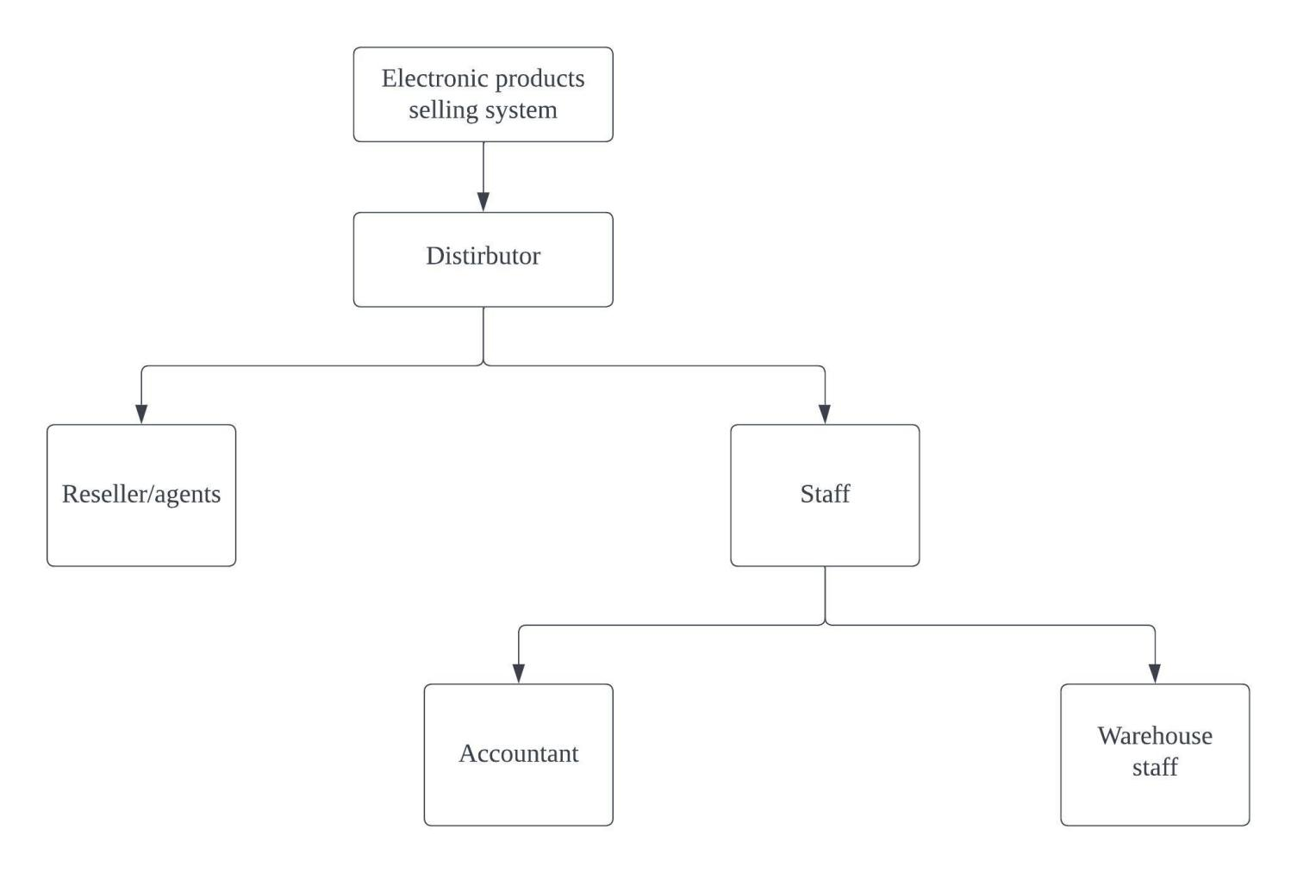

Figure 1. System's Organization Chart

* 1. Business Modelling/Requirements
* For system:
  + Friendly UX/UI.
  + Maintain correct data
  + Good received and good delivery note should be created without any errors.
  + Save good’s data when scanning RFID, barcode/OR.
  + Statistic demonstration status of orders and payment
* For accountants:
  + The accountants are able to create good received and good delivery note without setbacks.
  + Update status of orders as being transferred and update the payment status without errors.
* For seller/agents:
  + Able to place an order of items themselves and choose payment method without errors.
  + Able to make online payment and see the status of their orders.
* For warehous staff:
  + Easy to scan RFID, QR/barcode of the goods.
  1. Business process

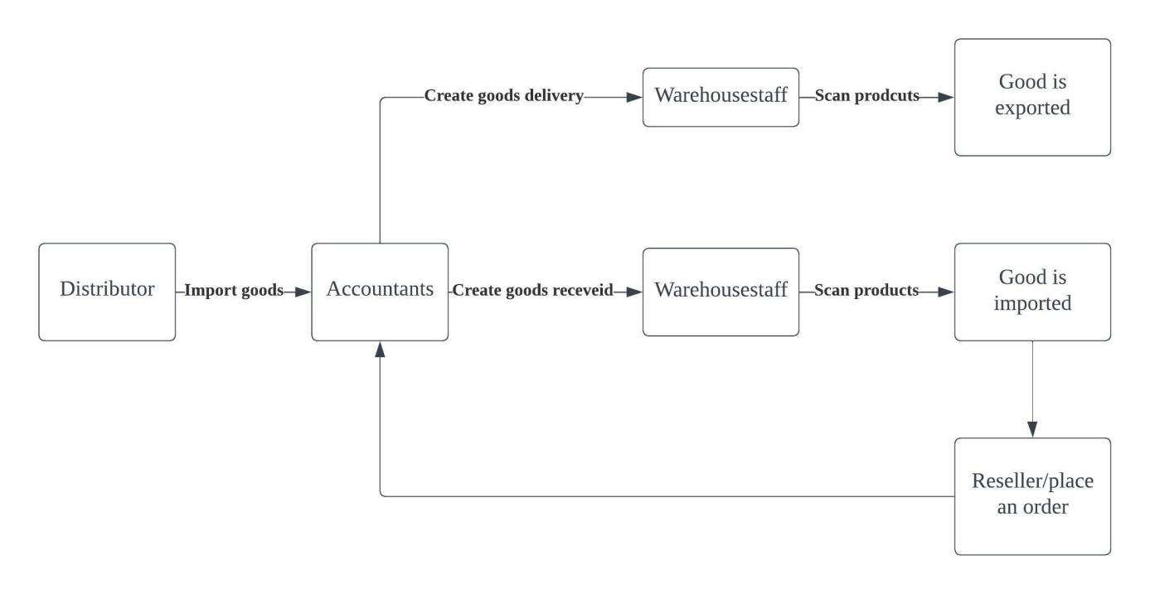

Figure 2. Business process

* 1. Activity Diagram

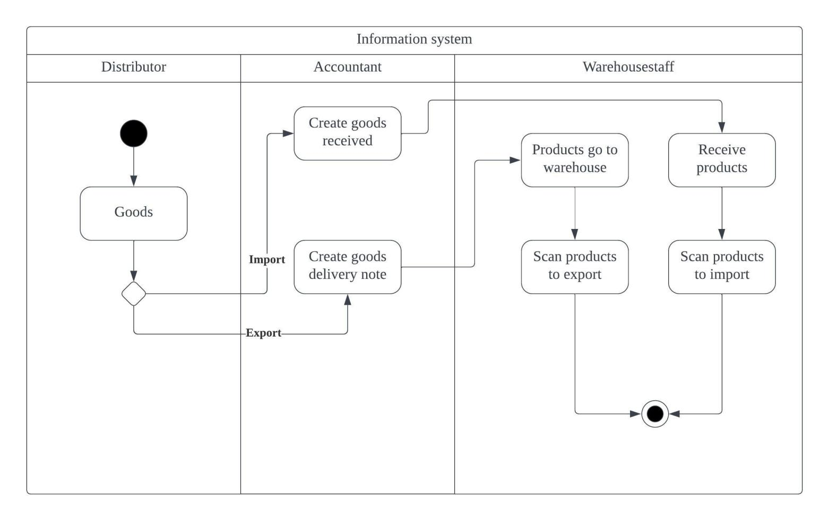

Figure 3. System’s activity diagram

* 1. List of Requirments

|  |  |  |
| --- | --- | --- |
|  |  |  |
|  |  |  |
|  |  |  |
|  |  |  |
|  |  |  |
|  |  |  |
|  |  |  |
|  |  |  |

CHAPTER 2 – THEORECTICAL BASIS

# 2.1 Translate from Business Use Case

## *2.1.1. System Narrative*

Design an information system for a distributor selling electronics devices products to authorized reseller / agents with the following functions include but not limited to:

* Accountants shall be able to create Goods Received when the distributor imports goods (a warehouse receipt will include many items). When receiving goods at the warehouse, warehouse staff will scan barcode/QR Code, RIFDs to perform the goods warehousing process
* Reseller / Agents shall be able to place an order of items by themselves and choose a payment method (Cash, bank transfer, Momo...). Reseller / Agents would also make an online payment and see the status of their orders
* The system allows accounting staff to make Goods Delivery Note (based on previously placed orders) to deliver goods to agents (print delivery slips), update the status of orders as being transferred and update the payment status of agents. The system also allows warehouse staff make use of barcode/QR Code/RFID for stock out.
* Accountants shall be able to view incoming/outgoing stock report (inventory movement), best-selling products and revenue report monthly.

## *2.1.2. Users and their goals*

|  |  |
| --- | --- |
| User/Actor | User Goals |
| Accountant | Create Goods Received Make Goods Delivery Note View business information monthly |
| Reseller/Agents | Place an order of items Choose payment method Make online payment See orders’ status |
| Warehouse staff | Scan products |

## *2.1.3. List of Events*

List of events and its use case

## *2.1.4. List of Actors*

## *2.1.5. List of Use Cases*

**Member Registration:** Register new member as when new member applies to be a member. Member would initiate this action and serviced by Attendant.

## *2.1.6. Use Case Diagram*

The use case diagram of abc System can be draw-able as the following :

## *2.1.7. Domain Class Model Diagram*

CHAPTER 3 – DEMONSTRATION

**REFERENCES**

[1]: [Open-Source UI Toolkit to Create Your Own Mobile Apps (ionicframework.com)](https://ionicframework.com/docs/)

[2]: [Ionic App Development: Advantages and Disadvantages - Softjourn](https://softjourn.com/insights/ionic-app-development-advantages-and-disadvantages)

[3]: Writing report guidance by Mr. Mai Văn Mạnh.

[4]: [Ionic (mobile app framework) - Wikipedia](https://en.wikipedia.org/wiki/Ionic_(mobile_app_framework))