**CATAIN QUICK TURNAROUND CHECKLIST**

This checklist is intended to guide the user through a quick turnaround of the CATAIN system. This checklist assumes that no changes are needed to the number of pictures per cycle, to the exposure values per picture, and to the time between system wake up cycles. A separate, more complex checklist has to be followed for that use case.

**DECOMMISSIONING**

* Throughly clean the housing and endcaps from organisms and debris
* Remove the 6 bolts that secure the camera endcap to the housing.
* Remove the vacuum vent plug from the other endcap
* Using a few of the 6 bolts previously removed, use them as jacking screws on the front endcap to pull the endcap and frame off the housing
* Once the endcap is lifted from the housing, use hands to pull the frame completely off the housing. Care should be taken so that parts of the frame do not touch/scratch the oring mating surface on the inner diameter of the housing.
* Place the frame, endcap side down, on a stable surface
* Unplug the battery connector from the system power input connector. Before doing so, be absolutely sure that no LEDs are lit on the sleepypi and the raspberry pi (if LEDs are lit, the system is currently powered on and in the middle of a picture-taking cycle so removing power in that state would have the potential to corrupt the SD card)
* Carefully remove the SD card from the raspberry pi slot, and plug it in a computer. Only Linux hosts (tested on ubuntu 16.04 and newer) which natively support EXT4 filesystems are currently supported and are proven to work reliably with the system without SD card corruption. Other third party software may be available to read EXT4 filesystems on other Operating Systems such as Windows that do not natively support this filesystem, but is not tested and as such has the potential to corrupt the SD card filesystem. If you choose to use other third party software to read EXT4 on operating systems other than Linux, do at your own risk reminding that engineering effort, engineering availability and system downtime may be necessary to repair eventual damage caused by that.
* On a Linux host, the SD card will be mounted automatically as two partitions, named “boot” and “writable” and the file browser will automatically open when the SD card is inserted. Browse to the “writable” partition, then to the “data” folder. In there there should be two folders, “images” and “logs”. COPY (do not cut) those folders to the host hard drive.
* After the copy operation is complete and you verified you have all the images and logs in your hard drive, go into the “images” folder in the SD card and delete all the pictures in it. DO NOT delete the “images” folder itself, but only its contents (the pictures). Deleting the “images” folder would cause the system to not log images on the next deployment.
* Go into the “logs” folder in the SD card and delete the “capture.log” in it. DO NOT delete the “logs” folder itself, but only its contents (the “capture.log” file). Deleting the “logs” folder would cause the system to not log system logs on the next deployment.
* Do not change anything else in the “writable” or “boot” partitions, as that would cause undefined behavior on the next deployment.
* Unmount BOTH the “writable” and “boot” partitions (press the “eject” button next to their name in the file browser) and once the OS notifies that it’s safe to remove the media, remove the SD card from the host
* Insert the SD card back in the raspberry pi until it’s securely plugged in, in the same orientation in which it was when it was removed.

**CHARGING**

* Set the charger at safe charging voltage and current for the battery to be charged (14.4V, current limited at 1.3A), then power off the charger output
* Plug the charger into the battery connector, plugging in-line the coulomb charge meter to monitor charge put back into the battery
* Power on the charger and start charging
* Charging is done when the power supply output current decreases to about 0A and voltage is stable
* While charging, take the opportunity to clean all the orings, clean all the oring grooves and all mating surfaces, and the interior of the front endcap from dust particles. Inspect orings for damage and if necessary replace them, clean the orings and lubricate the O-rings with grease (including the ones on the vacuum port plug). Care should be taken to not move the camera lens housing as that would have the undesired effect of changing focus or aperture
* if needed, replace the airflow limiting pinholed duct tape on the inside of the rear endcap by the vacuum port

**COMMISSIONING**

* Once charging is done, disconnect charger and coulomb meter from battery input
* Plug the battery into the system power input connector. A small LED on the sleepypi should do a quick yellow blink (see picture for LED location).
* About 10 second after the LED yellow blink, press the small black RESET button on the sleepypi (see picture for button location). The LED should do another quick yellow blink in response to the button press.

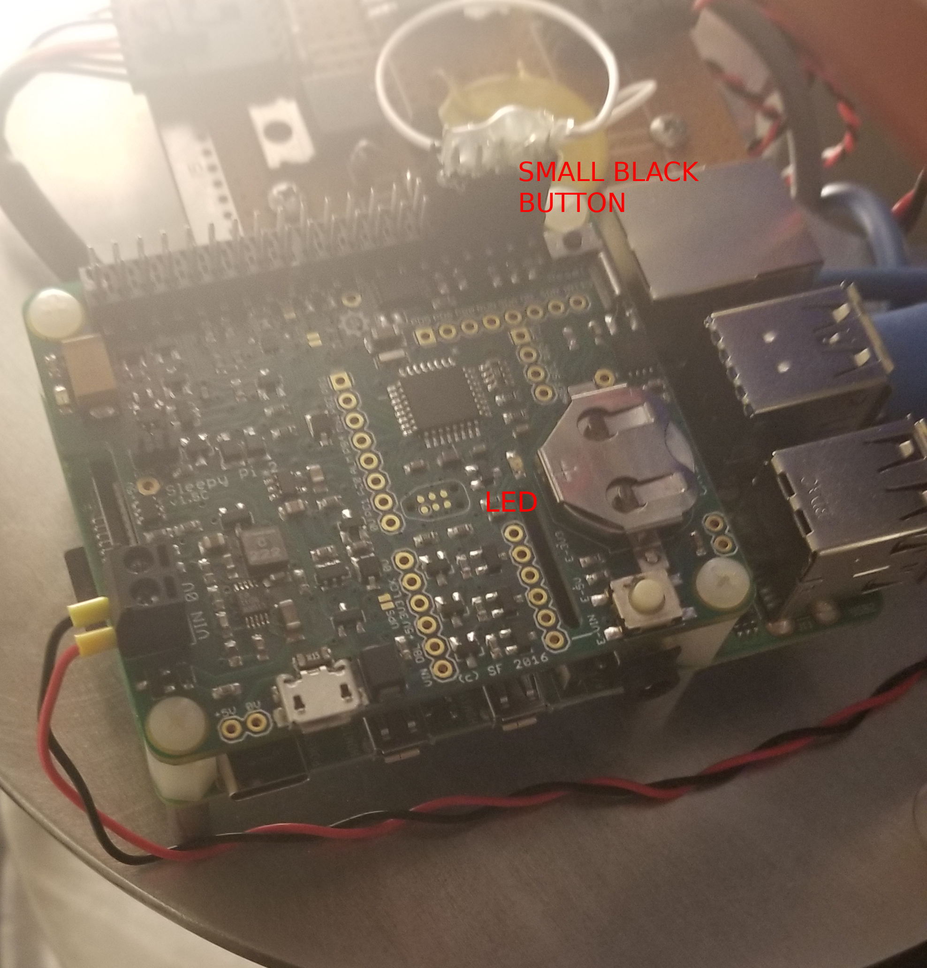

* At this point the system is started and no more buttons or connectors should be touched or disconnected. If starting was successful, after a couple of minutes from the last LED yellow blink many lights on the raspberry pi and sleepypi will light up (system woken up on first RTC alarm – note the time, as the system will power up to take pictures every N hours – currently 4 – after this time) and then after about a minute M strobe flashes (currently M=4 for 4 different exposure times) should be seen. After the last strobe flash, the system will go to sleep again and all the lights on the sleepypi and raspberry pi should completely turn off. If you observe this sequence of events, it means that the system started correctly and it’s safe to proceed.
* Make sure cables are secured and not dangling. If needed use zipties but be careful not to disconnect anything, especially power.
* Slide the housing on the frame, making sure that the frame does not scratch the housing inner diameter oring mating surface, and aligning the top of the camera picture with the “top” mark on the outside of the housing. The flat USB connector on the rear of the camera is on the bottom of the picture, so you can use that as a guide for knowing which side of the camera is the top of the picture and which side is bottom.
* Align the holes of the endcap with the holes of the frame, then push the frame in to go through the resistance of the two orings.
* Place the 6 endcap screws and tighten. Verify through the endcap plexiglass that orings are not pinched or generally out of place
* Connect the vacuum pump to the vacuum plug and activate. Pump until a few inches of mercury of vacuum are done in the housing. You can verify the vacuum pressure in the housing by choking the vacuum hose somewhere between the gauge on the hose and the pump – this will allow the gauge to measure vacuum in the housing without measuring the vacuum in the pump. Release the house choking to continue vaccuming.
* When an OK vacuum has been obtained, remove the vacuum pump hose from the vacuum port and quickly insert the vacuum plug screw into the hole, screwing it in. Screw the vacuum port bolt in all the way and tighten.

**SYSTEM VERIFICATION**

* The system should be left on in vacuum at least overnight. Before deployment, slowly open the vacuum port bolt. If you hear some hissing noise, it means the system held vacuum overnight and is OK for deployment. DO NOT let all the vacuum escape – the system needs a level of vacuum to operate safely as that helps keeping the endcaps pushed in during the first few feet of water of the descent to the deployment depth.
* Optionally, if you want to be extra sure the system is still waking up every N hours, observe for blue strobe flashes every N hours (currently 4) from the start time that you noted during the commissioning step

**SYSTEM DEPLOYMENT**

* Lower it in the water