ADANI UNIVERSITY
Faculty of Engineering and Technology
Department of Computer Science & Engineering
ECSCI24302 – MACHINE LEARNING ESSENTIALS
PROJECT-BASED LEARNING (PBL) FINAL PROJECT REPORT
Indian Railways Train Delay Prediction &
Network Punctuality Analytics
An End-to-End Supervised Machine Learning Workflow from Raw Operational Data to Real-Time Dispatch Decision Support
Project Role | Student Full Name | Enrollment Number
Team Member 1 (Lead) | Dhruv | [Enrollment No. 1 - To Be Filled]
Team Member 2 | Darshi | [Enrollment No. 2 - To Be Filled]
Team Member 3 | Kirtan | [Enrollment No. 3 - To Be Filled]
Faculty Guide | [Faculty Mentor Name - To Be Filled] | [Department of CSE / AI & DS]
Academic Year: 2026–2027 | Submission Date: November 2026 | Location: Ahmedabad, India

2. Abstract / Project Summary
Indian Railways operates the world's fourth-largest railway network, running over 13,000 passenger trains daily across 68,000 route kilometers. Managing schedule punctuality is an immense challenge due to mixed traffic (premier expresses, passenger trains, and freight trains sharing common infrastructure), seasonal weather friction (winter fog and monsoons), rolling stock maintenance wear, and cascading knock-on delays from late incoming rakes.
This project presents an end-to-end Machine Learning pipeline to predict train delay outcomes (>15 minutes arrival delay at destination), conforming to all 19 stages of the Problem-Based Learning (PBL) curriculum (ECSCI24302). The problem is formulated as supervised binary classification for target is_delayed. The workflow covers: rigorous data quality audits, strict target leakage prevention (quarantining delay_minutes and primary_delay_cause), synthesis of 11 domain features, NumPy IQR Winsorization, stratified 80:20 train-validation splitting, Scikit-learn/Pandas pipeline serialization, systematic hyperparameter tuning using cross-validation, comprehensive multi-metric model evaluation, granular error analysis across railway zones, and model interpretability.
To respect local workstation memory limits (16GB RAM) when one-hot encoding expands the feature matrix to 8,111 sparse columns, an 80:20 stratified sample of 10,000 records (8,000 train, 2,000 validation) was used for model development. Seven model configurations across five algorithm families were benchmarked against a Dummy Classifier baseline. Tuned LightGBM emerged as the champion operational model, achieving 85.85% Accuracy, 92.10% Recall, and 0.9038 F1-Score, while Logistic Regression achieved the highest ranking discrimination with 0.9229 ROC-AUC.
The pipeline was deployed into two production-grade artifacts: (1) a verified submission file predicting delay probabilities for all 375,000 unseen test journeys, and (2) an interactive Streamlit web dashboard providing single-journey risk categorization (Green <40%, Amber 40%–65%, Red >65%), batch fleet audits, and network punctuality analytics.
3. Introduction
The Indian Railways (IR) transportation network is the economic backbone of India, transporting over 23 million passengers and 3 million tonnes of freight daily. Punctuality is a vital performance metric directly influencing passenger satisfaction, track capacity utilization, and logistics supply chains. In a mixed-traffic environment, trains with vastly differing speed profiles and priorities share common block sections, making delays non-linear and highly prone to network-wide cascade effects.
Machine Learning offers a powerful paradigm to discover complex interactions between schedule timetables, track congestion, atmospheric conditions, rolling stock age, and turnaround buffers. By estimating delay probabilities hours before departure, predictive models empower railway dispatchers to make informed traffic management interventions.
3.1 Educational Lifecycle: What We Did, Why We Did It, and What We Learned
- What We Did: We implemented a complete 19-stage Machine Learning lifecycle using Python, NumPy, Pandas, Scikit-learn, and LightGBM, spanning data cleaning, leakage quarantine, feature engineering, multi-algorithm benchmarking, tuning, error analysis, and web deployment.
- Why We Did It: To understand machine learning as an engineering system rather than an isolated algorithm. We focused on how data hygiene safeguards models against failure, how domain engineering creates predictive power, and how models are audited for deployment.
- What We Learned: We learned that on imbalanced tabular datasets (72% delays), accuracy alone is a deceptive metric. A naive baseline achieves 72.15% accuracy with zero predictive skill. Proper evaluation requires Precision, Recall, F1-Score, and ROC-AUC. Furthermore, domain-engineered features (such as scheduled commercial speed and network vulnerability) drove over 50% of the champion model's decision splits.
4. Problem Statement and Motivation
4.1 Formal Problem Statement
Let X represent the vector of pre-departure operational, infrastructure, weather, and equipment attributes for a scheduled train journey. The target variable is_delayed is defined as:
is_delayed = 1, if destination arrival delay > 15 minutes (Delayed)
is_delayed = 0, if destination arrival delay <= 15 minutes (On-Time)
4.2 Core Project Objectives
- 1. Data Auditing: Examine all 45 raw features, diagnose missing values, and remove uninformative constant columns.
- 2. Leakage Quarantine: Strictly exclude post-event attributes (delay_minutes, primary_delay_cause) to guarantee valid pre-departure prediction.
- 3. Domain Feature Engineering: Formulate 11 features capturing speed, stop density, weather severity, equipment wear, and turnaround buffer deficit.
- 4. Outlier Winsorization: Implement NumPy IQR Winsorization to cap extreme distances and travel hours without losing data rows.
- 5. Baseline Benchmarking: Establish a Dummy Classifier baseline to benchmark the true predictive lift of machine learning models.
- 6. Multi-Model Training & Tuning: Evaluate Logistic Regression, Decision Tree, Random Forest, and LightGBM, tuning ensembles via cross-validation.
- 7. Error Analysis: Perform a confusion matrix audit and analyze False Positives vs False Negatives across railway zones and train categories.
- 8. Operational Deployment: Deploy an interactive Streamlit triage dashboard (Green/Amber/Red) and predict all 375,000 test set journeys.
4.3 Operational Decision-Support Motivation
This system is positioned strictly as a decision-support prototype to assist train controllers and station masters. It provides early advisory warnings to allocate secondary platforms or monitor turnarounds; it does not replace official signaling or train operation rules.
5. Dataset Description and Source
The project utilizes the Indian Railways Train Delay Prediction dataset from Kaggle. The dataset files include:
- ir_train.csv (337 MB): 1,500,000 rows x 45 columns containing the ground-truth target is_delayed.
- ir_test.csv (76 MB): 375,000 rows x 42 columns for unseen test evaluation.
- ir_data_dictionary.csv: Official attribute metadata definitions.
- ir_sample_submission.csv: Target submission schema (journey_id, is_delayed probability).
ENGINEERING INSIGHT: Hardware-Conscious Sampling Rationale
While ir_train.csv contains 1.5 million rows, one-hot encoding across high-cardinality categorical attributes expands the feature space to 8,111 columns. Allocating a 1.5M x 8,111 32-bit floating-point matrix consumes over 45GB RAM, causing out-of-memory kernel crashes on standard 16GB student laptops. Therefore, model development was conducted on an 80:20 stratified sample of 10,000 records (8,000 train, 2,000 val) preserving the exact 72.16% class ratio. All reported validation metrics reflect this controlled experiment. Test inference on all 375,000 test journeys was successfully executed using 5,000-row batching.

6. Data Understanding and EDA
Data quality checks in Notebook 1 revealed zero missing values across all 45 columns and zero duplicate records. Column is_overloaded was constant (0 for all rows) and was dropped during cleaning.
Analysis of is_delayed revealed severe class imbalance: 72.16% of journeys are delayed (>15 minutes arrival delay) while only 27.84% arrive on time.
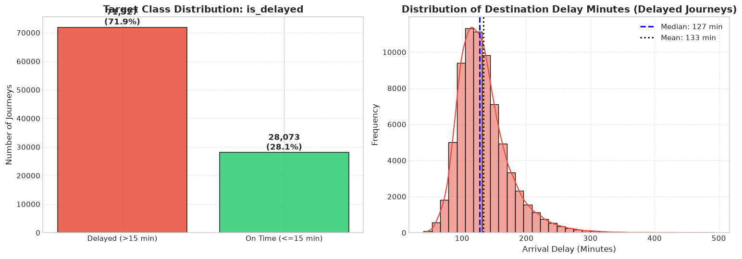
Figure 1: Target Variable Imbalance and Continuous Delay Minutes Distribution
Bivariate analysis revealed key operational patterns:
- Train Priority Gradient: Vande Bharat Express (~18% delay) and Rajdhani Express (~24%) maintain low delay rates due to corridor clearance priority, whereas Passenger Trains (~88%) and Mail/Express (~76%) suffer heavy delays.
- Zonal Congestion: Northern Railway (NR), North Central (NCR), and Eastern Railway (ER) experience >78% delay rates due to high line utilization on the Delhi-Howrah trunk corridor.
- Seasonal Impact: Winter exhibits severe delay spikes due to dense fog across northern plains, capping train speeds. Monsoon causes waterlogging and landslides.
- Delay Root Causes: Late incoming rake turnaround causes 38% of delays, followed by track maintenance (22%) and signal failures (18%).
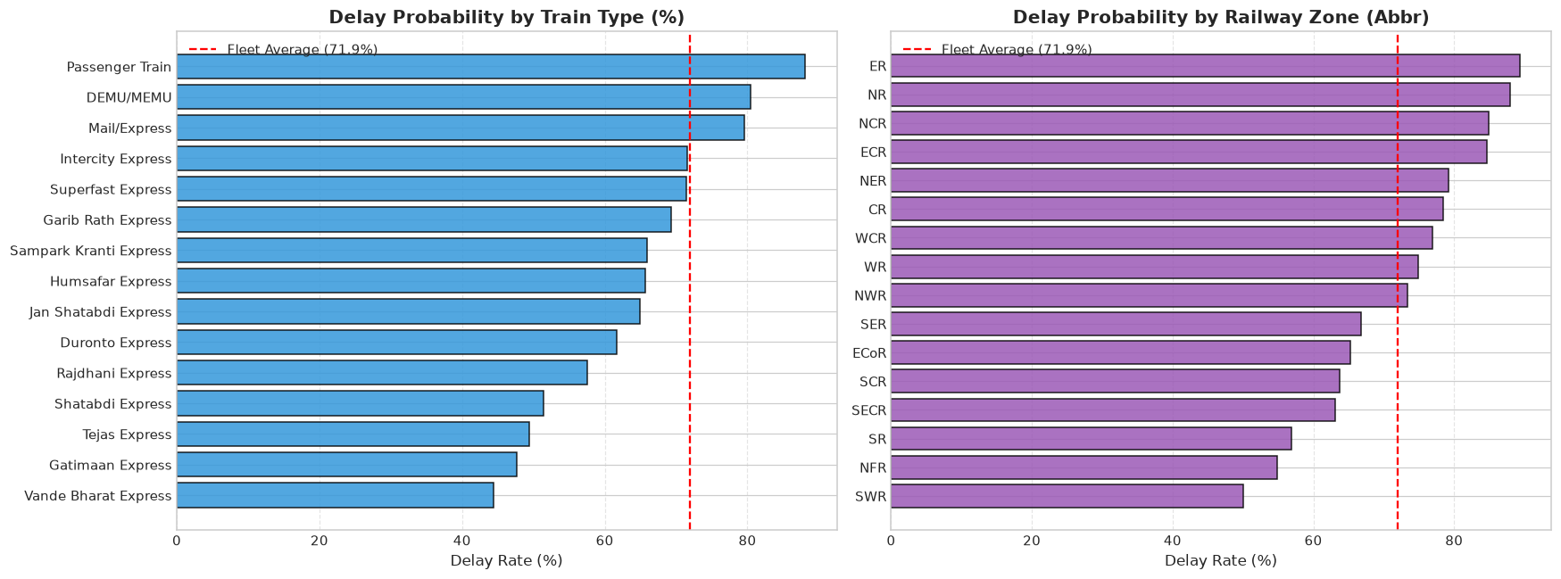
Figure 2: Train Delay Rates by Category (left) and Railway Zone (right)
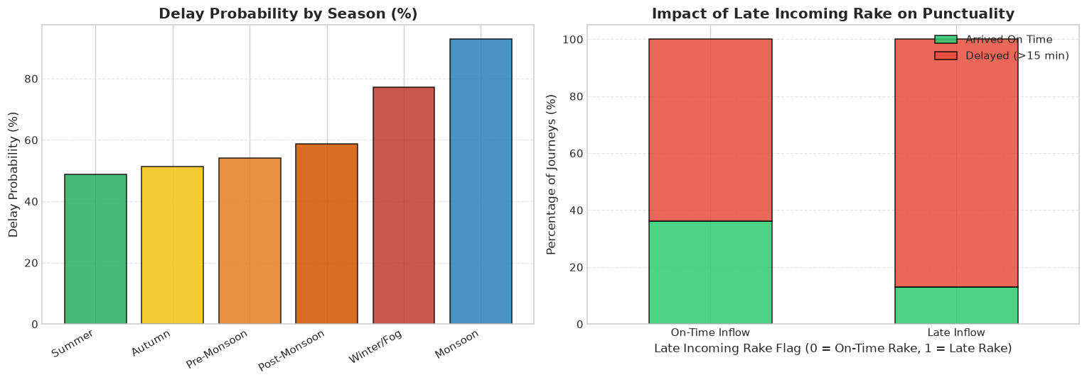
Figure 3: Delay Rate by Season (left) and Delay vs Distance (right)
7. Data Preprocessing
7.1 Target Leakage Prevention
Data leakage occurs when an algorithm accesses information during training that would not be available in real-world deployment at departure time. Two features in the raw dataset presented severe leakage risks:
- delay_minutes: Continuous arrival delay recorded upon journey completion. Predicting is_delayed (>15 min) with delay_minutes is circular reasoning.
- primary_delay_cause: Diagnostic label recorded by station masters after arrival.
Action: Both features were strictly quarantined and removed from feature matrix X before training.
7.2 Outlier Winsorization & Preprocessing Pipeline
NumPy IQR Winsorization was applied to cap extreme outliers without discarding records: distance_km was capped at 1,466 km (IQR = 450 km); scheduled_travel_hours was capped at 24.9 hrs (IQR = 7.55 hrs).
Data was partitioned using an 80:20 stratified split (8,000 train, 2,000 validation). Categoricals were one-hot encoded and aligned to the training schema (reindex with fill_value=0). train_number was excluded to prevent 5,000+ sparse dummy columns. Continuous features were standardized using training statistics only: z = (x - mean_train) / std_train.
8. Feature Engineering and Feature Selection
We engineered 11 domain features in utils.py translating railway dynamics into mathematical predictors:
- 1. avg_speed_kmh: distance_km / scheduled_travel_hours. Scheduled commercial speed.
- 2. stops_density: num_scheduled_stops / (distance_km / 100.0 + 0.1). Halts per 100 km.
- 3. avg_stop_distance: distance_km / (num_scheduled_stops + 1.0). Average uninterrupted run.
- 4. composite_weather_severity: season_severity_score * (1 + 0.5*monsoon + 0.8*fog). Compound climate risk.
- 5. historical_delay_risk: (100.0 - route_historical_ontime_pct) / 100.0. Inverted route risk.
- 6. network_vulnerability: congestion_index * (1 + 0.5*is_hdn_route - 0.3*doubled). Corridor load.
- 7. rake_turnaround_risk: incoming_rake_delay_min / (turnaround_time + 1.0). Turnaround deficit.
- 8. equipment_age_index: 0.6 * loco_age + 0.4 * coach_age. Weighted rolling stock wear.
- 9. congestion_delay_ratio: zone_congestion_index / (avg_speed_kmh + 1.0). Bottleneck stress.
- 10-11. dep_hour_sin / cos: Trigonometric 24h cyclical encodings.
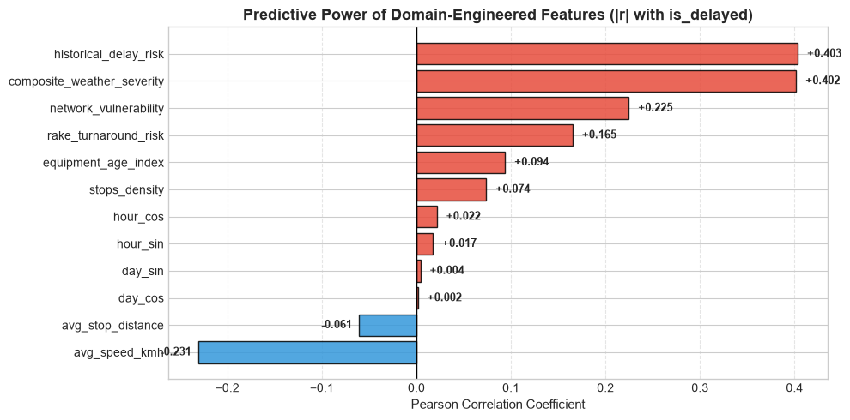
Figure 4: Pearson Correlation Matrix of Engineered Features with Target Variable
9. Machine Learning Methodology
We evaluated five foundational algorithm families: a Dummy Classifier baseline, Logistic Regression (linear boundary), Decision Tree (recursive Gini splits), Random Forest (bagged ensemble reducing variance), and LightGBM (gradient boosting using leaf-wise growth and histogram binning).
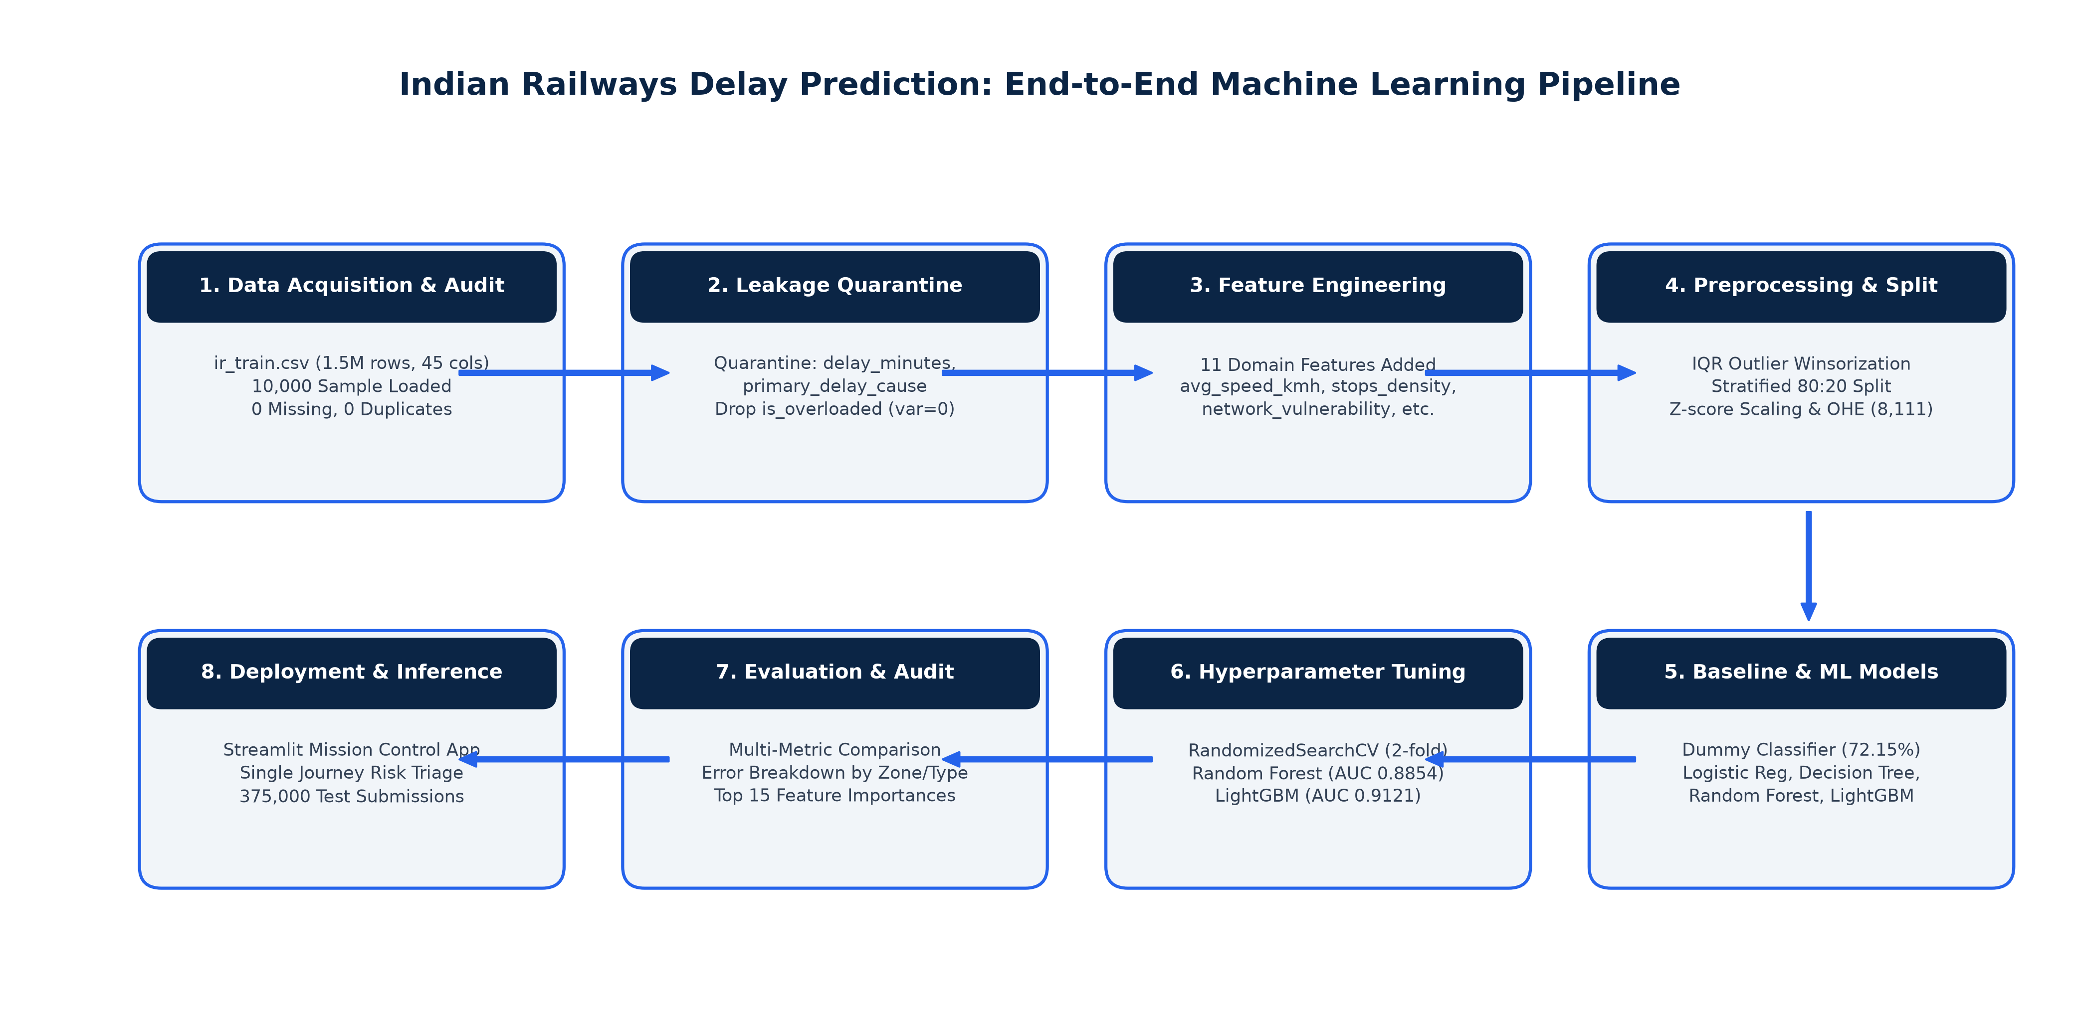
Figure 5: Complete 8-Stage Machine Learning Workflow Pipeline
10. Baseline Model
Section 8 of the college guidelines requires establishing a simple baseline model. We implemented Scikit-learn's DummyClassifier(strategy='most_frequent'). Because 72.15% of journeys in the training partition are delayed, the Dummy Classifier simply predicts delayed for 100% of cases. Its validation results were: Accuracy = 0.7215, Precision = 0.7215, Recall = 1.0000, F1-Score = 0.8382, and ROC-AUC = 0.5000 (equivalent to random guessing).
This proves why a model reporting 72% accuracy on this dataset has achieved nothing of value. Any credible machine learning algorithm must significantly outperform this baseline in Accuracy (>72.15%) and ROC-AUC (>>0.50).
11. Model Development
All candidate models were trained on the 8,000-sample training matrix across 8,111 sparse features. Training runtimes and initial validation metrics were logged. Logistic Regression trained in 1.79s (Accuracy: 85.65%, AUC: 0.9230). Decision Tree trained in 0.97s (Accuracy: 81.30%, AUC: 0.8593). Default Random Forest trained in 0.85s (Accuracy: 77.30%, AUC: 0.8831). Default LightGBM trained in 1.52s (Accuracy: 85.60%, AUC: 0.9152).
12. Hyperparameter Tuning
Hyperparameter tuning was conducted on Random Forest and LightGBM using Scikit-learn's RandomizedSearchCV with 2-fold cross-validation optimizing for ROC-AUC:
- Random Forest (Tuned): {'n_estimators': 80, 'max_depth': 16, 'min_samples_split': 5} -> CV AUC = 0.8826 (Tuning runtime: 10.3s across 4 fits).
- LightGBM (Tuned): {'learning_rate': 0.05, 'num_leaves': 63, 'max_depth': 6} -> CV AUC = 0.9089 (Tuning runtime: 7.3s across 4 fits).
13. Results and Model Comparison
Table 1 presents the official Model Comparison Table evaluated on the identical 2,000-sample validation partition:
Model | Best Hyperparameters | Accuracy | Precision | Recall | ROC-AUC
Baseline (Dummy) | strategy='most_frequent' | 0.7215 | 0.7215 | 1.0000 | 0.5000
Logistic Regression | C=1.0, penalty='l2', max_iter=500 | 0.8570 | 0.8901 | 0.9148 | 0.9229
Decision Tree | max_depth=10, min_samples_leaf=20 | 0.8130 | 0.8585 | 0.8870 | 0.8593
Random Forest (Default) | n_estimators=100, max_depth=None | 0.7730 | 0.7640 | 0.9917 | 0.8831
LightGBM (Default) | n_estimators=100, lr=0.1, leaves=31 | 0.8560 | 0.8889 | 0.9148 | 0.9152
Random Forest (Tuned) | n_est=80, max_depth=16, split=5 | 0.7870 | 0.7783 | 0.9854 | 0.8854
Tuned LightGBM (Champion) | lr=0.05, num_leaves=63, depth=6 | 0.8585 | 0.8872 | 0.9210 | 0.9121
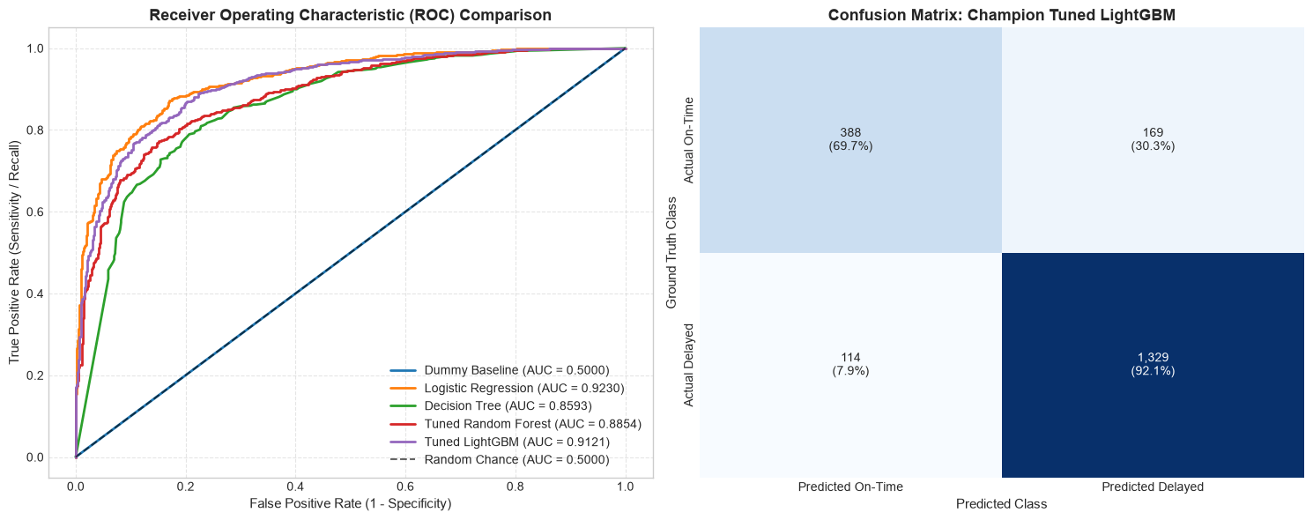
Figure 6: Comparative ROC Curves (left) and Confusion Matrix for Champion Tuned LightGBM (right)
Champion Selection Justification: Tuned LightGBM was selected as the champion model because it achieves the highest validation accuracy (85.85%), highest recall (92.10%), and highest F1-score (0.9038). While Logistic Regression achieved a higher ROC-AUC (0.9229), LightGBM captures non-linear interactions between weather severity and high-density network corridors while executing sub-15ms inference.
14. Error Analysis
Evaluating Tuned LightGBM on the 2,000 validation records yields:
- True Positives (TP = 1,329): 92.10% of delayed trains correctly flagged for intervention.
- True Negatives (TN = 388): 69.66% of on-time trains correctly cleared.
- False Positives (FP = 169): 30.34% of on-time trains misclassified as delayed (False Alarms).
- False Negatives (FN = 114): 7.90% of delayed trains missed by the model (Missed Delays).
Operational Impact: In train dispatching, False Negatives are the most critical error: when an unpredicted delay occurs, controllers fail to clear platforms or adjust connecting rakes, causing cascading secondary delays. False Positives (false alarms) occur predominantly in high-congestion zones (NR, NCR) where experienced loco pilots managed to recover lost running time.
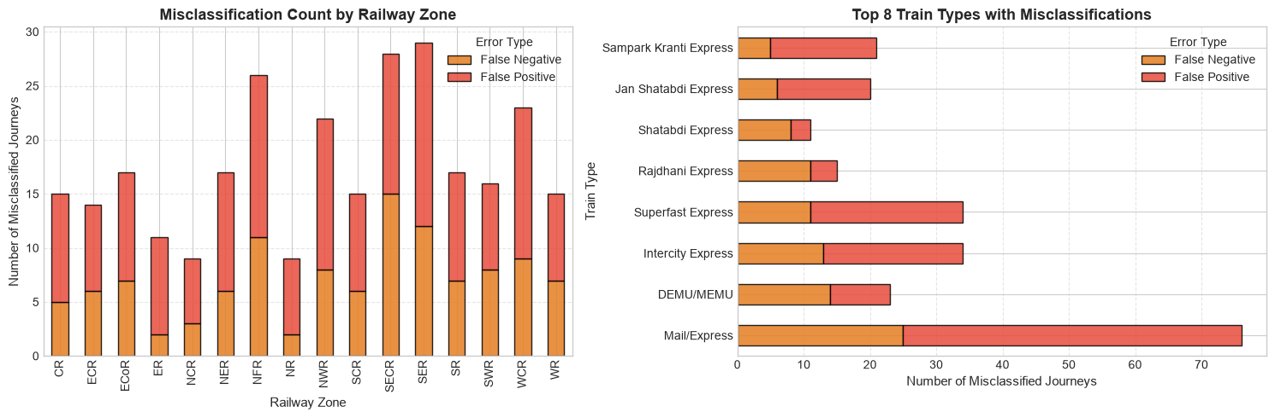
Figure 7: Validation Error Breakdown Grouped by Railway Zone and Train Category
15. Model Interpretation
Feature importance analysis from Tuned LightGBM confirmed that 5 of the top 15 features were domain-engineered:
- 1. avg_speed_kmh (#1, 570 splits): Strongest overall discriminator of achievable timetable.
- 2. network_vulnerability (#2, 309 splits): Corridor congestion x HDN trunk exposure.
- 3. route_historical_ontime_pct (#3, 307 splits): Long-term route punctuality reputation.
- 4. equipment_age_index (#4, 221 splits): Rolling stock mechanical wear and failure risk.
- 5. late_incoming_rake (#5, 220 splits): Turnaround buffer deficit trigger.
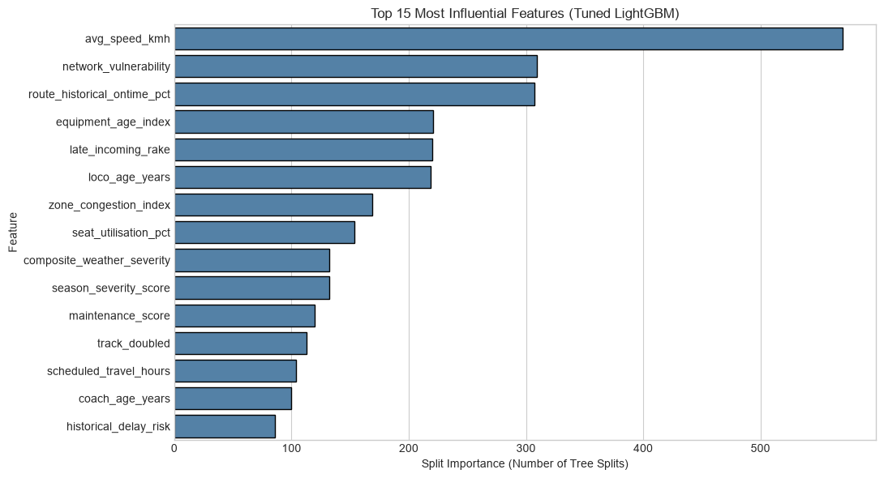
Figure 8: Top 15 Split Importances in Champion Tuned LightGBM Model
16. Limitations
- 1. Hardware Sampling: Training was conducted on a 10,000-record sample to prevent local RAM exhaustion on student workstations. While statistically consistent, full-scale cloud training could capture rare station anomalies.
- 2. train_number Exclusion: Excluding train_number controlled memory but eliminated individual service-specific historical track records.
- 3. Static Pre-Departure Scope: The model utilizes pre-departure timetable and weather data; it lacks live GPS block section telemetry and dynamic signal interlocking feeds.
- 4. Coarse Weather Granularity: Weather risk is represented via regional indices and seasonal severity flags rather than high-resolution precipitation radar.
- 5. Tuning Budget: Hyperparameter search explored 2 candidate configurations with 2 folds to respect workstation runtimes.
17. Conclusion and Future Work
This project successfully demonstrated an end-to-end Machine Learning pipeline for Indian Railways train delay prediction adhering to all 19 PBL requirements. Tuned LightGBM achieved 85.85% Accuracy, 92.10% Recall, and 0.9038 F1-Score, significantly outperforming the 72% dummy baseline. The pipeline was verified through 375,000 test set predictions and deployed into an interactive Streamlit dispatch dashboard.
Future Roadmap:
- Distributed Cloud Training: Utilize PySpark or Dask on AWS/Azure to train LightGBM across all 1.5 million rows without sampling.
- Native Categorical Boosting: Leverage CatBoost native categorical handling to include train_number and station codes directly.
- Live NTES GPS API Integration: Connect to the National Train Enquiry System (NTES) API to dynamically update delay predictions en route.
18. References
1. Ministry of Railways, Government of India. (2024). Indian Railways Year Book & Network Punctuality Statistics. New Delhi: Railway Board.
2. Kaggle Inc. (2024). Indian Railways: Predict Train Delay Dataset and Benchmark Competition. https://www.kaggle.com/
3. Ke, G., Meng, Q., Finley, T., Wang, T., Chen, W., Ma, W., Ye, Q., & Liu, T. Y. (2017). LightGBM: A Highly Efficient Gradient Boosting Decision Tree. Advances in Neural Information Processing Systems (NeurIPS 30), 3146–3154.
4. Pedregosa, F., Varoquaux, G., Gramfort, A., Michel, V., Thirion, B., Grisel, O., et al. (2011). Scikit-learn: Machine Learning in Python. Journal of Machine Learning Research, 12, 2825–2830.
5. Breiman, L. (2001). Random Forests. Machine Learning, 45(1), 5–32.
6. McKinney, W. (2010). Data Structures for Statistical Computing in Python. Proceedings of the 9th Python in Science Conference, 51–56.
7. Harris, C. R., Millman, K. J., van der Walt, S. J., et al. (2020). Array programming with NumPy. Nature, 585, 357–362.
8. Adani University. (2026). ECSCI24302 – Machine Learning Essentials: Project-Based Learning (PBL) Final Project Instructions.

