IT5016: Assignment 1

Flowchart and pseudo-code

Student name: - Kirtan Raghavbhai Sorathiya

Student ID: - 20241077

**Introduction: -**

Here, I am going to display Recipe of Toast by using two main methods which are Flowchart as well as pseudocode. Moreover, flowchart and pseudocode are useful and easier way to represent, write, and understand algorithm, codes in programming as well.

Flowchart of toast recipe: -

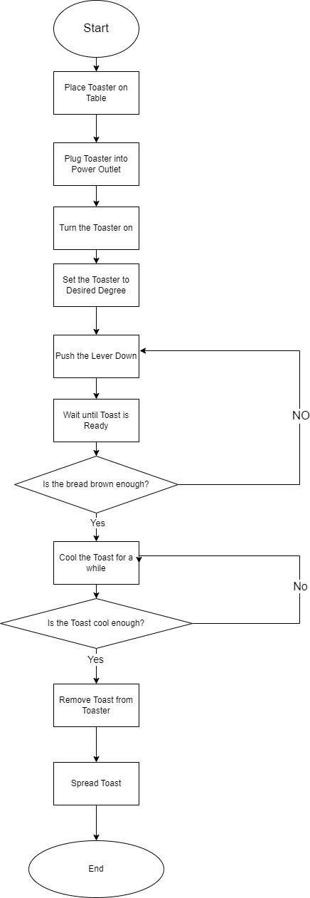

start

# Set up the toaster

place toaster on table

plug toaster into power outlet

turn the toaster on

set the toaster to desired degree

# Toast the bread

push the lever down

while toast is not brown:

  wait until toast is ready

  if toast is brown:

    cool the toast for a while

    if toast is cool:

      remove toast from toaster

      spread toast

end