**JHI: PASA:**

Kirtan Shrestha

BSc. (Hons.)

Computing, Softwarica Collage of IT and E-commerce, Coventry University

ST4008CEM Computing Activity LED Learning Project 1

Giriraj Rawat

February 23, 2023

**Contents**

JHI: PASA: 3

Introduction 3

Login Page 3

**Figure 1** 3

**Figure 2** 4

Sign Up page. 5

**Figure 3** 5

**Figure 4** 6

Back End 6

**Figure 5** 7

**Figure 6** 8

GitHub Commits 8

**Figure 7** 8

Conclusion 9

# **JHI: PASA:**

# **Introduction**

The main purpose of making this front end is to build a simple, user friendly, and interactive “Sign-in and Login” GUI for customer using Python Tkinter tools.

# **Login Page**

After clicking in our application the customer sees the login page. They must provide their registered username and password to get into main dashboard. The login credentials will allow access if they match the record that is kept in the database. It will display a dialog box with the words "Invalid Credentials" if the username and password entered do not match the record that is saved in the database.

## **Figure 1**

***Login page***

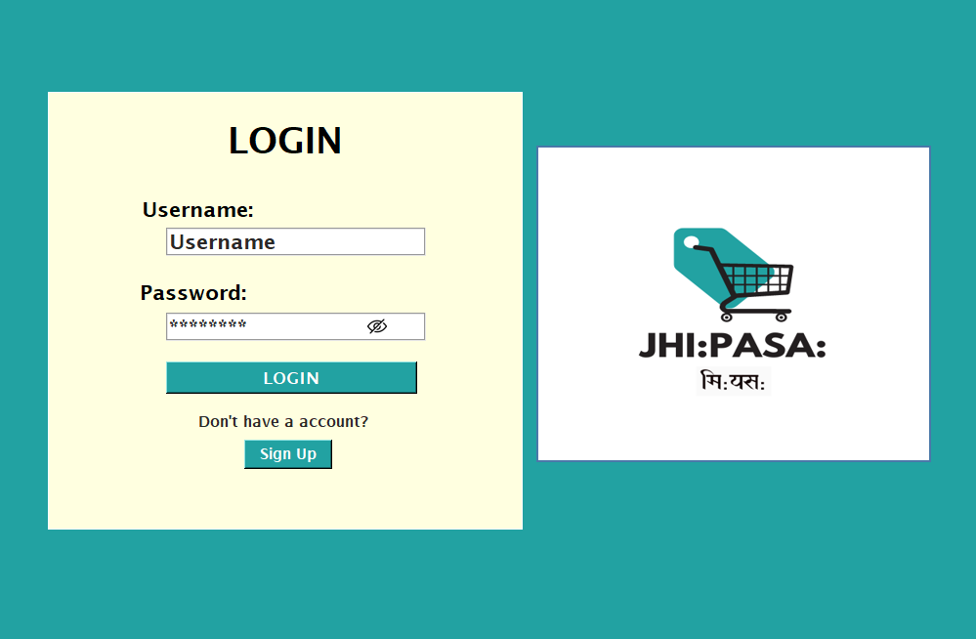

As we can see there is three features in login page they are “Login”, “Sign Up” and “Eye button. To log in to the main dashboard, click the login button. If you don't already have an account, you can create one by clicking the Sign-Up button. Our password can be "hidden and shown" with the eye button.**Figure 2**

***Login code***

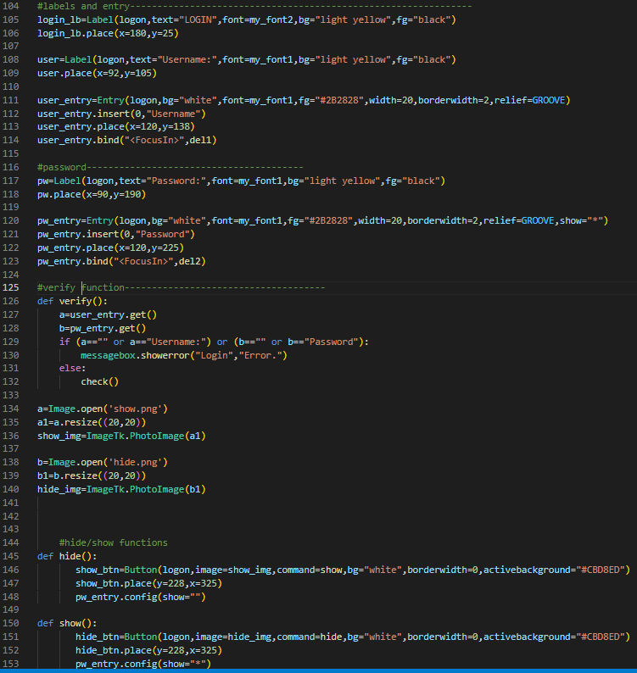

# **Sign Up page.**

If a user has not yet made an account in our program, they can do so on the second page, the sign-up page. In this page customer have to provide the following details to register themselves in our application.

As we can see there is two button one is “Sign in and Login” after filling all details we can sign in it. If you miss to fill one entry box also it will show us the “Error”.

## **Figure 3**

***Sign up page.***

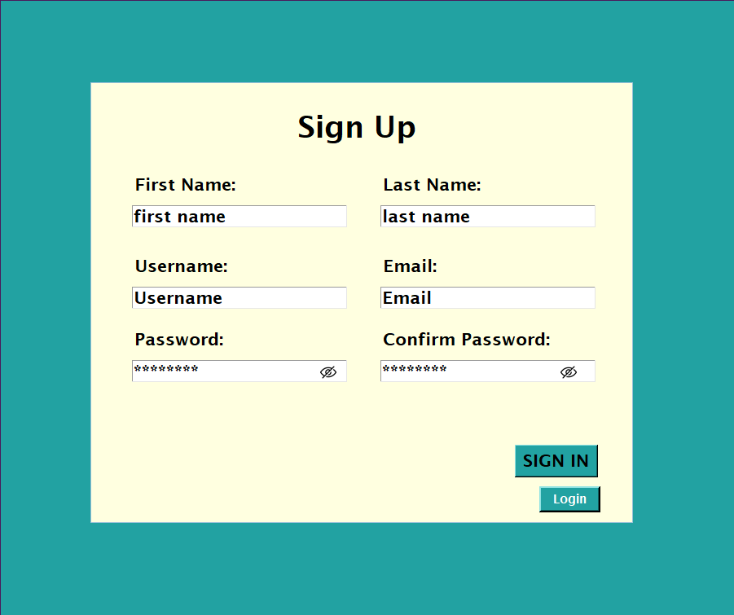

## **Figure 4**

***Code of Signup***

# **Back End**

In the back end the data which were written in the sign-up page were stored in database. It stored the value permanently and only the admin can delete or edit it. In backend import sqlite3 to connect and create a database where all the records were stored.

## **Figure 5**

***Backend code***

## **Figure 6**

***Data store in database***

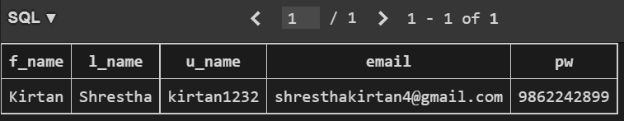

# **GitHub Commits**

## **Figure 7**

***Commits***

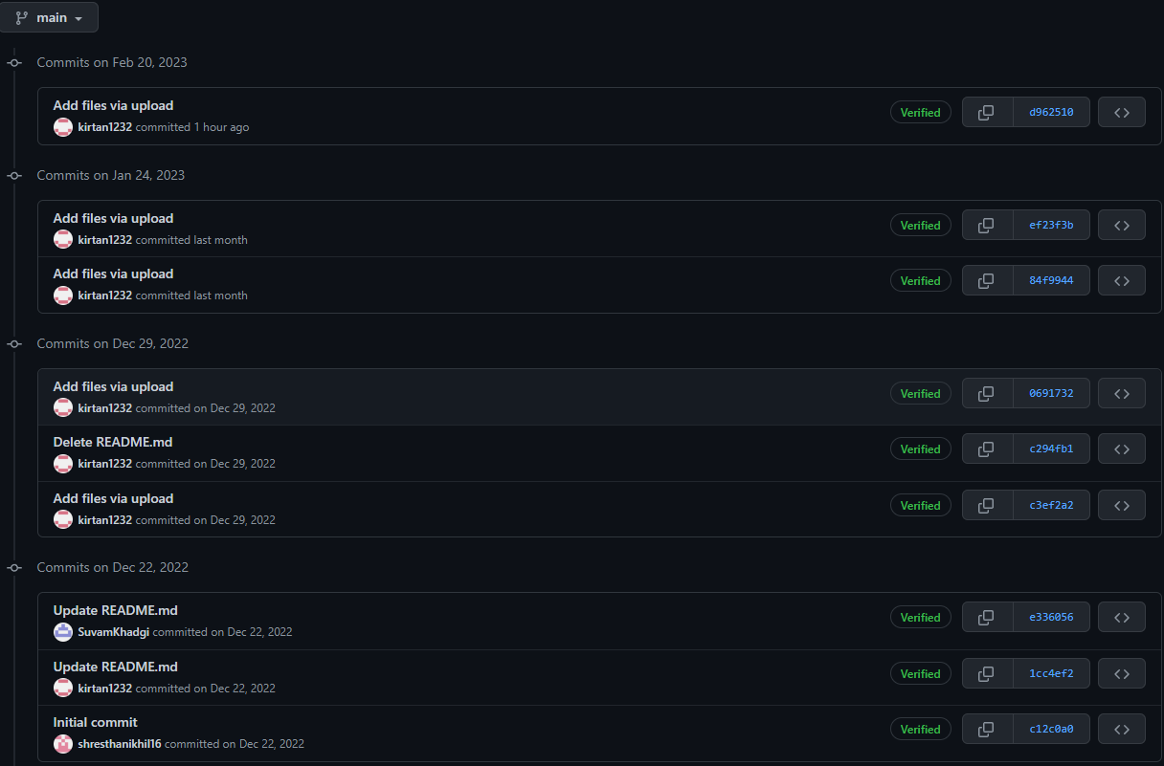

# **Conclusion**

The goal of our application is to make sure the customer can see which products are available in our shop. They won’t need to visit our shop to check out the products which they want to buy. They can check our application by staying at home and add the product into their cart and purchase it. It can save the time of people and also they won’t need to search our mart location. It also saved the bill of the customer which incase if they have any problem with our product they can contact us.

I feel that in terms of coding, I was not able to keep up with my fellow team members, but I was able to calmly gather all the required information necessary for this application and was able to systematically arrange them to help others.