EVision — EV charging demand and hotspot ranking
Generated from data/processed by scripts/build_report_assets.py

EVision — EV charging demand and hotspot ranking

Executive summary
EVision ranks 51 Indian cities by public charging demand. It combines a
2021–2026 city × month registration panel, charger counts at a fixed 10 km
radius, Census 2011 demographics, modelled petrol prices, state policy scores,
income and climate. The headline product is the Charging Demand Score (CDS),
which combines a count model, a classifier and a time-series forecast.
Key results:
- 3,519 city-months, 51 cities, 2021-01 to
2026-09; 96.9% observed.
- M1 drivers: non-EV market size is the strongest correlate
(IRR 2.72, p < 0.001); income is
negative (IRR 0.56) and policy is positive
(IRR 1.35, provisional).
- M2: logistic AUC 0.822 and LDA
0.818 under repeated 5-fold CV; the train–CV gap
is about 0.06.
- M3: all 51 cities forecast; 28 SARIMA and
23 Holt-Winters win their holdout. All fits are
finite after scaling; no city is unstable.
- CDS top five: Bengaluru, Jaipur, Delhi, Pune, Rajkot. 2 cities are Critical and 2 High.
- Robustness: dropping the fuel price or the provisional policy score does
not change the market-size and income findings. Dropping the seven unverified
demographics raises M2 AUC to nan.

1. Problem and objectives
Public charging demand is not observed. A raw EV-per-charger ratio is misleading
because 2W mostly charge at home while 3W and 4W rely on public infrastructure.
The project therefore: (1) builds a weighted demand metric; (2) models adoption
drivers with a negative binomial; (3) classifies High/Low demand with logistic
and LDA; (4) forecasts 12-month growth with SARIMA/Holt-Winters; and (5)
combines them into a ranked CDS and an interactive map.

2. Data and provenance
Input | Grain | Role
registrations/vehicle-registrations-by-fuel-type.csv | RTO × month × fuel | EV registrations (Electric(BOV) + Pure EV)
registrations/registrations-by-vehicle-category.csv | RTO × month × category | market size and 2W/3W/4W mix
registrations/registrations-by-vehicle-class.csv | RTO × month × class | transport vs non-transport
supply/city_chargers.csv | city | 15–30 km charger circle
supply/stations_clean.csv | station | fixed 5/10 km supply
demographics/city_population_density.csv | city | Census 2011 + 2023 estimate
prices/city_month_petrol_51.csv | city × month | fuel price
policy/state_ev_policy_scores.csv | state | policy score (provisional)
geo/india_state.geojson | state | choropleth

2021 comes from cached dashboard responses (panel_source = dashboard_cache),
2022 onward from the Vahan export (vahan_export). Nine cities have no 2021
cache; their leading 12 months stay empty. The manifest records them, along with
the 109 unobserved rows and the 17 covariate-poor configured cities.
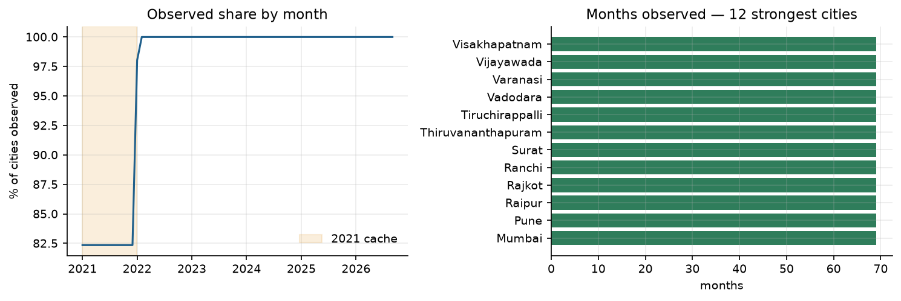
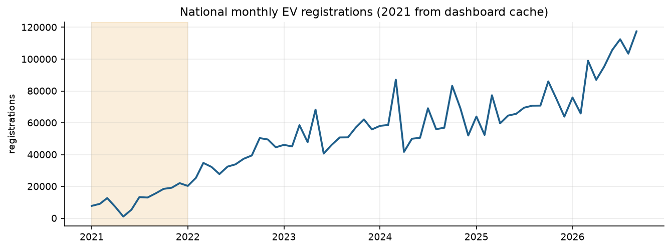

3. Cleaning and feature engineering
- Duplicate city-months are removed; the grid is reindexed so gaps are explicit.
- Gaps of at most two months are interpolated; longer gaps stay empty.
- IQR outliers are flagged per city and winsorised, never dropped
(72 flagged).
- Derived: cumulative stock, MoM/YoY growth, 3-month mean, market share, EV share
of new sales, commercial share, fixed-radius supply, demand ratios.
- master_ev_panel.csv is the analysis-ready merge: 3,519 × 116.

4. Objective 1 — effective public demand
effective_public_demand = weighted_ev_stock / stations_within_radius, where
weighted stock uses 0.15·2W + 0.70·3W + 1.00·4W + 0.60·COMM. The comparable
variant divides by stations_10km because the city circle radius varies 15–30 km.
42 cities have a measured split; 6 use a state proxy and 3 a national proxy.
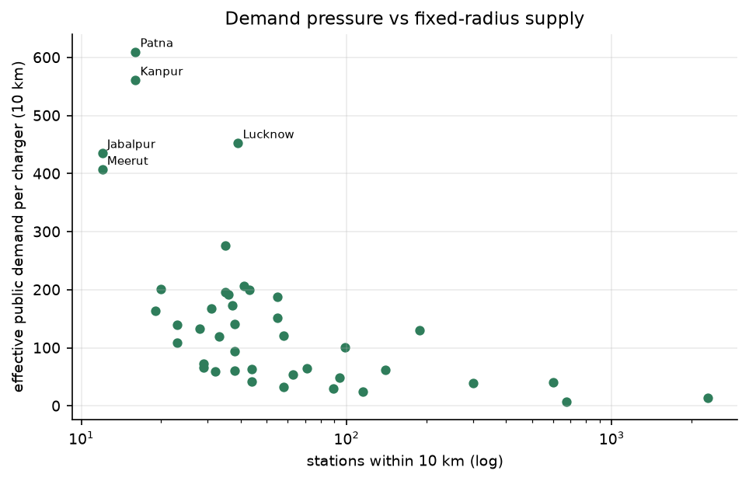

5. Objective 2 — adoption drivers (negative binomial)
M1a is between-city (n=51); M1b is a panel with city fixed effects. The table
reports incidence-rate ratios from M1a.
Term | IRR | p
log_non_ev_market | 2.72 | 1.56e-34
log_income | 0.56 | 1.1e-10
ev_policy_score | 1.35 | 0.000771
log_density | 0.8 | 0.0536
mean_fuel_price | 1.01 | 0.15
summer_max_temp_c | 0.98 | 0.242
log_population | 1.1 | 0.311
highway_corridor | 0.94 | 0.702

The fuel price is mostly the Delhi series times a city ratio, so its coefficient
is not a causal price effect. Refitting without it leaves the market-size and
income coefficients essentially unchanged (model_m1_sensitivity.csv). Removing
the provisional policy score also leaves the sign and significance of market size
and income intact (model_m1_policy_sensitivity.csv).

6. Objective 3 — High/Low demand classifier
The label is the upper half of effective_public_demand_10km. Predictors are
exogenous only: density, income, fuel price, policy, corridor, temperature. EV
stock, charger counts and growth are excluded.
Model | AUC mean | SD | p05–p95 | Accuracy | LOOCV | Train–CV gap
Logistic | 0.822 | 0.136 | 0.6–1.0 | 0.765 | 0.765 | 0.061
LDA | 0.818 | 0.138 | 0.6–1.0 | 0.768 | 0.784 | 0.059

Dropping the provisional policy score improves CV AUC to
0.837, which is
evidence that the provisional score adds noise. Restricting to the 44 verified
demographics raises AUC to
nan.
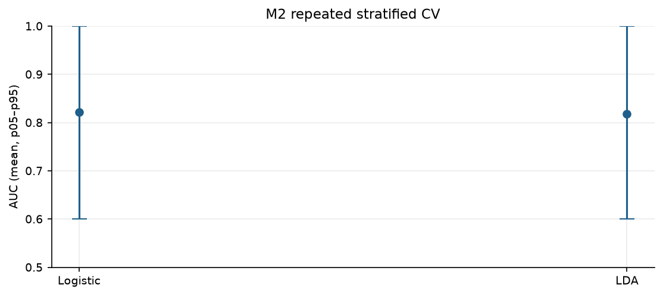

7. Objective 4 — 12-month forecasts
All 51 cities are fitted. Each model is scored on a 9-month holdout; the winner
is refit on the full series and forecast 12 months. Series are scaled before
fitting to prevent the non-converged fits that previously produced forecasts
around 1e30.
City | Winner | Last 12m | Forecast 12m | Growth | RMSE/level | Quality
Jaipur | Holt-Winters | 30,456 | 63,996 | 1.101 | 0.051 | ok
Rajkot | SARIMA | 8,300 | 15,780 | 0.901 | 0.052 | ok
Bhubaneswar | SARIMA | 36,036 | 60,525 | 0.680 | 0.049 | ok
Guwahati | Holt-Winters | 14,543 | 24,258 | 0.668 | 0.044 | ok
Pune | Holt-Winters | 67,754 | 107,179 | 0.582 | 0.044 | ok
Madurai | SARIMA | 5,455 | 8,585 | 0.574 | 0.054 | ok
Gurugram | SARIMA | 3,238 | 5,055 | 0.561 | 0.086 | ok
Srinagar | SARIMA | 3,092 | 4,780 | 0.546 | 0.046 | ok
Nashik | SARIMA | 29,344 | 45,007 | 0.534 | 0.038 | ok
Noida | SARIMA | 22,049 | 33,496 | 0.519 | 0.025 | ok
Vadodara | Holt-Winters | 11,872 | 17,612 | 0.483 | 0.051 | ok
Coimbatore | Holt-Winters | 10,769 | 15,784 | 0.466 | 0.025 | ok

Quality: 51 ok, 0 weak, 0
unstable. The 2022-only sensitivity changes forecast growth by a median of
0.033; the largest moves are
Bhopal +0.41, Guwahati -0.26, Rajkot -0.26.
The Dec-2021 → Jan-2022 seam flags 8 cities, led by Guwahati.
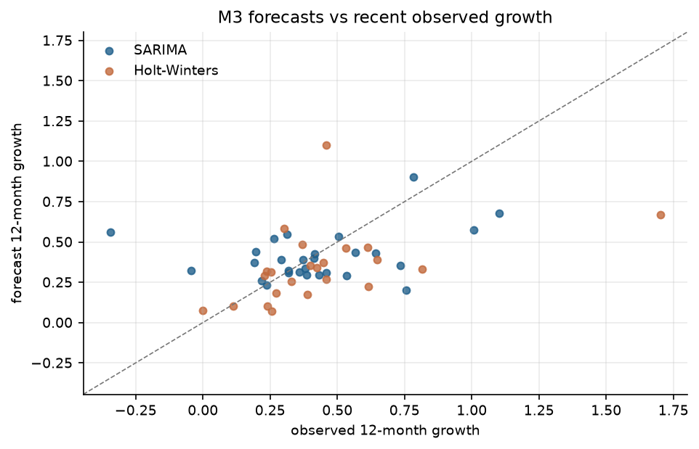

8. Objective 5 — Charging Demand Score
CDS = 0.4·z(M1 expected monthly) + 0.3·P(high) + 0.3·z(M3 growth). A forecast
only enters the score when forecast_quality = ok; otherwise observed growth is
used and m3_source says so.
Rank | City | CDS | Recommendation
1 | Bengaluru | 1.702 | Critical — immediate fast-charger deployment
2 | Jaipur | 1.513 | Critical — immediate fast-charger deployment
3 | Delhi | 1.498 | High — prioritise in the next wave
4 | Pune | 1.354 | High — prioritise in the next wave
5 | Rajkot | 0.734 | Moderate — monitor and plan
6 | Bhubaneswar | 0.719 | Moderate — monitor and plan
7 | Hyderabad | 0.634 | Moderate — monitor and plan
8 | Noida | 0.541 | Moderate — monitor and plan
9 | Lucknow | 0.484 | Moderate — monitor and plan
10 | Guwahati | 0.401 | Moderate — monitor and plan
11 | Patna | 0.389 | Moderate — monitor and plan
12 | Nashik | 0.365 | Moderate — monitor and plan
13 | Gwalior | 0.232 | Moderate — monitor and plan
14 | Indore | 0.219 | Moderate — monitor and plan
15 | Ranchi | 0.169 | Moderate — monitor and plan

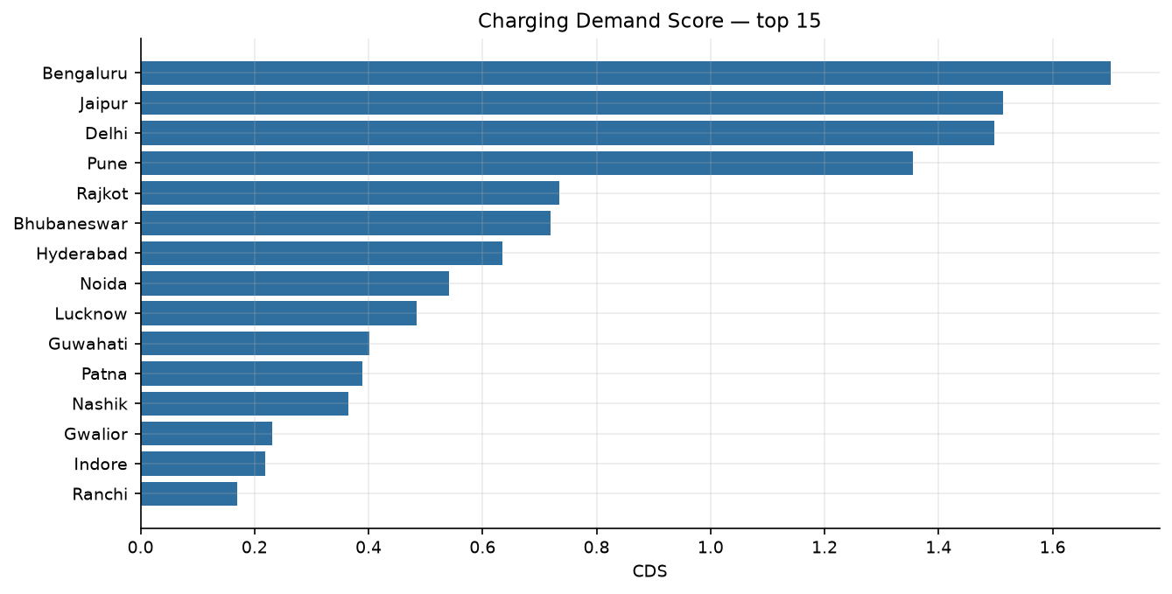
Weight sensitivity (top-15 membership):
Perturbation | Overlap | Entered | Dropped
m1 -0.10 | 15/15 | - | -
m1 +0.10 | 14/15 | Surat | Ranchi
m2 -0.10 | 14/15 | Surat | Ranchi
m2 +0.10 | 14/15 | Allahabad (Prayagraj) | Ranchi
m3 -0.10 | 14/15 | Allahabad (Prayagraj) | Ranchi
m3 +0.10 | 14/15 | Madurai | Indore

The interactive map is reports/cds_map.html.

9. Robustness and limitations
- Fuel price is modelled for most cities; M1 is shown with and without it.
- Policy scores are provisional for all 30 states. The rubric columns are
blank and 0 states are verified. The BEE policy host was unreachable from
the build environment, so the PDFs could not be read;
scripts/verify_policy_scores.py produces an evidence table where it is
reachable.
- Seven cities use municipal boundaries rather than urban agglomerations;
their populations are verified but M1/M2 are still shown with and without them.
- 2021 seam: 8 cities move by more than 1.5× into 2022; the 2022-only M3
sensitivity is reported above.
- Chargers are a single snapshot; no monthly supply series exists.
- 17 of 68 configured cities lack city-level covariates and are excluded from the
panel; 9 of the 51 analysed cities lack 2021 data.
- n=51 is small for a classifier; report the CV spread, not a single AUC.

10. Recommendations
- Verify the 7 demographic rows against Census UA tables before quoting
density-driven results; if they cannot be verified, use the 44-city model.
- Read the policy PDFs and fill the rubric with cited snippets; until then,
treat the policy coefficient as provisional.
- Use the fixed 10 km supply measure for comparisons; never compare the
variable-radius circle counts.
- Treat the 2021 seam as a source boundary and prefer the 2022-only forecast for
cities flagged in seam_2021_2022.csv.
- Deploy against the top 15 shortlist (cds_ranking_top15.csv), not the full
51-city ranking.

Appendix — output map
- data/processed/master_ev_panel.csv — analysis-ready city × month table.
- data/processed/cds_ranking.csv / cds_ranking_top15.csv — full and shortlist.
- data/processed/model_m1_*, model_m2_*, model_m3_* — model outputs.
- reports/cds_map.html — interactive map.
- reports/seam_2021_2022.csv — seam diagnostics.

