COGNIZANCE

TASK-1

BASIC OPERATIONS

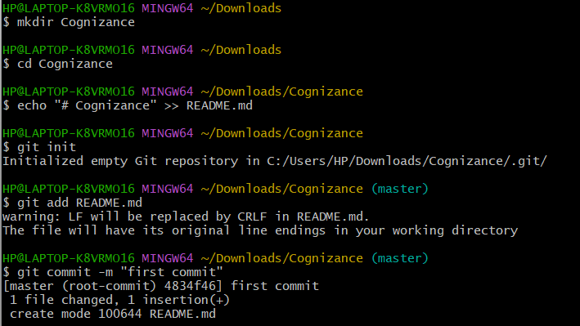

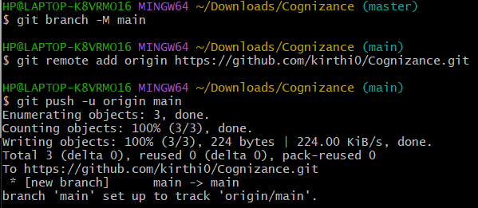



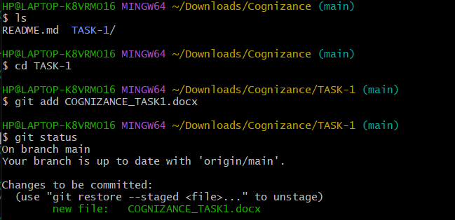

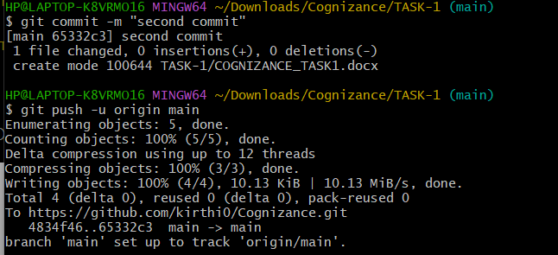

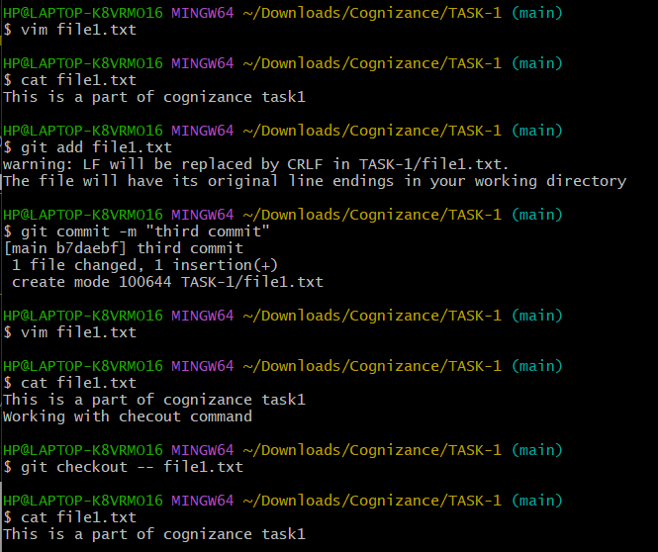

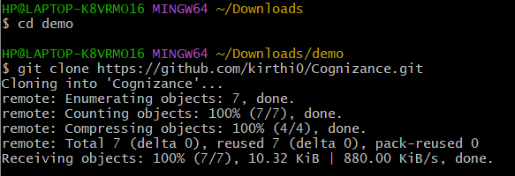

The following is a summary of basic git operations:

**git add**

Puts current working files into the stage.

**git checkout**

Replaces the current working files with files from a branch.

git checkout -b

Creates a new local branch from the current branch’s tip.

**git clone**

Clone an existing repository into a new directory.

**git commit**

Commits staged changes to a local branch.

git commit -a

Commits all modified files to a local branch(shorthand for “git add” followed by “git commit” for each modified file).

git fetch

Downloads changes from a remote repository into the local clone.

git merge

Merges files from a given branch into the current branch.

git pull

Fetches remote changes on the current branch into the local clone, and merges them into the current working files.

git push

Uploads changes from all local branches to the respective remote repositories.

git reset

Makes the current branch point to some specific revision or branch

git rebase

Integrates changes from one branch into another. It is an alternative to the better known “merge” command.

git fork

Fork will create a copy of the repository in your GitHub account so that you can make changes to the project.