**Functions, Arrays and Objects**

**Functions**

* DRY in other words don't repeat yourself. And it's thanks to functions that you can avoid repetition
* function declaration (build) and function invocation (call)
* With functions you can take several lines of code that performs a set of related actions and then group them together under a single label. Then when you need to run the code that you've saved, you just invoke or call the function. You can run the code as many times as you want.
* 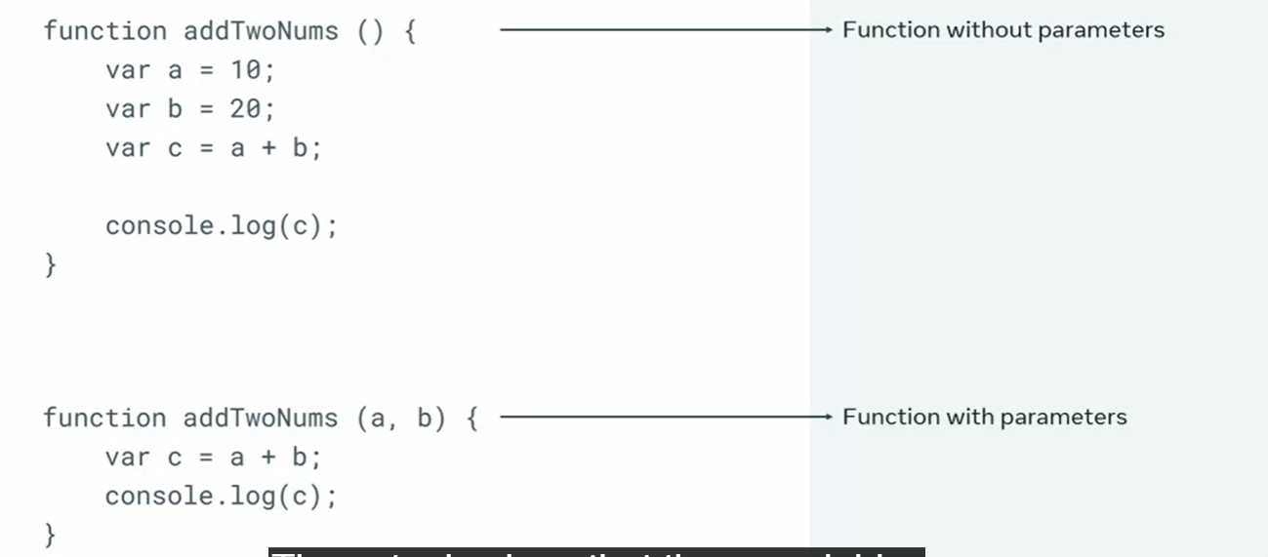
* 
* Function addTwoNums(a,b) {} => a,b function parameters
* addTwoNums(2,2) => function arguments

**Arrays**

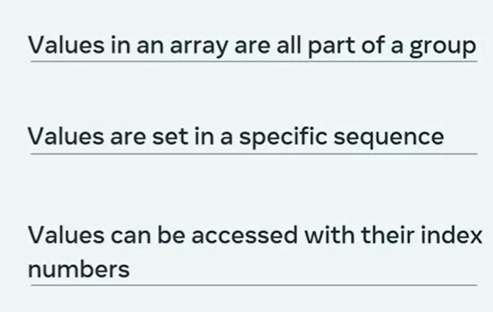

* 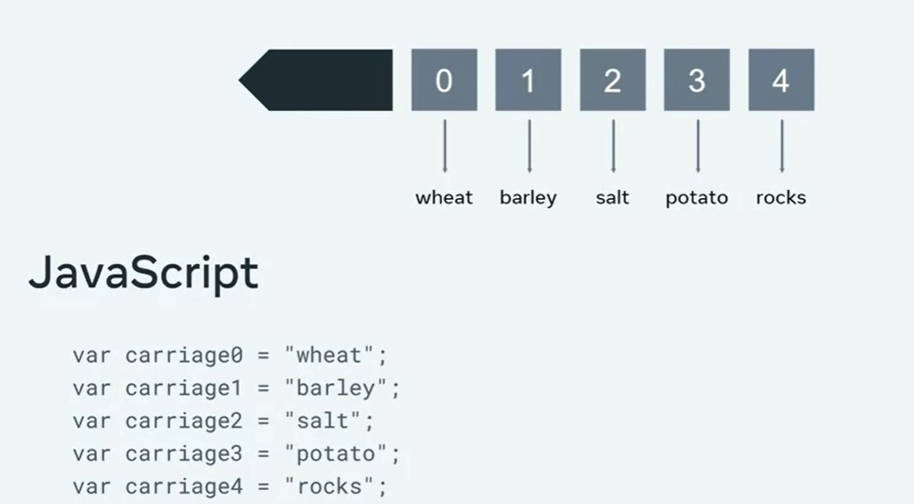
* Array index starts with 0
* Array literal syntax: [ ]
* 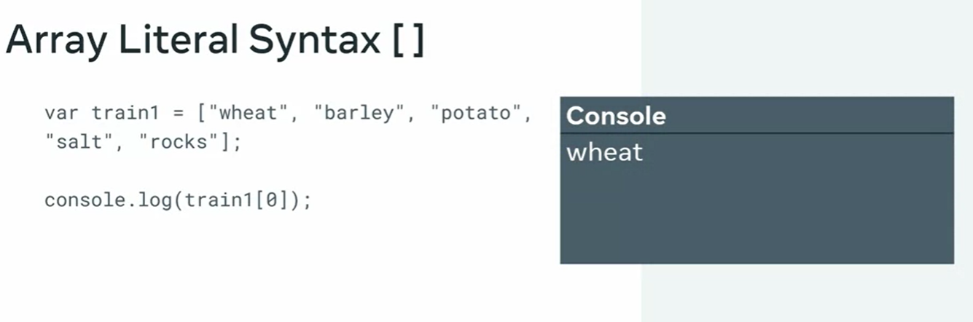

**Program to iterate through an elements in array using functions**

| function listArrayItems(arr) {  for (var i = 0; i < arr.length; i++) {  console.log(arr[i]);  console.log(i, arr[i]);  console.log(i+1, arr[i])  }  }  var colors = ['red', 'orange', 'yellow', 'green', 'blue', 'purple', 'pink'];  listArrayItems(colors); //display all items in the array at once |
| --- |

function listArrayItems(arr) {

for (var i = 0; i < arr.length; i++) {

if (arr[i] == 'red') {

console.log(i*100, "tomato!")

} else {

console.log(i*100, arr[i])

}

}

}

| red  orange  yellow  green  blue  purple  pink | 0 'red'  1 'orange'  2 'yellow'  3 'green'  4 'blue'  5 'purple'  6 'pink' | 1 'red'  2 'orange'  3 'yellow'  4 'green'  5 'blue'  6 'purple'  7 'pink' | 0 'tomato!'  100 'orange'  200 'yellow'  300 'green'  400 'blue'  500 'purple'  600 'pink' |
| --- | --- | --- | --- |

Exercise

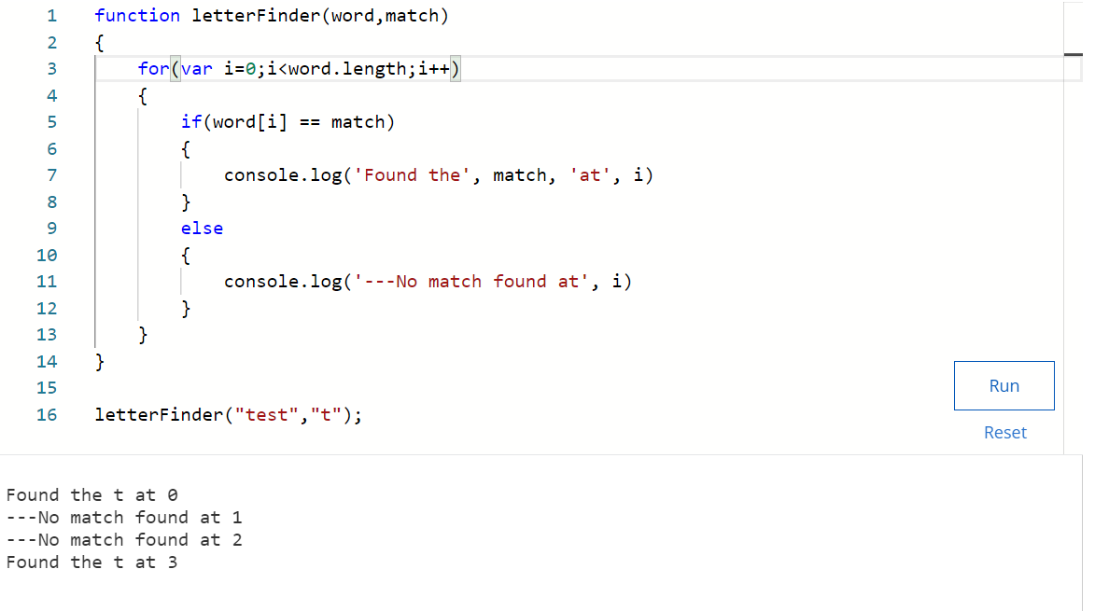

**Objects**

* Objects can be described as collections of related properties where each property is represented as a key value pair.
* object literal syntax: **{}**.
* In programming, if you have groups of data that you would like to relate, you can assign them to something known as an object.
* Groups of variables related to each other
* 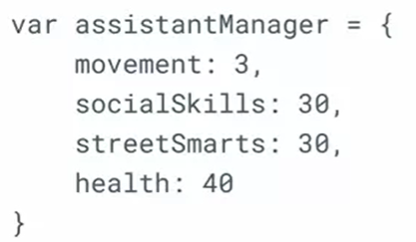
* assistantManager.nextAchievement = “get promoted” => new property added to previous ones
* var user = {}; //create an object
* //creating an object with properties and their values

var assistantManager = {

rangeTilesPerTurn: 3,

socialSkills: 30,

streetSmarts: 30,

health: 40,

specialAbility: "young and ambitious",

greeting: "Let's make some money"

}

| var table = {  legs: 3,  color: "brown",  priceUSD: 100,  }  console.log(table);//display the object in the developer console  Output: {legs: 3, color: 'brown', priceUSD: 100}  console.log(table.color); // 'brown' |
| --- |

* An alternative approach of building objects is to first save an empty object literal to a variable, then use the dot notation to declare new properties on the fly, and use the assignment operator to add values to those properties;

var house2 = {};

house2.rooms = 4;

house2.color = "pink";

house2.priceUSD = 12345;

console.log(house); // {rooms: 3, color: "brown", priceUSD: 10000}

house.windows = 10;

console.log(house); // {rooms: 3, color: "brown", priceUSD: 10000, windows: 10}

house.windows = 11;

console.log(house); // {rooms: 3, color: "brown", priceUSD: 10000, windows: 11} update already existing properties

**Object literals and the brackets notation**

* There is an alternative syntax to the dot notation I used up until this point.
* This alternative syntax is known as *the brackets notation*.

var house2 = {};

house2["rooms"] = 4;

house2['color']= "pink";

house2["priceUSD"] = 12345;

console.log(house2); // {rooms: 4, color: 'pink', priceUSD: 12345}

var car = {};

car.color = "red";

car["color"] = "green";

car["speed"] = 200;

car.speed = 100;

console.log(car); // {color: "green", speed: 100}

* With the brackets notation, I can add space characters inside property names,

car["number of doors"] = 4;

console.log(car); // {color: 'green', speed: 100, number of doors: 5}

* I can add numbers (as the string data type) as property keys:

car["2022"] = 1901;

console.log(car); // {2022: 1901, color: 'green', speed: 100, number of doors: 5}

* there's one really useful thing that bracket notation has but is not available in the dot notation: It can evaluate expressions.

var arrOfKeys = ['speed', 'altitude', 'color'];

var drone = {

speed: 100,

altitude: 200,

color: "red"

}

for (var i = 0; i < arrOfKeys.length; i++) {

console.log(drone[arrOfKeys[i]])

}

Output:

100

200

red

**Arrays are objects**

* In JavaScript, arrays are objects. That means that arrays also have some built-in properties and methods.
* One of the most commonly used built-in methods on arrays are the **push()** and the **pop()** methods.

var fruits = [];

fruits.push("apple"); // ['apple']

fruits.push('pear'); // ['apple', 'pear']

To remove the last item from an array, I can use the **pop()** method:

fruits.pop();

console.log(fruits); // ['apple']

function arrayBuilder(one, two, three) {

var arr = [];

arr.push(one);

arr.push(two);

arr.push(three);

console.log(arr);

}

arrayBuilder('apple', 'pear', 'plum'); // ['apple', 'pear', 'plum']

-return array

function arrayBuilder(one, two, three) {

var arr = [];

arr.push(one);

arr.push(two);

arr.push(three);

return arr;

}

var simpleArr = arrayBuilder('apple', 'pear', 'plum');

console.log(simpleArr); // ['apple','pear','plum']

**popular built-in objects is the Math object**

* The PI number: Math.PI which is approximately 3.14159
* The Euler's constant: Math.E which is approximately 2.718
* The natural logarithm of 2: Math.LN2 which is approximately 0.693
* **Math.ceil()** - rounds up to the closest integer
* **Math.floor()** - rounds down to the closest integer
* **Math.round()** - rounds up to the closest integer if the decimal is **.5** or above; otherwise, rounds down to the closest integer
* **Math.trunc()** - trims the decimal, leaving only the integer
* **Math.pow(2,3)** - calculates the number **2** to the power of **3**, the result is **8**
* **Math.sqrt(16)** - calculates the square root of **16**, the result is **4**
* **Math.cbrt(8)** - finds the cube root of **8**, the result is **2**
* **Math.abs(-10)** - returns the absolute value, the result is **10**
* Logarithmic methods: **Math.log()**, **Math.log2()**, **Math.log10()**
* Return the minimum and maximum values of all the inputs: **Math.min(9,8,7)** returns **7**, **Math.max(9,8,7)** returns **9**.
* Trigonometric methods: **Math.sin()**, **Math.cos()**, **Math.tan()**, etc.