NUMBER GAME
Project Title
Number Game - Java Console Application
Submitted By
Name: Kirthi
Internship: DecodeLabs
Technology: Java
1. Introduction
Number Game is a Java-based console application where the user tries to guess a randomly generated number.
The program generates a number within a specific range and asks the user to enter guesses until the correct number is found.
2. Objective
The objective of this project is to implement a simple interactive game using Java programming concepts.
This project helps to understand:
- User input handling
- Random number generation
- Loops
- Conditional statements
3. Problem Statement
Develop a Java application that:
- Generates a random number between 1 and 100
- Accepts user guesses
- Compares the entered value with the generated number
- Gives hints to the user
- Displays the number of attempts
4. Tools and Technologies Used
- Java
- Scanner Class
- Random Class
- Visual Studio Code
- GitHub
5. Project Description
The Number Game application generates a random number using the Random class.
The user enters guesses through the console. The application checks whether the guess is higher, lower, or equal to the generated number.
The game continues until the user finds the correct number.
6. Algorithm
- Start the program.
- Import required Java classes.
- Generate a random number.
- Take input from the user.
- Compare input with generated number.
- Display "Too High" if the guess is greater.
- Display "Too Low" if the guess is smaller.
- Display success message if correct.
- Count total attempts.
- End the program.
7. Features
- Random number generation
- Multiple guessing attempts
- User interaction
- Hint messages
- Attempt counter
8. Implementation Concepts
The project uses:
- Variables
- Data types
- While loop
- If-else statements
- Scanner class
- Random class
9. Output Screenshots
Screenshot 1:
Program start

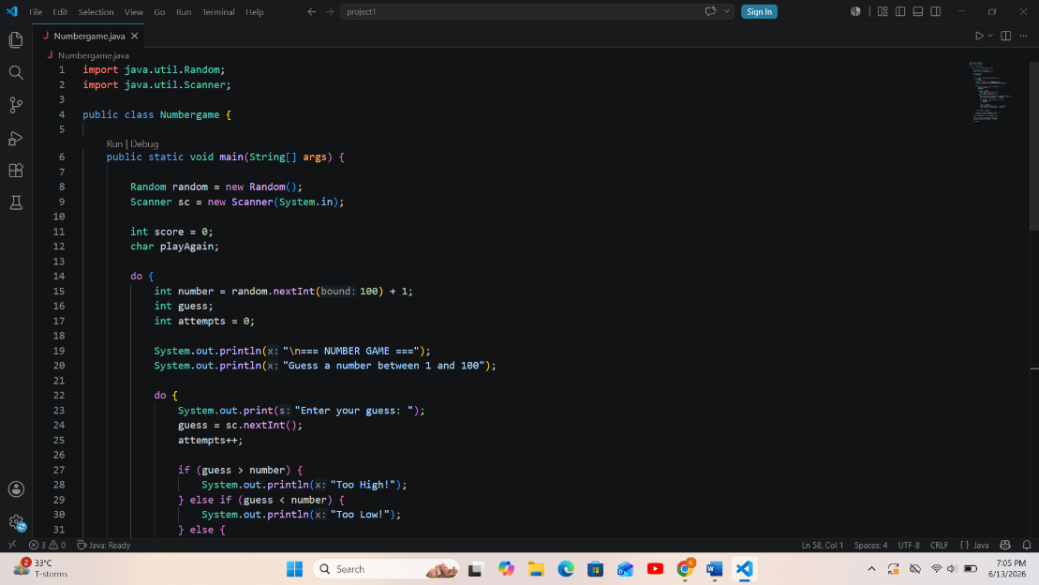

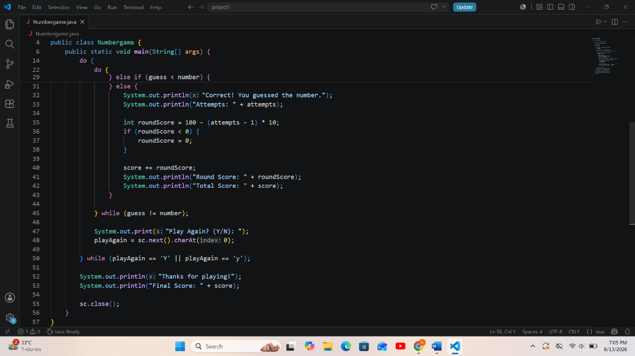

Screenshot 2:
User entering guesses

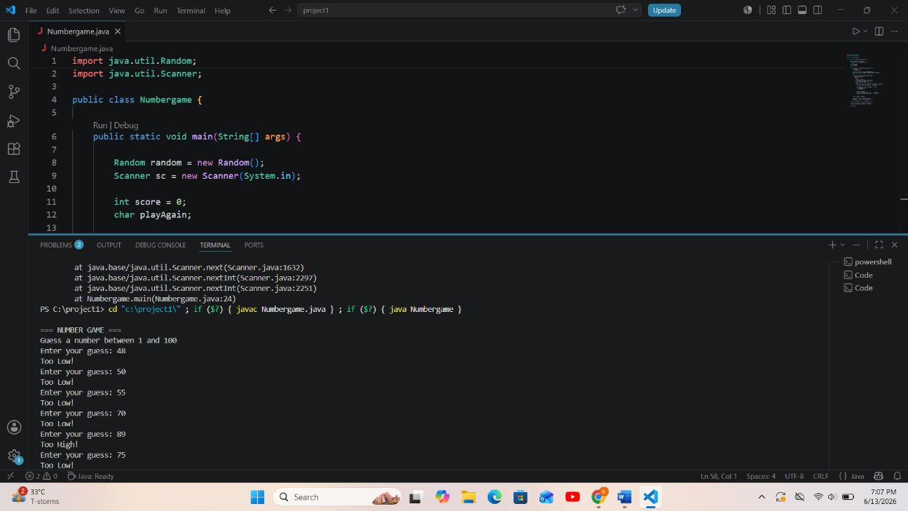

Screenshot 3:
Correct answer message

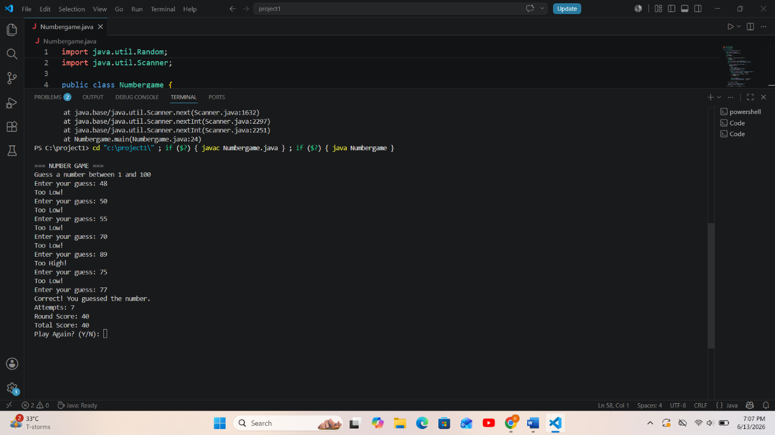

10. Result
The Number Game application successfully generates random numbers and allows users to guess the correct number with proper feedback.

11. Conclusion
This project helped in understanding Java basics and applying programming logic to build a real-world console application.

