STUDENT GRADE CALCULATOR
Project: DecodeLabs Java Programming Project 2
Submitted By
Name: K.kirthi
Batch: 2026
Technology: Java
1. Objective
The objective of this project is to create a Java application that calculates total marks, average percentage, and grade of a student.
2. Problem Statement
Develop an application that accepts marks of multiple subjects and calculates the student's academic performance.
The system should display:
- Total marks
- Average percentage
- Final grade
3. Tools and Technologies Used
- Java
- Scanner Class
- Visual Studio Code
- GitHub
4. Project Description
The Student Grade Calculator accepts marks entered by the user for multiple subjects.
The program calculates the total marks and average percentage.
Based on percentage, the application assigns grades:
A, B, C, D, or Fail.

5. Algorithm
- Start the program.
- Take number of subjects.
- Accept marks for each subject.
- Calculate total marks.
- Calculate average percentage.
- Check percentage using conditions.
- Assign grade.
- Display final result.
- Stop program.
6. Features
- Multiple subject support
- Automatic calculations
- Percentage calculation
- Grade assignment
- User-friendly output
7. Implementation Concepts
Concepts used:
- Variables
- Loops
- Arithmetic operations
- Conditional statements
- Scanner input

8. Output Screenshots
Screenshot 1:
Input marks

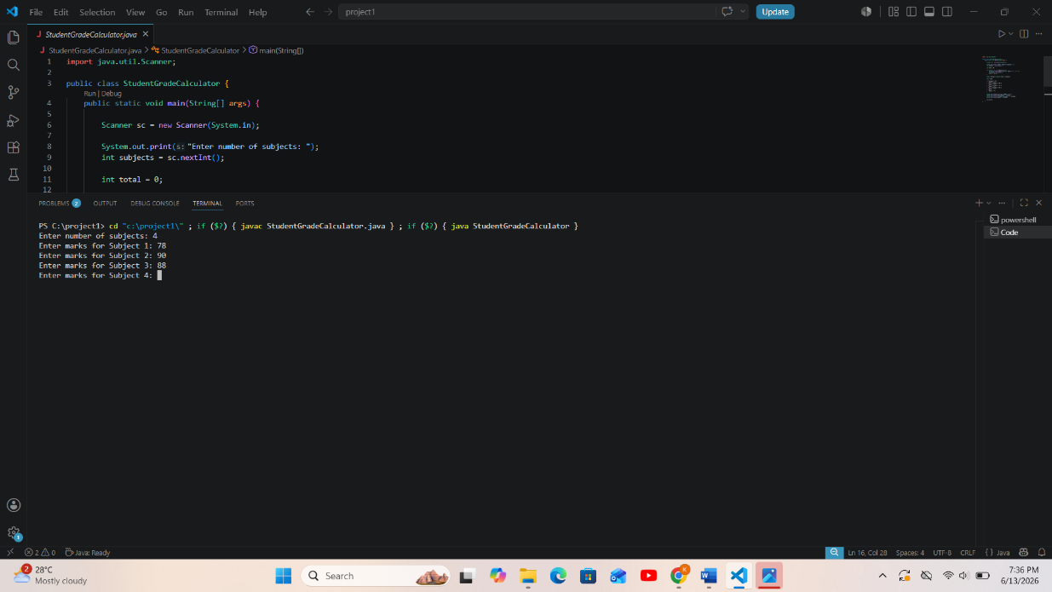

Screenshot 2:
Grade output
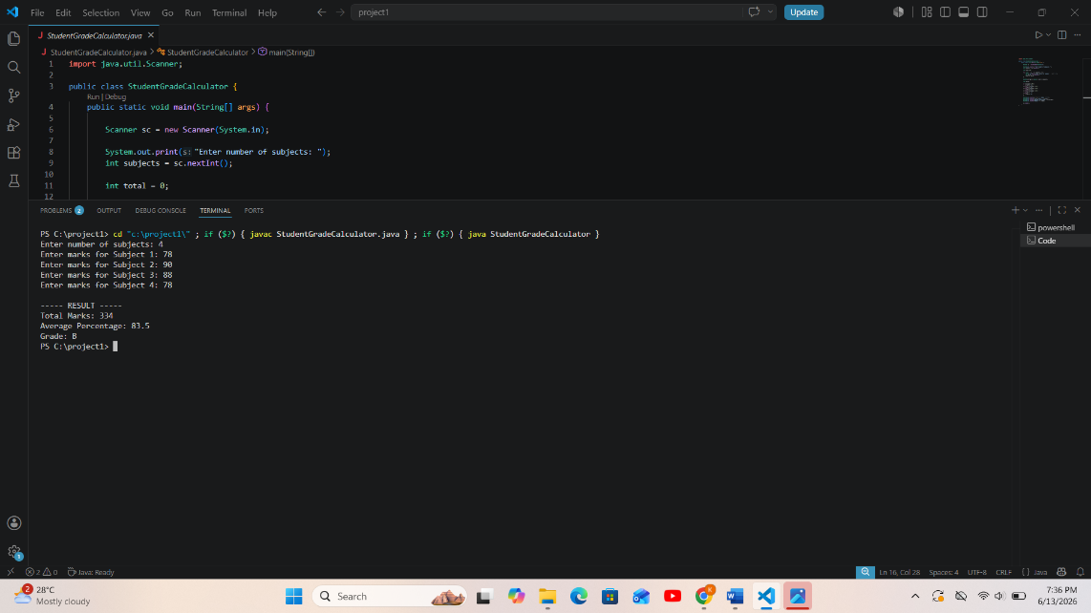

9. Result
The application successfully calculates student performance and displays the appropriate grade.
10. Conclusion
This project improved understanding of Java calculations, loops, and decision-making statements.

