ATM INTERFACE
Project: DecodeLabs Java Programming Project 3
Submitted By
Name: K.kirthi
Batch: 2026
Technology: Java
1. Objective
The objective of this project is to develop a Java-based ATM Interface using Object-Oriented Programming concepts.
2. Problem Statement
Develop an ATM simulation system that allows users to perform banking operations such as:
- Deposit money
- Withdraw money
- Check balance
The system should validate transactions and maintain account details.
3. Tools and Technologies Used
- Java
- OOP Concepts
- Visual Studio Code
- GitHub
4. Project Description
The ATM Interface simulates basic banking operations.
The project uses Object-Oriented Programming concepts by creating classes and methods.
The user can select operations from the ATM menu and perform transactions.
5. Algorithm
- Start the program.
- Create Bank Account class.
- Create ATM menu.
- Accept user choice.
- Perform selected operation.
- Validate amount.
- Update account balance.
- Display transaction message.
- Repeat until exit.
6. Features
- Deposit functionality
- Withdrawal functionality
- Balance checking
- Input validation
- Menu-driven interface
7. Implementation Concepts
Concepts used:
- Classes
- Objects
- Methods
- Encapsulation
- Constructors
- Switch statement

8. Output Screenshots
Screenshot 1:
ATM menu

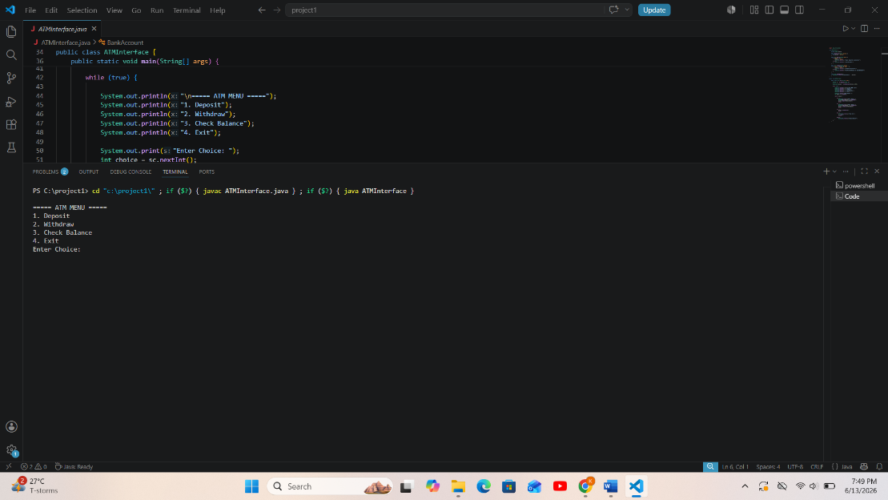

Screenshot 2:
Deposit transaction
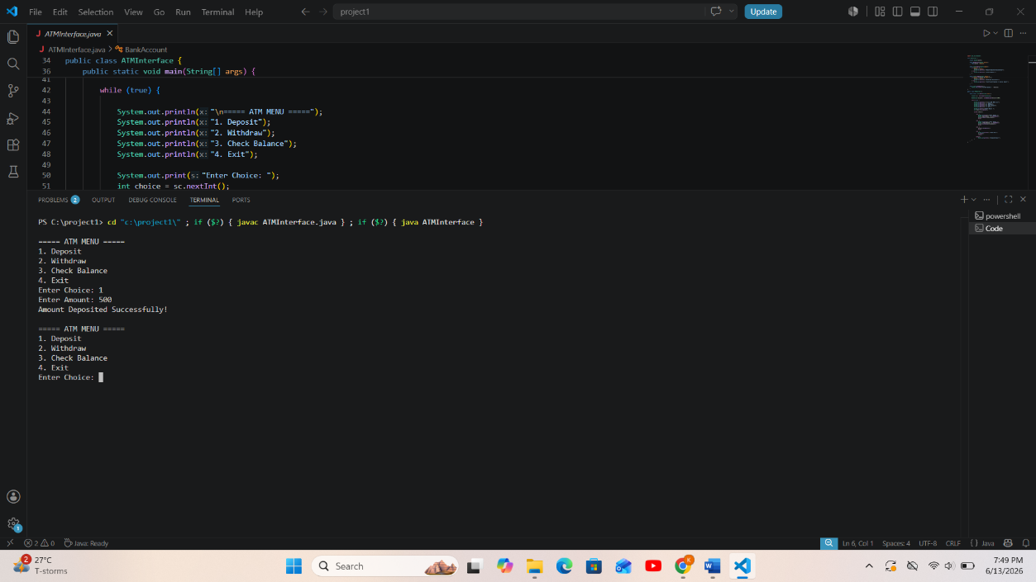

Screenshot 3:
Withdrawal transaction
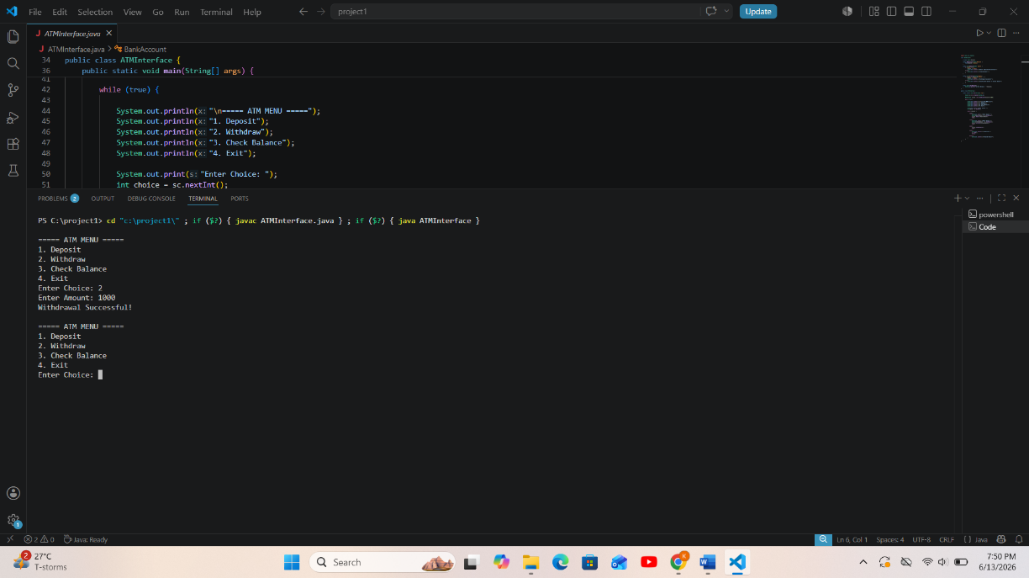

Screenshot 4:
Balance display

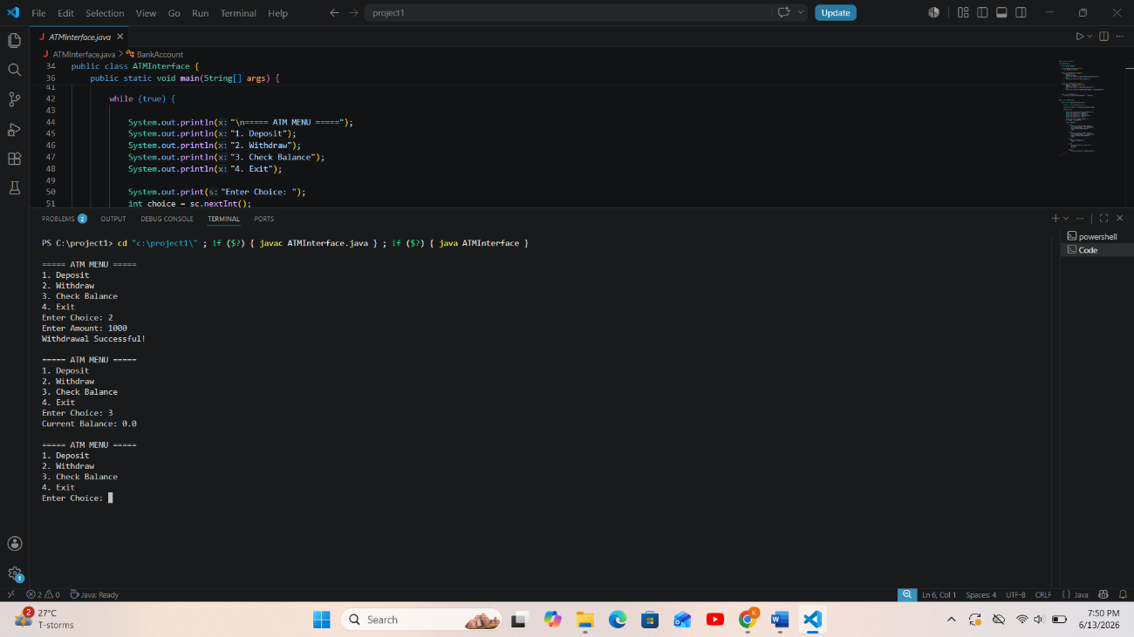

9. Result
The ATM Interface successfully performs banking operations and maintains account balance using OOP principles.
10. Conclusion
This project helped in understanding Object-Oriented Programming concepts and designing real-world applications using Java.

