2023_SKCET_Cloud_CC1Time:30 minutesMarks: 16Q1.

Create an EC2 Instance in the us-east-1 region with the following requirements.

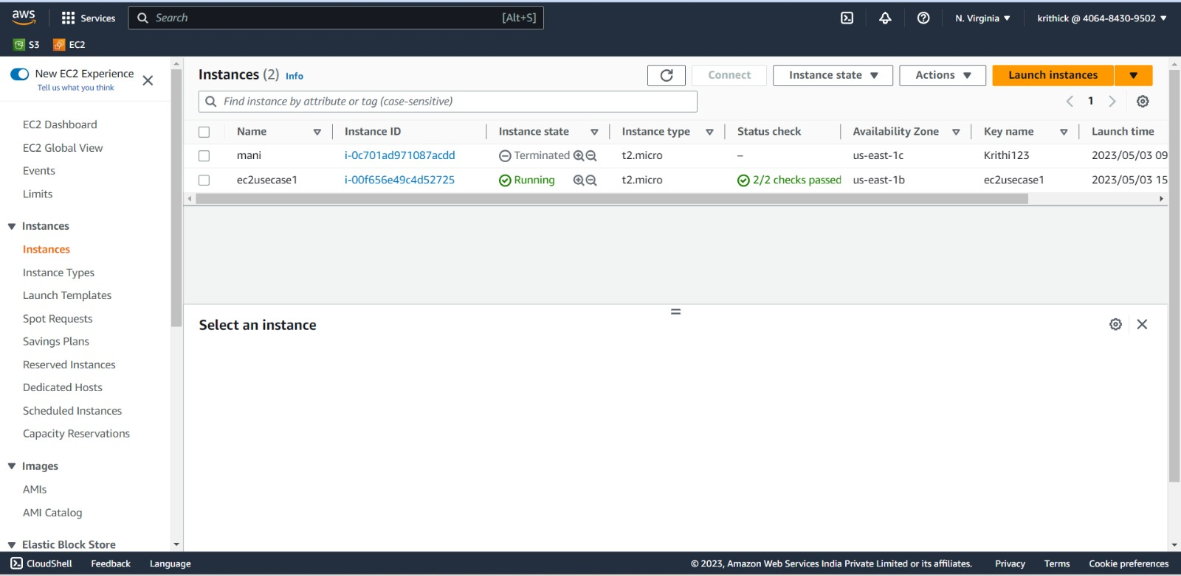

Give the Name tag of both EC2 instance & keypair as "ec2usecase1"(Name).(4 Marks)

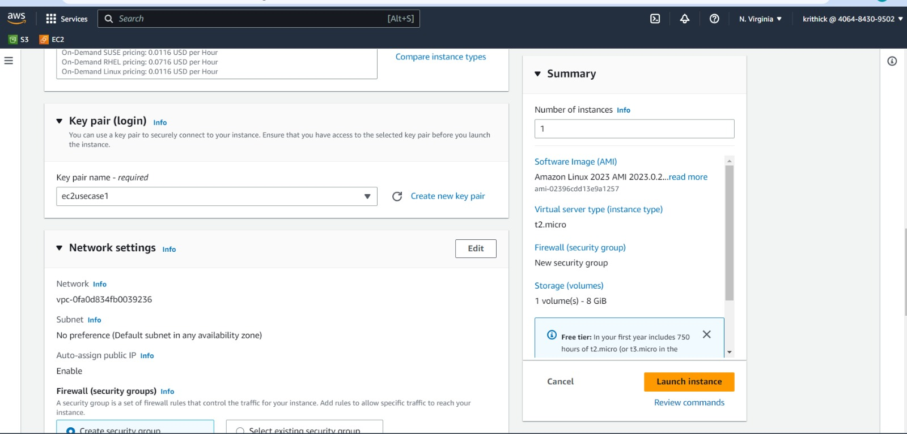

EC2 instance AMI should be "Amazon Linux 2".(4 Marks)

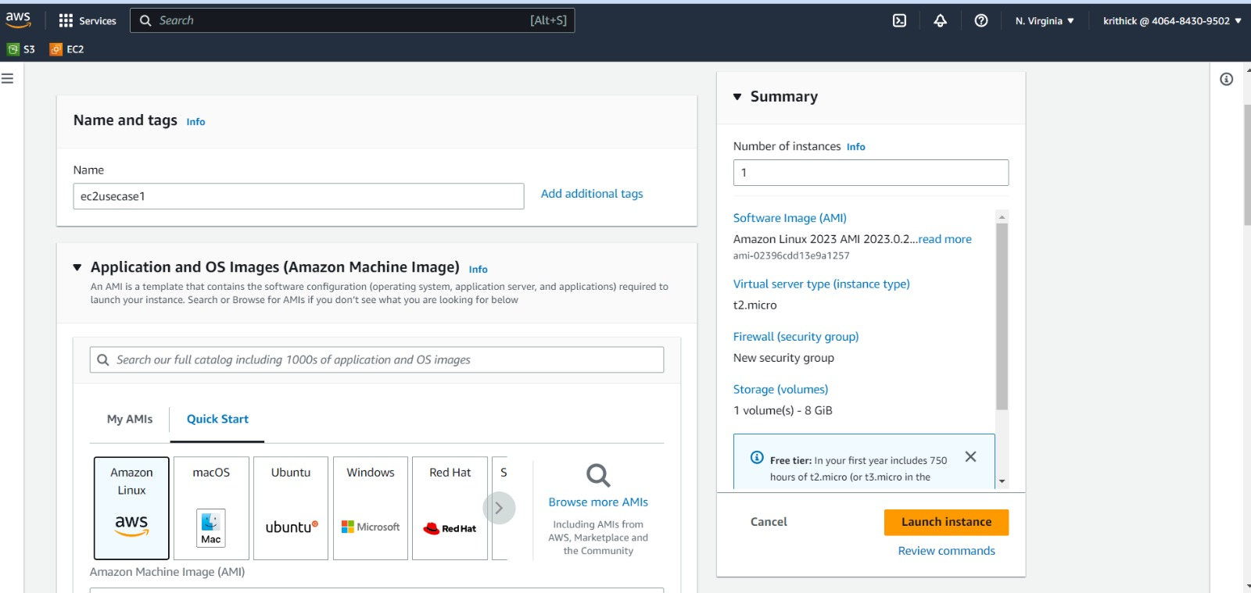

Allow SSH traffic for taking puttyremote connection.(4 Marks)

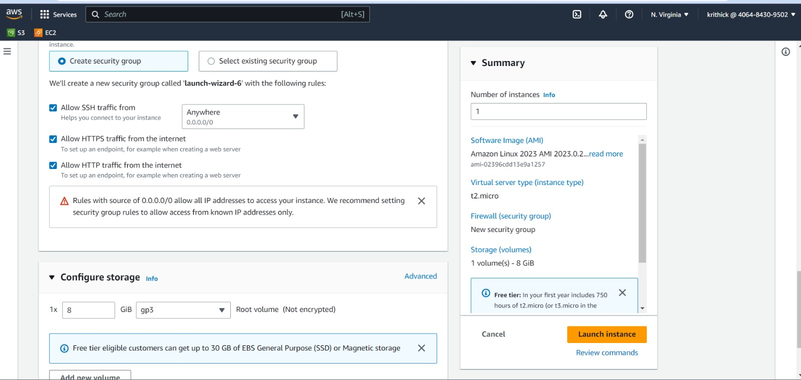

Allow HTTP traffic from the internet for reaching website requests.(4 Marks)

