Coupling :

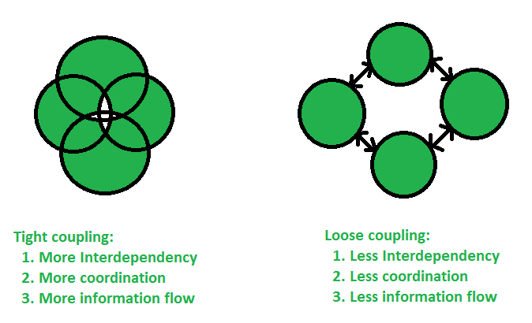  
**Example 1:** Imagine you have created two classes, A and B, in your program. Class A is called volume, and class B evaluates the volume of a cylinder. If you change class A volume, then you are not forced to change class B. This is called loose coupling in Java. When class A requires changes in class B, then you have tight coupling.  
**Example 2:** Imagine you have created two classes A and B, in your program. Class A is called volume, and class B evaluates the volume of a cylinder. If you make any changes in the volume, then the same changes will reflect in class B. Hence, we can say both the classes are highly dependent on each other and are tightly coupled.