**SSO :**

Single Sign-On (SSO) is a system that allows users to log in once and gain access to multiple applications or services without having to log in again for each one. Here's how it works in simple terms:

1. **User Logs In**: The user enters their credentials (like username and password) on a login page.
2. **Authentication Server**: The login page sends these credentials to an SSO authentication server. This server checks if the credentials are correct.
3. **Token Generation**: If the credentials are correct, the authentication server generates a special token. This token is a secure, unique piece of data that confirms the user has been authenticated.
4. **Token Distribution**: The token is sent back to the user's browser.
5. **Access to Other Apps**: When the user tries to access another application, the browser automatically includes this token with the request. The application checks the token with the SSO authentication server.
6. **Access Granted**: If the token is valid, the user is granted access to the application without having to log in again.

**Example Scenario**

1. **Logging In**: Alice logs into her company's main portal using her username and password.
2. **Getting a Token**: The portal's SSO server checks Alice's credentials and gives her browser a token.
3. **Accessing Another App**: Alice then tries to access the company's email service. Her browser sends the token to the email service.
4. **Verification**: The email service verifies the token with the SSO server.
5. **Seamless Access**: Since the token is valid, Alice gets access to the email service without having to log in again.

**Key Points**

* **Convenience**: Users don't have to remember multiple passwords for different applications.
* **Security**: Tokens are usually short-lived and encrypted, making them secure.
* **Centralized Control**: IT departments can manage user access centrally, improving security and compliance.

SSO makes the user experience smoother and enhances security by centralizing the authentication process.

**Spring Boot SSO Integration :**

To integrate Single Sign-On (SSO) into a Spring Boot application, you can use OAuth2 and OpenID Connect (OIDC) standards. One popular way to do this is by using Spring Security along with an Identity Provider (IdP) like Okta, Keycloak, or any other OAuth2-compliant provider. Here’s a step-by-step guide on how to set it up:

**Step 1: Set Up the Identity Provider**

Choose an Identity Provider (IdP) that supports OAuth2/OIDC. For example, you can use Okta for this purpose. You’ll need to:

1. **Create an Application** in the IdP’s console.
2. **Configure Redirect URIs**: Set up redirect URIs for your Spring Boot application (e.g., **http://localhost:8080/login/oauth2/code/okta**).

**Step 2: Add Dependencies**

Add the necessary Spring Security dependencies to your **pom.xml**:

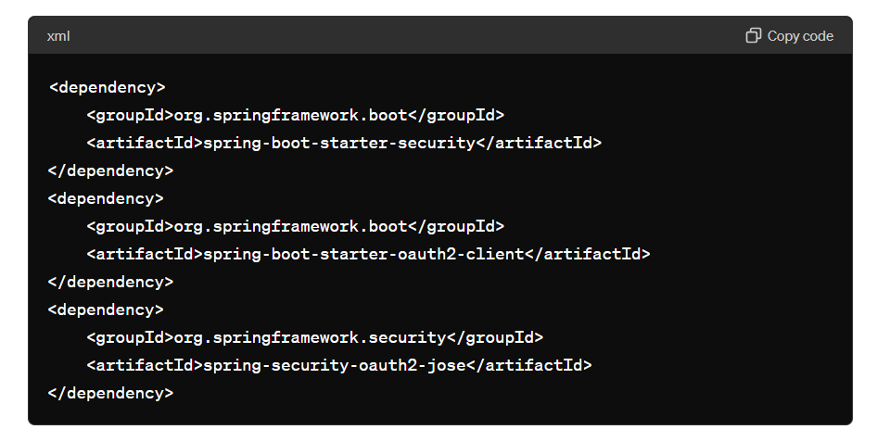

### Step 3: Configure Spring Security

Create a configuration class to set up OAuth2 login:

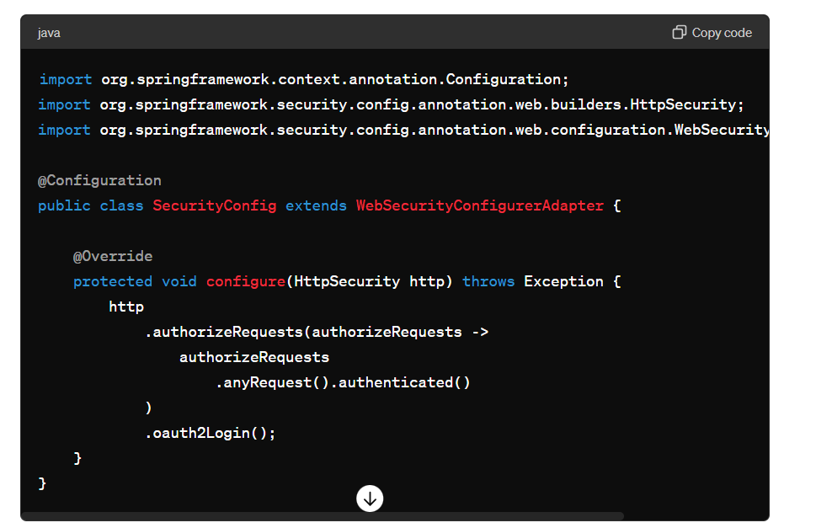

### Step 4: Application Properties

Add the configuration for your OAuth2 provider in **application.properties** or **application.yml**:

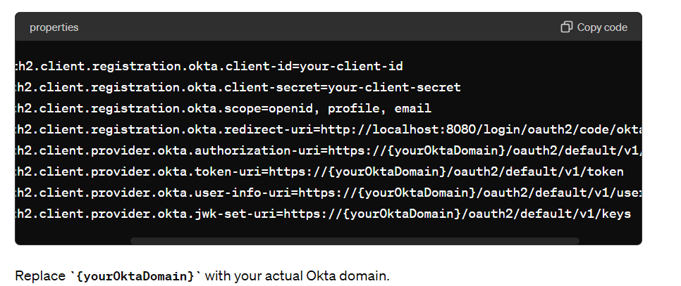

### Step 5: Run Your Application

Start your Spring Boot application. When you navigate to **http://localhost:8080**, it should redirect you to the Okta login page. After logging in, you'll be redirected back to your application, authenticated.

**Okta :**

Okta is a cloud-based identity and access management service that provides a secure way for organizations to manage user authentication and authorization. It offers a range of features to help companies implement Single Sign-On (SSO), multi-factor authentication (MFA), user provisioning, and more. Here’s a brief overview of Okta and its key features:

**What Okta Does**

1. **Identity Management**: Okta manages user identities across multiple applications and services, both on-premises and in the cloud. This includes handling user registration, profile updates, password resets, and deactivation.
2. **Single Sign-On (SSO)**: With Okta, users can log in once and gain access to all their applications and services without needing to log in again. This simplifies the user experience and reduces the need to remember multiple passwords.
3. **Multi-Factor Authentication (MFA)**: Okta enhances security by requiring additional verification methods beyond just passwords. This can include SMS codes, email verification, biometric data, or mobile app authentication.
4. **User Provisioning**: Okta automates the process of creating, updating, and deleting user accounts in various applications. This ensures that users have the right access permissions and reduces administrative overhead.
5. **API Access Management**: Okta can secure APIs by managing authentication and authorization, ensuring that only authorized users and systems can access your APIs.
6. **Universal Directory**: This feature provides a single place to manage all your users, groups, and devices. It can integrate with other directories like Active Directory (AD) or Lightweight Directory Access Protocol (LDAP).

**Key Features of Okta**

* **Integration with Many Applications**: Okta supports integration with thousands of applications out-of-the-box, including popular SaaS applications like Salesforce, Google Workspace, Microsoft Office 365, and many more.
* **Customizable Authentication Flows**: Okta allows customization of authentication flows to fit specific business requirements, including adaptive authentication that adjusts the level of security based on user behavior and context.
* **Security Policies and Compliance**: Okta provides tools to enforce security policies and help organizations comply with regulations like GDPR, HIPAA, and others.
* **Developer-Friendly**: Okta offers comprehensive APIs and SDKs for developers to integrate authentication and authorization into their applications. This makes it easy to add secure login features to web, mobile, and API applications.

**How Okta Works**

1. **User Requests Access**: When a user tries to access an application, they are redirected to Okta for authentication.
2. **Authentication**: Okta verifies the user’s identity using the configured authentication methods (password, MFA, etc.).
3. **Token Issuance**: Once authenticated, Okta issues a token (such as an OAuth2 token) that the application uses to grant access to the user.
4. **Single Sign-On**: If the user accesses another application integrated with Okta, the token is reused, and the user does not need to log in again.
5. **Session Management**: Okta manages the user's session and can handle session termination and revocation if necessary.

**OAuth2 :**

OAuth2 (Open Authorization 2.0) is a widely used authorization framework that allows third-party applications to access a user's resources without exposing their credentials. It provides secure, delegated access to server resources on behalf of a resource owner. Here’s a simplified explanation of how OAuth2 works and its key components:

**Key Components of OAuth2**

1. **Resource Owner**: The user who authorizes an application to access their account.
2. **Client**: The application requesting access to the resource owner's account.
3. **Resource Server**: The server hosting the protected resources (APIs).
4. **Authorization Server**: The server that authenticates the resource owner and issues access tokens to the client.

**OAuth2 Authorization Flows**

OAuth2 defines several flows for different use cases. The most common ones are:

1. **Authorization Code Flow**: Used for server-side applications.
2. **Implicit Flow**: Used for single-page applications (SPAs).
3. **Client Credentials Flow**: Used for machine-to-machine communication.
4. **Resource Owner Password Credentials Flow**: Used when the resource owner has a trust relationship with the client.