**Swagger :**

Swagger is an open-source framework for designing, building, documenting, and consuming RESTful web services. It simplifies the process of developing APIs by providing a standardized way to describe them using a common language and toolset. Swagger includes a suite of tools for automatically generating interactive API documentation and client libraries in various programming languages.

1. **API Documentation**: Swagger automatically generates API documentation that is interactive, allowing developers to understand and interact with the API easily.

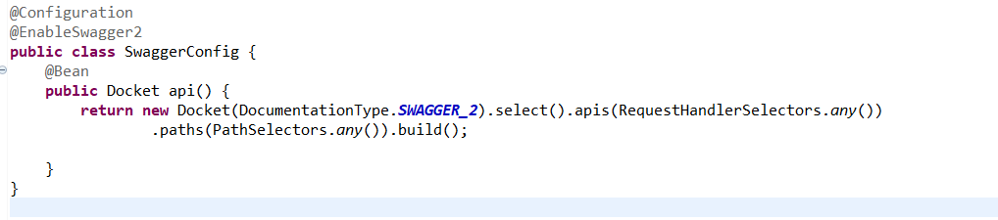

Start your Spring Boot application and navigate to **http://localhost:8080/swagger-ui/** in your browser. You will see an interactive documentation page for your API, generated automatically by Swagger.