### 1. Primary Key:

A primary key uniquely identifies each record in a table. It must be unique and not null.

**Example:** Consider a table named **Students**:

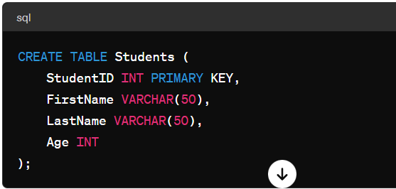

### 2. Foreign Key:

A foreign key establishes a relationship between two tables by referencing the primary key of another table. It ensures referential integrity.

**Example:** Suppose we have another table named **Courses**:

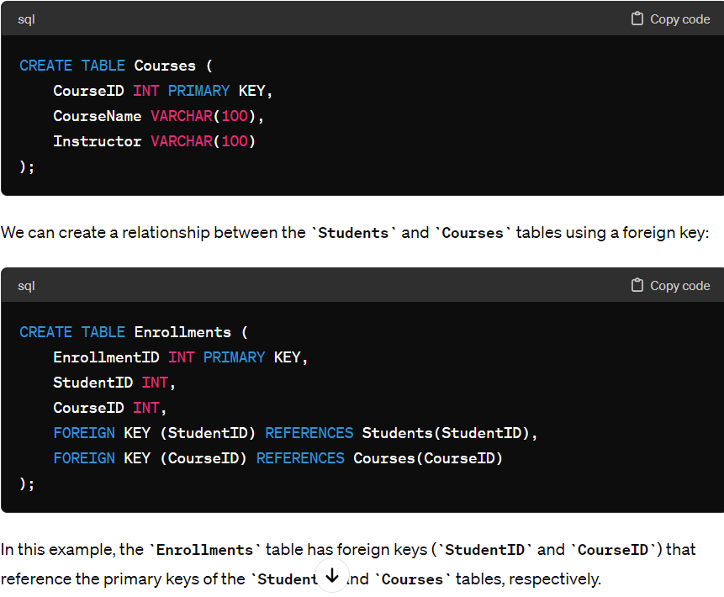

### 3. Unique Key:

A unique key ensures that each value in a column or a group of columns is unique across the table.

**Example:** Let's say we want to ensure that each student has a unique email address:

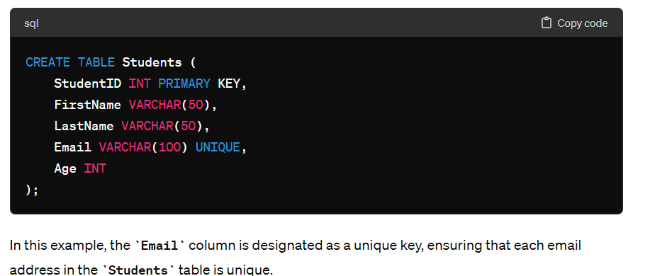

## **Candidate Key**

A candidate key is a set of one or more columns that can identify a record uniquely in a table, and YOU can use each candidate key as a [Primary Key.](https://www.simplilearn.com/tutorials/sql-tutorial/primary-key-in-sql)

Now, let’s use an example to understand this better.



### Super Key

Super key is a set of over one key that can identify a record uniquely in a table, and the Primary Key is a subset of Super Key.

Let’s understand this with the help of an example.

