 

**Placement Empowerment Program**

***Cloud Computing and DevOps Centre***

Host a Static Website Locally: Set Up a Local Server Apache and Host a Simple HTML page with your name

Name: Kirthika S Department: CSE



**Introduction and Overview**

Hosting a static website locally allows you to test and preview web pages on your computer before deploying them online. Apache, a widely used open-source web server, enables you to serve static HTML pages efficiently. In this POC, you will learn how to set up an Apache local server and host a simple HTML page displaying your name. This process involves installing Apache, creating an HTML file, and accessing it via localhost in a web browser.

**Objective**

The goal of this project is to:

1.Install Apache web server.

2. Set up a local server.

3. Create and host an HTML page.

4. Run the page in Chrome using 127.0.0.1.

5. Edit and test the code in VS Code.

**Importance of Local Hosting**

Local hosting is an essential skill for developers, as it allows them to test and experiment with web applications in a controlled environment. It offers several advantages, such as:

**Hands-On Learning:** Gain practical experience with server setup and configuration.

**Testing Ground:** Safely test and debug websites before deploying them to a live server.

**Offline Development:** Work on web projects without requiring an active internet connection.

**Step-by-Step Overview**

Step1:

Search for "Apache Lounge" on Google and click the first link to access the official website.

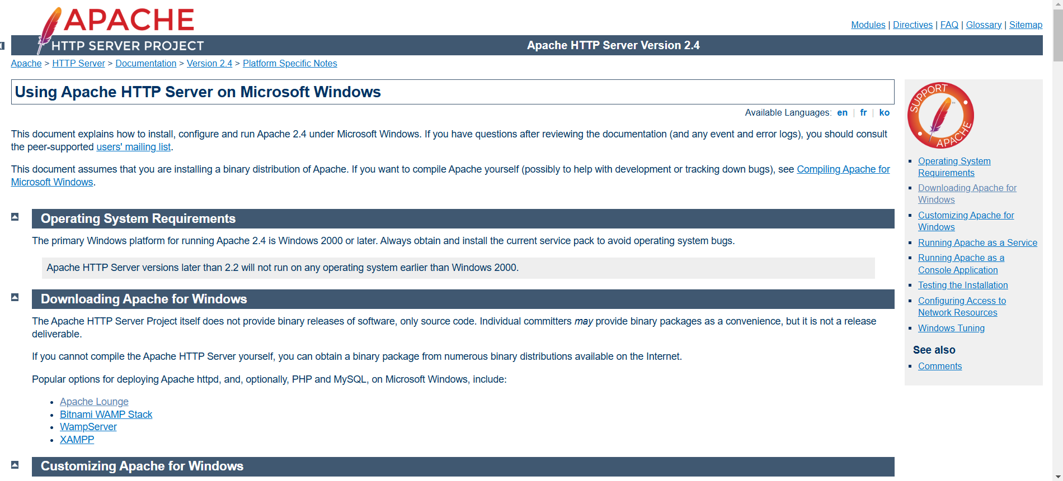

Step 2:

Click on the link **"Apache 2.4.62-240904 Win64"** (Windows version), download the file, and extract all its contents.

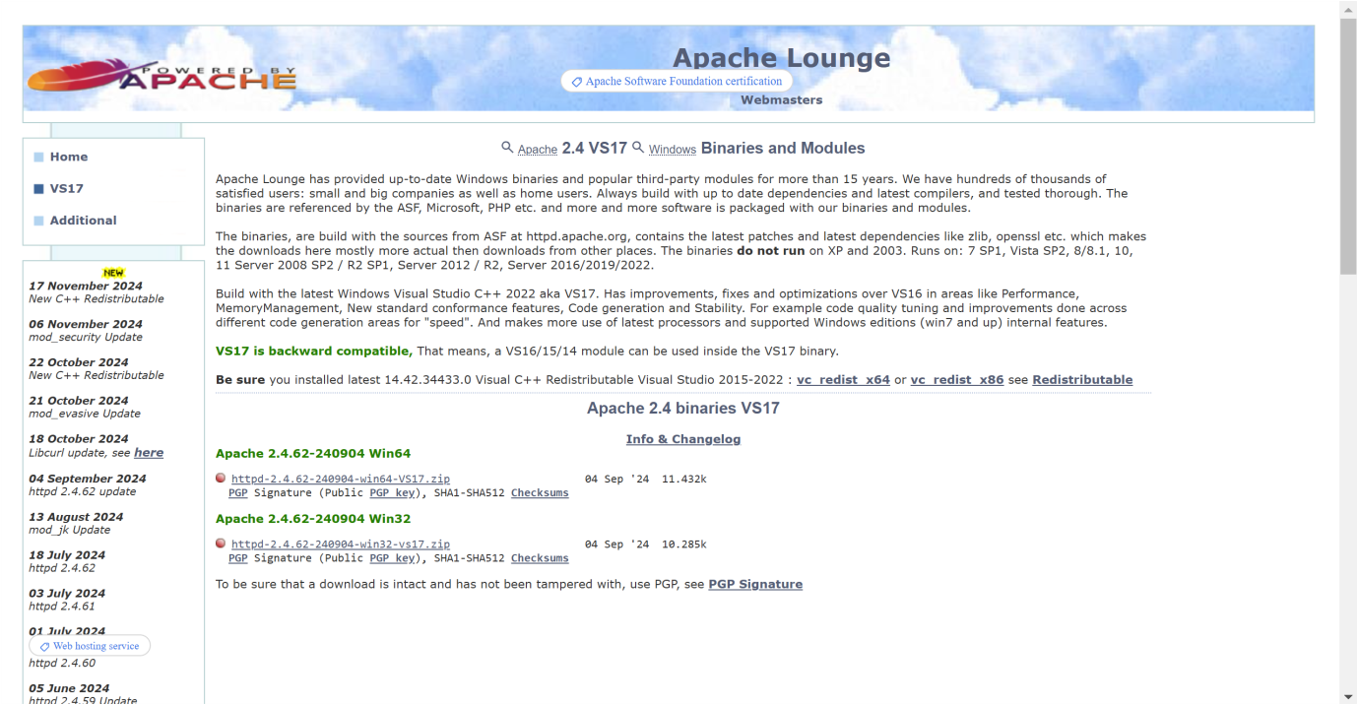

Step 3:

After downloading, extract the contents to C:\Apache24 for easy access.

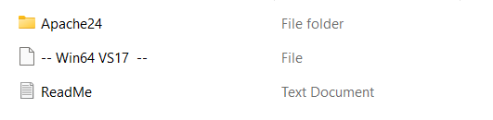

Step 4:

Click **Start**, type **cmd**, right-click on **Command Prompt**, and select **Run as Administrator**.

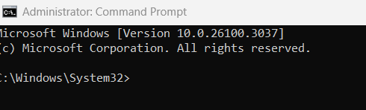

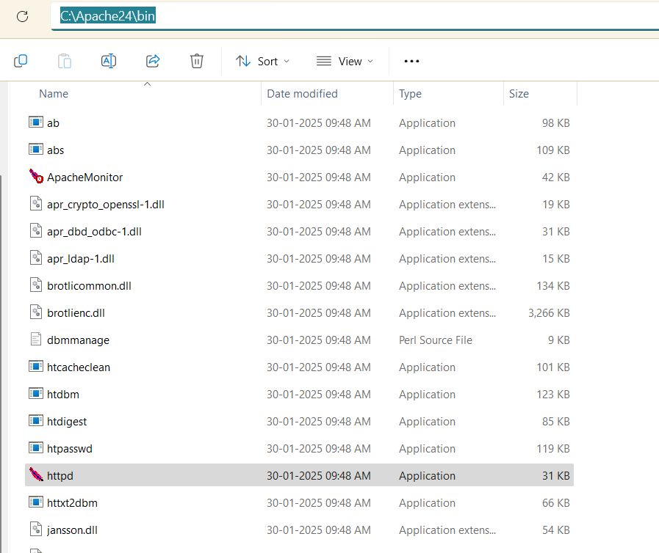

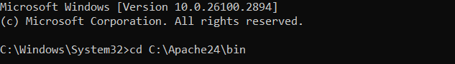

Step 5:

Then Run the installation command:

**httpd -k install**

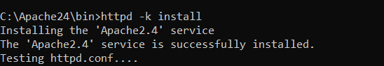

Step 6:

To test the locally hosted website, open **Chrome** or any web browser and type **http://127.0.0.1/** in the address bar. If Apache is running correctly, the browser will display the contents of the index.html file. This confirms that your local server is properly configured and hosting the static website.

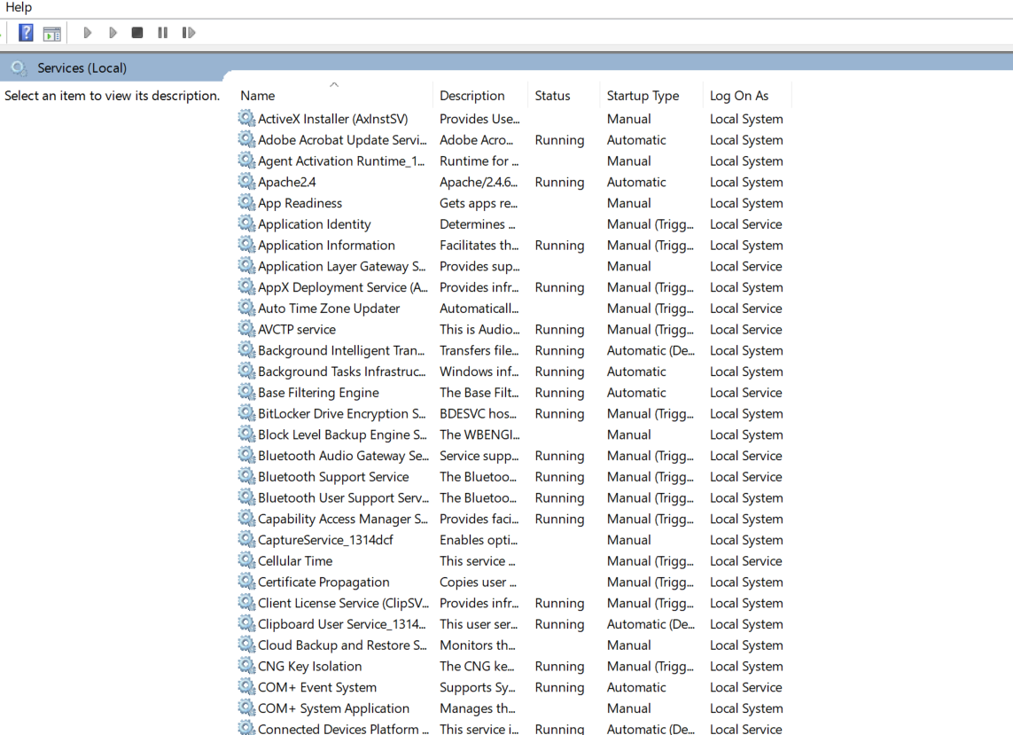

Step 7:

Go to the Apache folder, navigate to the **htdocs** folder. The htdocs folder is the root directory where Apache serves web pages. Located in **C:\Apache24\htdocs\** (Standalone Apache).

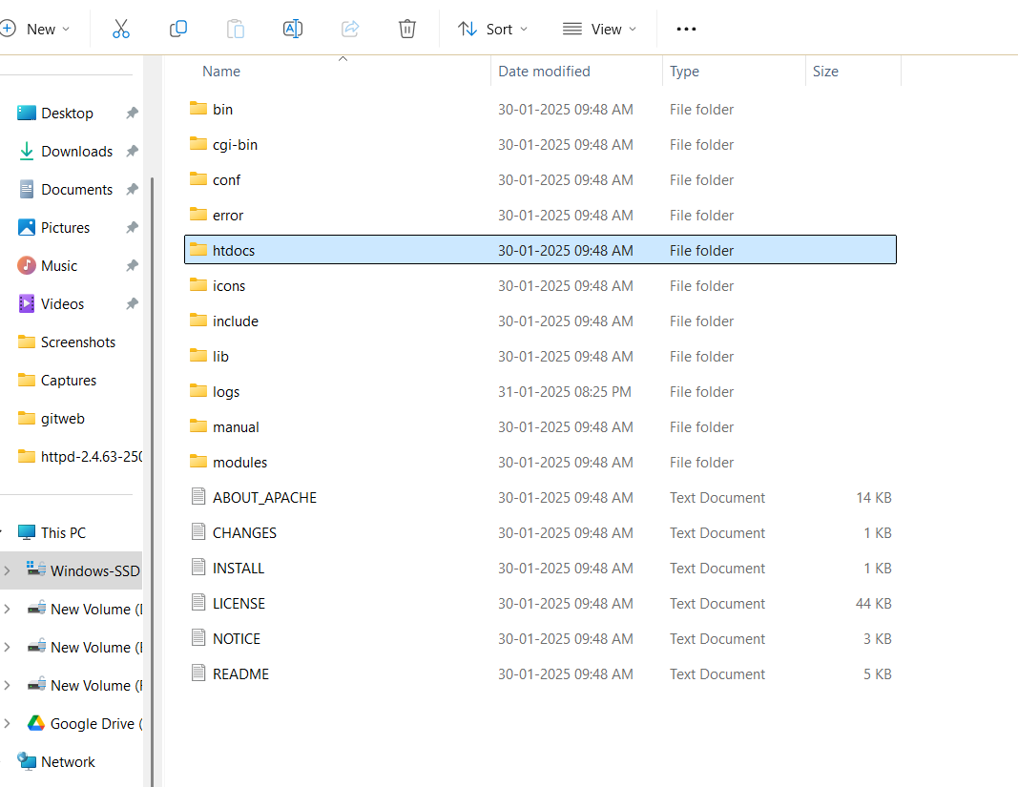

Step 8:

To access and modify your website files, you need to open this folder and locate the index.html file. Open with VS Code, Notepad, or any text editor to modify content.

**Viewing the webpage:** Open http://127.0.0.1/ in a browser to see your hosted page.

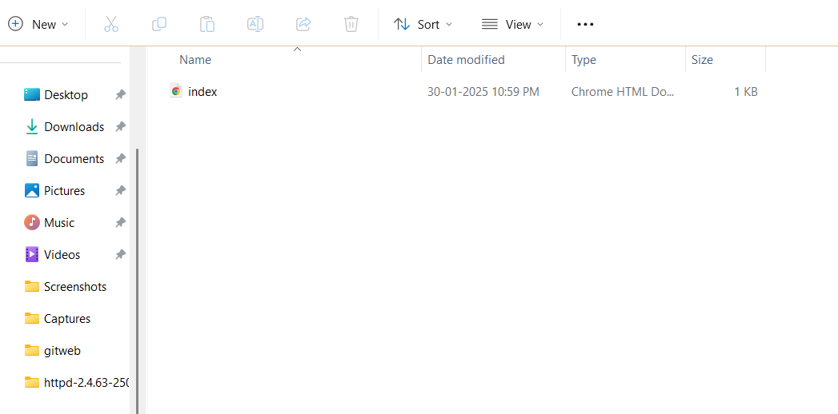

Step 9:

Right click it **index.html**, and open with into **VS CODE**

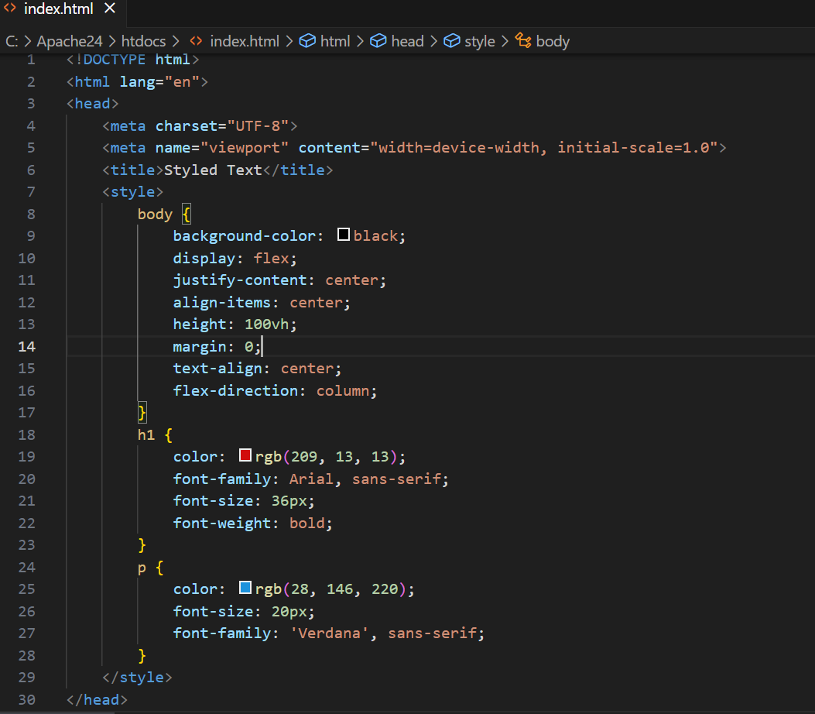

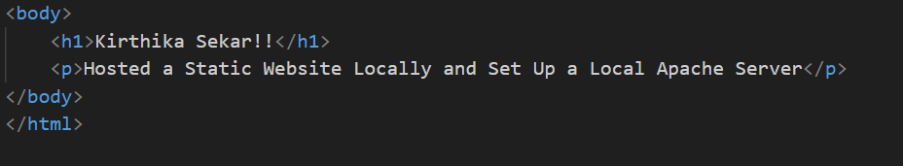

Step 10:

Open the Chrome browser and type **localhost/index.html** in the address bar. You should be able to see the website hosted successfully.

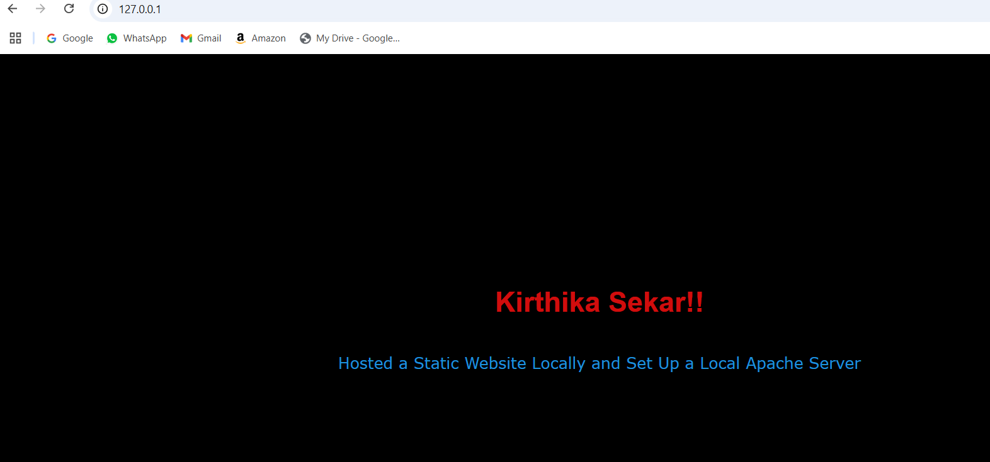

**Outcome**

By completing this POC, you will:

Successfully set up a local Apache server, created an HTML page, and hosted it locally. This setup is useful for testing web pages before deploying them online.