

**Placement Empowerment Program**

***Cloud Computing and DevOps Centre***

**Hosting a Static Website on a Cloud**

**Virtual Machines**

**Name: Kirthika S Department:CSE**

**Introduction**

Cloud computing has revolutionized how businesses manage IT resources. In this task, we will focus on deploying a virtual machine (VM) in the cloud. This hands-on activity will provide an understanding of cloud platforms, virtual machine provisioning, and secure SSH access.

**Objectives**

1. Understand the concept of cloud computing and VMs.

2.Create a free-tier account on a cloud provider (AWS, Azure, or GCP).

3. Launch a Linux virtual machine.

4.Connect to the VM securely using SSH.

**Step 1:**

Sign up for **AWS, Azure,** or **GCP** and complete the verification process.

Navigate to the respective cloud console and create a new VM instance.

**Step 2:**

Navigate to the **EC2 Dashboard**, click "Launch Instance,"

Sselect an AMI (Amazon Machine Image) like **Ubuntu, Windows Server, or Amazon Linux.**

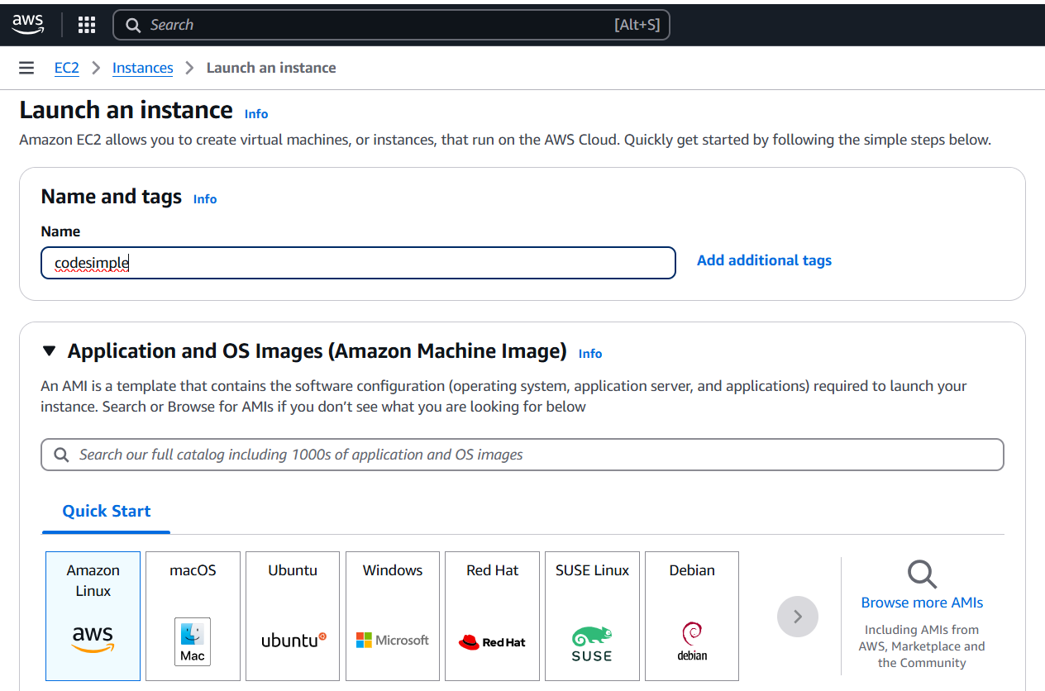

**Step 3:**

Configure instance details such as **CPU, RAM, and storage** (e.g., t2.micro in AWS, B1s in Azure, f1-micro in GCP for free-tier eligibility).

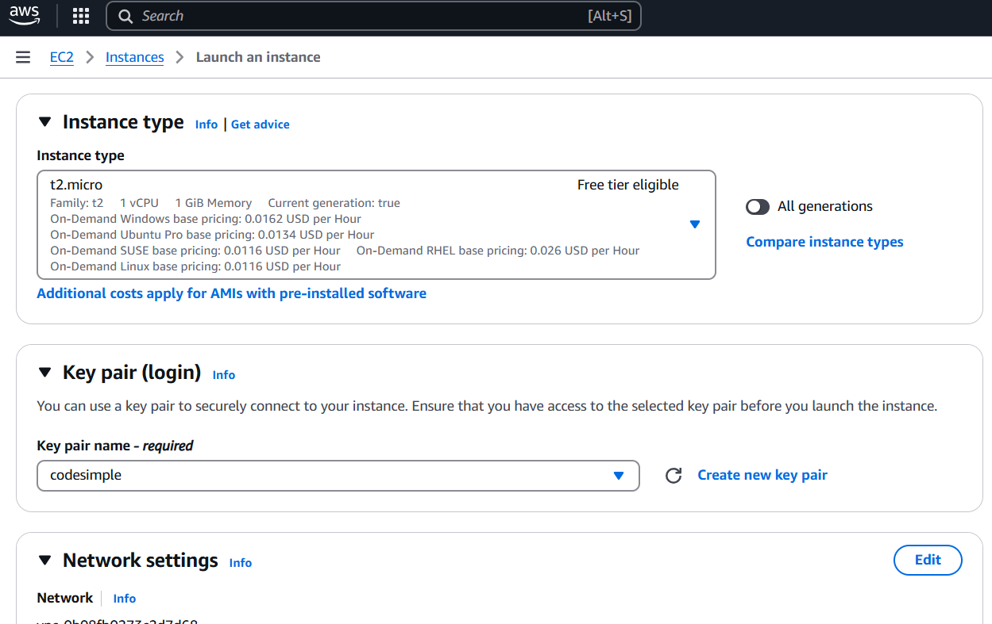

**Step 3:**

Click **Launch/Create** and wait for the VM to start

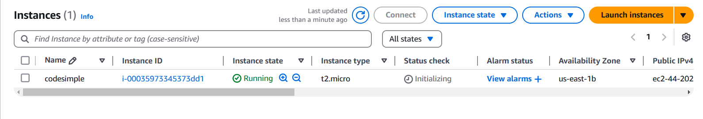

**Step 4:**

Open a terminal (Linux/macOS) or **Command Prompt/PowerShell** (Windows).

Use SSH to connect to the VM using the **public IP address**:

* ssh -i /path/to/key.pem username@your-vm-public-ip



For **AWS (Ubuntu)**, the default username is **ubuntu**; for **Amazon Linux**, it is **ec2-user**.

**Step 5:**

**Install Apache or Nginx:**

Update the package list:

sudo apt update

Install Apache:

sudo apt install apache2 -y

OR

Install Nginx:

sudo apt install nginx -y

**Step 6:**

If you have a local website folder, use **SCP (Secure Copy Protocol)** to upload files

scp index.html <user>@<IP_address>:/var/www/html/

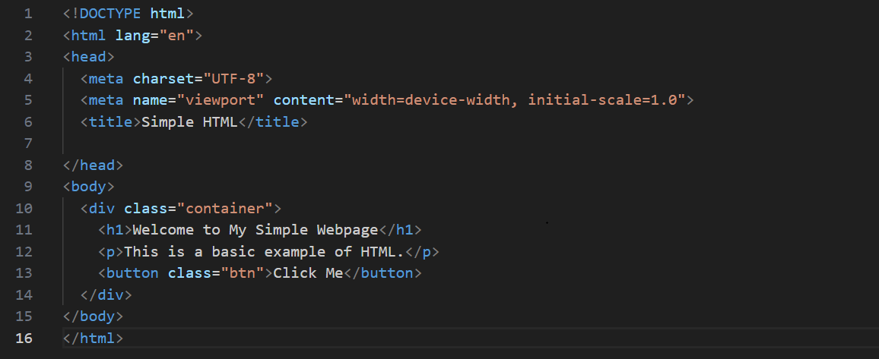

Verify the Website,

sudo systemctl restart apache2 or

sudo systemctl restart nginx

**Overview:**

Hosting a static website on a cloud VM involves launching a VM on AWS, Azure, or GCP, installing a web server like Apache or Nginx, and configuring network access. After uploading HTML, CSS, and JavaScript files to the server’s web directory, the site becomes accessible via the VM’s public IP.