

**Placement Empowerment Program**

***Cloud Computing and DevOps Centre***

**Set Up a Cloud Based Monitoring Service Enable basic cloud monitoring (e.g.,CloudWatch on AWS).View metrics like CPU usage and disk I/O for your cloud VM**

**Name: Kirthika S Department: CSE**

**Introduction:**

Cloud-based monitoring services help track the performance and health of cloud resources such as Virtual Machines (VMs), storage, databases, and applications. These services provide **real-time insights** into resource usage, system health, and potential performance bottlenecks. By enabling cloud monitoring, you can view key metrics such as **CPU usage, disk I/O, memory consumption, and network traffic**. This helps with **proactive troubleshooting, cost optimization, and performance tuning**.

**Objective:**

**Understand cloud monitoring concepts** and their role in infrastructure management.

**Enable monitoring services** to collect key system metrics such as CPU usage, disk I/O, memory, and network activity.

Install and configure **monitoring agents** for collecting detailed system data.

**Analyze real-time metrics** using the cloud platform’s dashboard.

Set up **alerts and notifications** to receive automatic updates on critical performance changes.

**Step 1:**

Open the **Amazon EC2 Dashboard**.

Select your Virtual Machine (EC2 instance).

Click on **Monitoring** → This will show basic metrics like CPU utilization, disk I/O, and network usage.

Launch the Instance.

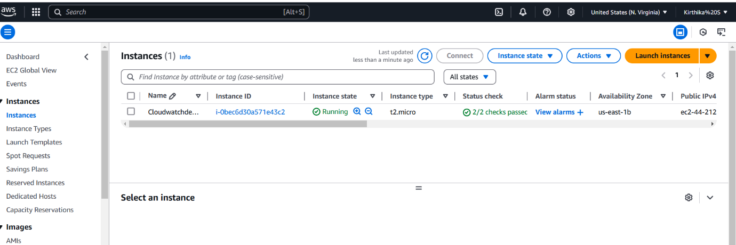

**Step 2:**

**AWS:** Open the AWS Management Console → Navigate to **CloudWatch**

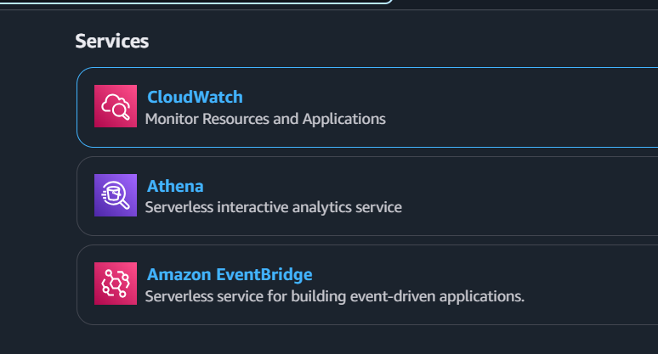

**Step 3:**

Open **CloudWatch** → Go to **Metrics** → Choose **EC2**.

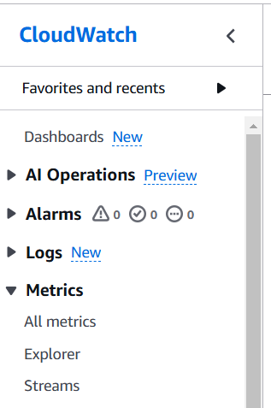

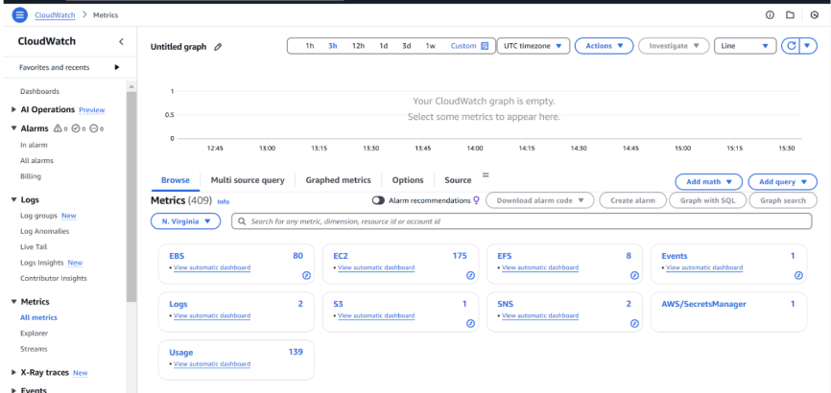

**Step 4:**

View CPU utilization, disk read/write, and network activity.

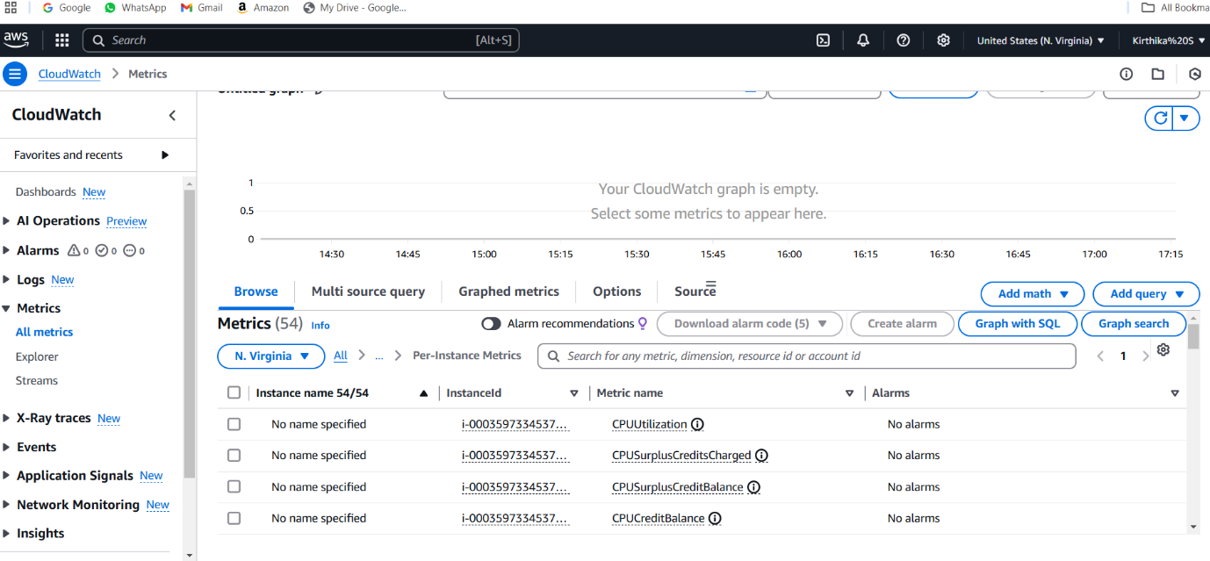

**Step 5:**

Set **Alarms**

Set conditions like **CPU utilization > 80% for 5 minutes**.

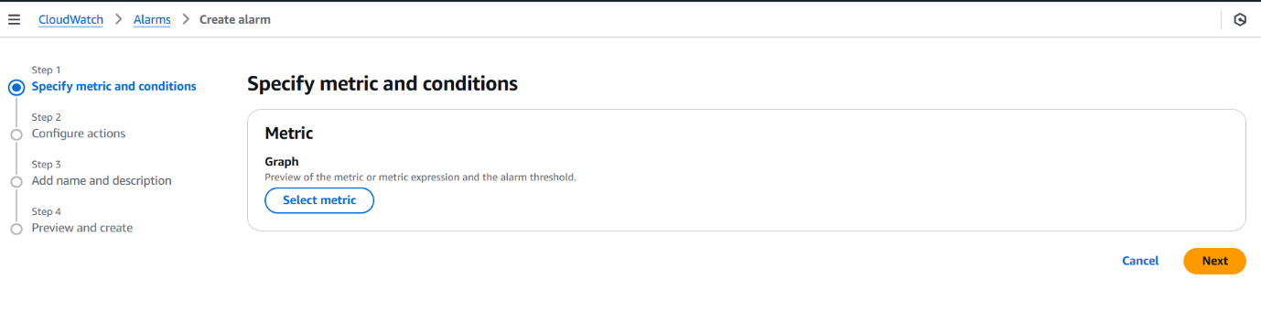

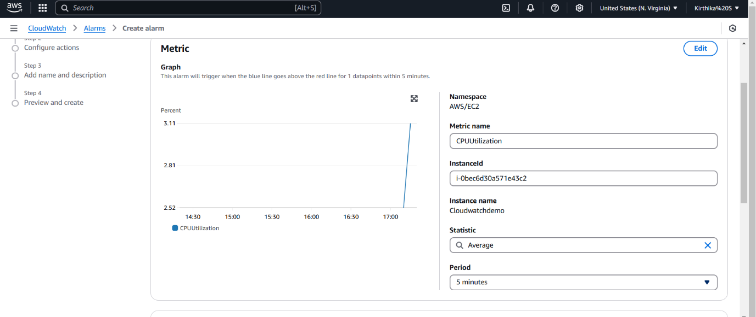

Define **a threshold** (e.g., CPU > 15 for 5 minutes).

Click NEXT

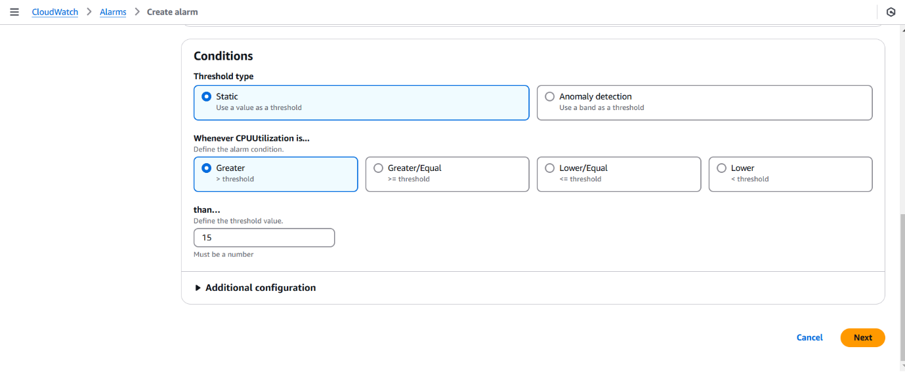

**Step 6:**

The next step is to **preview and create** the monitoring setup.

This step ensures that your monitoring configurations are correct before deployment

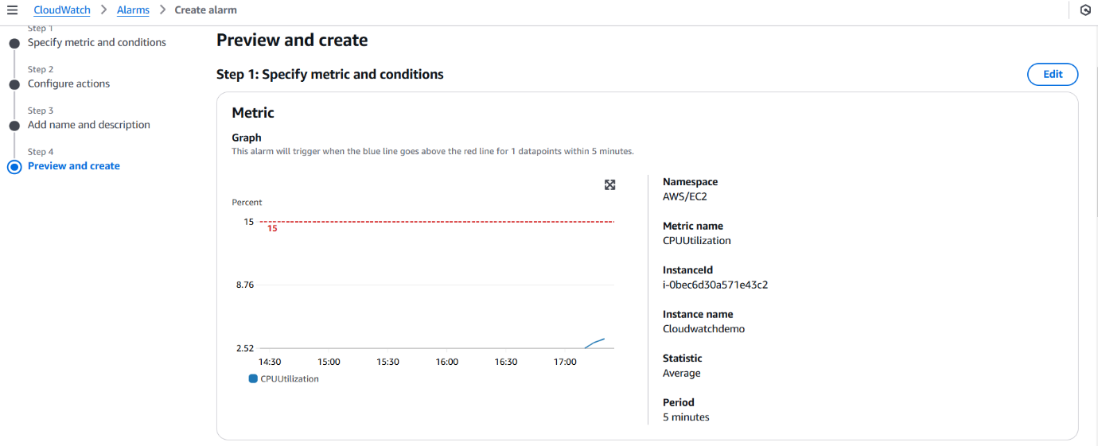

**Overview:**

✅ Enabled **cloud monitoring** for your Virtual Machine.  
✅ Viewed **real-time metrics** like CPU, memory, and disk usage.  
✅ Configured **alerts and notifications** for proactive monitoring.

This setup helps improve **performance, security, and cost management**, ensuring your cloud resources run efficiently.