

**Placement Empowerment Program**

***Cloud Computing and DevOps Centre***

Install Docker and Run Your First Container: Install

Docker and run a basic container (e.g., Nginx). Test accessing the containerized application.

Name: Kirthika S Department: CSE



# Introduction

In the world of cloud computing and DevOps, containerization plays a crucial role in deploying and managing applications efficiently. Docker, one of the most popular containerization platforms, allows developers to package applications and their dependencies into lightweight, portable containers. This POC focuses on installing Docker and running an Nginx container to understand how containerized applications work.

# Overview

This Proof of Concept (POC) demonstrates the process of setting up Docker on Windows, pulling an Nginx image, running it inside a container, and accessing the containerized application through a web browser. It provides hands-on experience in managing containers and understanding the basics of Docker networking and deployment.

**Steps Involved:**

1. Install Docker on Windows.
2. Pull the official Nginx image from Docker Hub.
3. Run an Nginx container and expose it on port 8080.
4. Verify the running container using Docker commands.
5. Access the Nginx web page in a browser.

# Objectives

1. Understand the fundamentals of containerization with Docker.
2. Learn how to install and configure Docker on Windows.
3. Explore how to pull and run a containerized application.
4. Gain experience in managing and troubleshooting Docker containers.
5. Demonstrate the accessibility of a running containerized service.

# Importance

1. **Foundation for Cloud and DevOps:** Learning Docker is essential for modern cloud-based and DevOps workflows.
2. **Portability & Efficiency:** Containers eliminate the "works on my machine" problem by ensuring consistency across different environments.
3. **Scalability & Deployment:** Running Nginx in a container helps in understanding web server deployments, a key aspect of cloud infrastructure.
4. **Hands-on Experience:** This POC provides practical knowledge applicable in real-world cloud projects, CI/CD pipelines, and Kubernetes deployments.

**Step-by-Step Overview**

Step 1:

In Google Search for **Docker windows Download**.

Step 2:

Scroll Down and **Download Docker Desktop**. Complete the installation process.

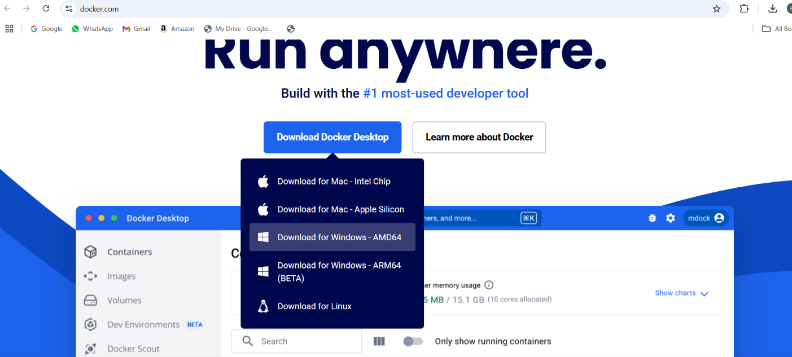

Step 3:

Open Command Prompt and run:

**docker –version**

This should return a version number, confirming Docker is installed.

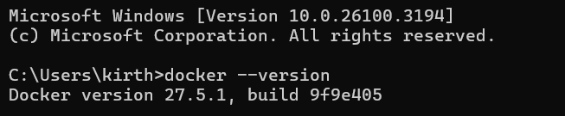

Step 4:

Build your first Docker container(Nginx) Pull the Nginx Image: **docker pull nginx**

This downloads the latest Nginx image.

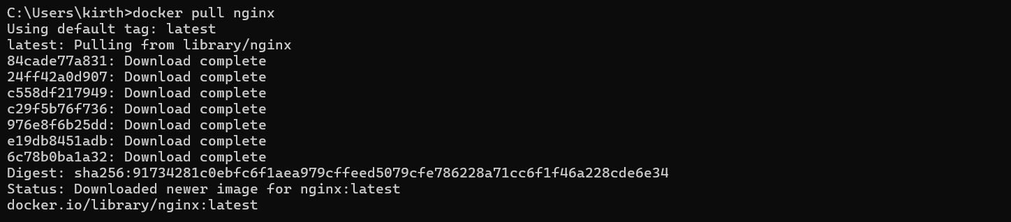

Step 5:

Run the Nginx Container:

**docker run -d -p 8080:80 --name my-nginx nginx**

1. -d: Runs the container in detached mode (in the background).
2. -p 8080:80: Maps port 80 inside the container to port 8080 on your local machine.
3. --name my-nginx: Names the container my-nginx.



Step 6:

Verify the Running Container: **docker ps**

You should see my-nginx running in the list.



Step 7:

Test Accessing Nginx:

1. Open a browser and go to: http://localhost:8080
2. You should see the default Nginx welcome page.

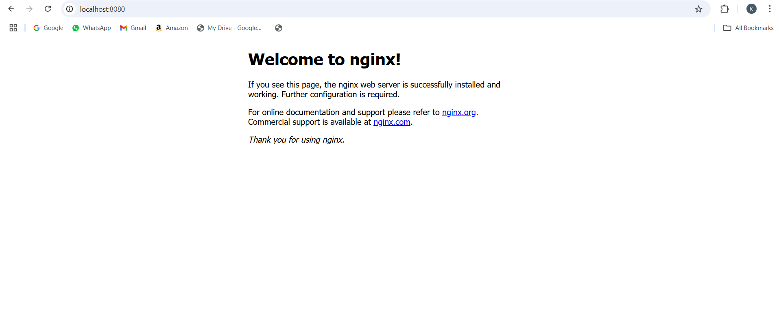

Step 8:

By Opening Docker Desktop App We can see our container running.

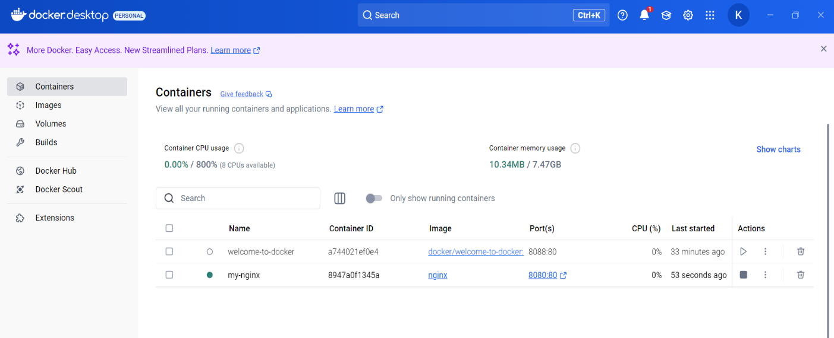

Step 9:

Stop and Remove the Container

1. Stop the container:

**docker stop my-nginx**

1. Remove the container:

**docker rm my-nginx**

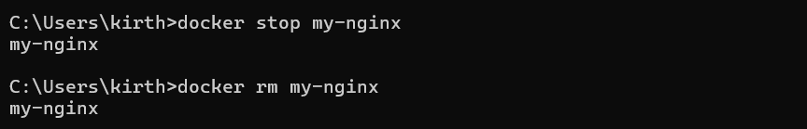

You have successfully installed Docker, run your first Nginx container, and tested it!

# Outcomes

By completing this POC, you will:

1. **Install and Configure Docker:** Learn to set up Docker on Windows and prepare the environment for containerized applications.
2. **Pull and Run an Nginx Container:** Gain hands-on experience in downloading and deploying a web server using Docker.
3. **Expose and Access the Web Server:** Understand how to map ports and access the running Nginx container via a browser.
4. **Manage and Monitor Containers:** Learn essential Docker commands to start, stop, inspect, and remove containers efficiently.
5. **Understand the Benefits of Containerization:** Explore how Docker simplifies application deployment, enhances scalability, and streamlines DevOps workflows.