

**Placement Empowerment Program**

***Cloud Computing and DevOps Centre***

Write the Shell Script to Monitor Logs : Create a script

that monitors server log for errors and alert you

**Name: Kirthika S Department: CSE**



**Introduction:**

Log files are essential for tracking server activity, troubleshooting errors, and ensuring system stability. However, manually checking logs for errors can be time-consuming and inefficient. To automate this process, we can use a shell script to **monitor logs in real-time** and **send alerts** when issues arise.

This approach helps system administrators and DevOps teams proactively respond to critical issues, minimizing downtime and improving server reliability.

**Objectives:**

**Send Real-Time Alerts**

* Notify system administrators via email, Slack, or other communication channels when errors are found.

**Enhance System Reliability**

* Reduce downtime by allowing administrators to respond quickly to server issues.

I**ntegrate with Task Scheduling**

* Use cron jobs to run the script at scheduled intervals for continuous monitoring.

**Lightweight and Customizable Solution**

* No need for third-party tools, and can be modified for different log files or alert methods.

**Step 1:**

Create a Folder called log for Your Logs and Script



**Step 2:**

Open Notepad and Add the following sample text to it and Save the file as **mylog.log** inside the logs folder

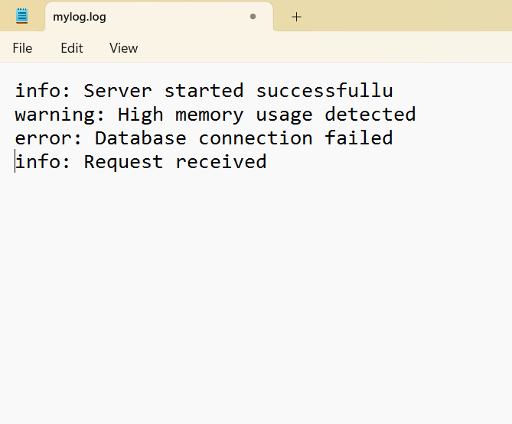

## 

**Step 3:**

Open Notepad and Type the following PowerShell script into it and Set the **$LogFilePath** address to the mylog.log which you saved in logs folder. Save the file as monitor_logs.ps1 inside the same logs folder

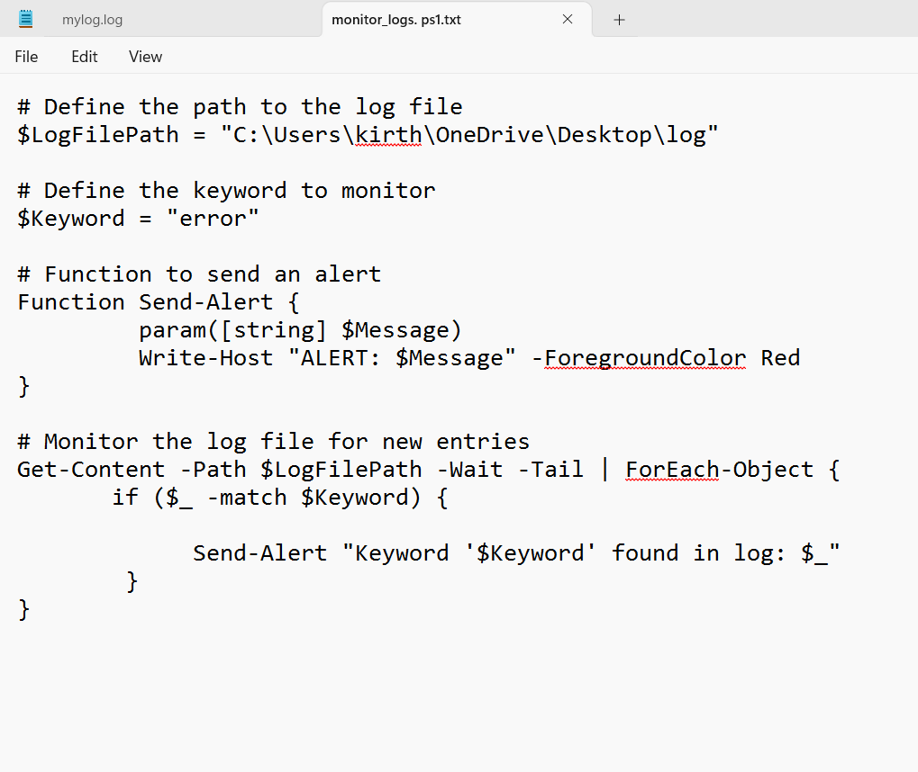

**Step 4:**

Click the Windows Key and Search for Windows PowerShell and click Run as Administrator.

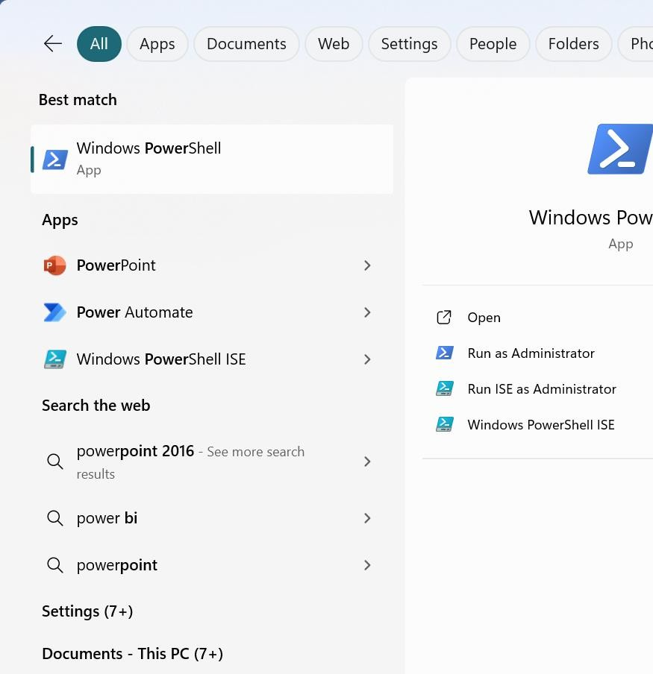

**Step 5:**

Run the following command to allow script execution:

**Set-ExecutionPolicy -Scope CurrentUser -ExecutionPolicy RemoteSigned**

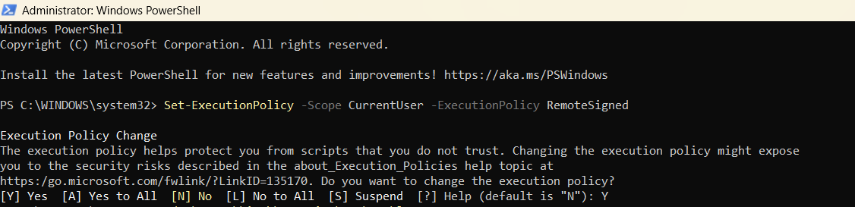

**Step 6:**

Navigate to the logs folder

Run the script: **.\monitor_logs.ps1**



**Step 7:**

Open mylogfile.log in Notepad and Add a new line with the word "error" and Save the file.

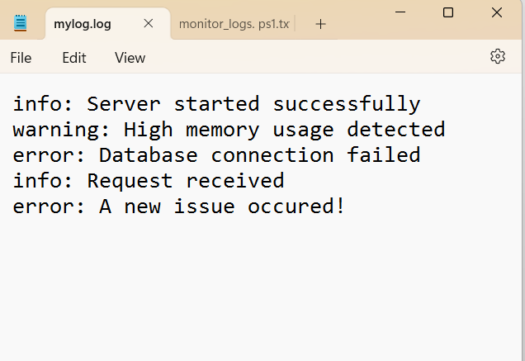

**Step 8:**

Check PowerShell — you should see an alert like:

**ALERT: Keyword 'error' found in log: error: A new issue occurred!**



**Overview:**

* 1. Successfully create and execute a PowerShell script to monitor log files in real time.
  2. Detect and alert on predefined keywords (e.g., "error") to highlight critical events.
  3. Gain hands-on experience with PowerShell scripting and automation on a Windows system.
  4. Understand the importance of log monitoring in proactive system maintenance and troubleshooting.