

Placement Empowerment Program
Cloud Computing and DevOps Centre

Create a Simple Backup Script: Create a script that backs up your entire Git repository to a local folder daily

Name: Kirthika S Department: CSE

Introduction:
Backing up your Git repositories is a crucial part of version control management. It ensures that your work remains safe and accessible even in the event of unforeseen data loss, such as accidental deletions, hardware failures, or repository corruption. Automating this process saves time, reduces manual intervention, and guarantees regular updates.
Objective:
1. Automate Backups: Develop a script to back up the entire Git repository daily.
2. Minimize Data Loss: Safeguard the repository from accidental deletions or hardware failures.
3. Ease of Management: Create timestamped backups for quick identification and restoration.
4. Hands-Free Automation: Leverage Task Scheduler to eliminate the need for manual execution.
Step 1:
Create a folder named GitHub Backup to store your Backup files
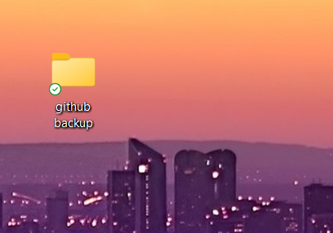

Step 2:
Open Notepad and type this script. Make sure that in set REPO_URL give the URL of the repository you want to backup and in set BACK_DIR give the file path of the folder which you created in first step.
Then save it as .bat format(eg:backup.bat) in Desktop
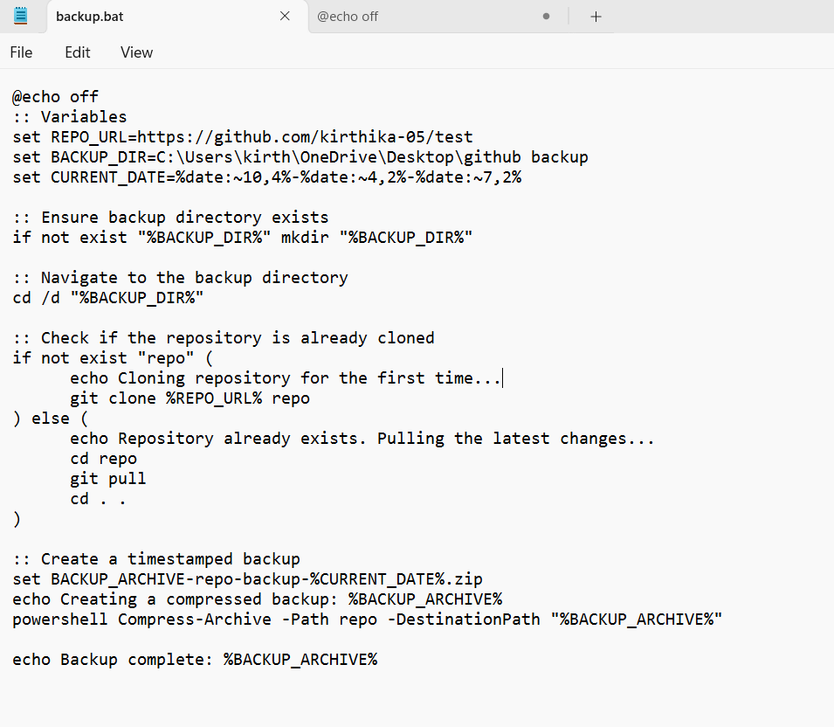
Step 3:
Press Win + R on your keyboard.
A small "Run" dialog box will pop up.
Type taskschd.msc (without quotes) in the Run box.
Press Enter or click OK.
This will open the Task Scheduler window
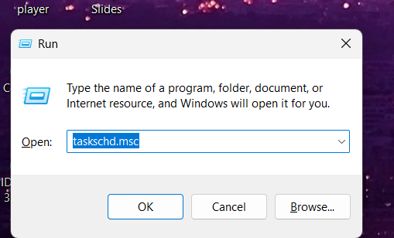
Step 4:
In the Task Scheduler window, look to the right-hand side for a button called "Create Basic Task".
Click it.
A wizard will open to guide you through the setup.

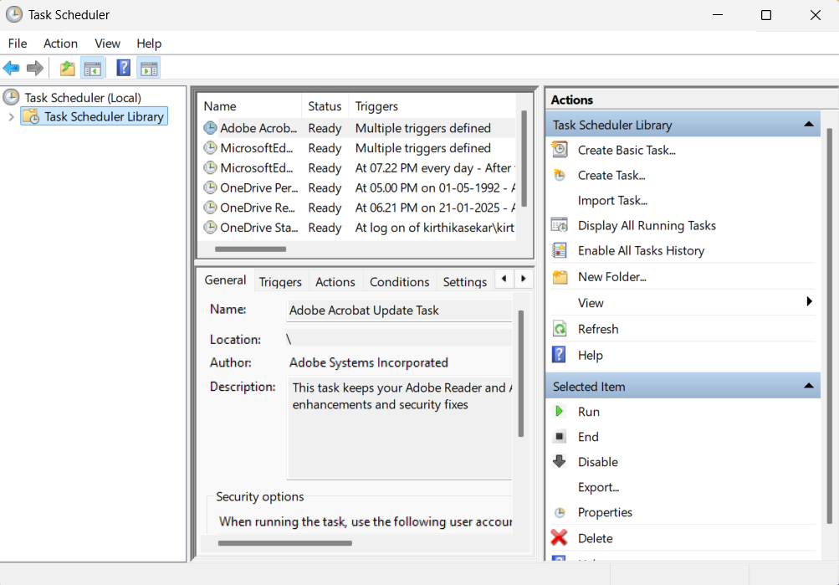

Step 5:

1. Enter a Name for the Task:
For example: "Github_backup.(This can be anything that helps you remember what the task does.)
Optionally, you can add a description like "Backup files".
2. Click Next to continue

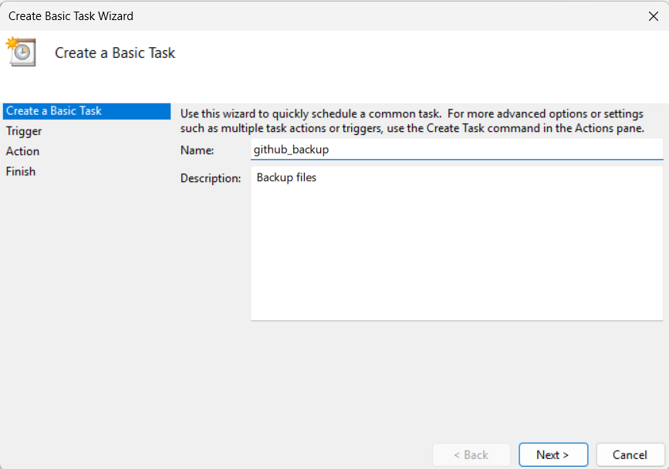
Step 6:
Choose a Schedule:
You will see options like:
Daily (runs every day).
Weekly (runs once a week).
One time (runs only once at a specific time).
Choose what works for you (e.g., Daily) and click Next.
Step 7:
Set the Time and Frequency:
If you chose Daily, specify:
The start date (it defaults to today).
The time (e.g., 06:20 PM).
Click Next to move on.
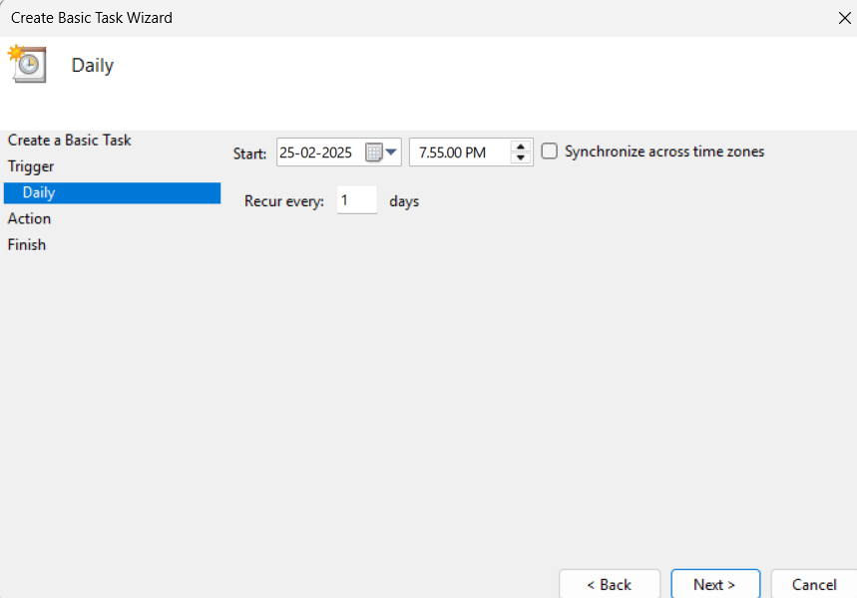
Step 8:
Set the Action
Now, we tell Task Scheduler what to do when it runs.
Select "Start a Program":
On the "Action" screen, select the option "Start a Program" and click Next.
Step 9:
Point to the Program or Script:
In the Program/script field, click Browse and navigate to the location of your .bat file.
Example: If your script is named backup.bat and saved on the desktop, navigate to that file and select it.
Click Next.
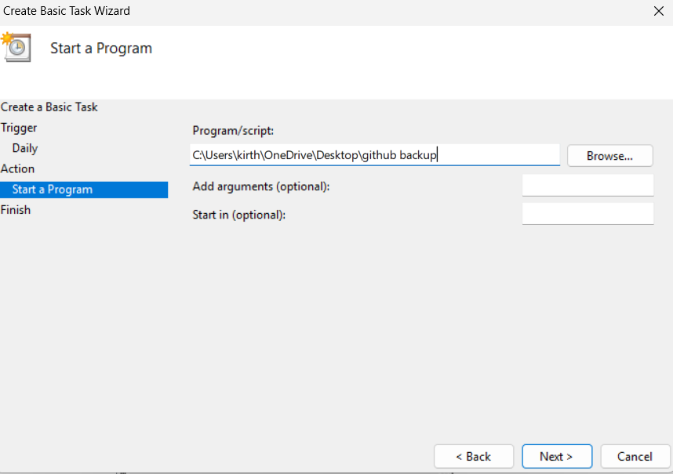
Step 10:
Review and Finish .Click Finish to save and schedule the task
In Task Scheduler, go to the Task Scheduler Library (on the left-hand side).
Find your task (it should have the name you gave it, e.g., "GitRepoBackup"). Right-click the task and select Run.
This will manually trigger the task immediately
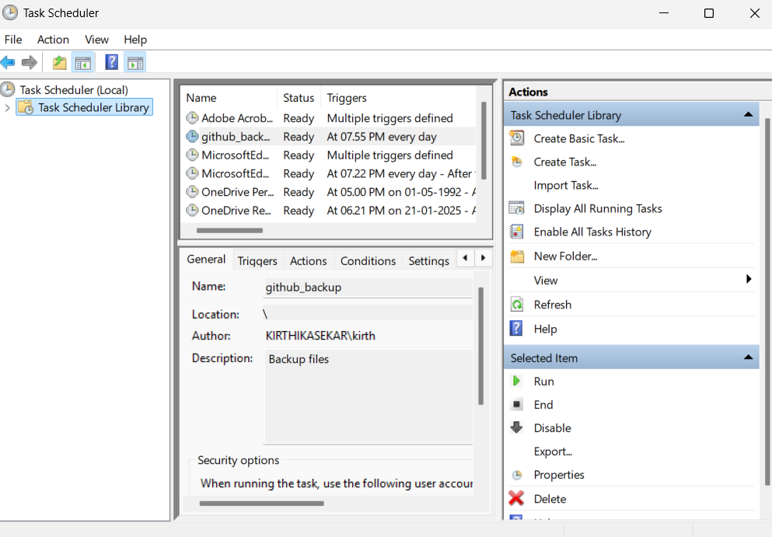
Step 12:
Now u can see the folder which you created (GitHub Backup Folder)in the first step will now contains the files which is in your repository.
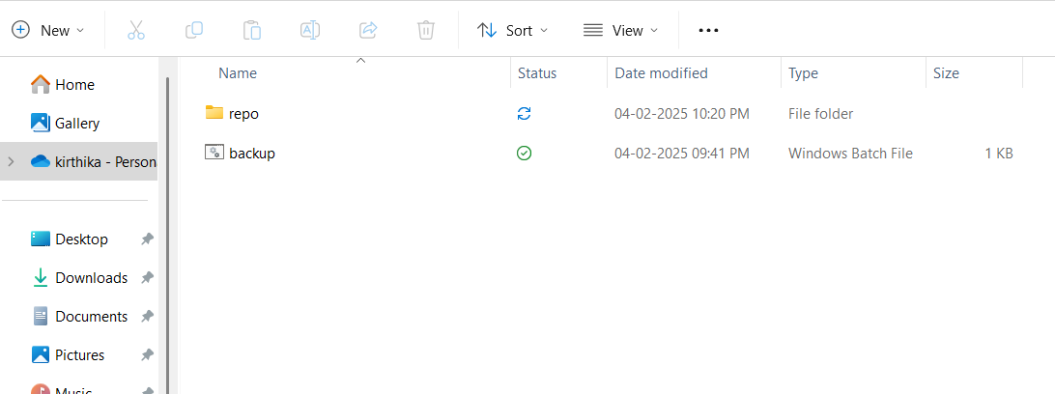
Outcome
Successfully implement a backup system for Git repositories: Automate the process of creating daily backups for your Git repositories, ensuring that all updates and changes are securely stored in a local folder.
Master the use of batch scripting for task automation: Learn to create and execute a .bat script that clones, pulls updates, and compresses a Git repository into timestamped backup archives.
Understand Task Scheduler's automation capabilities: Gain practical experience with Task Scheduler, learning how to set triggers, define actions, and configure conditions to automate repetitive tasks seamlessly on a Windows system

