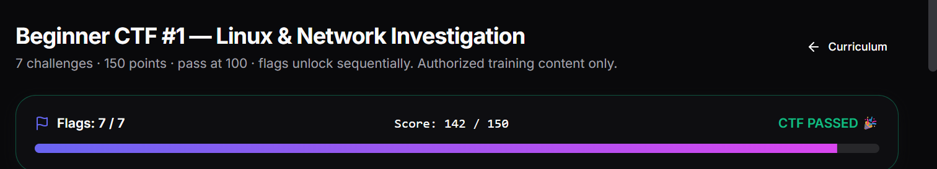

CTF LEARNING REPORT
- Which challenge was easiest, and why?
Task 1 was the easiest challenge cause it is a command that we had used a lot on previous sessions.

- Which challenge was hardest, and what made it hard?
- The last challenge Task 7 was the hardest mostly finding answer for each section is easy but when it comes to combine them and submit it took a lot of attempt to get the correct format.

- Which Linux commands did you use during the CTF?
- For Task 1 we used pwd – print working directory.
- For Task 2 we used ls-a – to display hidden files or dot files.

- What did you learn about permissions?
- I learned about linux file permissions that it can control read, write and execute a file.
- The numeric value 640 means the owner can read and write but group can only read and have no access.

- What did you learn about DNS?
- I learned about DNS that it translates domain names into IP addresses so it makes it easy for computers to communicate with servers.
- Port 53 is commonly used DNS.

- What did you learn about ports?
- I learned that ports help computer identifying which service runs on which port.
- Port 22: SSH, Port 53: DNS, Port 80: HTTP, Port 443: HTTPS.

- What did you learn from reading Nmap output?
- I learned how to identify open, closed and filtered ports. Open ports indicate service is open for connections, closed port indicates no connections are accepted. Filtered ports indicates there is gonna be a firewall or security measures running behing.
- What would you revise before the next CTF?
- I would revise common port numbers and their services, DNS basics, Linux file permissions, network addresses, and how to interpret Nmap results. I would also practise reading hints carefully and checking flag formats before submitting answers.

Include your CTF score summary (challenges solved + total points) at the top.

