INSTALLING NGINX:

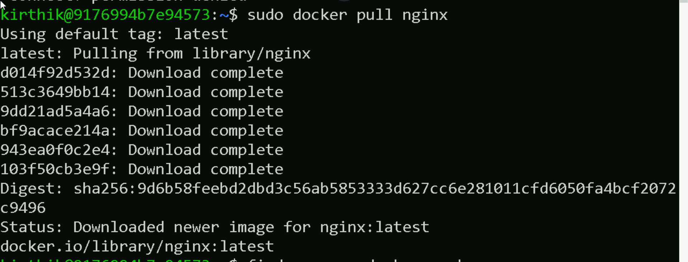

DISPLAYING THE IMAGE LIST:

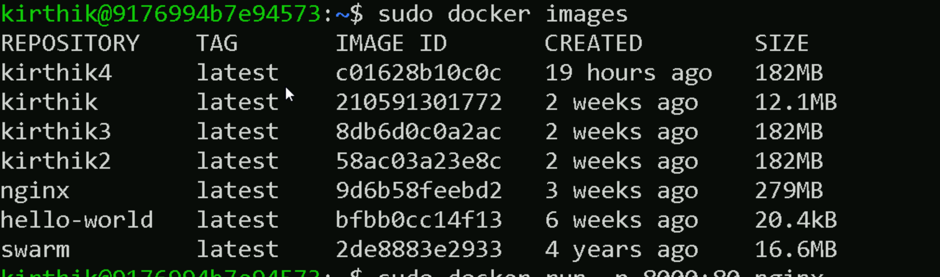

RUNNING THE CONTAINER: 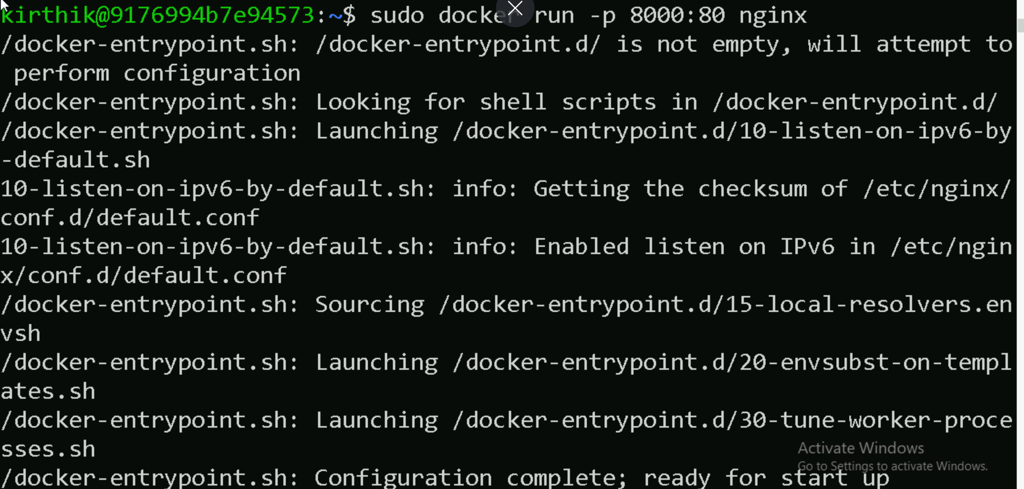

RUNNING A DETACHED CONTAINER:



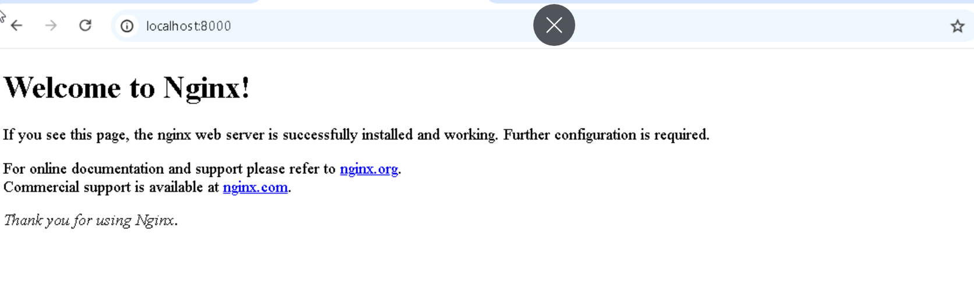

DISPLAYING RUNNING CONTAINER:

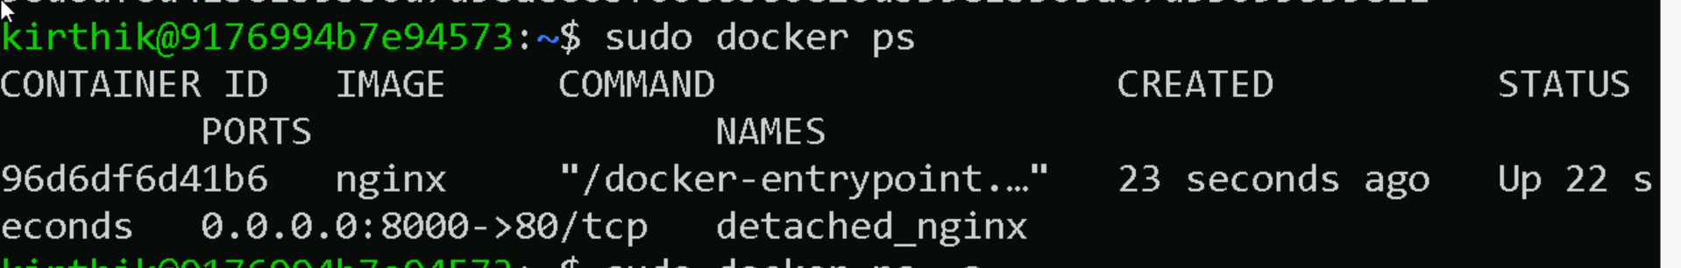

INTERACTING DIRECTLY WITH DETACHED CONTAINER:

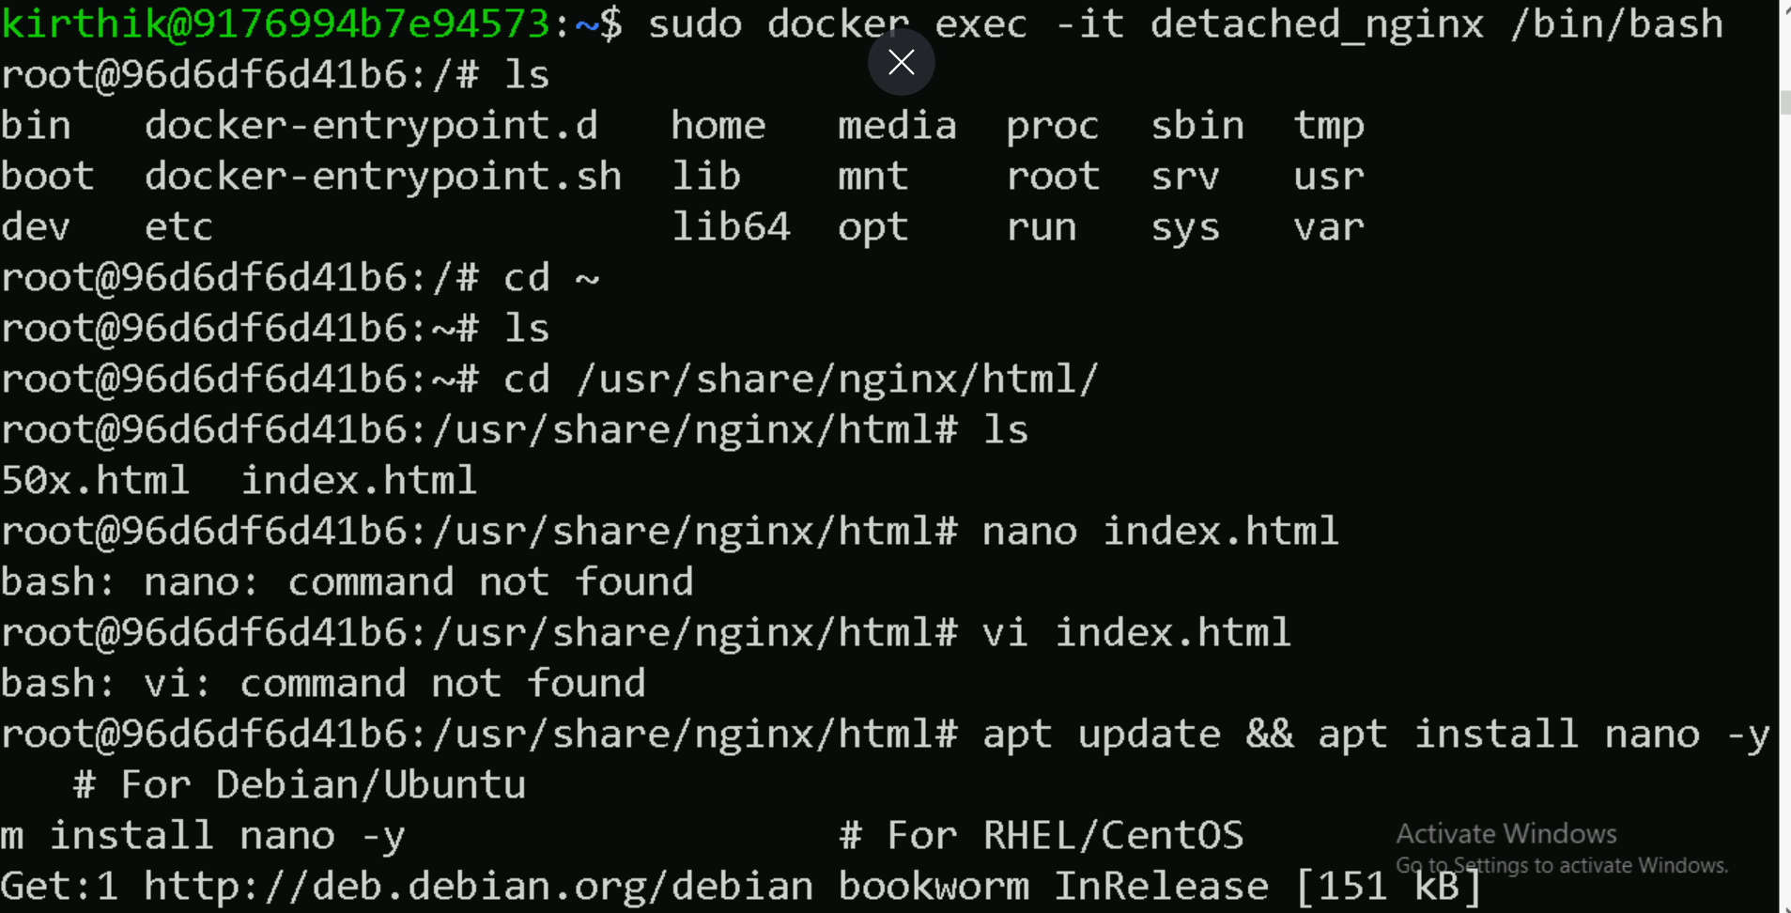

MODIFING THE INDEX.HTML



