**KUBERNETES HANDS-ON EXERCISES WITH STEP-BY-STEP COMMANDS AND SOLUTIONS**

**Kubernetes hands-on exercises** with **step-by-step commands and solutions** to help you gain practical experience. These exercises range from basic to intermediate levels.

**Exercise 1: Deploy an Nginx Pod**

**Objective: Deploy a simple Nginx pod and access it.**

**Steps & Commands:**

1. **Start a Kubernetes cluster (Minikube or other cluster):**

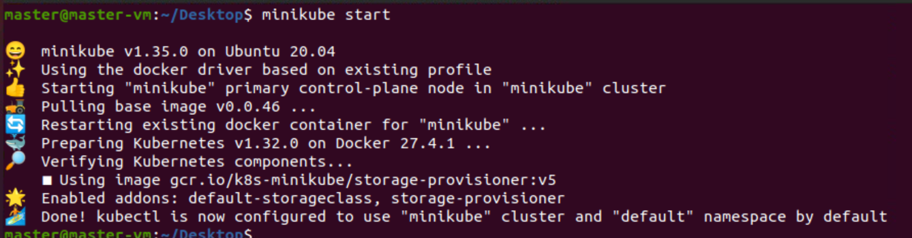

1. **Create an Nginx pod:**



1. **Verify the pod is running:**

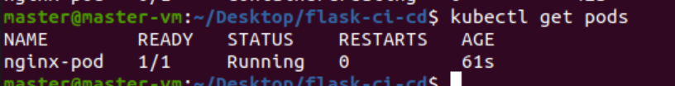

1. **Check pod details:**

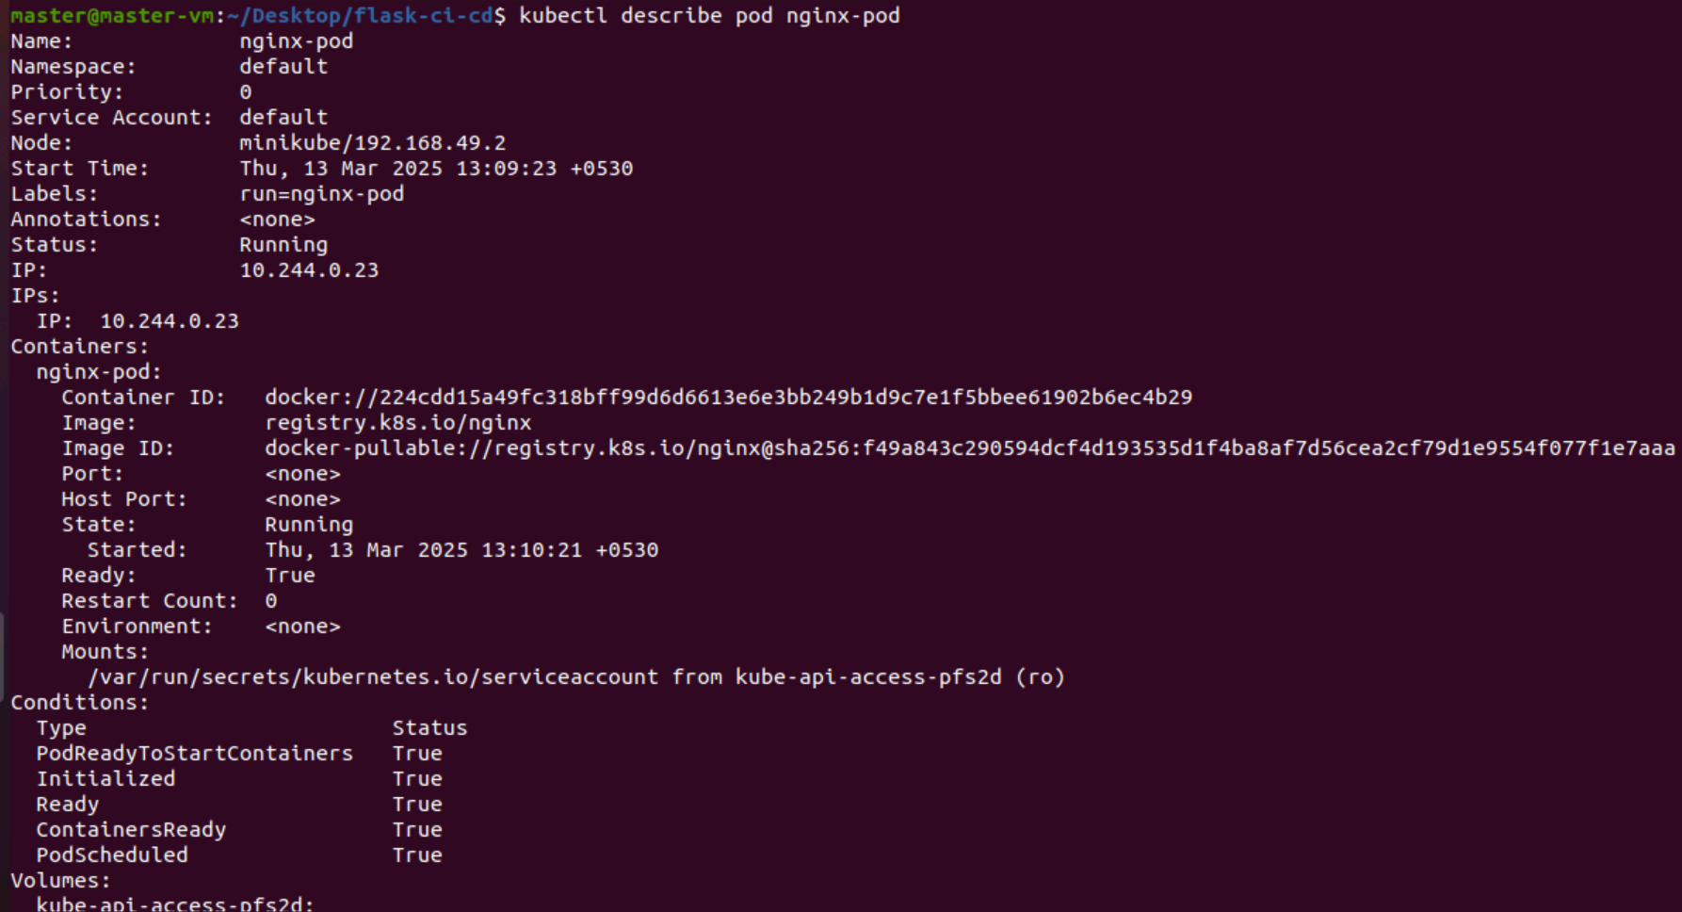

1. **Delete the pod:**



**Exercise 2: Create an Nginx Deployment and Scale It**

**Objective: Create an Nginx deployment and scale it up.**

**Steps & Commands:**

1. **Create a deployment with Nginx:**



1. **Check the deployment:**

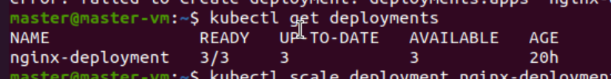

1. **Scale the deployment to 3 replicas:**



1. **Check the running pods:**



1. **Delete the deployment:**

