RefactorGraph Heterogeneous Graph Attention with Frozen
CodeBERT Features for Python Code Smell Detection

Kirti Vispute – 23102C0078 | Anjali Atawadkar – 24102C2007

Abstract - This paper presents RefactorGraph, an applied machine learning system for detecting Long Method, Feature Envy, and God Class smells in Python. Source files are parsed into heterogeneous graphs with seven node types and fourteen directed relations. Structural metrics are fused with frozen 768-dimensional CodeBERT embeddings and processed by a two-layer heterogeneous graph attention network with three task-specific heads; the God Class head also mean-pools method embeddings. A repository-level split of 9 training, 3 validation, and 3 test repositories prevents overlap, and the corrected held-out test set contains 1,574 Python files. The deployed seed-43 model achieves F1 scores of 0.7740, 0.5272, and 0.8075 for Long Method, Feature Envy, and God Class, respectively, with macro-F1 of 0.7029. Replacing aggregate external access count with dominant external receiver count improves macro-F1 by 0.0444 over a parser-consistent baseline. FastAPI and React components provide interactive graph inspection and refactoring guidance.

Index Terms - code smell detection, heterogeneous graph neural network, graph attention network, CodeBERT, static analysis, software maintainability.
I. INTRODUCTION
Code smells describe structures that do not necessarily prevent execution but can make software harder to understand, change, and test. Long methods concentrate several responsibilities in one routine, Feature Envy indicates that a method depends more strongly on another object than on its own state, and God Classes accumulate excessive behavior and size. These smells are commonly addressed through Extract Method, Move Method, and Split Class refactorings, respectively [1]. Manual review can identify such patterns, but it becomes costly and inconsistent across large repositories. Automated detection therefore requires both measurable evidence and enough program context to distinguish intentional complexity from poor structure.
Earlier learning-based detectors commonly model code as metric vectors or token sequences. Metric vectors retain interpretable size and coupling signals but discard relationships among program entities. Token models learn semantic regularities but may compress structural dependencies into a single sequence. RefactorGraph combines these views by representing each Python file as a typed graph and attaching both structural measurements and frozen CodeBERT features to graph nodes. A heterogeneous graph attention network then propagates information along containment, call, use, access, import, and inheritance relations.
The study makes four concrete contributions. First, it defines an end-to-end Python pipeline from abstract syntax tree parsing to three node-level smell predictions. Second, it uses a heterogeneous code graph with seven node types and fourteen directed relation types. Third, it introduces a class-method pooling pathway for God Class detection and aligns the Feature Envy input with the dominant external receiver used by the label rule. Fourth, it evaluates the selected checkpoint on three held-out repositories under a controlled, parser-consistent comparison and packages the model in a working web application.
II. RELATED WORK
A. Learning Based Code Smell Detection
Code smell detection has progressed from rule and metric combinations toward supervised and deep learning. Sharma et al. showed that neural models can learn smell indicators directly from tokenized code and that transfer across programming languages is feasible, although performance remains smell dependent [2]. Recent replication evidence also shows that imbalance treatment and feature design affect different smells unevenly, with Feature Envy requiring especially careful representation [3]. SCSmell combines structural features with BERT-derived textual features before stacked classification [4]. RefactorGraph follows the same broad motivation for hybrid evidence but preserves explicit program relationships through a typed graph.
B. Code Representations and Graph Attention
CodeBERT is a bimodal pretrained model for programming and natural languages that produces reusable code representations [5]. RefactorGraph keeps the pretrained encoder frozen and uses its 768-dimensional output as semantic context rather than fine-tuning it on silver smell labels. Graph attention networks assign learned importance to neighboring nodes while aggregating graph information [6]. This mechanism is suitable for code graphs because a method may receive distinct evidence from its containing class, called routines, and accessed program entities. The implementation uses PyTorch Geometric, which provides sparse graph data structures and operators for representation learning [7].
C. Model Explainability
GNNExplainer identifies compact subgraphs and feature subsets associated with a graph model's prediction [8]. RefactorGraph applies it offline to selected validation errors to inspect receptive fields and feature influence. The production endpoint does not run GNNExplainer; it returns structural metrics alongside each prediction. This separation matters because those metrics are descriptive evidence, not learned attribution, and the model score is an uncalibrated sigmoid output rather than a probability guarantee.
III. SYSTEM DESIGN
A. Analysis Pipeline
Figure 1 summarizes the inference path. The parser accepts Python source text and builds an abstract syntax tree without executing the program. Graph construction creates typed nodes for modules, classes, methods, functions, attributes, parameters, and imports. Fourteen relations encode containment, calls, attribute use, parameter access, imports, and inheritance. The graph therefore retains information that a flat per-method feature vector cannot represent directly.
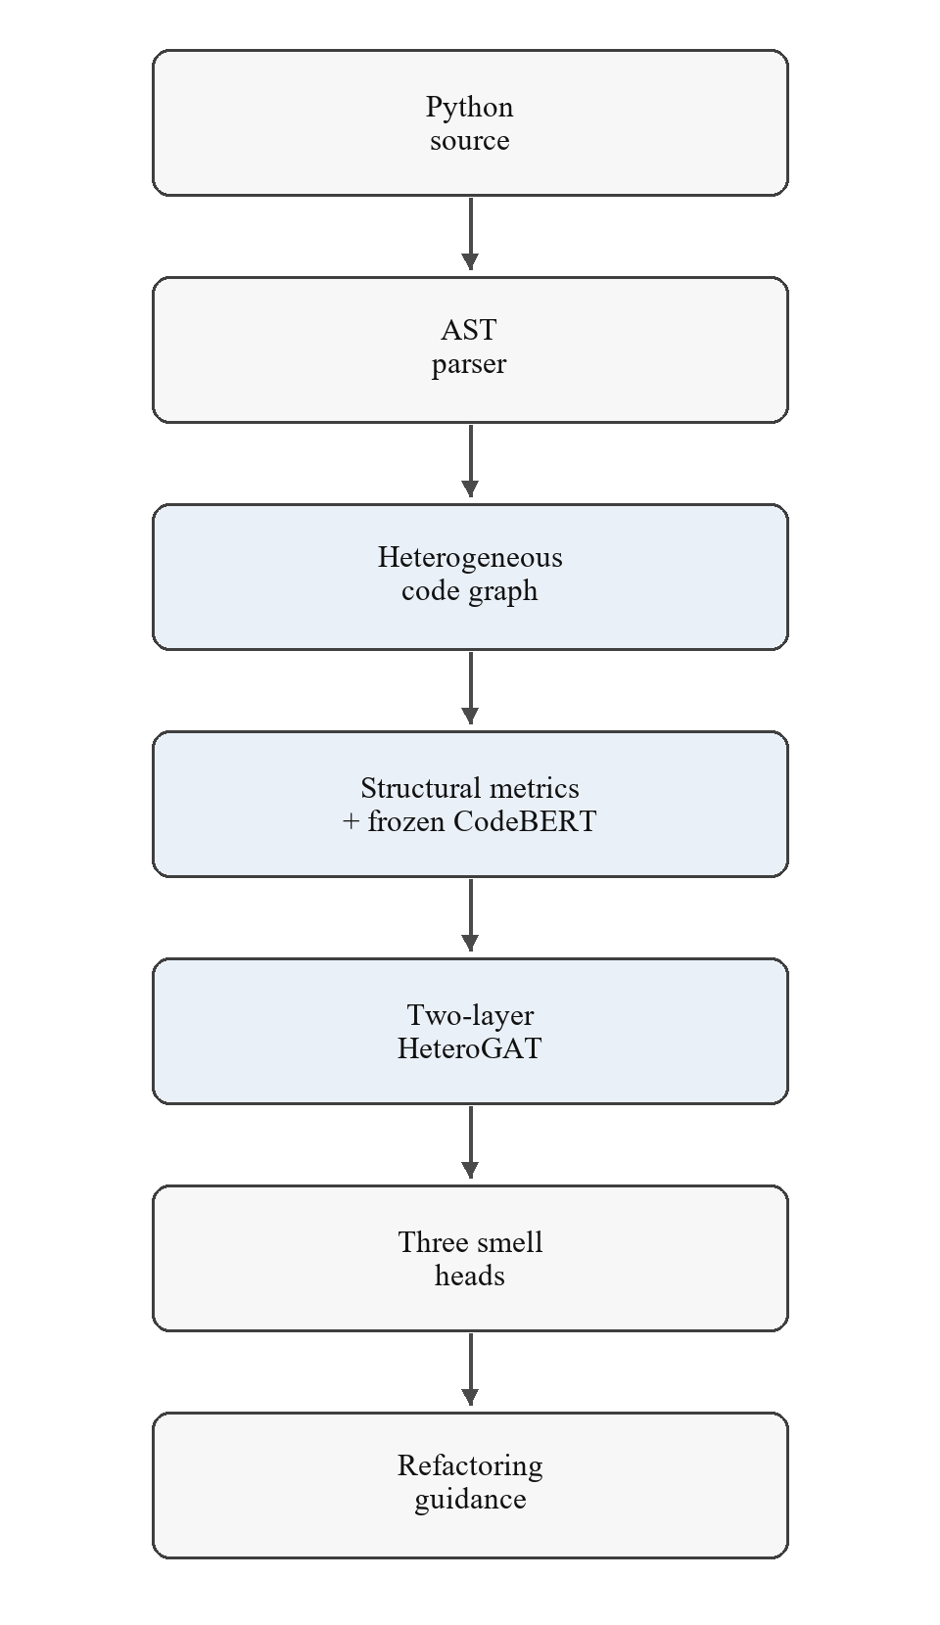
Fig. 1. End-to-end RefactorGraph analysis and recommendation pipeline.
B. Hybrid Node Features
Each node type has a compact structural feature vector. Method and function nodes use lines of code, statement count, parameter count, self-access count, and dominant external receiver count. Class nodes use lines of code, method count, and field count; lightweight node types retain a single structural value. The method and function representation concatenates five structural values with a frozen CodeBERT vector, giving 773 dimensions. Class nodes similarly combine three structural values with CodeBERT for 771 dimensions. Saved normalization statistics are applied before inference.
The dominant external receiver feature records the greatest number of attribute accesses associated with one external receiver. It replaces a previous aggregate count over all external receivers. This definition matches the Feature Envy rule, which asks whether a method concentrates at least three accesses on one external object and exceeds its self-access count. The change preserves tensor dimensionality while correcting feature semantics.
C. Heterogeneous Graph Attention Model
Per-type linear encoders project all node features to a shared 64-dimensional hidden space. Two heterogeneous graph attention layers process relation-specific messages with two attention heads. Residual additions retain each destination node's own encoded measurements because several graph relations are bipartite and are constructed without self-loops. Dropout of 0.174 is applied after the first layer. Three linear heads produce logits for Long Method, Feature Envy, and God Class. The model contains 269,315 trainable graph and classifier parameters; CodeBERT remains frozen.
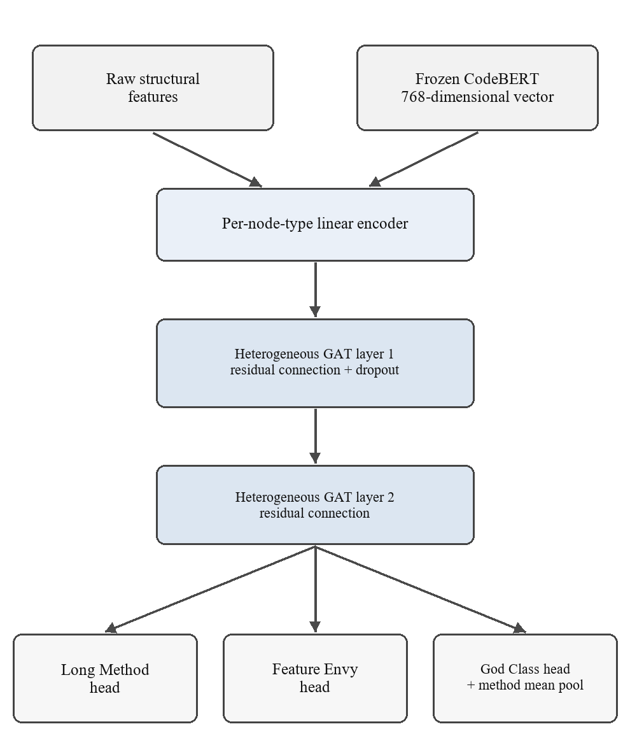
Fig. 2. Hybrid feature fusion and task-specific prediction architecture.
The Long Method head scores method and function embeddings, and the Feature Envy head scores method embeddings. For God Class, the final class embedding is concatenated with the mean of the final embeddings of its contained methods. Pooling occurs after graph propagation, which gives the class head access to method behavior without feeding sibling-method aggregates back into the shared method representations.
D. Prediction and Recommendation
Sigmoid scores are compared with configured thresholds to produce binary predictions. The live service uses 0.50 for Long Method and God Class and 0.65 for Feature Envy. A positive Long Method prediction maps to Extract Method, Feature Envy maps to Move Method, and God Class maps to Split Class. Recommendations describe likely refactoring directions; the system does not rewrite source files.
IV. DATASET AND EXPERIMENTAL PROTOCOL
A. Repository Corpus
The corpus contains fifteen permissively licensed, real Python repositories. Nine repositories form the training split, three form validation, and three form test. The split was fixed at repository level before labeling and training. Training repositories include Click, Black, HTTPX, Gunicorn, Flask, Tornado, Requests, Scrapy, and pytest. Validation uses SQLAlchemy, Starlette, and Sphinx. Django, pandas, and Celery are reserved for held-out testing. Resolved commit identifiers are recorded separately for reproducibility.
TABLE I
REPOSITORY LEVEL DATASET COMPOSITION
Split | Repositories | Python files | Parse errors
Train | 9 | 547 | 0
Validation | 3 | 514 | 0
Test | 3 | 1,574 | 0

Duplicate removal operates both within splits and across splits. The preprocessing audit reports 1,326 within-split and 124 cross-split duplicate methods removed, together with 73 within-split and 17 cross-split duplicate classes. These controls reduce direct content leakage while preserving the repository-level generalization test.
B. Silver Label Construction
Labels are generated from abstract-syntax-tree metrics and are therefore silver labels rather than human judgments. Thresholds were derived from the training split using the 90th percentile with explicit floors. Table II gives the implemented rules. These labels provide a reproducible learning target, but they also bound the interpretation of the evaluation: the model is measured against the project rules, not against a manually adjudicated universal definition of each smell.
TABLE II
IMPLEMENTED SMELL LABEL RULES
Smell | Positive rule
Long Method | statement_count >= 15
Feature Envy | dominant_external_count >= 3 and greater than self_access_count
God Class | method_count >= 10 and LOC >= 192

C. Model Selection and Test Integrity
Architecture, hyperparameters, feature definitions, and seed selection were determined from training and validation evidence. The final checkpoint uses seed 43 and the best validation epoch 79. The corrected final comparison evaluated two architecture-compatible checkpoints once each on matching parser-consistent test representations: the earlier model with aggregate external access count and the candidate with dominant external receiver count. Both forward passes used batches of 64, no shuffling, and a 0.50 decision threshold for all three research metrics. No checkpoint, threshold, or label was changed after the test became visible.
The corrected test evaluation contains 25,599 Long Method candidates with 2,367 positives, 20,420 Feature Envy candidates with 554 positives, and 3,766 class candidates with 328 God Class positives. The task-specific sample counts differ because each head applies to a different set of node types and eligible entities.
V. RESULTS AND ANALYSIS
A. Held Out Test Performance
Table III reports the deployed candidate on the corrected held-out test set. God Class obtains the strongest balance of precision and recall, with F1 of 0.8075. Long Method reaches F1 of 0.7740 and recall of 0.8978, indicating broad coverage at the cost of more false positives than God Class. Feature Envy remains the most difficult task: its F1 is 0.5272, with precision 0.5717 and recall 0.4892. The macro-F1 across the three heads is 0.7029.
TABLE III
CORRECTED HELD OUT TEST METRICS FOR THE DEPLOYED CANDIDATE
Task | Precision | Recall | F1
Long Method | 0.6802 | 0.8978 | 0.7740
Feature Envy | 0.5717 | 0.4892 | 0.5272
God Class | 0.8296 | 0.7866 | 0.8075
Macro | - | - | 0.7029

The area-under-curve results provide threshold-independent context. ROC-AUC is 0.9823 for Long Method, 0.9501 for Feature Envy, and 0.9777 for God Class. PR-AUC is 0.8425, 0.5510, and 0.8837, respectively. The lower Feature Envy PR-AUC is consistent with its smaller positive class and the limited precision-recall tradeoff available at a fixed threshold.
B. Controlled Feature Comparison
Figure 3 compares the deployed candidate with the corrected baseline. The candidate improves every task: Long Method increases from 0.7515 to 0.7740, Feature Envy from 0.4360 to 0.5272, and God Class from 0.7879 to 0.8075. Macro-F1 rises from 0.6585 to 0.7029. The largest absolute gain, 0.0912, occurs for Feature Envy, the task directly affected by the feature definition.
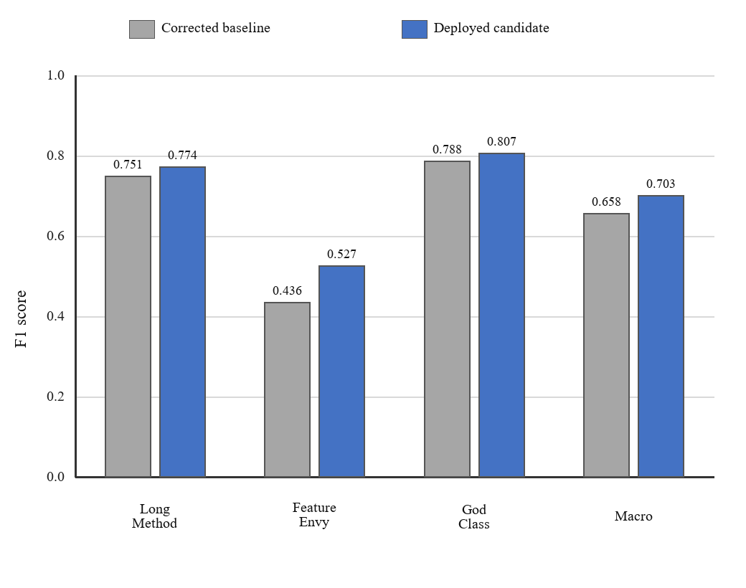
Fig. 3. F1 comparison on corrected held-out test data. Both evaluations use matching feature semantics and a 0.50 research threshold.
TABLE IV
F1 CHANGE FROM CORRECTED BASELINE TO CANDIDATE
Task | Baseline | Candidate | Change
Long Method | 0.7515 | 0.7740 | +0.0225
Feature Envy | 0.4360 | 0.5272 | +0.0912
God Class | 0.7879 | 0.8075 | +0.0196
Macro-F1 | 0.6585 | 0.7029 | +0.0444

For Feature Envy, the corrected baseline produced 497 false positives and 293 true positives. The candidate reduced false positives to 203 while retaining 271 true positives. Precision consequently increased from 0.3709 to 0.5717, while recall decreased from 0.5289 to 0.4892. The resulting F1 gain reflects a substantial reduction in false alarms with a smaller loss in detected positives. The direction and concentration of the gain support the intended interpretation of dominant external receiver count.
Long Method and God Class also improve by 0.0225 and 0.0196. Because the architecture shares graph message passing before task-specific heads, a change to one method feature can alter representations used by the other tasks. These secondary gains are empirically observed but should not be treated as proof of a causal mechanism beyond the controlled model comparison.
C. Historical Metric Clarification
An earlier project report recorded F1 scores of 0.740, 0.525, and 0.767 with macro-F1 0.677. Those values came from test artifacts created before two parser corrections and are retained only as historical results. They are not the baseline in Figure 3. The corrected baseline uses the same current parser as the candidate and is therefore the valid comparator for the feature experiment.
VI. IMPLEMENTATION AND OPERATIONAL VALIDATION
A. Inference Service and User Interface
A FastAPI service loads the frozen checkpoint and normalization statistics once during application startup. The health endpoint reports service and model status, while the analysis endpoint accepts Python source and returns the graph, per-node scores, binary predictions, explanations based on structural measurements, and recommendations. Response schemas are validated with typed models. The React interface uses Cytoscape.js to render the returned heterogeneous graph and presents summary and detail views for detected smells.
B. Explainability Boundary
Offline GNNExplainer runs examine selected validation false positives and false negatives. The reports identify important edges and structural features in each prediction's receptive field and helped reveal the need for a class-method aggregation pathway. Live analysis deliberately omits this computational step. Users see the node's measured structure and raw model score, which should be interpreted as diagnostic support rather than a calibrated confidence estimate.
C. Verification Evidence
The frozen deployment passed 94 backend and machine learning tests and 25 frontend component tests. The frontend production build completed successfully. Runtime verification confirmed that the health endpoint reported a loaded model and that analysis returned the expected summary, graph, and three prediction groups. A rollback copy preserves the earlier checkpoint and the two production files changed during deployment.
TABLE V
FROZEN PROJECT VERIFICATION SUMMARY
Verification item | Observed result
Backend and ML tests | 94 passed, 0 failed
Frontend tests | 25 passed
Frontend build | Succeeded
Health endpoint | status ok; model loaded
Analysis contract | Graph plus three smell outputs

VII. THREATS TO VALIDITY
A. Construct Validity
The labels encode project-specific metric rules. They provide consistent targets but cannot capture every context in which a large method or class is justified. Feature Envy detection uses attribute-access patterns without complete type inference, so aliases, reassignment, and framework idioms can be misattributed. A human-reviewed benchmark is required before interpreting these results as agreement with expert judgment.
B. Internal Validity
Repository-level separation and duplicate removal reduce leakage, and the final candidate was selected before the corrected test result was inspected. However, both labels and several input metrics originate from the same static analysis pipeline. This relationship can favor models that reproduce the rule boundary rather than learn a broader maintainability concept. The feature comparison isolates column-four semantics with matching checkpoints, but the secondary gains on other tasks remain observational.
C. External Validity
The corpus spans fifteen open-source Python repositories, while the held-out result covers Django, pandas, and Celery. Generalization to proprietary systems, other programming languages, generated code, or highly dynamic Python patterns has not been established. Training thresholds are tied to the selected repository pool and should not be presented as universal smell definitions.
D. Operational Validity
Offline evaluation used a 0.50 threshold for all heads to support a controlled comparison. Production raises the Feature Envy threshold to 0.65, so deployed positive rates are not identical to those implied by Table III. The raw sigmoid score has not been calibrated, and no browser-level automated test currently exercises the complete network path from the real frontend to the running backend.
VIII. CONCLUSION
RefactorGraph demonstrates a complete applied machine learning approach to Python code smell detection. It combines AST-derived program structure, frozen CodeBERT semantics, and relation-specific graph attention in a single model with three prediction heads. On corrected held-out repositories, the deployed checkpoint reaches macro-F1 0.7029, with the strongest results for God Class and Long Method. Aligning the Feature Envy input with the dominant external receiver improves that task's F1 by 0.0912 and reduces false positives from 497 to 203 relative to the corrected baseline. The implementation also provides a verified API, interactive graph view, offline GNN explanations, and refactoring recommendations.

The main limitation is the use of rule-derived labels. Future evaluation should introduce a stratified, human-reviewed benchmark and report inter-rater agreement, calibrated scores, and cross-project performance under fixed decision thresholds. A full frontend-to-backend integration test would strengthen operational evidence. Further model tuning should wait for a new held-out set so that the current test result remains a valid final estimate for this project cycle.
REFERENCES
[1] M. Fowler, Refactoring: Improving the Design of Existing Code, 2nd ed. Boston, MA, USA: Addison-Wesley, 2018.
[2] T. Sharma, V. Efstathiou, P. Louridas, and D. Spinellis, "Code smell detection by deep direct-learning and transfer-learning," J. Syst. Softw., vol. 176, Art. no. 110936, 2021, doi: 10.1016/j.jss.2021.110936.
[3] H. G. Nunes, A. Santana, E. Figueiredo, and H. A. X. Costa, "Tuning code smell prediction models: A replication study," in Proc. IEEE/ACM 32nd Int. Conf. Program Comprehension (ICPC), 2024, pp. 316-327, doi: 10.1145/3643916.3644436.
[4] D. Zhang, S. Song, Y. Zhang, H. Liu, and G. Shen, "Code smell detection research based on pre-training and stacking models," IEEE Latin Amer. Trans., vol. 22, no. 1, pp. 22-30, Jan. 2024, doi: 10.1109/TLA.2024.10375735.
[5] Z. Feng et al., "CodeBERT: A pre-trained model for programming and natural languages," in Findings Assoc. Comput. Linguistics: EMNLP, 2020, pp. 1536-1547, doi: 10.18653/v1/2020.findings-emnlp.139.
[6] P. Velickovic et al., "Graph attention networks," in Proc. 6th Int. Conf. Learning Representations (ICLR), Vancouver, BC, Canada, 2018.
[7] M. Fey and J. E. Lenssen, "Fast graph representation learning with PyTorch Geometric," in Proc. ICLR Workshop Representation Learning on Graphs and Manifolds, 2019, arXiv:1903.02428.
[8] Z. Ying, D. Bourgeois, J. You, M. Zitnik, and J. Leskovec, "GNNExplainer: Generating explanations for graph neural networks," in Adv. Neural Inf. Process. Syst., vol. 32, 2019, pp. 9240-9251.

