Key Points :

Step 1 - Idea -> Wireframe -> Static html ( technology -html5 , css syntax- start from base)

* deploy at heroku // this will help you to know deployment/ server concept

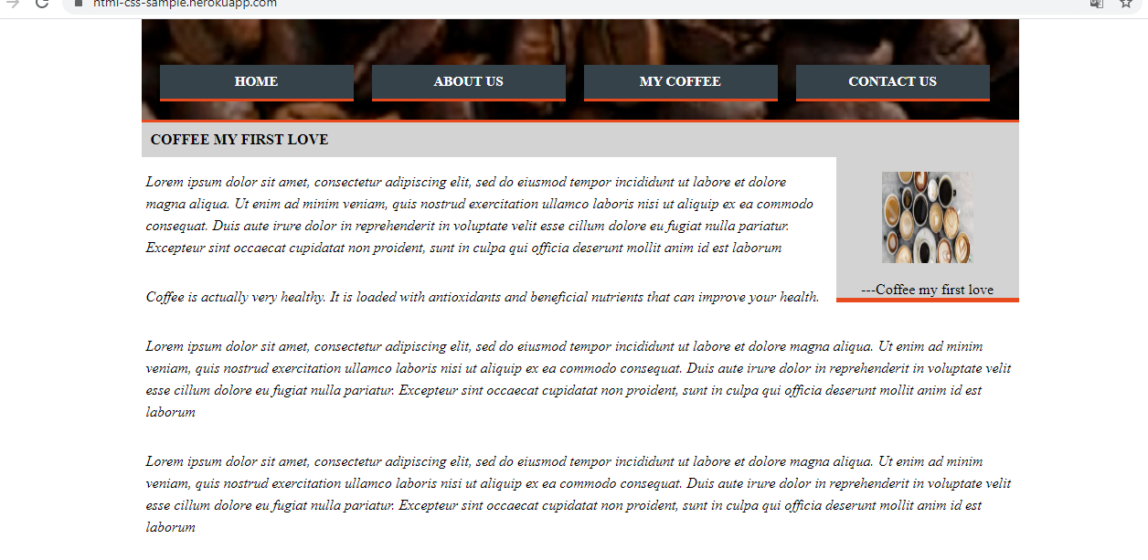

Step 2 - // it will help to learn how to convert html to react project //

* React setup // It will help you to learn package.json,setup and npm
* b)) convert static website -> react with functional components

Step 3 - > This is help to learn redux , router and axios, fetch ,arrays , ES6 concept

* Redux - with - hardcoded state - then try to understand (Redux-store->state->props) with functional components
* fetch data from live api and then start learning how to set dynamic data
* Deploy code at heroku // it will help to understand how to deploy react app and how to troubleshoot issue over local to server

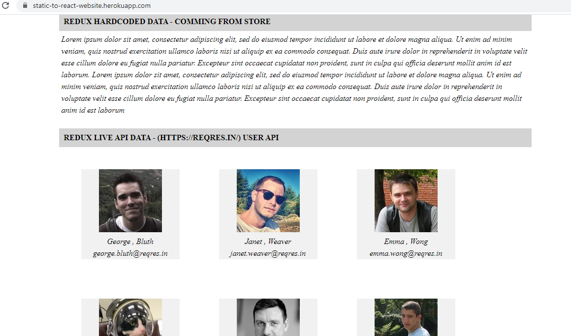

Step 4 - >This will help to understand JEST ,testing libraries

* Unit test
* start with simple (reducers , action , containers and then components)

Step 5 - This will help to setup mockserver / backend

* express
* backend setup with hardcoded response
* deploy in heroku // it will hell to understand how to connect backend and front end deployment

Step 6 - Dynamic data from database ( full stack experience)

* Learn database / Mongo db
* connect backend with database
* Unit test for backend code
* deploy in heroku // this wil give you experience how to connect backend , database and front end )

Step 7 - take break

Step 8 - Repeat 1-7 steps for at least 5 times with small idea's to understand the process .

// if you want to help to