Taxi Booking Simulator Code
- Introduction: A taxi booking application where users can request rides and book the taxi. The application handling User Onboarding, Taxi Onboarding, fetch available taxi and Book taxi, ensuring a seamless and secure experience for both passengers and drivers. Below is the Api call handler created:
- User Onboarding
- Taxi Onboarding
- Fetch available taxi call
- Book taxi
- Generate Random Location

- User Onboarding – First the user is being registered by calling User Registration Api
  - Request Parameters:
{
"name": "Kirti",
"email": "kirti14holkar@gmail.com",
"phone": "9754895223",
"location": {
"lat": 13.13,
"lng": 77.62
},
"preferred_taxi_type": "economy"
}

  - Response:

- Taxi Onboarding- In this feature we are registering taxi by calling Taxi Registration Api.
  - Request Parameters:
{
"name": "John",
"email": "kirti14holkar@gmail.com",
"phone": "9758767523",
"location": {
"lat": 13.13,
"lng": 77.62
},
"preferred_taxi_type": "economy"
}

  - Response:
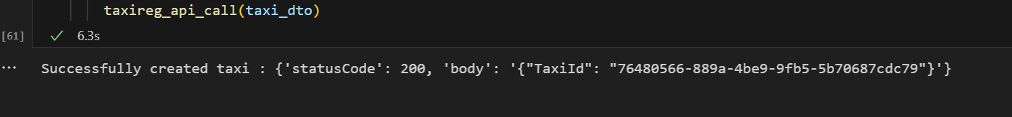

- Fetch available taxi call- This feature is used to fetch taxis by calling fetchAvailableTaxi Api. Shown graphical representation in response
  - Request Parameters:
{
"user_location": {
"lat": 13.13,
"lng": 77.62
},
"taxi_type": "economy"
}

  - Response:
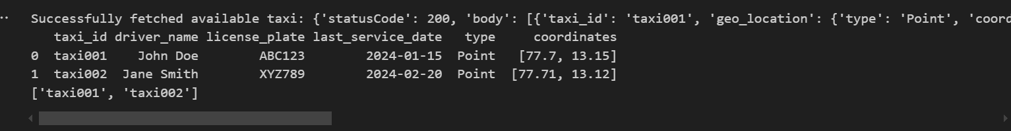

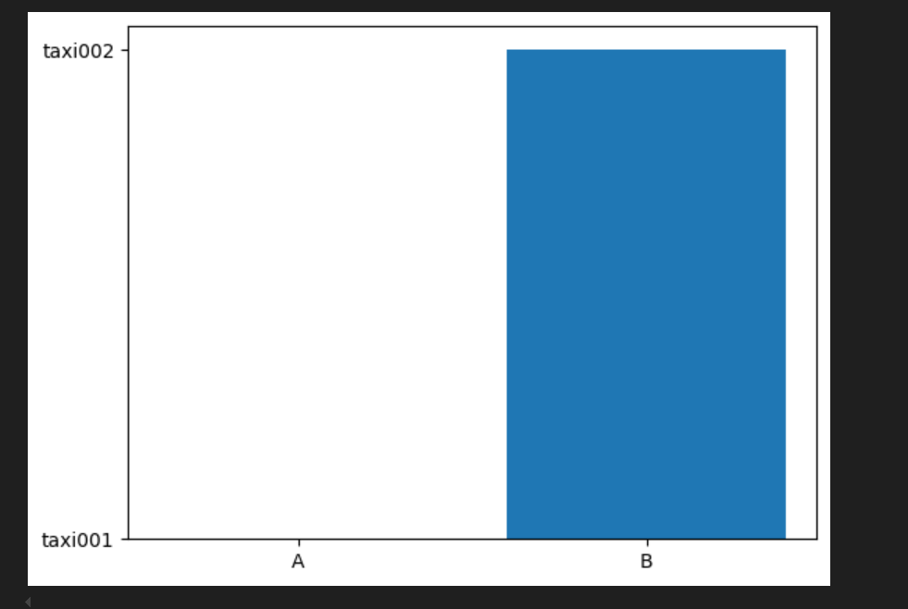
- Book taxi call– User can book the taxis using this feature. We are calling the BookTaxi Api.
  - Request Parameters:
{
"user_id": "user001",
"taxi_id": "taxi001",
"pickup_location": {
"lat": 13.13,
"lng": 77.62
},
"dropoff_location": {
"lat": 13.135,
"lng": 77.625
},
"taxi_type": "economy"}

  - Response:

- Generate Random Location – We are getting location by calling GenerateLocation Api.
- Response:

