Taxi Booking Project Progress

- Database : Mongo DB Atlas

Name : taxi-booking-data

Collections Created for this project:

- TaxiInformation – Data will be inserted as part of taxi registration
- UserInformation –Data will be inserted as part of User registration
- UserBookingHistory – Booking details contains user id, Pickup , drop location
- TaxiLocationHistory – For Data analysis we are maintaining location and booking history

TaxiInformation Data:

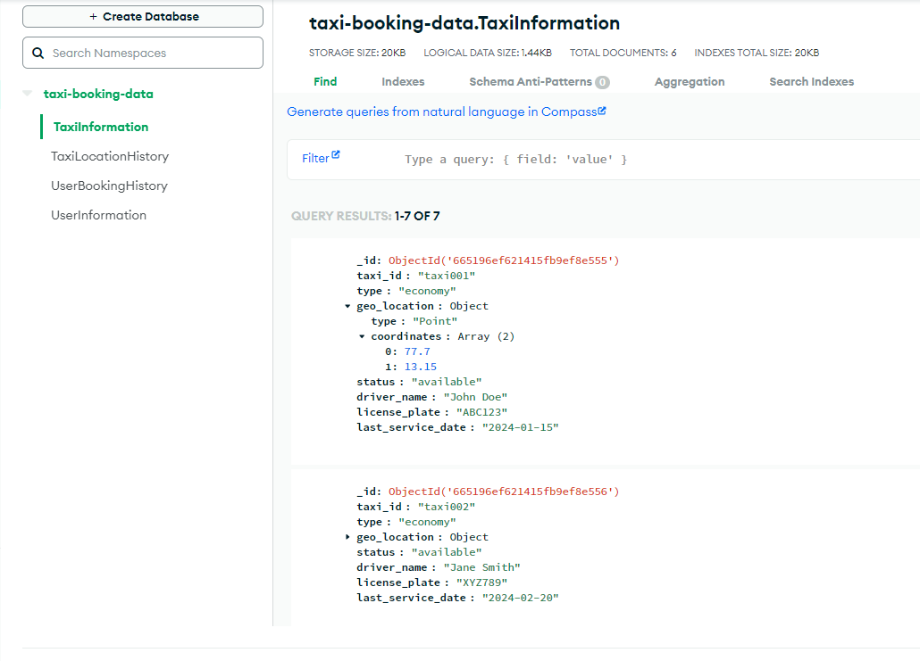
UserInformation Data:
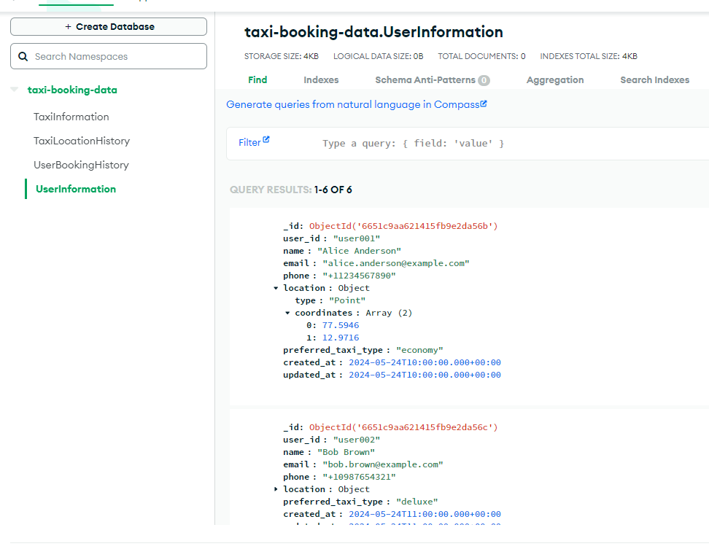
UserBookingHistory Data
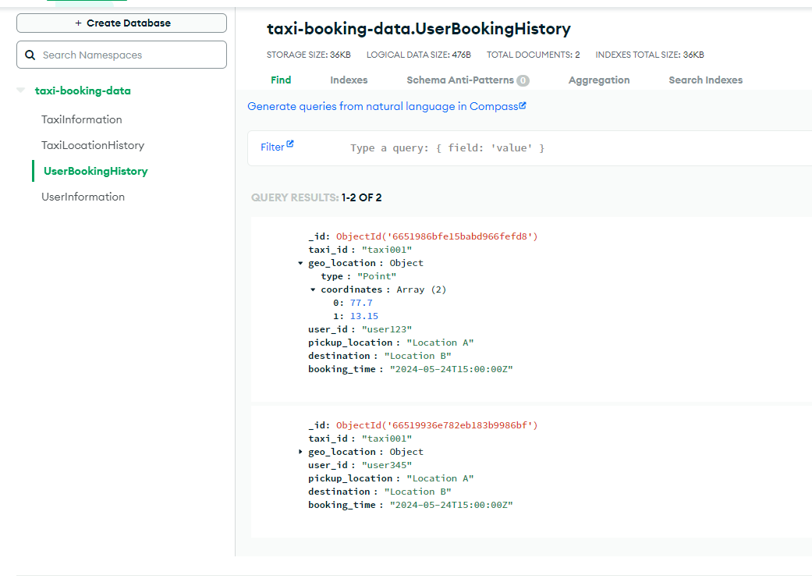
Below are the API exposed for the above activities:
Endpoint: https://bz7z5hcugi.execute-api.us-east-1.amazonaws.com/dev

Resource Path:
/dev/BookRide
/dev/FetchAvailableTaxi
/dev/TaxiRegister
/dev/UserRegister

Mapped to corresponding Lambda function

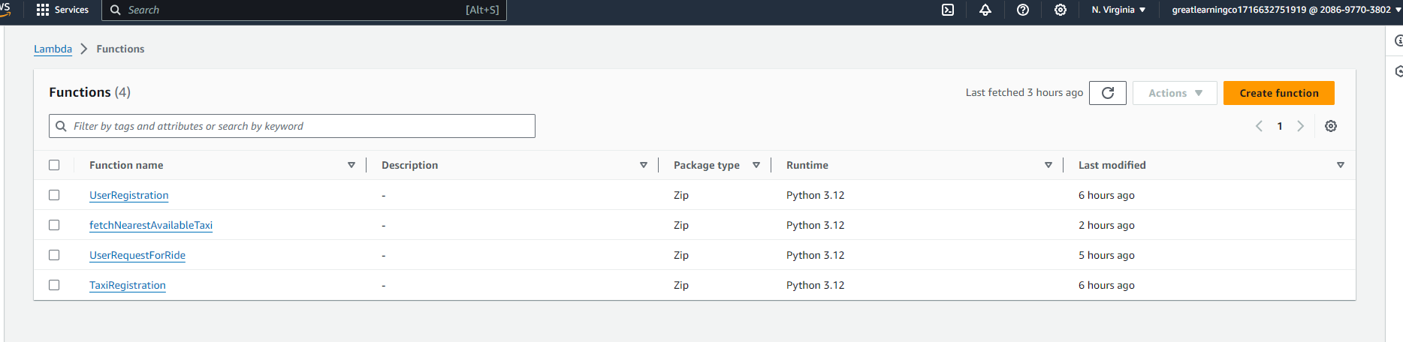

To interact with Mongo DB, we have added Pymongo dependency as lambda layers,

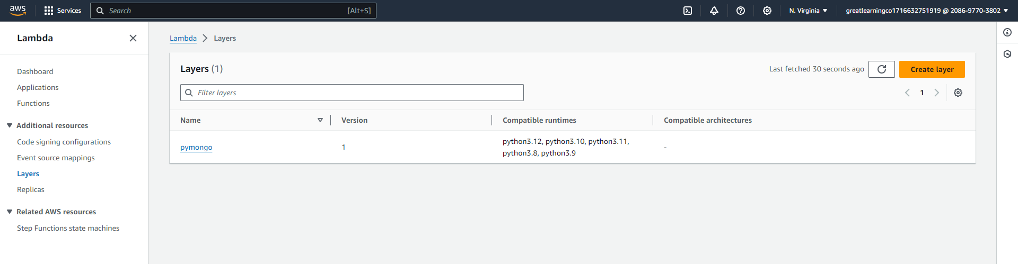

Mongo DB URI and DB name, we are maintaining in Environment Variables,

