N8N Hands-On Beginner Assessment Submission
Workflow Name: My First N8N Workflow

Assessment Overview
Successfully created a workflow using Manual Trigger and Edit Fields nodes.

Workflow Architecture
Manual Trigger -> Edit Fields (Set)

Verified Output
{"greeting":"Hello, n8n!"}

Screenshot 1 - Workflow Canvas

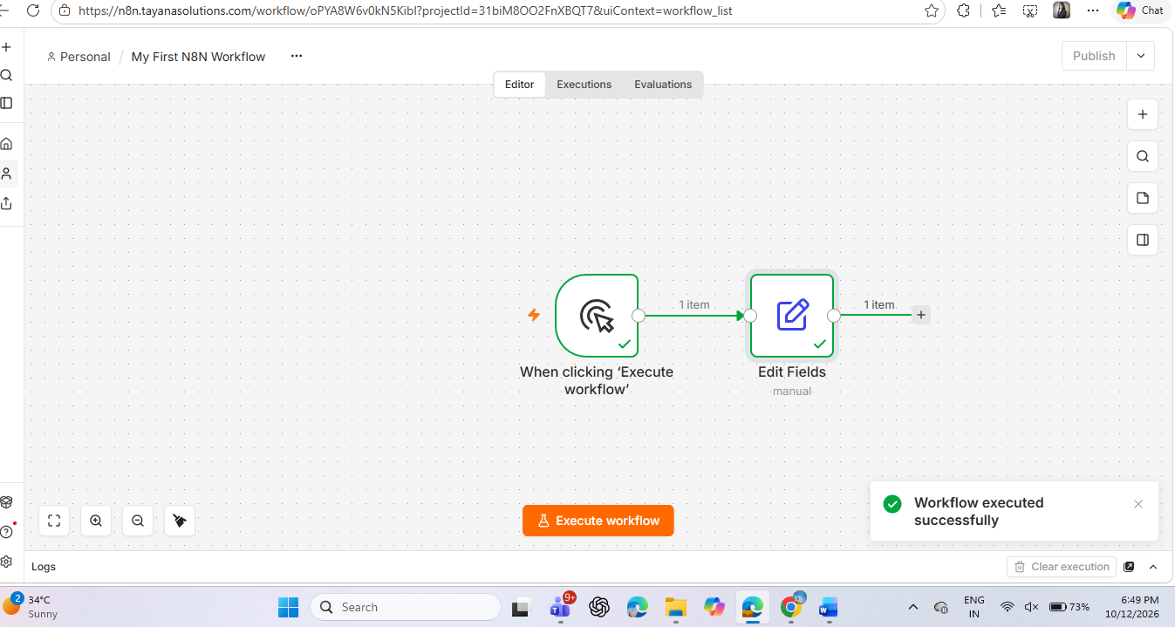

Screenshot 2 - Edit Fields Configuration
Insert screenshot showing greeting field configuration.

Screenshot 3 - Successful Execution
Insert screenshot showing green check marks.

Screenshot 4 - JSON Output

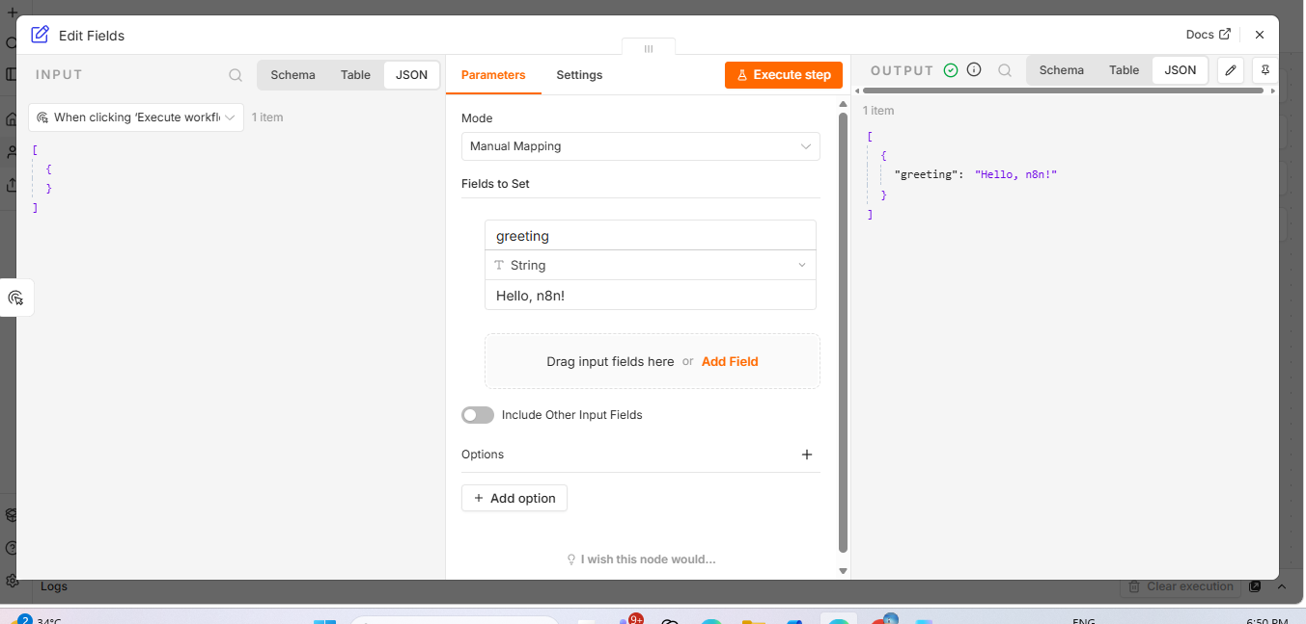Screenshot 5 - Final Workflow
Insert screenshot showing final connected workflow.

