ls - The most frequently used command in Linux to list directories
pwd - Print working directory command in Linux
cd - Linux command to navigate through directories
mkdir - Command used to create directories in Linux
mv - Move or rename files in Linux
cp - Similar usage as mv but for copying files in Linux
rm - Delete files or directories
touch - Create blank/empty files
ln - Create symbolic links (shortcuts) to other files
cat - Display file contents on the terminal

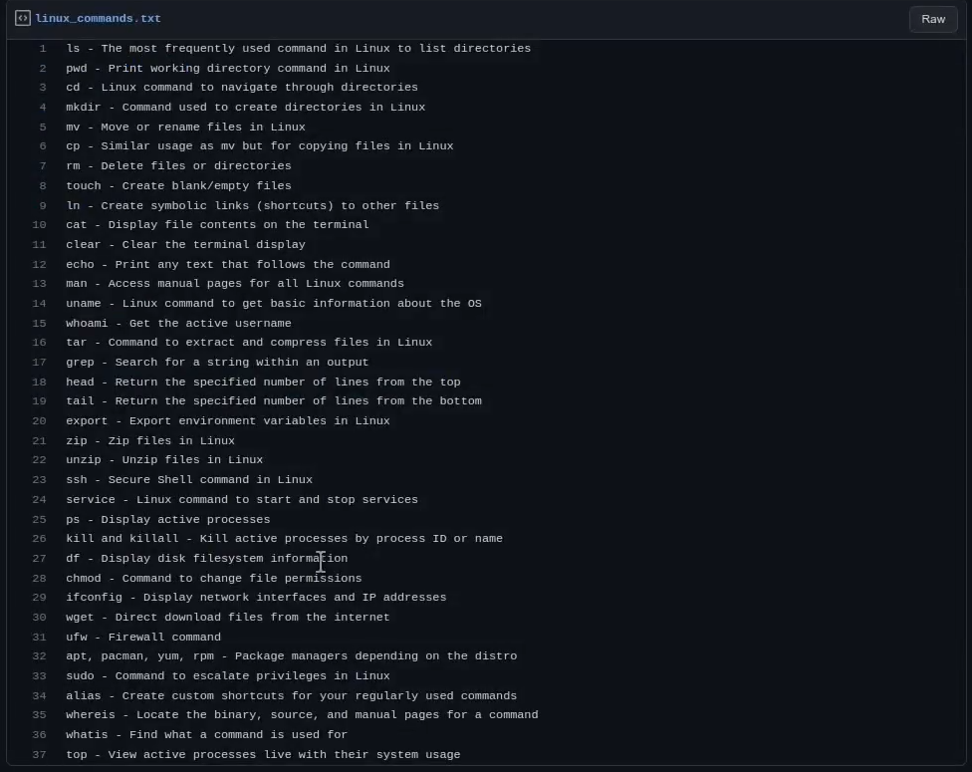

1. Creating and Renaming Files/Directories
Create a directory named test_dir using mkdir: mkdir test_dir
Inside test_dir, create an empty file called example.txt: cd test_dir -> touch example.txt
Rename example.txt to renamed_example.txt using mv: mv example.txt renamed_example.txt
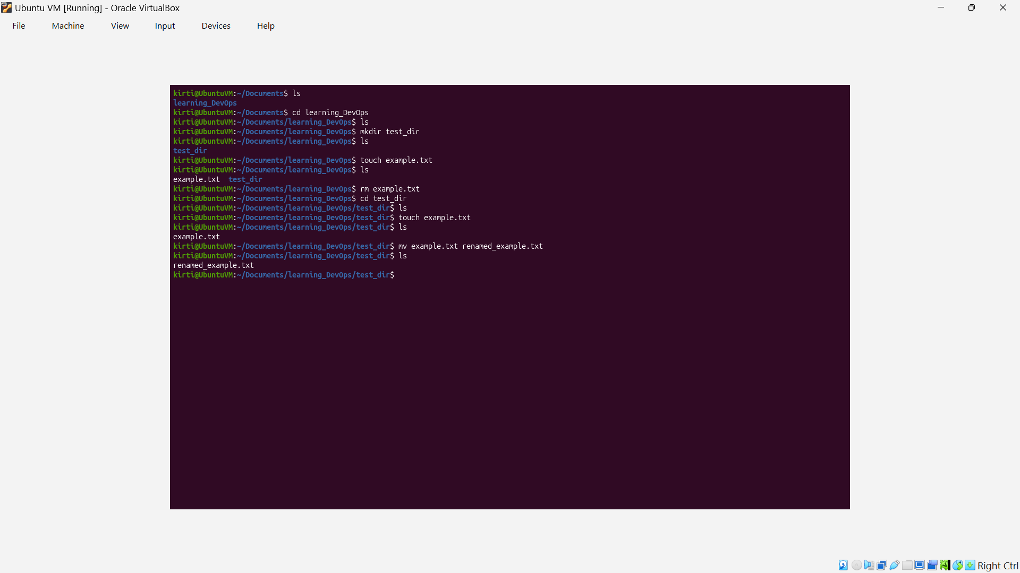
Syntax:
Mkdir directory_name
Mv file_to_rename renamed_file

2. Viewing File Contents
Use cat to display the contents of /etc/passwd: cat /etc/passwd
Display only the first 5 lines of /etc/passwd using head: head -5 /etc/passwd
Display only the last 5 lines of /etc/passwd using tail: tail /etc/passwd
Cat is used to display the contents of the file and we can truncate the output using these two commands ie head and tail where head returns the output from top and tail returns the output from the bottom.
Syntax:
Cat directory

3.Searching for Patterns
Use grep to find all lines containing the word "root" in /etc/passwd: grep "root" /etc/passwd
To search for patterns inside any text we use grep
Syntax: grep “text_to_search” directory

4. Zipping and Unzipping
Compress the test_dir directory into a file named test_dir.zip using zip: zip -r test_dir.zip test_dir
Unzip test_dir.zip into a new directory named unzipped_dir: unzip test_dir.zip -d unzipped_dir
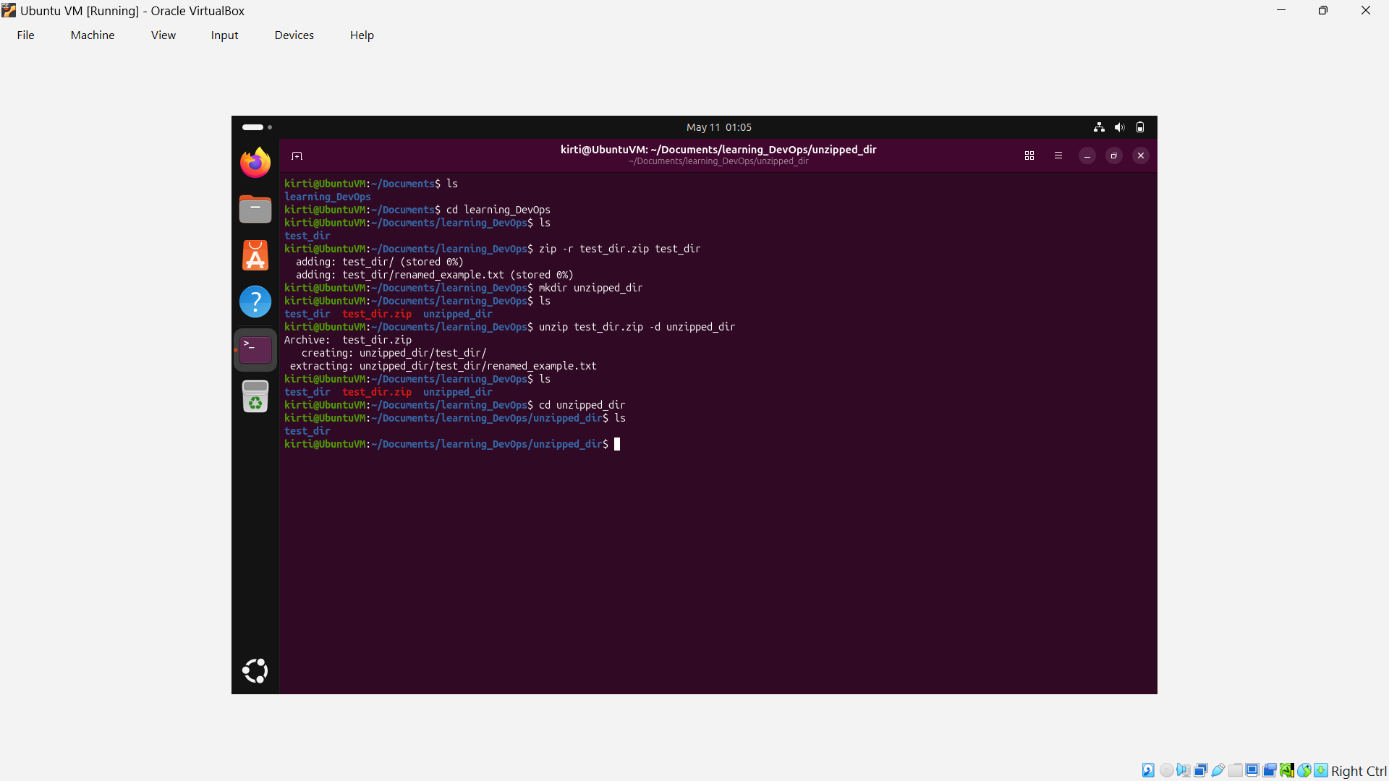

5. Downloading Files
Use wget to download a file from a URL (e.g., https://example.com/sample.txt).
wget https://example.com/sample.txt
syntax: wget url

6. Changing Permissions
Create a file named secure.txt and change its permissions to read-only for everyone using chmod.
touch secure.txt
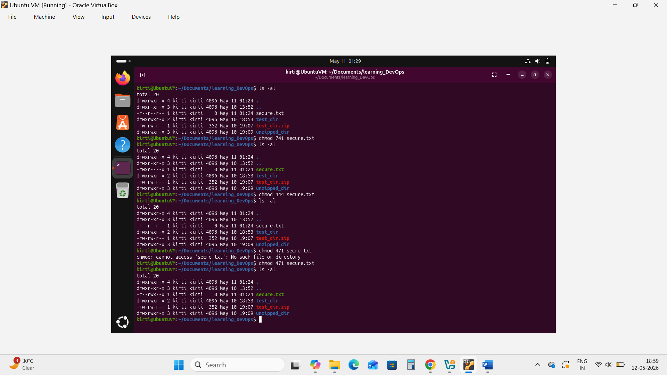
Chmod 444 secure.txt
Chmod a=r secure.txt
Syntax: chmod permissions filename

7. Working with Environment Variables
Use export to set a new environment variable called MY_VAR with the value "Hello, Linux!".
Export MY_VAR=”Hello, Linux!”
Echo $MY_VAR
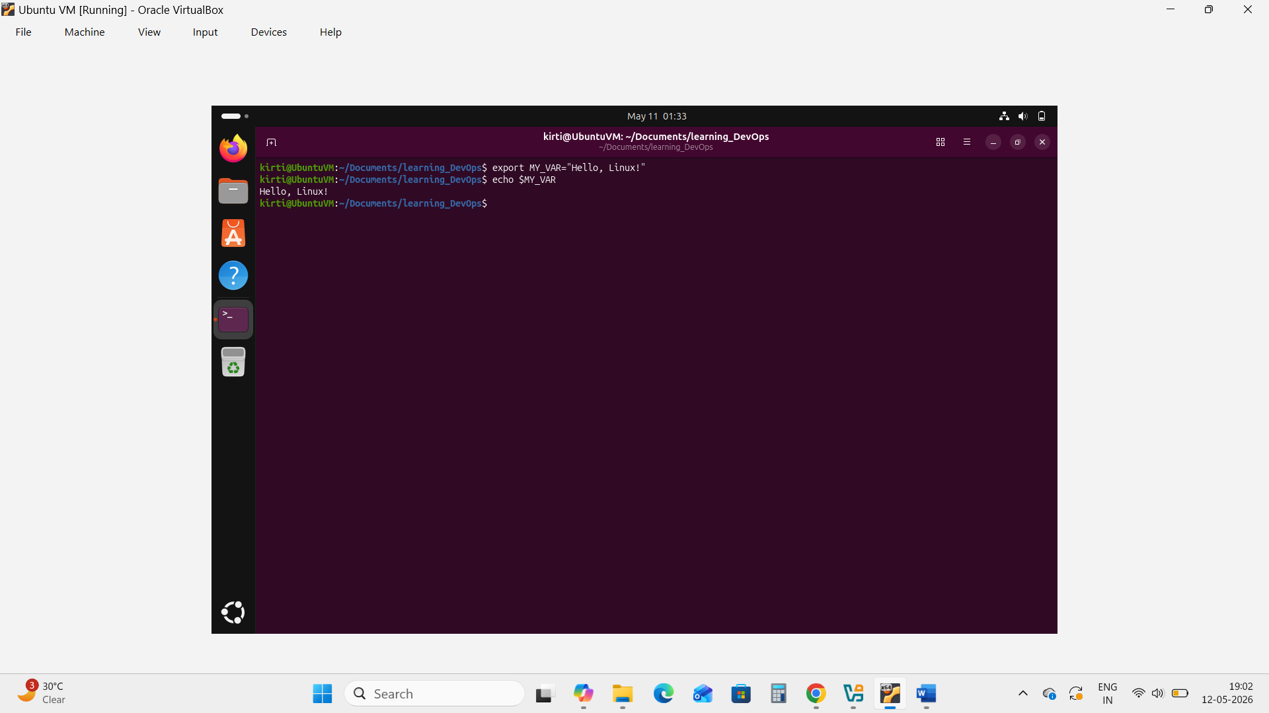
Syntax: export VAR_NAME=”VALUE”
Submission Guidelines -: Attach Screenshots or command along with explanation and submit in doc (google doc or microsoft doc) format also attach github repo link

