

What is React?
The React.js framework is an open-source JavaScript framework and library developed by Facebook.
It’s used for building interactive user interfaces and web applications quickly and efficiently with significantly less code than you would with vanilla JavaScript.
In React, you develop your applications by creating reusable components that you can think of as independent Lego blocks. These components are individual pieces of a final interface, which, when assembled, form the application’s entire user interface.
-----→https://blog.hubspot.com/website/react-js
React allows developers to build reusable UI components and organize the application logic into smaller, more manageable pieces.
React uses a virtual DOM (Document Object Model) to optimize performance by only updating the parts of the UI that need to be updated, rather than re-rendering the entire page. React can be used with other libraries and frameworks, such as Redux, React Router, and Material UI.

History of React JS
React is a new technology when compared with other technologies in the market. It came into existence in 2011, when Jordan Walke, a software engineer at Facebook created the library. React is influenced by the likes of XHP which is a simple HTML component framework for PHP. The first use case of React was in Facebook’s newsfeed in 2011.

https://educationecosystem.com/guides/programming/react-js/history

Let’s look at the history of React.js on a timeline

2010 – The first signs of React
- Facebook introduced xhp into its php stack and open sourced it.
Xhp allowed creating composite components. They introduced this syntax later in React.
2011 – An early prototype of React
- Jordan Walke created FaxJS, the early prototype of React – shipped a search element on Facebook.
2012 – Something new had started at Face book
- Facebook Ads became hard to manage, so Facebook needed to come up with a good solution for it. Jordan Walke worked on the prototype and created React.
- April 9: Instagram was acquired by Facebook.
2013 – The year of the Big Launch
May 29-31: JS ConfUS. Jordan Walke introduced React. React gets open sourced.
- June 2: React (by Facebook) is available on JSFiddle
- July 30: React and JSX in available in Ruby on Rails
- August 19: React and JSX available in Python Applications
- Sept 14-15: JSConfEU 2013. Pete Hunt’s speech of rethinking best practices.
- Dec 17: David Nolen Introduces OM, based on React.

2014 – The year of Expansion
React had gradually gained its reputation and started to go through to ‘early majority’ of its potential users. At this point, they needed a new message instead of solely relying on its technical benefits, and it is: how is React stable? By focusing on this, they aimed to appeal to enterprises, like Netflix.

2015 – React is Stable
- Sept 2: The first stable version of the new React Developer Tools launched.
- Sept 14: React Native for Android was released.

2016 – React gets mainstream

2017 – The year of further improvements
- Early 2017: Airbnb introduces their new open source library React Sketch.app
- Apr 19: React Fiber gets open sourced at F8 2017.
- October: Netflix removes client-side React.js
- November 28: React v16.2.0: Improved Support for Fragments

2018 – What’s up with React now?
- March 1-2: JSConf Iceland – Beyond React 16 by Dan Abramov
- 2018 March 29: React 16.3.0 was released.
For more visit-------→ https://blog.risingstack.com/the-history-of-react-js-on-a-timeline/

React JS Tools
As a developer, you should use tools to refine your working environment. There are many ReactJS tools that you can use and make your workflow more productive and meaningful. Let’s go through them one by one.
- Structor- Structor is a very simple user interface builder. It is used with the node.js web application that utilizes the React UI. The tool is useful for the new ReactJS projects as it replaces the old deprecated React UI Builder.
- React-jsx- React-jsx runs on both the client-side and the server-side and can be used as a stand-alone template.
- Coffee-react- Coffee-react lets you write JSX code with Coffeescript.
- ESLint- ESLint is simple tool to handle a pluggable JavaScript linter. The JavaScript linter should support native JSX syntax.
- Reactify- A transformation of Browserify for ReactJS.
- Babel- Babel is a JavaScript compiler that can be used with ReactJS.
- Node-jsx- node-jsx offers native Node support.
- React-hot-loader- A simple loader file for web pack. It lets you edit JSX file on the go and doesn’t require to reload the web page every time you make any changes.
- Jsx-loader- Another simple loader for webpack.
- Express-jsxtransform- A simple utility tool that offers jsx compilation on the fly for Express framework.
-→ https://educationecosystem.com/guides/programming/react-js/history
Versions
For versions ,visit-→https://en.wikipedia.org/wiki/React_(JavaScript_library)#:~:text=React%20was%20created%20by%20Jordan,JSConf%20US%20in%20May%202013.
Current version of React.JS is V18.0.0 (April 2022).
Initial Release to the Public (V0.3.0) was in July 2013.
React.JS was first used in 2011 for Face book's Newsfeed feature.

React Features


Currently, ReactJS gaining quick popularity as the best JavaScript framework among web developers. It is playing an essential role in the front-end ecosystem. The important features of ReactJS are as following.
- JSX
- Component-based architecture
- One-way Data Binding
- Virtual DOM
- Simplicity
- Performance
- Declarative programming
- React native
React.js comes with a range of features that make it a popular choice for building modern web and mobile applications. Some of the key features of React are:
- Component-Based Architecture: React.js uses a component-based architecture that allows developers to build reusable UI components. This makes it easier to manage and organize the application's UI logic, and reduces the amount of code that needs to be written.
- Virtual DOM: React uses a virtual DOM that allows it to efficiently update the UI without re-rendering the entire page. This makes React applications fast and responsive, even for complex UIs.
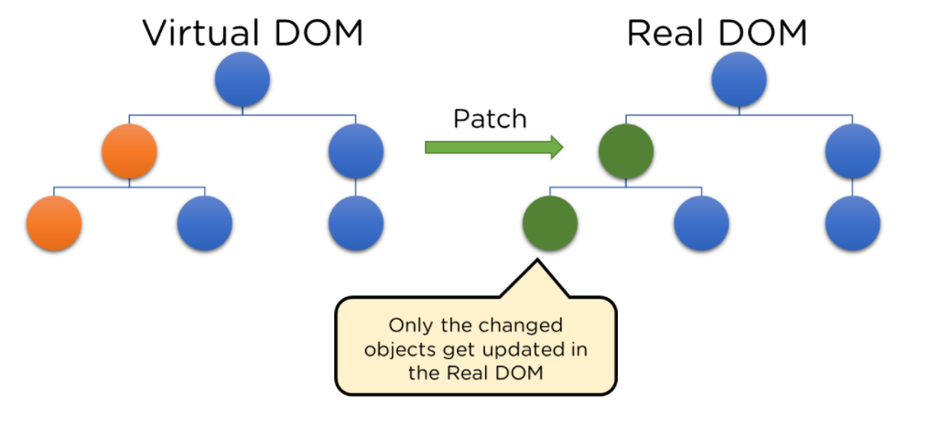
- JSX: React uses a syntax called JSX that allows developers to write HTML-like code in JavaScript. This makes it easier to write and maintain UI code, and enables developers to use JavaScript logic to modify the UI.
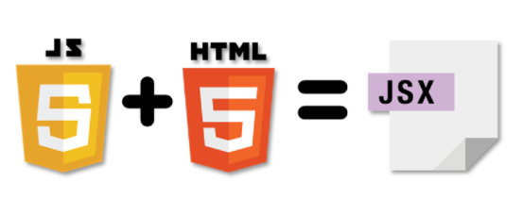
- One-way Data Binding: React uses one-way data binding, which means that data flows in one direction, from parent components to child components. This makes it easier to manage the application's state and reduces the risk of bugs caused by unexpected changes in the data.
- React Native: React Native is a framework that allows developers to build native mobile applications using React. This enables developers to use the same codebase for both web and mobile applications, reducing development time and costs.
- Declarative Programming: React is based on declarative programming, which means that developers describe what they want the UI to look like, rather than how to create it. This makes it easier to write and maintain UI code, and reduces the risk of bugs caused by unexpected behavior.
- Simplicity: ReactJS uses JSX file which makes the application simple and to code as well as understand. We know that ReactJS is a component-based approach which makes the code reusable as your need. This makes it simple to use and learn.
- Performance: ReactJS is known to be a great performer. This feature makes it much better than other frameworks out there today. The reason behind this is that it manages a virtual DOM. The DOM is a cross-platform and programming API which deals with HTML, XML or XHTML. The DOM exists entirely in memory. Due to this, when we create a component, we did not write directly to the DOM. Instead, we are writing virtual components that will turn into the DOM leading to smoother and faster performance.

----→ https://www.javatpoint.com/react-features
React JS Keys
Let’s know what keys are----
While dealing with components that are produced periodically in React, keys are essential.
Your component will continue to be uniquely identifiable after the modification if the key value is set. They aid React in determining which elements have changed, been eliminated, or been added.
When making lists of components in React, you must use a special string personality factor "key". React uses keys to indicate which list items have been modified, destroyed, or altered. Or, to put it another way, we may say that keys are utilized to identify the components in lists.
Advantages of React JS -
- React.js builds a customized virtual DOM. Because the JavaScript virtual DOM is quicker than the conventional DOM, this will enhance the performance of apps.
- React JS makes an amazing UI possible.
- Search - engine friendly React JS.
- Modules and valid data make larger apps easier to manage by increasing readability.
- React integrates various architectures.
- React makes the entire scripting environment process simpler.
- It makes advanced maintenance easier and boosts output.
- Guarantees quicker rendering
- The availability of a script for developing mobile apps is the best feature of React.
- React JS is supported by a large community.
- Makes use of the JavaScript structure known as virtual DOM. Since JavaScript's virtual DOM is quicker than the conventional DOM, this will boost the speed of programs.
- Can be used with various systems and on both client and server sides is commendable.
- Components and identify trends make larger apps easier to manage by increasing clarity.
---→ https://www.simplilearn.com/tutorials/reactjs-tutorial/what-is-reactjs

- It’s easy to learn
- It helps to build rich user interfaces
- It allows writing custom components
- It uplifts developers’ productivity
- It offers fast rendering
- It is SEO-friendly
- It comes with useful developer toolset
- Strong community support
- It offer better code stability
- It is used by many fortune 500companies
- ToolKit support
- Testing of components
- Availability of extensions
For more visit --→https://www.peerbits.com/blog/reasons-to-choose-reactjs-for-your-web-development-project.html

ReactJS Advantages-
- React.js creates its own virtual DOM. This will improve apps performance since JavaScript virtual DOM is faster than the regular DOM.
- ReactJS helps to create awesome UI.
- ReactJS is SEO-friendly.
- Component and Data patterns improve readability which helps to maintain larger apps.
- React can be used with other frameworks.
- React simplifies the complete process of the scripting environment.
- It facilitates advanced maintenance and increases productivity.
- Ensures faster rendering
- The best thing about React is the provision of a script for mobile app development.
- A strong community backs ReactJS.
- React JS comes with a helpful developer toolset
- Both startups and fortune 500 companies use React.

Is React Worth Learning?
React has been the most used web framework by developers worldwide over the years. Most of the businesses are inclining towards React because of the simplicity it offers.
React developers are drawing lucrative salaries compared to other technology professionals. Due to the rising demand for React across the companies, the demand for talented professionals is high across all geographies.
Indeed shows the average salaries for React developers in the US range between 55k to 110k USD.
The popularity of React has been consistently gaining, and the Google Trends chart also shows the speed with which it is rising consistently with adding new features over time.
---→https://mindmajix.com/introduction-to-react-js

Disadvantages of React JS-

Just like with every platform or framework, in spite of its numerous benefits, React JS does have some disadvantages.
Fortunately, they are very few in number. They are:
- Lack of adequate documentation – in spite of there being a large community of React users and developers, there is a need for more documentation.
- Only covers User interface – it is not possible to develop the entire application using only react js; we need to use other languages as well.
- High pace – the development of applications based in React is very fast, and it can put a lot of pressure on the developer.
- Migrating data from React Js -can be time consuming and cumbersome; if you are unsure about the app’s future, you may have to go in a different direction for your frontend framework.
- Setting up React -can take more time than other popular frameworks like Vue

When to Use React JS?

Now that we have read about React JS basics, its pros and cons, let us move ahead and see what ReactJS is used for.

While it’s not exactly a one-size-fits-all solution, there are plenty of reactjs use cases.
This framework is especially ideal for:

- User friendly, fast, and responsive single page applications.
- Creating interactive elements within any UI.
- To develop components for high-volume, high performing apps.
- Developing quick loading web apps.
- Creating mobile apps in native platform.
- Ensuring stable and steady coding.
- Creating apps that are SEO friendly.
- Making scalable apps where you may need to frequently add new features.

Why Choose React JS for Web Development?

We have already seen the humungous advantages offered by React JS, and those are the very reasons why you should choose reactjs for developing web apps and mobile applications. Let’s do a quick recap of those benefits:

- It’s easy to learn
- You can create engaging interfaces
- You can build custom components as per your requirements
- Components can be reused
- It has stable code
- The development time is also quite fast
- The user community is large and supportive
- Facebook has provided ample tools for developers
- It enhances the productivity of developers
- Apps developed with React JS can load in a short time
- It is SEO friendly
--→https://webandcrafts.com/blog/react-js-features/

React.js Examples -
Because of its ability to create fast, efficient and scalable web applications, React has gained stability and popularity. Thousands of web applications use it today, from well-established companies to new start-ups. A few notable mentions are:

- Facebook
- Instagram
- Netflix
- Uber
- The New York Times
- Khan Academy
- Code academy
- Sound Cloud
- Discord
- WhatsApp Web

React Lifecycle

Lifecycle of Components
Each component in React has a lifecycle which you can monitor and manipulate during its three main phases.
The three phases are: Mounting, Updating, and Unmounting.

Mounting
Mounting means putting elements into the DOM.
React has four built-in methods that gets called, in this order, when mounting a component:
- constructor()
- getDerivedStateFromProps()
- render()
- componentDidMount()
The render() method is required and will always be called, the others are optional and will be called if you define them.

Updating
The next phase in the lifecycle is when a component is updated.
A component is updated whenever there is a change in the component's state or props.
React has five built-in methods that gets called, in this order, when a component is updated:
- getDerivedStateFromProps()
- shouldComponentUpdate()
- render()
- getSnapshotBeforeUpdate()
- componentDidUpdate()
The render() method is required and will always be called, the others are optional and will be called if you define them.

Unmounting
The next phase in the lifecycle is when a component is removed from the DOM, or unmounting as React likes to call it.
React has only one built-in method that gets called when a component is unmounted:
- componentWillUnmount()

componentWillUnmount
The componentWillUnmount method is called when the component is about to be removed from the DOM.
For more visit--→https://www.w3schools.com/react/react_lifecycle.asp

