For this project assignment, you will solve a problem based on what you have learnt in this course.

**Instructions**

* Write Name and SNU ID of both the group members in the header of this document.
* Assignment submitted after the due date will not be evaluated and a score of zero will be awarded.
* Upload a word version of this document.
* Properly document/comment your code, followed by snapshots of output as desired.

**Due Date and Time:**  **10 pm, November 24, 2019.**

**Submitting this Assignment**

You will submit (upload) this assignment in Blackboard. Email/paper submissions will not be accepted. All students must upload their project individually.

* Name this document as Project_CSD207-2019_John_Bill.doc in case the first names of group members are John and Bill respectively.

**Grading Criteria**

**This assignment has 20 points (with weightage of 10% in your overall 100 points). Points will be awarded as follows:**

1. Functionality – **14 points**
2. Look and Feel of node creation, deletion and searching implementations – **06 points**

**Project Problem**

Write a java program to create a **binary search tree** (as shown in the figure) that will make use of several Swing components, event handling, graphics and Java Collections Framework to implement. GUI must contain buttons to perform following operations:

1. Insert - to insert a node (element) into the tree
2. Delete - to delete a node from the tree
3. Find- to search an element in the tree
4. Print – to print the sorted list of elements

Program should keep updating the following details at the bottom of the Frame:  
 a. height of the tree  
 b. number of vertices

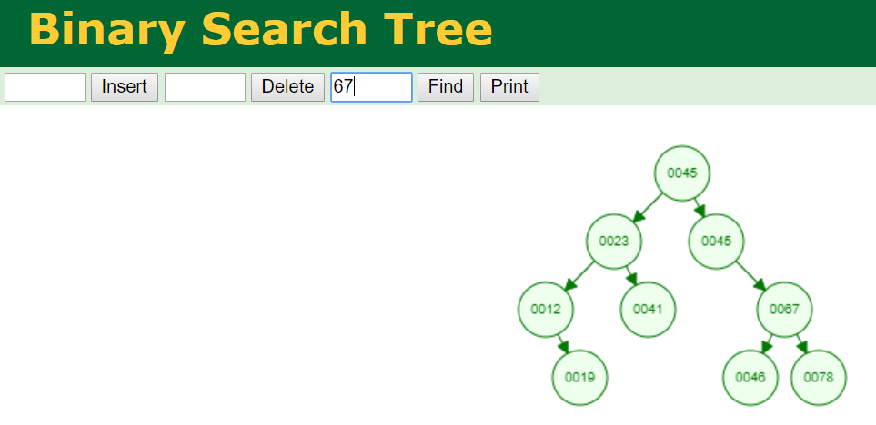

RUNNING CODE

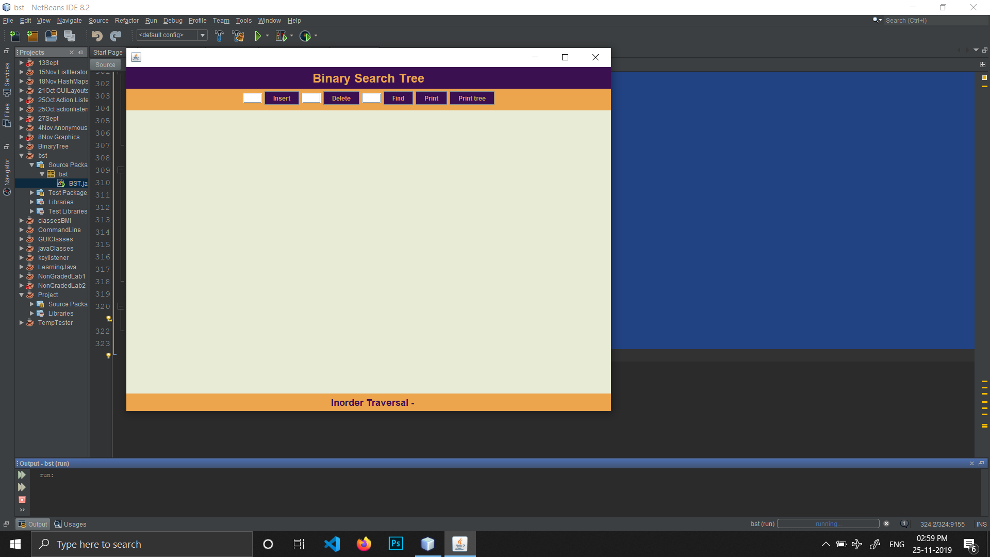

INSERTION IN BST

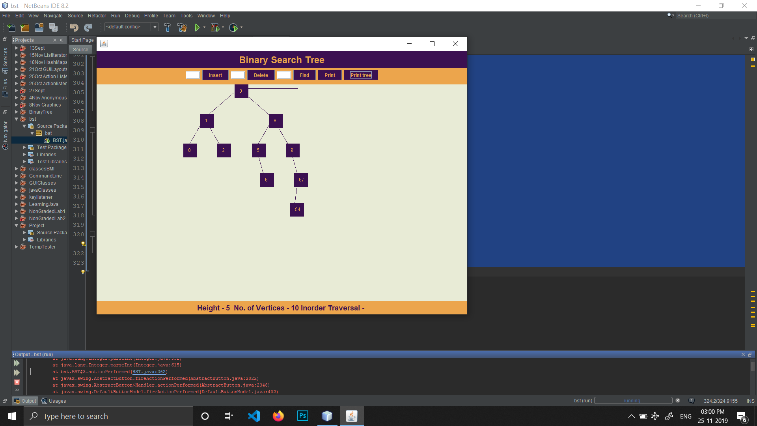

DELETION IN BST

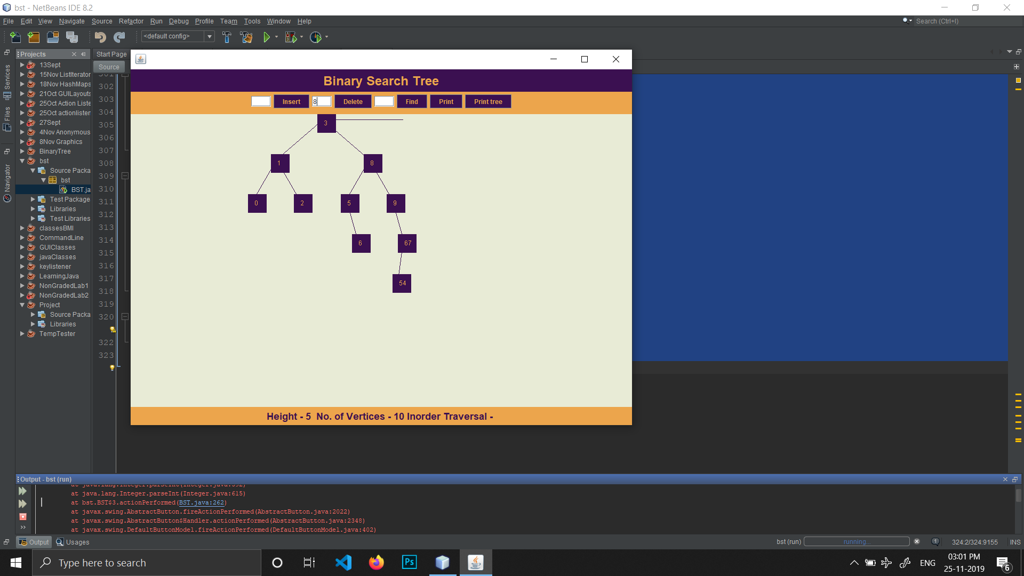

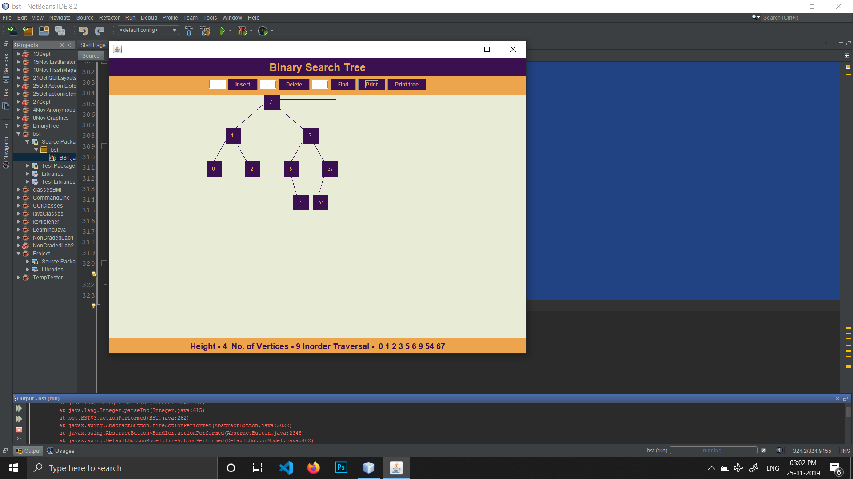

SEARCH IN BST