Progress Seminar Report

(Jan-Jul 2026 session)

Submitted by
Kirti Swagat Mohanty
Registration no. 21-3-04-068

Under the guidance of
Dr. Prabina Pattanayak (Supervisor)
Assistant Professor, ECE Dept, NIT Silchar
Dr. Chandrajit Choudhury (Co-supervisor)
Assistant Professor, ECE Dept, NIT Silchar



Department of Electronics & Communication Engineering
National Institute of Technology Silchar

I. Introduction
Medical image analysis using deep learning has significantly advanced automated diagnosis of thoracic diseases. Convolutional Neural Networks (CNNs) have achieved expert-level performance in detecting abnormalities from chest X-ray images and lung cancer from CT scans [1], [2]. However, most existing approaches rely on single-modality learning, which limits diagnostic reliability due to incomplete representation of anatomical and pathological information.
Chest X-ray imaging is widely used for screening due to its low cost and accessibility, but it suffers from projection overlap and limited sensitivity for early-stage diseases. In contrast, CT imaging provides high-resolution volumetric details suitable for accurate lung cancer characterization, albeit at higher cost and radiation exposure [3]. Recent studies highlight that multi-modal deep learning, which jointly learns from complementary imaging modalities, improves robustness and clinical reliability [4].
Motivated by these findings, this work implements a dual-modal deep learning architecture that simultaneously processes chest X-ray and CT images using pretrained CNN backbones. The system performs multi-label thoracic disease classification from X-ray images and multi-class lung cancer classification from CT scans within a unified multi-task learning framework.
II. Problem Statement and Objectives
Problem Statement
Most deep learning models for thoracic diagnosis operate independently on either chest X-ray or CT data, ignoring the complementary diagnostic cues across modalities. Additionally, handling heterogeneous prediction tasks—multi-label disease detection and multi-class cancer classification—within a single unified architecture remains challenging.

Objectives
The objectives of this work are:
- To design a dual-modal CNN-based encoder for joint learning from chest X-ray and CT images.
- To perform multi-label classification of thoracic diseases from chest X-ray images.
- To perform multi-class classification of lung cancer types from CT scans.
- To implement feature-level fusion for learning complementary representations.
- To evaluate the model using Accuracy, Precision, Recall, F1-score, and ROC-AUC metrics.
III. Methodology & System Architecture
A. Dual-Modal Encoder Design
The implemented architecture consists of two independent CNN encoders based on EfficientNet-B0, a state-of-the-art scalable convolutional architecture known for superior accuracy-to-parameter efficiency [5].
- X-ray Encoder:
Processes chest X-ray images resized to 224×224×3. Global average pooling is applied, followed by dense layers with batch normalization and dropout for regularization.
- CT Encoder:
Processes CT scan images using an identical EfficientNet-B0 backbone and feature refinement layers.
- Refinement: Each modality features a sequential refinement block consisting of Dense layers (1024 units), ReLU activation, Batch Normalization, and Dropout (0.3) to enhance discriminative capacity.
Both encoders are trainable, enabling fine-tuning on medical imaging data.

B. Feature Fusion Strategy
The extracted 512-dimensional feature vectors from X-ray and CT encoders are concatenated and passed through fully connected layers to form a shared fused representation. This combined vector is processed through a fusion network consisting of:
- Concatenation Layer: Merges X-ray and CT feature maps.
- Fusion Dense Block: A 1024-uit later followed by a 512-unit bottleneck layer to produce a shared latent embedding.
Feature-level fusion has been shown to outperform decision-level fusion in multi-modal medical image analysis [4].
C. Multi-Task Learning Framework
The fused representation is used for two parallel prediction tasks:
- Disease Prediction Head:
Employs Sigmoid activation for multi-label classification of multilabel diseases (e.g., Atelectasis, Cardiomegaly) [6].
- Cancer Classification Head:
Employs Softmax activation for multi-class classification of CT categories.
This joint learning approach improves generalization by sharing representations across related tasks [7].
D. Dataset Preparation and Training
- Chest X-ray images are loaded from a folder-structured dataset with multi-label annotations.
- CT images are loaded using class-wise directory organization.
- Random pairing of X-ray and CT samples is used during training.
- The model is trained using Adam optimizer with binary cross-entropy and sparse categorical cross-entropy losses.
- Early stopping, learning-rate scheduling, and model checkpointing are employed to prevent overfitting.
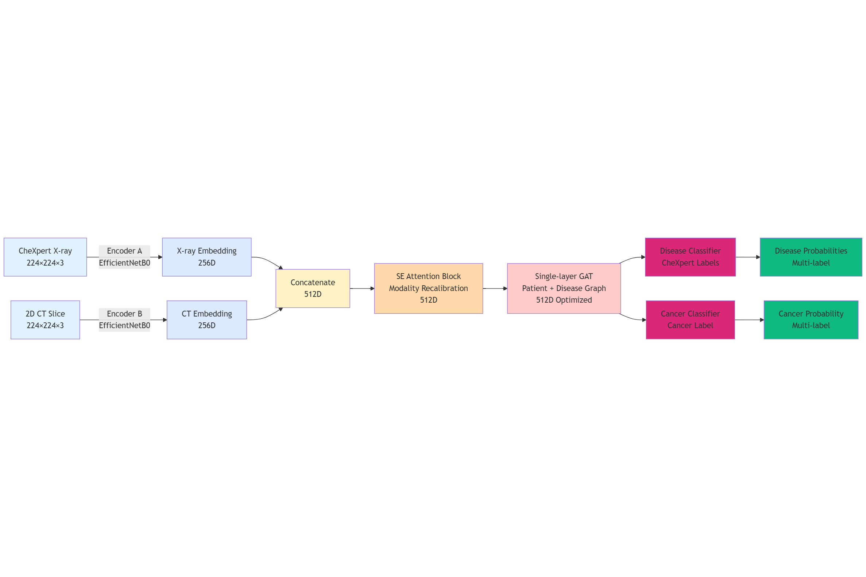

IV. Key Accomplishments (July–Dec 2025)
- Implemented a dual-modal EfficientNet-based encoder architecture.
- Developed a multi-task learning pipeline supporting heterogeneous prediction objectives.
- Designed custom data loaders for multi-label and multi-class datasets.
- Integrated ROC-AUC, F1-score, and confusion matrix evaluation for robust performance analysis.
- Successfully trained and validated the system using TensorFlow and Keras.
V. Preliminary Results
Initial experimental evaluation demonstrates:
- Stable convergence of training and validation loss curves.
- Effective learning of multi-label disease patterns from chest X-ray images.
- High class separability in CT-based cancer classification, as observed from ROC-AUC analysis.
- Improved representational robustness due to feature-level fusion and multi-task learning.

References
[1] J. Irvin, P. Rajpurkar, et. al, "CheXpert: A large chest radiograph dataset with uncertainty labels and expert comparison," in Proc. AAAI Conf. Artif. Intell., 2019, pp. 590–597.image.jpg​
[2] S. G. Armato III, G. McLennan, et. al, "The lung image database consortium (LIDC) and image database resource initiative (IDRI): A completed reference database of chest CT images and lesion annotations," Medical Physics, vol. 38, no. 2, pp. 915–931, 2011
[3] J. Hu, L. Shen, and G. Sun, "Squeeze-and-excitation networks," in Proc. IEEE/CVF Conf. Comput. Vis. Pattern Recognit. (CVPR), 2018, pp. 7132–7141.
[4] A. Vaswani, N. Shazeer, P. N. Parmar, J. Uszkoreit, L. Jones, A. N. Gomez, Ł. Kaiser, and I. Polosukhin, "Attention is all you need," in Advances in Neural Information Processing Systems (NeurIPS), 2017, pp. 5998–6008.
[5] T. Baltrušaitis, C. Ahuja, and L. P. Morency, "Multimodal machine learning: A survey and taxonomy," IEEE Trans. Pattern Anal. Mach. Intell., vol. 41, no. 2, pp. 423–443, 2018
[6] P. Veličković, G. Cucurull, A. Casanova, A. Romero, P. Liò, and Y. Bengio, "Graph attention networks," in Proc. Int. Conf. Learn. Representations (ICLR), 2018.
[7] T. N. Kipf and M. Welling, "Semi-supervised classification with graph convolutional networks," in Proc. Int. Conf. Learn. Representations (ICLR), 2017.
[8] X. Wang, Y. Peng, L. Lu, Z. Lu, M. Bagheri, R. Summers, and R. M. Summers, "Chexpert: A large chest radiograph dataset with uncertainty labels and expert comparison," in Proc. IEEE/CVF Conf. Comput. Vis. Pattern Recognit. (CVPR), 2018, pp. 7098–7107
[9] T. Y. Lin, P. Goyal, R. Girshick, K. He, and P. Dollár, "Focal loss for dense object detection," in Proc. IEEE/CVF Int. Conf. Comput. Vis. (ICCV), 2017, pp. 2980–2988.
[10] M. Yeung, E. Sala, C. B. Schönlieb, and A. Ruyeto, "Unified focal loss: Generalising Dice and cross entropy losses to handle class imbalance," in Proc. Med. Image Comput. Comput.-Assist. Interv. (MICCAI), 2021, pp. 479–488.
[11] G. King and L. Zeng, "Logistic regression in rare events data," Political Analysis, vol. 9, no. 2, pp. 137–163, 2001.

