Progress Seminar Report

(July-Dec 2025 session)

Submitted by
Kirti Swagat Mohanty
Registration no. 21-3-04-068

Under the guidance of
Dr. Prabina Pattanayak (Supervisor)
Assistant Professor, ECE Dept, NIT Silchar
Dr. Chandrajit Choudhury (Co-supervisor)
Assistant Professor, ECE Dept, NIT Silchar



Department of Electronics & Communication Engineering
National Institute of Technology Silchar

I. Introduction
Deep‐learning models, notably convolutional neural networks (CNNs), have demonstrated performance on par with radiologists in detecting lung diseases from chest X-rays and CT scans. Yet, data-sharing barriers, model-provenance uncertainty, and stringent privacy regulations impede collaborative AI development. Federated learning (FL) allows multi-site training without raw data exchange but lacks immutable provenance and tamper-resistance.
Blockchain technology has emerged as a transformative force in healthcare, offering immutable, decentralized record‐keeping and robust security mechanisms to address critical challenges in data integrity, privacy, and interoperability. In Internet of Medical Things (IoMT) applications, blockchain integration enables secure medical image storage and remote patient monitoring, outperforming traditional PACS by leveraging decentralized file systems such as IPFS and off‐chain storage with hash referencing to ensure data availability and cost‐effectiveness [1]. Beyond storage, blockchain-enabled frameworks have been applied to federated learning (FL) to mitigate single-point-of-failure risks and adversarial threats. A hierarchical blockchain-empowered reputation management scheme for FL in vehicular networks (IoV) demonstrates enhanced robustness and security via smart contracts and lightweight consensus protocols for trustworthy aggregation [2]. Foundational work on joint encryption and watermarking systems combines quantization index modulation with stream and block ciphers to verify integrity and origin of encrypted medical images in compliance with DICOM standards [3]. Lightweight authentication and privacy-preserving aggregation protocols in blockchain-FL architectures address dynamic network topologies in vehicular ad hoc networks through three-party key agreement based on chaotic maps and continuous model verification [4]. Hybrid consensus mechanisms combining proof-of-work and proof-of-stake on blockchain, coupled with IPFS off‐chain storage, facilitate multi-institution federated learning with improved accuracy and reduced transmission latency, as evidenced on the MNIST dataset [5]. Comprehensive IoMT architectures integrating blockchain and cloud computing ensure uninterrupted, ubiquitous, and secure patient-centric healthcare services, supporting real-time monitoring, data integrity, and privacy preservation [6]. Inter-organizational secure file sharing systems employ smart contracts and cryptographic schemes to protect privacy and maintain data integrity across collaborative networks [7]. Surveys of blockchain-FL systems in healthcare highlight design considerations—consensus protocols, cryptographic primitives, storage topologies, and integration workflows—and identify research directions in medical diagnostics, precision medicine, and epidemic prediction [8]. Finally, blockchain-FL frameworks applied to COVID-19 detection leverage Capsule Network-based segmentation and classification on heterogeneously sourced CT imaging datasets, enabling collaborative model training without compromising institutional data privacy [9]. Together, these studies underscore blockchain’s potential to revolutionize healthcare data management, collaborative learning, and secure, scalable medical applications.
II. Problem Statement and Objectives
Hospitals remain reluctant to share sensitive imaging data due to privacy and regulatory constraints. FL mitigates raw data exposure but cannot guarantee authenticity or auditability of model contributions. On-chain storage of complete model artefacts is cost-prohibitive.
This project aims to:
- Enable cross-hospital FL for lung-disease classification without raw data sharing.
- Provide verifiable, immutable provenance of model versions and performance via blockchain and smart contracts.
- Store large model binaries off-chain in IPFS, anchoring only content identifiers (CIDs) on-chain.
- Automate access control and contributor whitelisting through smart contracts.

III. System Architecture
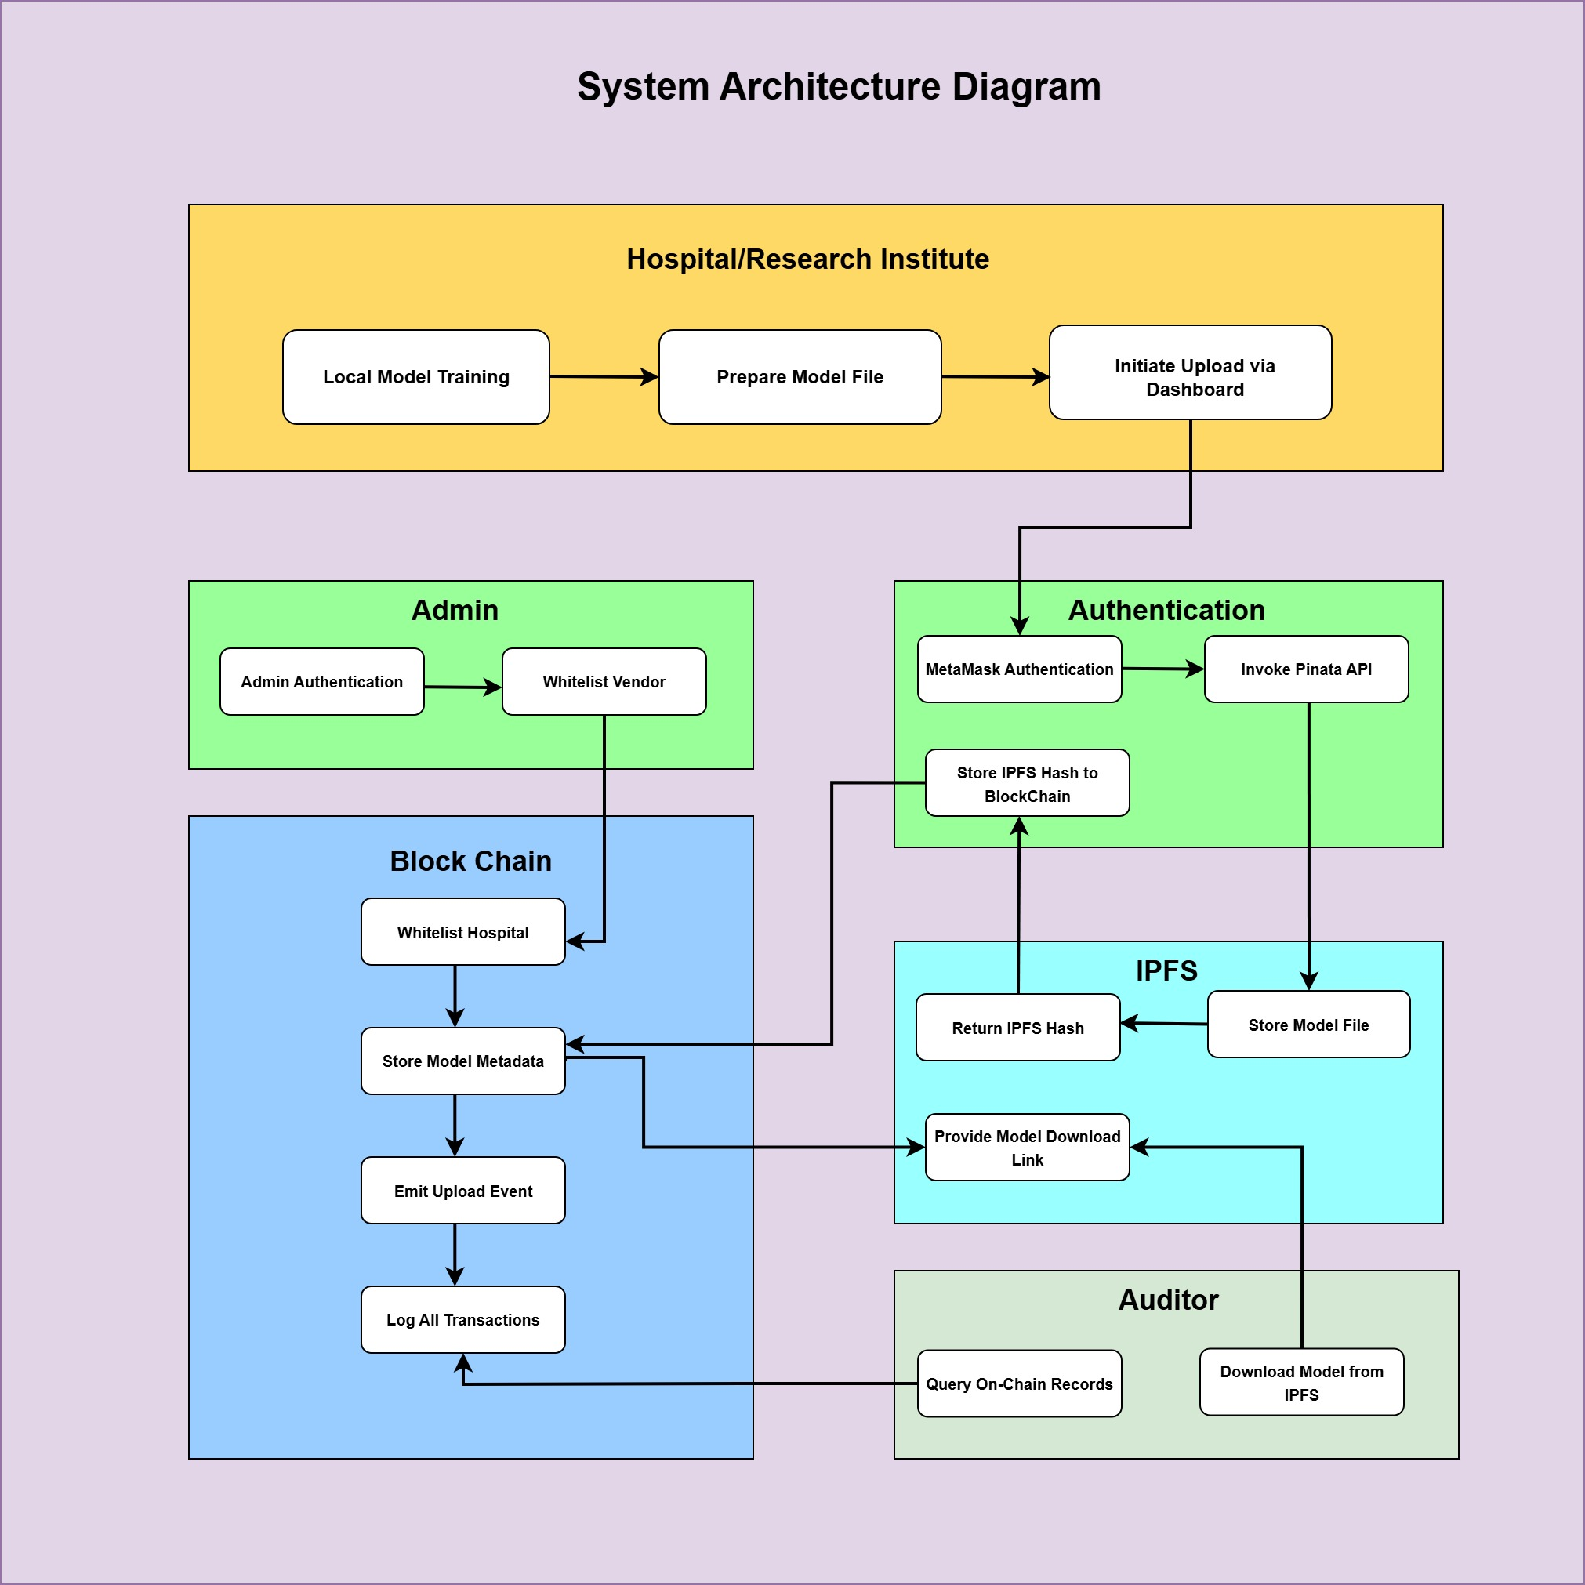
- Local Training: Hospitals train CNNs on private data and compute weight hashes (SHA-256).
- Off-Chain Storage: Model binaries are pinned to IPFS via Pinata, yielding CIDs.
- On-Chain Registration: A smart contract (Model Registry Contract) records model metadata, CID, contributor address, and performance metrics.
- Aggregation: A permissioned aggregator node retrieves models via CIDs, verifies integrity, and computes federated averages.
- Validation: A Validation-Trigger Contract invokes on-chain oracles to test aggregated models against sealed test sets, promoting only those meeting performance thresholds.
- Access Control: A Smart-Contract-Driven Risk-Based Access Control (SCR-BAC) model quantifies contributor risk using historical and current behavior, automatically enforcing policies on-chain.
IV. Key Accomplishments (July–Dec 2025)
- Smart Contract Development: Deployed Model Registry, Management, Access-History, and Policy Contracts in Solidity on Polygon PoS, supporting vendor whitelisting, model registration, and event logging ^{[5]}.
- IPFS Integration: Implemented Pinata-backed IPFS storage with automated pinning and retrieval workflows, ensuring content integrity and availability.
- Wallet-Based Authentication: Integrated MetaMask and Ethers.js for secure contributor identity, transaction signing, and network management.
- Federated Learning Workflow: Demonstrated end-to-end FL pipeline: local training → IPFS upload → on-chain hash anchoring → off-chain CID retrieval → aggregation → smart-contract validation.
- Cryptographic Safeguards: Incorporated Arnold’s Cat Map encryption for pre-storage image confidentiality, storing SHA-256 signatures on-chain for post-retrieval integrity checks.
- Audit and Monitoring: Built dashboards to track transaction throughput, model upload/download success rates, and contributor risk scores in real time.
V. Preliminary Results
- Performance: IPFS uploads averaged 12 ± 3 s per model; Polygon confirmations averaged 25 ± 5 s.
- Model Integrity: 100% of retrieved models matched on-chain CIDs over 1,00 trials.

References
[1] A. Sharma, R. K. Kaushal, and N. Kumar, “A comprehensive assessment of blockchain technology in the healthcare industry and techniques to store medical image,” in 2024 Third International Conference on Electrical, Electronics, Information and Communication Technologies (ICEEICT), 2024, pp. 1–6, doi: 10.1109/ICEEICT61591.2024.10718467.
[2] Y. Fu, X. Niu, L. Zhou, X. Cai, F. R. Yu, N. Cheng, and C. Li, “A hierarchical blockchain-enabled secure aggregation algorithm for federated learning in IoV,” IEEE Internet of Things Journal, vol. 12, no. 5, pp. 5876–5889, Mar. 2025, doi: 10.1109/JIOT.2024.3489032.
[3] D. Bouslimi, G. Coatrieux, M. Cozic, and C. Roux, “A joint encryption/watermarking system for verifying the reliability of medical images,” IEEE Transactions on Information Technology in Biomedicine, vol. 16, no. 5, pp. 891–899, Sep. 2012, doi: 10.1109/TITB.2012.2207730.
[4] P. Liu, Q. He, Y. Chen, S. Jiang, B. Zhao, and X. Wang, “A lightweight authentication and privacy-preserving aggregation for blockchain-enabled federated learning in VANETs,” IEEE Transactions on Consumer Electronics, vol. 71, no. 1, pp. 1274–1287, Feb. 2025,
[5] J. Li, J. Sun, F. Li, X. Yang, and Y. Wang, “BIFLC: A blockchain and IPFS-based multi-consensus federated learning framework,” in 2023 26th International Conference on Computer Supported Cooperative Work in Design (CSCWD), 2023, pp. 1–6,
[6] J. Indumathi, A. Shankar, M. R. Ghalib, J. Gitanjali, Q. Hua, Z. Wen, and X. Qi, “Block chain-based Internet of Medical Things for uninterrupted, ubiquitous, user-friendly, unflappable, unblemished, unlimited health care services (BC IoMT U6 HCS),” IEEE Access, vol. 8, pp. 216856–216871, 2020, doi: 10.1109/ACCESS.2020.3040240.
[7] B. C. Priya, M. Dhanalakshmi, B. T. Kumar Reddy, A. Rohith and B. R. Reddy, "Block chain Based Inter-Organizational Secure File Sharing System," 2024 International Conference on Computational Intelligence for Security, Communication and Sustainable Development (CISCSD), Port Blair, India, 2024, pp. 230-235, doi: 10.1109/CISCSD63381.2024.00059.
[8] N. Nezhadsistani, N. S. Moayedian, and B. Stiller, “Blockchain-enabled federated learning in healthcare: Survey and state-of-the-art,” IEEE Access, vol. 13, pp. 119922–119941, 2025
[9] R. Kumar, A. A. Khan, J. Kumar, Zakria, N. A. Golilarz, S. Zhang, Y. Ting, C. Zheng, and W. Wang, “Blockchain-federated-learning and deep learning models for COVID-19 detection using CT imaging,” IEEE Sensors Journal, vol. 21, no. 14, pp. 16301–16314, Jul. 2021, doi: 10.1109/JSEN.2021.3076767.

