Assignments:-

Q1:- What is SDLC?
Ans:- Software Development Life Cycle (SDLC) is a process used by the software industry to design, develop and test high quality software. It is also called as Software Development Process. SDLC is a framework defining tasks performed at each step in the software development process.
Q2:- How many phases/stages do we have in a SDLC? And what are they?
Ans:- There are 6 phases/stages of SDLC
- Planning
- Analysis
- Design
- Implementation
- Testing
- Maintenance
Q3:- What is V-Model?
Ans:- The V-model is an SDLC model where execution of processes happens in a sequential manner in a V-shape. It is also known as Verification and Validation model. For every single phase in the development cycle, there is a directly associated testing phase. This is a highly-disciplined model and the next phase starts only after completion of the previous phase.
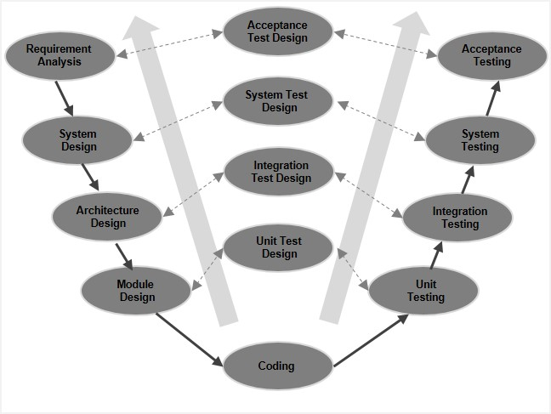

Q4:- What is Incremental SDLC?
Ans:- Incremental Model is a process of software development where requirements are broken down into multiple standalone modules of software development cycle. Incremental development is done in steps from analysis design, implementation, testing/verification, maintenance. Each iteration passes through the requirements, design, coding and testing phases. And each subsequent release of the system adds function to the previous release until all designed functionality has been implemented.

Q5:- What is Build?
Ans:- In software development, a build is the process of converting source code files into standalone software that can be run on a computer. It is generally pre-release version of any Product.

Q6:- What are difference between Freeware and OpenSource?
Ans:- FreeWare:- Freeware are software that is available at no cost.
OpenSource:- Its is software with source code that is publicly available under a license that gives user the right to study, change and distribute the software as they wish.

Q7:- What are command line arguments in java?
Ans:- The java command-line argument is an argument i.e. passed at the time of running the java program. The arguments passed from the console can be received in the java program and it can be used as an input. So, it provides a convenient way to check the behavior of the program for the different values. You can pass N (1,2,3 and so on) numbers of arguments from the command prompt.
Q8:- How to use command line argument on eclipse IDE?
Ans:-
- Click on Run -> Run (not Run Last Launched).
In the large sub window of the Run window, there is a set of tabs,
labelled Main, Arguments, JRE, etc.
- Click on the Arguments tab
This action brings up a window with a few places to enter values You want to type in all your input values into the Program arguments window, with spaces (blank characters) between each value.
- Then just click Apply, followed by Run.

