**Summer Internship Project Report on**

**Data Analytics in Governance**

**Submitted by:**

**Kirty Gupta**

**03317711922**

**Under the Guidance of:**

**Mr. Sandeep Jain**

**Senior Technical Director, NIC Delhi**



**School of Engineering & Technology**

**Vivekananda Institute of Professional Studies – Technical Campus**

**JULY 2024**

**DECLARATION**

I, Kirty Gupta, hereby declare that the Summer Internship Project Report entitled “Data Analytics in Decision Making” submitted to VIPS-TC, GGSIP University is a record of my original work done under the guidance of Mr. Sandeep Jain, Senior Technical Director, NIC, Delhi. This project report is submitted in partial fulfilment of the requirements for the award of the degree of Bachelor of Technology in Artificial Intelligence & Data Science.

I also declare that this project report has not been submitted to any other university or institute for the award of any degree or diploma.

Kirty Gupta

03317711922

Date: 31st July 2024

**CERTIFICATE BY SUPERVISOR**

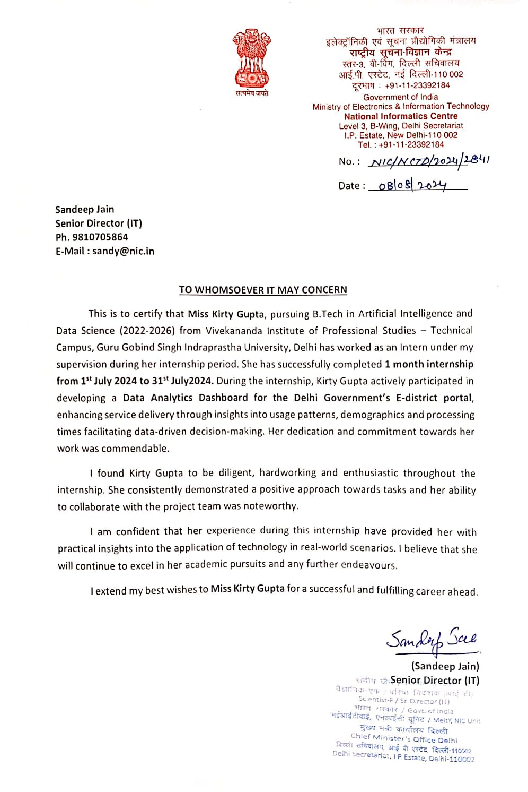

**ACKNOWLEDGEMENT**

I would like to express my deepest gratitude to Mr. Sandeep Jain, Senior Technical Director, National Informatics Centre (NIC), Delhi, for granting me the opportunity to undertake my Summer Internship at NIC. His invaluable guidance, support, and encouragement were instrumental to the success of my internship.

I extend my sincere thanks to the members of the Software Division and Network Division teams at NIC for their assistance and cooperation throughout my time there. Their expertise and willingness to help greatly contributed to my learning experience.

I am also profoundly grateful to my family and friends for their unwavering support and encouragement during this period.

Lastly, I wish to acknowledge all those who provided assistance in any form during my internship. Your contributions, no matter how small, were greatly appreciated.

Kirty Gupta

03317711922

Date: 31st July 2024

**EXECUTIVE SUMMARY**

The internship project focused on developing a data analytics dashboard for the Delhi Government's E-district portal, aimed at enhancing the delivery of government services. The dashboard was designed to provide insights into service usage patterns, demographics, and application processing times, enabling data-driven decision-making and improved public service delivery. The project followed an Agile methodology, emphasizing flexibility, continuous improvement, and stakeholder collaboration.

**PROJECT PHASES**

The project was executed in several key phases:

1. **Requirement Gathering and Analysis:** Initial meetings with NIC officials and stakeholders helped define project goals, key metrics, and data points such as gender distribution, approval duration, age distribution, and application status.
2. **Data Extraction and Cleaning:** Relevant data was extracted from a PostgreSQL database, cleaned for inconsistencies, and prepared for analysis. This included standardizing formats and handling missing values.
3. **Design and Development:** The dashboard was developed using ASP.NET Web Forms and Chart.js, with a focus on creating an intuitive user interface. The backend logic was implemented using C#, and interactive charts were integrated for data visualization.
4. **Testing and Validation:** The dashboard underwent rigorous testing, including unit testing, integration testing, and user acceptance testing (UAT). Performance testing ensured the dashboard's stability under varying data loads.
5. **Deployment and Launch:** The final deployment was carried out on NIC's internal server, followed by a demonstration to stakeholders.
6. **Documentation and Training:** Comprehensive user manuals and technical documentation were created, along with training sessions for end-users to effectively use the dashboard.
7. **Feedback and Continuous Improvement:** Channels for user feedback were established, and iterative improvements were made based on this feedback.

**KEY INSIGHTS OF THE PROJECT**

The analysis provided several key insights:

1. **Gender Distribution:** Females constituted only 35% of the total applicants, indicating a gender disparity. District-level analysis showed significant variations, with New Delhi having the highest gender diversity and Yamuna Vihar the lowest.
   * **Recommendations:** Implement targeted initiatives to encourage female participation, such as awareness campaigns and community-based programs. Focus on addressing cultural barriers and logistical challenges that may deter women from accessing services.
2. **Service Usage Patterns:** The issuance of caste certificates (SC and OBC) and domicile certificates were among the most availed services, highlighting their importance in accessing government benefits.
   * **Recommendations:** Streamline the processes for obtaining these certificates and improve information dissemination about their benefits. Consider creating specialized service counters or online facilitation for high-demand services.
3. **District-Specific Service Usage:** Variations in service demand across districts indicated diverse needs. For example, Central District showed high demand for caste certificates, while East District had unique needs like delayed birth orders.
   * **Recommendations:** Develop targeted outreach programs and tailor service delivery models to address the specific needs of each district. This could involve deploying additional resources or specialized staff in areas with unique service demands.
4. **Application Processing Times:** The mean processing time was approximately six months, with Central Delhi showing the shortest times due to efficient administrative procedures.
   * **Recommendations:** Implement standardized procedures and workflows across districts, adopt digital tools for process automation, and allocate resources to districts with longer processing times to balance workloads and improve efficiency.
5. **Age Distribution of Applicants:** The most engaged age group was 23 to 28 years, indicating a strong demand for services among young adults.
   * **Recommendations:** Tailor communication strategies and service offerings to this demographic, including digital outreach and services focused on career and educational development.

**CONCLUSION OF THE INSIGHTS**

The dashboard provides valuable insights that can help the Delhi Government improve the efficiency, accessibility, and equity of its services. The recommendations focus on addressing gender disparities, streamlining high-demand services, and optimizing administrative processes. Continuous monitoring and feedback are crucial for refining these services and adapting to the evolving needs of the population.

**TABLE OF CONTENTS**

|  |  |  |
| --- | --- | --- |
| **S.No.** | **Content** | **Page No.** |
| 1. | Introduction | 6-9 |
| 2. | Objectives of the project undertaken | 10-11 |
| 3. | Problem Statement | 12-13 |
| 4. | Literature Review | 14 |
| 5. | Methodology & Steps Taken | 15-18 |
| 6. | Result, Findings & Recommendations | 19-24 |
| 7. | References | 25 |
| 8. | Annexure | 26-30 |

**CHAPTER 1**

**INTRODUCTION**

The rapid advancements in information technology and the increasing availability of digital data have transformed various sectors worldwide, including governance. The National Informatics Centre (NIC) plays a pivotal role in this digital transformation in India, providing essential technology solutions to the government. This internship report focuses on the development of a data analytics dashboard designed to enhance the governance capabilities of the Delhi Government by analyzing citizen data from the E-district portal. The dashboard's objective is to provide insightful visualizations, aiding in decision-making processes and improving service delivery.

**1.1) Industry Profile**

The information technology (IT) industry has seen exponential growth globally, revolutionizing how businesses operate and how governments interact with citizens. The industry is divided into various sectors, including software development, hardware, telecommunications, and IT services. The digital transformation brought about by IT has enabled the automation of processes, enhanced communication, and improved data management across industries.

In the context of government, IT solutions are integral to the functioning of E-Governance, which refers to the use of electronic means to deliver government services to citizens. This shift towards digital governance has been driven by the need for more efficient, transparent, and accessible public services. The adoption of E-Governance allows for the streamlining of administrative processes, reduction of paperwork, and increased engagement with the public.

India's IT industry is among the largest in the world, contributing significantly to the country's GDP. The industry is supported by a robust infrastructure, a large pool of skilled professionals, and a growing demand for digital services. In recent years, the focus has expanded to include emerging technologies such as artificial intelligence (AI), machine learning (ML), big data analytics, and cloud computing. These technologies are being leveraged to create more efficient and responsive government services, a trend that has been particularly evident in the implementation of E-Governance initiatives across the country.

**1.2) Organization Profile**

The National Informatics Centre (NIC) is a premier science and technology organization under the Ministry of Electronics and Information Technology (MeitY) in India. Established in 1976, NIC has been instrumental in steering E-Governance initiatives and providing IT services to the Government of India, state governments, and UT administrations. NIC's mission is to promote digital opportunities and drive the digital transformation agenda of the government.

NIC's services encompass a wide range of areas, including:

* **E-Governance Solutions:** Development and implementation of digital platforms and applications for various government departments, enabling online service delivery and efficient administration.
* **Data Centers and Cloud Services:** Management of secure data centers and cloud infrastructure to support government applications and data storage.
* **Cyber Security:** Ensuring the security of government systems and data through robust cybersecurity measures.
* **Capacity Building:** Providing training and support to government officials and staff on the use of ICT tools and solutions.
* **Research and Development:** Innovating new technologies and solutions to address emerging challenges in governance and public administration.

NIC's work is characterized by its focus on creating scalable, secure, and sustainable digital solutions that can be deployed across different levels of government. The organization's contributions have been crucial in enhancing the efficiency, transparency, and accountability of public services in India.

**1.3) Domain of Internship**

The internship was undertaken in the Data Analytics domain, a rapidly evolving field that focuses on extracting meaningful insights from vast amounts of data. Data analytics involves the use of statistical techniques, machine learning algorithms, and data visualization tools to analyze and interpret data. In the context of governance, data analytics can play a transformative role in improving decision-making processes, optimizing resource allocation, and enhancing service delivery.

The primary focus of this internship was to develop a data analytics dashboard for the Delhi Government's E-district portal. The E-district portal is an online platform that provides citizens of Delhi with access to a wide range of government services, such as issuance of certificates, licenses, and permits. The portal serves as a one-stop solution for citizens to avail of government services online, reducing the need for physical visits to government offices and streamlining the application process.

The Data Analytics domain is crucial in this context as it allows for the analysis of user data from the E-district portal. This analysis can reveal patterns and trends in service usage, user demographics, and application processing times. Such insights are valuable for the government to improve the efficiency of service delivery, identify areas that need attention, and make data-driven policy decisions.

**1.4) List of Activities During Internship**

The internship involved a series of activities aimed at designing, developing, and deploying a data analytics dashboard. The key activities undertaken during the internship include:

1. **Requirement Gathering and Analysis:**
   * Engaged with NIC officials and stakeholders to understand the requirements for the data analytics dashboard.
   * Identified the key metrics and data points to be visualized, such as gender distribution, approval duration, age distribution, and application status.
   * Defined user personas and their specific needs to tailor the dashboard's features accordingly.
2. **Data Extraction and Cleaning:**
   * Extracted relevant data from the PostgreSQL database used by the E-district portal.
   * Cleaned and preprocessed the data to ensure its accuracy and consistency, including handling missing values, duplicates, and formatting inconsistencies.
3. **Design and Development:**
   * Designed the user interface and layout of the dashboard using wireframes and mockups.
   * Developed the backend logic using ASP.NET Web Forms and C# to retrieve and process data.
   * Implemented the frontend using HTML, CSS, and JavaScript, and integrated the Chart.js library for chart rendering.
4. **Chart Rendering and Data Visualization:**
   * Created various charts to visualize the data, including a pie chart for gender distribution, line charts for approval duration and age distribution, and a clustered bar graph for pending and approved applications.
   * Configured chart options, such as labels, legends, and tooltips, to enhance the readability and usability of the dashboard.
5. **Dropdown Filters Implementation:**
   * Added dropdown filters for services, districts, and subdivisions to allow users to filter the data displayed on the dashboard.
   * Implemented event handlers to dynamically update the charts based on user selections.
6. **Testing and Validation:**
   * Conducted unit testing and integration testing to ensure the accuracy and functionality of the dashboard.
   * Performed user acceptance testing (UAT) with NIC officials to gather feedback and refine the dashboard.
7. **Deployment and Launch:**
   * Deployed the dashboard on NIC's internal server, ensuring it was accessible to authorized users.
   * Conducted training sessions for end-users on how to navigate and utilize the dashboard effectively.
8. **Documentation and Training:**
   * Prepared comprehensive user manuals and technical documentation detailing the features, functionalities, and technical aspects of the dashboard.
   * Provided training and support to NIC officials and other stakeholders on the use of the dashboard and data analytics principles.
9. **Feedback and Continuous Improvement:**
   * Established channels for ongoing feedback from users to identify areas for improvement.
   * Implemented updates and enhancements based on user feedback and changing requirements.

**CHAPTER 2**

**OBJECTIVES OF THE PROJECT UNDERTAKEN**

* **Develop a Comprehensive Dashboard for Enhanced Data Visualization**

**Objective**: Create a user-friendly dashboard that consolidates key metrics and data points related to the E-district portal.

**Elaboration**: The primary goal was to design a dashboard that presents complex data in an easily understandable format. The dashboard was developed using ASP.NET Web Forms, integrating various charts and graphs. The aim was to enable stakeholders to gain quick insights into the portal's performance, such as gender distribution, age demographics, and application status. By providing a centralized platform for data visualization, the dashboard helps in monitoring the usage patterns and identifying potential areas for improvement.

* **Enable Interactive Filtering for Targeted Analysis**

**Objective**: Implement dropdown filters to allow users to refine data based on specific criteria, such as services, districts, and subdivisions.

**Elaboration**: The dashboard was equipped with three dropdown filters to enhance user interaction and data exploration. The first dropdown includes all the services offered on the E-district portal, the second lists the districts of Delhi, and the third provides subdivisions within the selected district. These filters enable users to drill down into specific data sets, such as viewing the age distribution of applicants for a particular service or analyzing the approval duration trends in a specific district. This functionality aids in more targeted analysis and supports informed decision-making.

* **Improve Operational Efficiency Through Data Insights**

**Objective**: Use data analysis to identify bottlenecks and inefficiencies in the application approval process.

**Elaboration**: By analyzing the data related to approval duration, the project aimed to uncover patterns that could indicate inefficiencies in the application processing workflow. The line chart displaying average approval times year-wise provides insights into whether certain periods experienced delays or improvements. Understanding these trends can help the organization streamline processes, allocate resources more effectively, and ultimately reduce the time taken to approve applications, enhancing overall operational efficiency.

* **Provide Demographic Insights to Inform Policy Decisions**

**Objective**: Analyze and visualize demographic data, such as age and gender distribution, to support policy-making and resource allocation.

**Elaboration**: The dashboard includes a Gender Distribution Chart and an Age Distribution Chart, which provide valuable demographic insights. These charts help in understanding the composition of the applicant pool, revealing trends such as the predominance of a particular age group or gender. Such insights are crucial for policymakers to design targeted outreach programs, improve service accessibility, and ensure equitable service delivery across different demographic segments.

* **Monitor and Report on Application Status Trends**

**Objective**: Track the number of pending and approved applications over time to assess the portal's performance and user satisfaction.

**Elaboration**: The Pending Applications Chart displays the number of pending and approved applications on a year-wise basis, offering a clear view of the portal's operational status. This information is vital for assessing the efficiency of the portal in handling applications and the overall satisfaction of users. By monitoring these trends, the organization can identify periods of backlog, allocate additional resources when necessary, and implement measures to enhance the user experience.

* **Enhance Data Accessibility and Usability for Stakeholders**

**Objective**: Ensure that the dashboard is accessible and usable by various stakeholders, including government officials, policy makers, and public users.

**Elaboration**: A key objective was to make the data accessible and understandable to a wide range of users. The dashboard's design focuses on clarity, with intuitive navigation and visualizations that do not require specialized knowledge to interpret. The inclusion of filters and straightforward charts makes it easy for users to find the information they need. This accessibility is crucial for enabling informed decision-making at different levels of government and for enhancing public transparency.

* **Support Continuous Improvement through Feedback Mechanisms**

**Objective**: Implement mechanisms to gather feedback from users and stakeholders to continuously refine and enhance the dashboard.

**Elaboration**: The project included setting up feedback channels to gather input from the users of the dashboard. This feedback loop is essential for identifying any usability issues, additional features that users might require, or data points that need more clarification. By incorporating feedback into ongoing development, the dashboard can be continuously improved, ensuring it remains relevant and useful for its intended audience.

**CHAPTER 3**

**PROBLEM STATEMENT**

**Challenges in Indian Governance Without Data Analytics**

In the modern era, the effective governance of a nation as vast and diverse as India requires the ability to process and analyze large volumes of data to inform policy decisions and public service delivery. However, without the adoption of data analytics, several challenges arise that hinder the efficiency, transparency, and effectiveness of governance.

**3.1) Inefficient Resource Allocation**

**Problem:** Without data-driven insights, the allocation of resources such as funds, personnel, and infrastructure often rely on outdated or inaccurate information. This can lead to an imbalance where some areas receive more resources than needed while others are underserved.

**Impact:** This inefficiency results in wastage of public funds, inadequate service delivery in critical areas, and dissatisfaction among citizens. For example, without proper data, healthcare resources might be concentrated in urban areas, leaving rural regions underserved.

**Addressing the Issue with Data Analytics:** Data analytics enables the collection and analysis of data from various sources, such as census reports, service usage statistics, and geographic information systems (GIS). By analyzing this data, governments can identify regions that require more resources and allocate them more effectively. For instance, data analytics can reveal trends in healthcare needs, helping to prioritize the distribution of medical supplies and personnel to areas with higher demand.

**3.2) Lack of Personalized Services**

**Problem:** Governance without data analytics tends to adopt a one-size-fits-all approach, failing to account for the diverse needs of different population segments. This results in generic policies that may not effectively address specific issues faced by particular groups, such as women, elderly, or economically disadvantaged individuals.

**Impact:** This lack of personalization can lead to policies that are less effective and do not fully address the needs of all citizens. For example, without data on the specific needs of senior citizens, government programs may fail to provide adequate support for this demographic.

**Addressing the Issue with Data Analytics:** Data analytics can segment the population into various groups based on demographics, economic status, health conditions, and other factors. This segmentation allows for the design of targeted policies and programs that address the unique needs of each group. For instance, analytics can identify areas with high numbers of elderly residents, prompting the implementation of specialized healthcare services and social support systems in those regions.

**3.3) Limited Transparency and Accountability**

**Problem:** In the absence of data analytics, there is limited transparency in government operations and decision-making processes. This lack of transparency can lead to corruption, inefficiencies, and a lack of accountability among public officials.

**Impact:** Citizens may lose trust in government institutions, and public resources may not be used effectively. For example, without transparent tracking of funds and projects, it becomes difficult to hold officials accountable for mismanagement or delays in public works.

**Addressing the Issue with Data Analytics:** Data analytics can provide real-time tracking and reporting of government projects and expenditures. By making this data publicly available, it enhances transparency and allows citizens to hold officials accountable. For instance, a dashboard displaying the progress and budget allocation of infrastructure projects can help the public and oversight bodies monitor and ensure that projects are completed on time and within budget.

**3.4) Inadequate Policy Evaluation and Adjustment**

**Problem:** Traditional governance approaches often lack mechanisms for evaluating the effectiveness of policies and programs. Without data analytics, it is challenging to assess whether a policy is meeting its objectives or if it requires adjustments.

**Impact:** Policies may continue to be implemented even if they are ineffective or outdated, leading to wasted resources and missed opportunities for improvement. For example, a job training program might not yield the expected employment outcomes, but without data analytics, this issue may go unnoticed.

**Addressing the Issue with Data Analytics:** Data analytics enables the continuous monitoring and evaluation of policies and programs by analyzing key performance indicators (KPIs) and outcomes. This data-driven approach allows for the timely adjustment of policies to improve their effectiveness. For instance, by analyzing employment data, governments can adjust job training programs to better align with current market demands and skills shortages.

**3.5) Challenges in Crisis Management and Response**

**Problem:** In times of crisis, such as natural disasters, pandemics, or economic downturns, governments without data analytics capabilities struggle to respond effectively. The lack of real-time data and predictive analytics can hinder decision-making and delay critical interventions.

**Impact:** This can result in slow response times, inadequate resource allocation, and increased harm to the affected populations. For example, during a pandemic, without data analytics, it is challenging to track the spread of the virus and allocate medical resources appropriately.

**Addressing the Issue with Data Analytics:** Data analytics provides tools for real-time monitoring and predictive modeling, enabling governments to anticipate and respond to crises more effectively. For example, during a pandemic, analytics can track infection rates, predict hotspots, and optimize the distribution of medical supplies and vaccines. This proactive approach can save lives and reduce the overall impact of the crisis.

**CHAPTER 4**

**LITERATURE REVIEW**

* **Bhardwaj, A., & Singh, W. (2017, December). Systematic review of big data analytics in governance. In *2017 International Conference on Intelligent Sustainable Systems (ICISS)* (pp. 501-506). IEEE.**

**Abstract:** With advent of technology, data is increasing abruptly day by day. Traditional database systems are not capable of processing and handling such a voluminous data. Big data analytics has the capability of processing, handling and analyzing the large datasets or stream of data. Big data analytics play important role in fields such as healthcare, agriculture, smart grid and policy making. Big data analytics with governance improves planning and decision-making phases for government projects. It helps to improve the quality of government services. This paper focuses on the different application areas of governance in which big data analytics play a role and tools used to handle big data management problem. The existing work is classified into different categories and is presented using visualizations. This paper also deals with challenges related to governance field.

**Keywords:** {Big Data; Tools; Databases; Java;Conferences; Government; Decision making; Big data analytics; Governance; Tools; Challenges; Big data framework}, URL: <https://ieeexplore.ieee.org/stamp/stamp.jsp?tp=&arnumber=8389462&isnumber=8389225>

* **Malhotra, C., Anand, R., & Singh, S. (2018). Applying big data analytics in governance to achieve sustainable development goals (SDGs) in India. *Data science landscape: Towards research standards and protocols*, 273-291.**

**Abstract:** One of the chief obligations of governance in democratic countries is creating and co-creating value in public service delivery, the process of which is undertaken in a participatory manner so as to ensure an accountable, responsive, and transparent ecosystem (Good Governance, The United Nations Economic and Social Commission for Asia and the Pacific- UNESCAP). To translate these Good Governance ideologies into practical implementation, it is necessary to ensure the achievement of development targets defined as Sustainable Development Goals such as no poverty, zero hunger, complete gender equality, and so on (SDGs, UNDP, 2015). Further, to achieve these development targets in a sustained manner, converged governance efforts are required at the grassroots, which in turn would inevitably result in the generation of continuous baseline data. This colossal amount of data thus generated at the grassroots when coupled with unstructured citizens’ data generated through other digital devices, holds immense potential to revolutionize governance processes by providing a foundation for data-backed decision-making. Hence, such structured baseline data and unstructured citizens’ data must be continuously combined and analyzed by application of Big Data Analytics and other emerging ICTs (information and communication technologies).

**Keywords:** Evidence-based decision making, Sustainable Development Goals (SDGs), Local Governance, Baseline data, Good Governance, Digital India, Mission Mode Projects (MMPs), e-Governance, Information and Communication Technologies (ICTs), Emerging technologies, Challenges of Big Data Analytics, India

**CHAPTER 5**

**METHODOLOGY AND STEPS TAKEN**

**5.1) Methodology**

The project employed an Agile methodology, which is an iterative and incremental approach to software development. This methodology emphasizes flexibility, continuous improvement, and collaboration between cross-functional teams. Agile is well-suited for projects where requirements may evolve over time, allowing for adaptive planning and early delivery of functional components. The use of Agile methodology facilitated a structured yet flexible development process, ensuring that the dashboard met the evolving needs of stakeholders.

**Key Phases of Agile Methodology:**

1. **Planning:** Initial planning to define project goals, scope, and timelines.
2. **Design:** Design of the system architecture, user interface, and data flow.
3. **Development:** Iterative development of the dashboard and its components.
4. **Testing:** Continuous testing to identify and fix issues.
5. **Review and Feedback:** Regular review meetings with stakeholders to gather feedback and make necessary adjustments.
6. **Deployment:** Final deployment of the dashboard on the internal server.
7. **Maintenance and Updates:** Ongoing maintenance and updates based on user feedback.

**5.2) Steps Taken**

**5.2.1)** **Requirement Gathering and Analysis**

**Objective**: Understand the needs and expectations of the stakeholders, including the types of data to be visualized, user roles, and technical constraints.

**Activities**:

* Conducted meetings with NIC officials and stakeholders to gather detailed requirements.
* Identified the key metrics and data points to be displayed on the dashboard, such as gender distribution, approval duration, age distribution, and application status.
* Defined user personas, including government officials, policy makers, and public users, to tailor the dashboard's features to their needs.
* Assessed technical constraints, such as server capacity, data availability, and security requirements.

**5.2.2)** **Data Extraction and Cleaning**

**Objective**: Extract and prepare the data from the PostgreSQL database for analysis and visualization.

**Activities**:

* Wrote SQL queries to extract relevant data from the PostgreSQL database.
* Performed data cleaning to remove inconsistencies, duplicates, and missing values. This involved standardizing formats, correcting errors, and handling null values.
* Preprocessed data to create derived metrics and aggregate values, such as average approval times and age group distributions.
* Stored the cleaned and processed data in a structured format, ready for use in the dashboard.

**5.2.3)** **Design and Development**

**Objective**: Design the user interface and develop the dashboard using ASP.NET Web Forms and Chart.js.

**Activities**:

* UI/UX Design: Created wireframes and mockups to visualize the layout and design of the dashboard. Focused on an intuitive design with clear navigation and easy-to-read charts.
* Backend Development: Developed the backend logic using C# in ASP.NET Web Forms, ensuring seamless data retrieval and processing.
* Frontend Development: Implemented the frontend using HTML, CSS, and JavaScript. Integrated the Chart.js library to render interactive charts and graphs. Chart.js was chosen for its versatility, ease of use, and wide range of customizable chart types.
* Dropdown Filters Implementation: Added three dropdown filters to the dashboard to allow users to filter data based on services, districts, and subdivisions. Implemented event handlers to update the charts dynamically based on user selections.

**5.2.4)** **Chart Rendering with Chart.js**

**Objective**: Visualize data using interactive charts and graphs.

**Activities**:

* Chart Selection: Chose appropriate chart types for each metric:
  + Pie Chart for Gender Distribution to represent the proportion of male and female applicants.
  + Line Chart for Approval Duration to show the trend of average approval times over the years.
  + Line Chart for Age Distribution to depict the number of applicants in different age groups.
  + Clustered Bar Graph for Pending Applications to compare the number of pending and approved applications year-wise.
* Chart.js Integration: Integrated Chart.js into the ASP.NET Web Forms project. Configured the chart options, such as labels, legends, tooltips, and color schemes, to enhance clarity and aesthetics.
* Data Binding: Bound the data to the charts, ensuring real-time updates based on user interactions with the dropdown filters.

**5.2.5)** **Testing and Validation**

**Objective**: Ensure the accuracy, reliability, and usability of the dashboard.

**Activities**:

* Unit Testing: Tested individual components of the dashboard, including data extraction scripts, backend logic, and chart rendering functions.
* Integration Testing: Verified the integration of various components, ensuring that data flows seamlessly from the database to the frontend charts.
* User Acceptance Testing (UAT): Conducted UAT sessions with stakeholders to gather feedback on the dashboard's functionality, usability, and accuracy. Iteratively refined the dashboard based on this feedback.
* Performance Testing: Assessed the dashboard's performance under different data loads and user interactions to ensure responsiveness and stability.

**5.2.6)** **Deployment and Launch**

**Objective**: Deploy the dashboard on the NIC's internal server and ensure smooth operation.

**Activities**:

* Server Setup: Prepared the server environment, including setting up the necessary software and security configurations.
* Deployment: Deployed the ASP.NET Web Forms application along with the Chart.js library and associated assets.
* Launch: Officially launched the dashboard for use by NIC officials and stakeholders. Provided a brief demonstration of its features and functionality.

**5.2.7)** **Documentation and Training**

**Objective**: Create comprehensive documentation and provide training for users.

**Activities**:

* User Manual: Developed a user manual detailing how to use the dashboard, including instructions on navigating the interface, using filters, and interpreting the charts.
* Technical Documentation: Documented the technical aspects of the project, including the architecture, data flow, code structure, and configuration settings.
* Training Sessions: Conducted training sessions for end-users, focusing on how to use the dashboard effectively and interpret the data presented.

**5.2.8)** **Feedback and Continuous Improvement**

**Objective**: Gather feedback from users and implement ongoing improvements.

**Activities**:

* Feedback Collection: Established channels for users to provide feedback on the dashboard's performance and functionality.
* Iterative Improvements: Continuously improved the dashboard based on user feedback, adding new features, refining existing components, and addressing any issues.
* Monitoring and Maintenance: Monitored the dashboard's usage and performance, conducting regular maintenance and updates to ensure optimal functionality.

**CHAPTER 6**

**RESULT, FINDINGS & RECOMMENDATIONS**

**Introduction**

The Government of NCT Delhi provides an online portal to facilitate the application process for various beneficiary services. This report aims to analyze the data collected from this portal, highlighting key insights regarding gender diversity, service usage, and application processing times across different districts and subdivisions. The report also provides actionable recommendations to enhance service delivery and ensure equitable access to all citizens.

**6.1) Gender Distribution and Diversity**

**Overall Gender Ratio**

The data reveals that females constitute 35% of the total applicants, indicating a significant gender disparity. This gender gap suggests potential barriers that may deter women from accessing government services, such as lack of awareness, cultural factors, or logistical challenges.

**District-Level Analysis**

* **New Delhi District**: With a female-to-male ratio of 61.2%, New Delhi district demonstrates the highest level of gender diversity among applicants. This could be attributed to better awareness programs, accessibility, or socio-economic factors that empower women to apply for government services. The high female participation rate in New Delhi can serve as a model for other districts aiming to achieve gender parity.
* **South West District**: The district shows the lowest gender diversity, with females constituting only 28.5% of applicants. This disparity highlights a need for targeted initiatives to encourage female participation, potentially focusing on addressing cultural norms, enhancing outreach, and providing additional support for women applicants.

**Subdivision-Level Analysis**

* **Vasant Vihar Subdivision**: Remarkably, Vasant Vihar subdivision has a gender diversity ratio of 79.5%, the highest among all subdivisions. This suggests successful local initiatives or favorable socio-economic conditions that support female engagement. Understanding the factors contributing to this success could provide valuable insights for replication in other areas.
* **Yamuna Vihar Subdivision**: With only 11% female applicants, Yamuna Vihar exhibits the most significant gender imbalance. This stark disparity calls for urgent intervention, such as community-based programs, partnerships with local organizations, and educational campaigns to encourage more women to utilize government services.

**Implications and Broader Context**

The overall gender disparity in the applicant pool raises concerns about equitable access to government services. Ensuring that women have equal access to these services is crucial for social equity and economic development. The differences in gender ratios across districts and subdivisions indicate varying levels of outreach effectiveness, cultural acceptance, and infrastructure accessibility. Addressing these issues requires a multifaceted approach, including policy interventions, public awareness campaigns, and infrastructure improvements.

**6.2) Service Usage Patterns**

**Most Availed Services**

* The **Issuance of caste (SC) certificate** emerges as the most frequently availed service, reflecting a significant demand among the Scheduled Caste population for formal recognition and associated benefits. This service's popularity underscores the importance of caste certificates in accessing educational and economic opportunities, as well as social welfare programs.
* The **Issuance of caste (OBC) certificate** and the **Issuance of Domicile certificate** are the second and third most availed services, respectively. The demand for OBC certificates highlights the relevance of these documents in claiming reservations and other benefits under government schemes. The high availing of domicile certificates indicates their necessity for proving residency and eligibility for local benefits.

**Gender-Specific Service Usage**

* For **males**, the top three services are the issuance of caste (SC) certificate, caste (OBC) certificate, and income certificate. The preference for income certificates suggests a significant interest in financial documentation, possibly for tax purposes or accessing financial aid.
* For **females**, the top three services are the issuance of caste (SC) certificate, caste (OBC) certificate, and domicile certificate. The similar pattern in service usage between genders indicates shared needs across different demographic groups. However, the higher preference for domicile certificates among females may reflect a greater focus on establishing legal residency, potentially for property ownership, local benefits or education related purposes.

**Analysis and Implications**

The data on service usage highlights the critical role of certificates in accessing various social and economic opportunities. The high demand for caste certificates indicates the importance of formal documentation in availing reservations and other government benefits. The gender-specific patterns also suggest that while both males and females prioritize similar services, there may be subtle differences in how these services are utilized.

This analysis points to a broader need for streamlined processes and better information dissemination regarding the availability and benefits of these certificates. Ensuring that all demographic groups can easily access these services is vital for promoting social equity and economic inclusion.

**6.3) District-Specific Service Usage**

The analysis of district-specific service usage reveals varying demands across regions, reflecting the diverse needs of Delhi's population.

* **Central District**: The issuance of caste (OBC) and caste (SC) certificates is most prevalent, indicating a significant OBC and SC population that relies on these certificates for accessing reservations and welfare schemes.
* **East District**: The most availed service, the issuance of delayed birth orders, suggests a unique local demand, possibly due to a higher occurrence of unregistered births or a cultural tendency to delay birth registration. This finding highlights the need for targeted awareness campaigns about the importance of timely birth registration.
* **Gautam Buddha Nagar District**: The top service, the authorization for testing and certifying lifts, is indicative of the district's industrial or commercial nature, with a significant number of businesses requiring certification services. This suggests that the district has a unique demographic or economic profile that necessitates specialized services.
* **New Delhi District**: The predominance of caste (SC) certificates as the most availed service aligns with the overall trends, highlighting a significant SC population in the capital district.
* **North, North East, North West, Shahdara, South, South East, and South West Districts**: The widespread availing of caste (OBC) and caste (SC) certificates across these districts underscores the broad necessity of these documents in the region. It reflects a substantial population requiring proof of caste status for various socio-economic benefits.
* **West District**: The most availed services include the issuance of Income and Assets certificates for the Economically Weaker Section (EWS) and domicile certificates. This pattern suggests a notable interest in financial documentation and residency proof, which may be linked to eligibility for economic benefits and property rights.

**Implications and Recommendations**

The district-specific analysis provides valuable insights into the unique needs and priorities of different regions within Delhi. Understanding these variations is crucial for designing targeted outreach programs and service delivery models. For instance, districts with a high demand for caste certificates may benefit from dedicated service counters or online facilitation services to expedite the process.

In areas like East District, where delayed birth orders are prevalent, awareness campaigns emphasizing the importance of timely birth registration could help reduce delays and ensure better access to social services. Similarly, specialized services in Gautam Buddha Nagar for industrial certifications highlight the need for tailored solutions that cater to the unique economic landscape of each district.

**6.4) Application Processing Times**

**Central Delhi's Performance**

The Central Delhi district is noted for its efficiency, with the shortest average time for processing and approving applications. This performance can be attributed to several factors, including well-organized administrative procedures, adequate staffing, and possibly more advanced technological infrastructure. Central Delhi's example highlights the benefits of streamlined processes and effective resource management.

**Overall Processing Times**

The overall mean time taken for application approval across Delhi is approximately 6 months. This relatively long duration indicates potential bottlenecks in the application processing system. Factors contributing to these delays may include bureaucratic red tape, understaffing, or outdated processing systems. Reducing this time is crucial for improving public satisfaction and trust in government services.

**Analysis and Implications**

The variation in processing times across districts suggests that some regions may be better equipped to handle administrative tasks than others. The relatively long approval times in some districts could discourage applicants and contribute to lower engagement with government services. This disparity calls for a comprehensive review of administrative practices and resource allocation across districts.

**Recommendations**

1. **Streamlining Processes**: Implementing standardized procedures and workflows across all districts can help reduce processing times. This could involve adopting best practices from districts like Central Delhi and ensuring consistent training for staff.
2. **Technology Integration**: Investing in digital infrastructure, such as automated workflows and online tracking systems, can enhance efficiency and transparency. Such systems can help applicants monitor their application status in real-time and reduce the workload on administrative staff.
3. **Resource Allocation**: Assessing and reallocating resources, including staff and technology, to districts with longer processing times can help balance the workload and improve overall efficiency.
4. **Public Awareness and Communication**: Providing clear information on expected processing times and the steps involved in each service can help manage public expectations and reduce frustration.

**6.5) Age Distribution of Applicants**

The data indicates that the highest number of applicants in each district falls within the age bracket of 23 to 28 years. This demographic pattern suggests that young adults are the most engaged group in utilizing government services. This age group is likely in the early stages of their careers, education, or family life, making them more likely to seek services such as caste certificates, domicile certificates, and financial aid.

**Implications and Recommendations**

Understanding the demographic profile of applicants can help tailor services and communication strategies to better meet their needs. For instance, young adults may prefer digital communication channels and online application processes.

1. **Targeted Communication**: Developing targeted outreach programs and communication strategies for young adults can enhance engagement and awareness. This might include social media campaigns, mobile-friendly websites, and online chat support.
2. **Youth-Oriented Services**: Introducing services specifically aimed at young adults, such as career counseling, entrepreneurship support, and educational scholarships, can further increase engagement from this demographic.
3. **Educational and Career Support**: Given the age group's focus on career and educational development, offering workshops, webinars, and informational resources on topics like job searching, skill development, and financial planning can be highly beneficial.
4. **Feedback Mechanisms**: Establishing feedback mechanisms, such as surveys or focus groups, specifically targeting young adults can provide valuable insights into their needs and preferences, helping to refine and improve service delivery.

**6.6) Continuous Monitoring and Feedback**

Establishing a regular feedback mechanism from users is crucial for identifying pain points and areas for improvement in the service delivery process. This can involve user surveys, focus groups, or an online feedback portal, allowing citizens to share their experiences and suggestions.

**Recommendations**

1. **User Feedback Systems**: Implementing a robust feedback system can help gather real-time data on user experiences and satisfaction. This data can inform continuous improvements and help address any emerging issues promptly.
2. **Data Analytics**: Leveraging data analytics to monitor service usage patterns, processing times, and user feedback can provide actionable insights for improving service delivery.
3. **Transparency and Communication**: Regularly communicating with the public about changes and improvements based on feedback can build trust and demonstrate a commitment to responsive governance.

**6.7) Promoting Awareness of Less Utilized Services**

The data indicates that some services are less frequently utilized, which may be due to a lack of awareness or understanding of their benefits.

**Recommendations**

1. **Awareness Campaigns**: Conducting targeted awareness campaigns can help inform the public about the availability and benefits of lesser-known services. This can include informational sessions, brochures, and digital content.
2. **Community Engagement**: Engaging with local community leaders and organizations can help spread awareness and encourage more people to utilize these services.
3. **Accessible Information**: Providing clear and easily accessible information on the portal, including step-by-step guides and FAQs, can help users understand and access these services more effectively.

**Conclusion of findings & recommendations**

The analysis of the Government of NCT Delhi's online portal data provides valuable insights into the usage patterns, demographic trends, and service delivery efficiency across various districts and subdivisions. The findings highlight the importance of addressing gender disparities, improving service efficiency, and tailoring services to meet the unique needs of different regions and demographic groups.

The recommendations outlined in this report aim to enhance the accessibility, efficiency, and responsiveness of the portal, ensuring that all citizens can benefit from the services offered. By implementing these recommendations, the Government of NCT Delhi can improve public satisfaction, promote social equity, and ensure that its services are effectively meeting the needs of its diverse population.

**CHAPTER 7**

**REFERENCES**

* Delhi, e-D. (n.d.). *Home: E-district delhi*. E-District. <https://edistrict.delhigovt.nic.in/>
* Schwaber, K., & Beedle, M. (2002). *Agile software development with Scrum*. Prentice Hall.
* Silberschatz, A., Korth, H. F., & Sudarshan, S. (2019). *Database system concepts* (7th ed.). McGraw-Hill Education.
* *Documentation*. PostgreSQL. (n.d.). <https://www.postgresql.org/docs/>
* *# Chart.js*. Chart.js | Chart.js. (n.d.). <https://www.chartjs.org/docs/latest/>
* Freeman, A., & Sanderson, A. (2020). *Pro ASP.NET Core 3*. Apress
* Dotnet-Bot, M. (n.d.). *SHA512 class (system.security.cryptography)*. (System.Security.Cryptography) | Microsoft Learn. [https://learn.microsoft.com/en-us/dotnet/api/system.security.cryptography.sha512?view=net-8.0](https://learn.microsoft.com/en-us/dotnet/api/system.security.cryptography.sha512?view=net-8.0%20)

**CHAPTER 8**

**ANNEXURE**

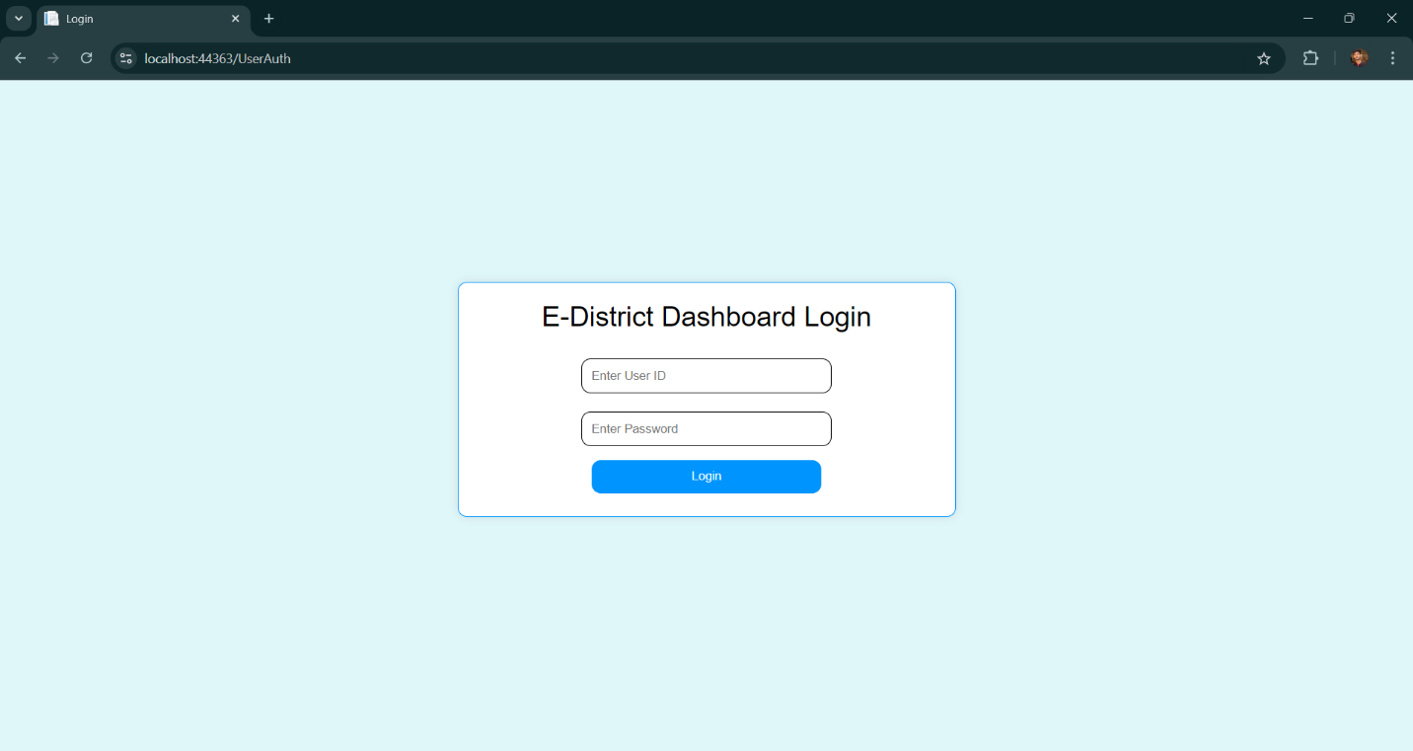

Figure 1: Homepage for User Authentication

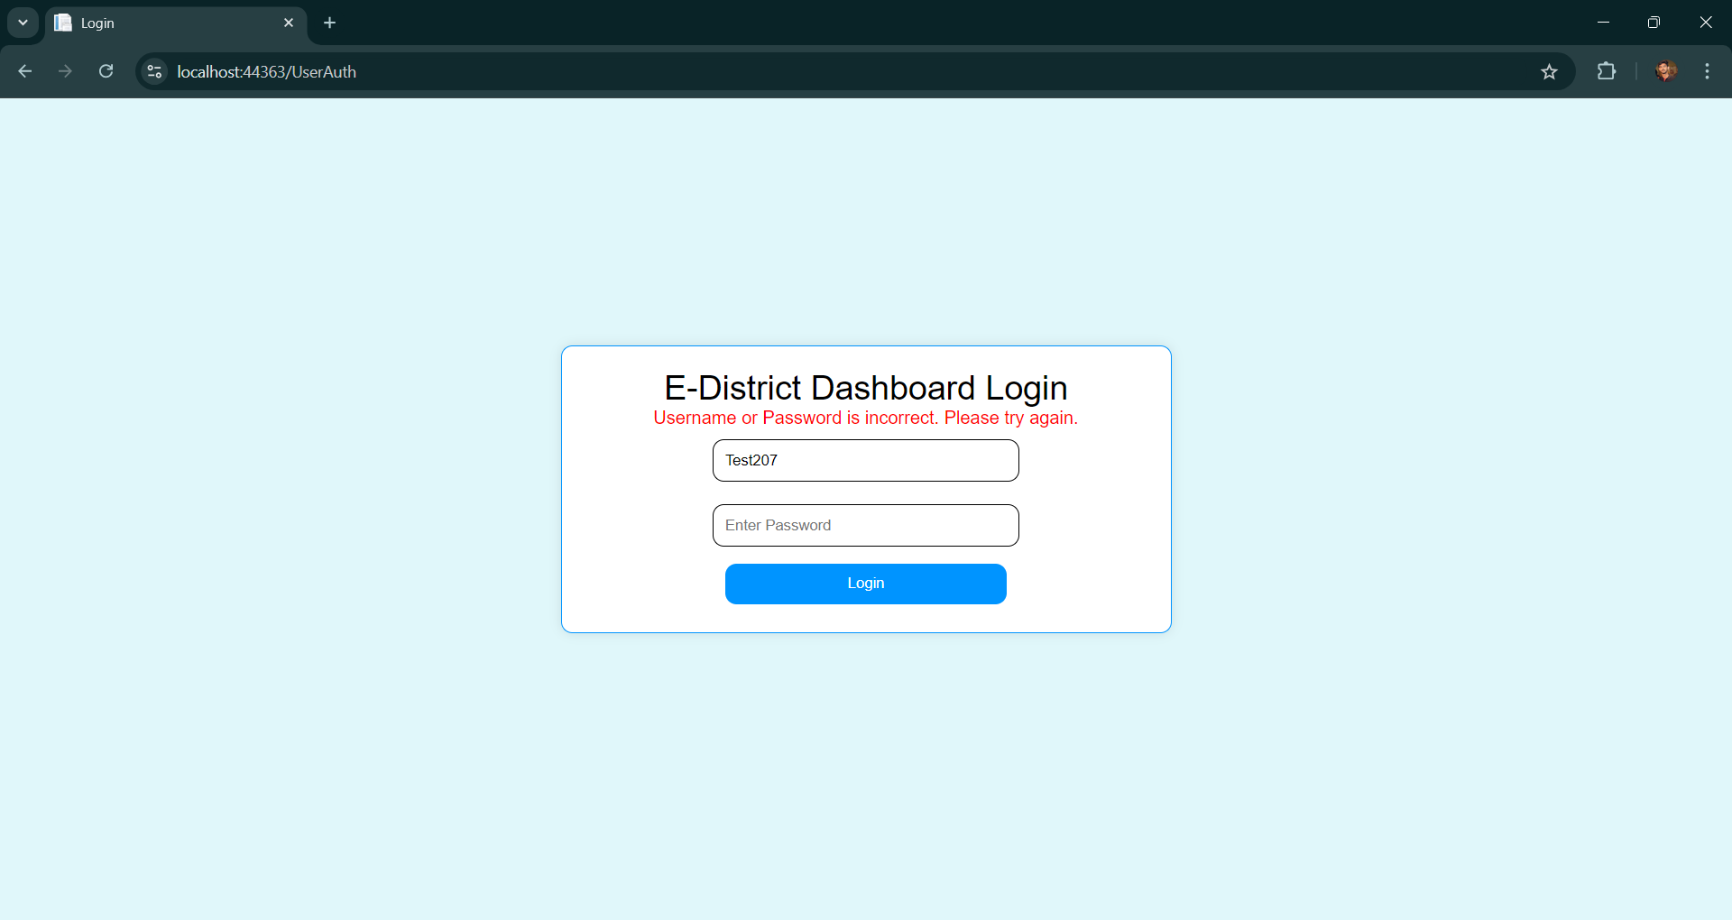

Figure 2: Validation of User Authenticity

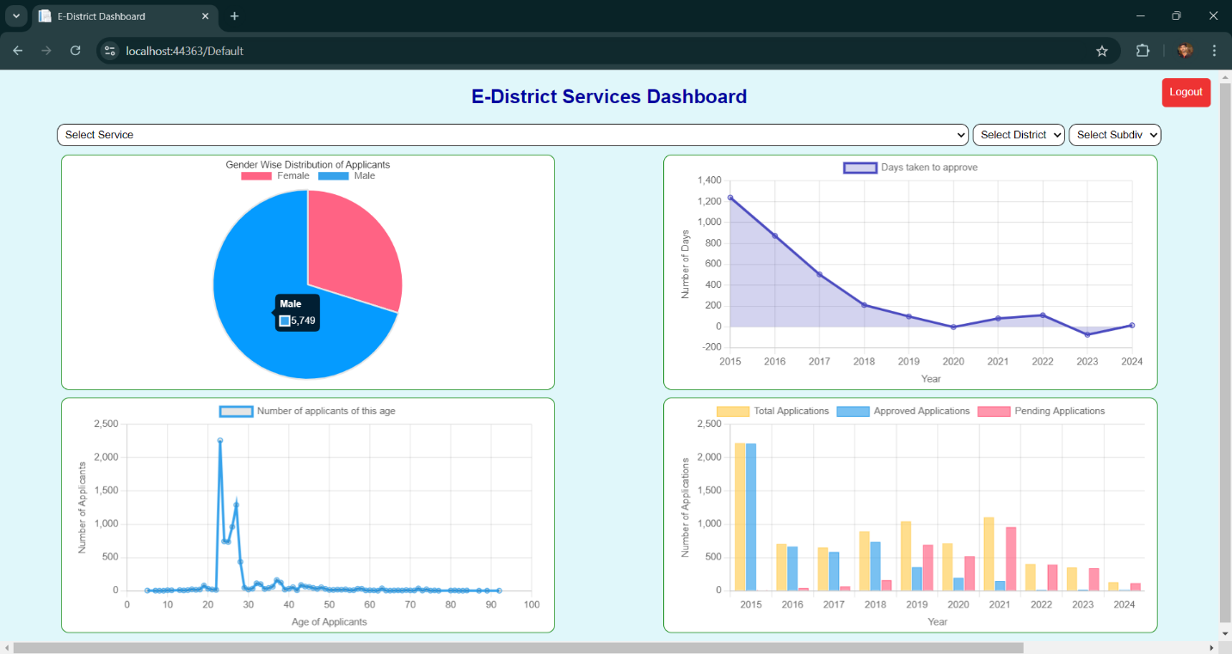

Figure 3: Overall performance of applications on portal

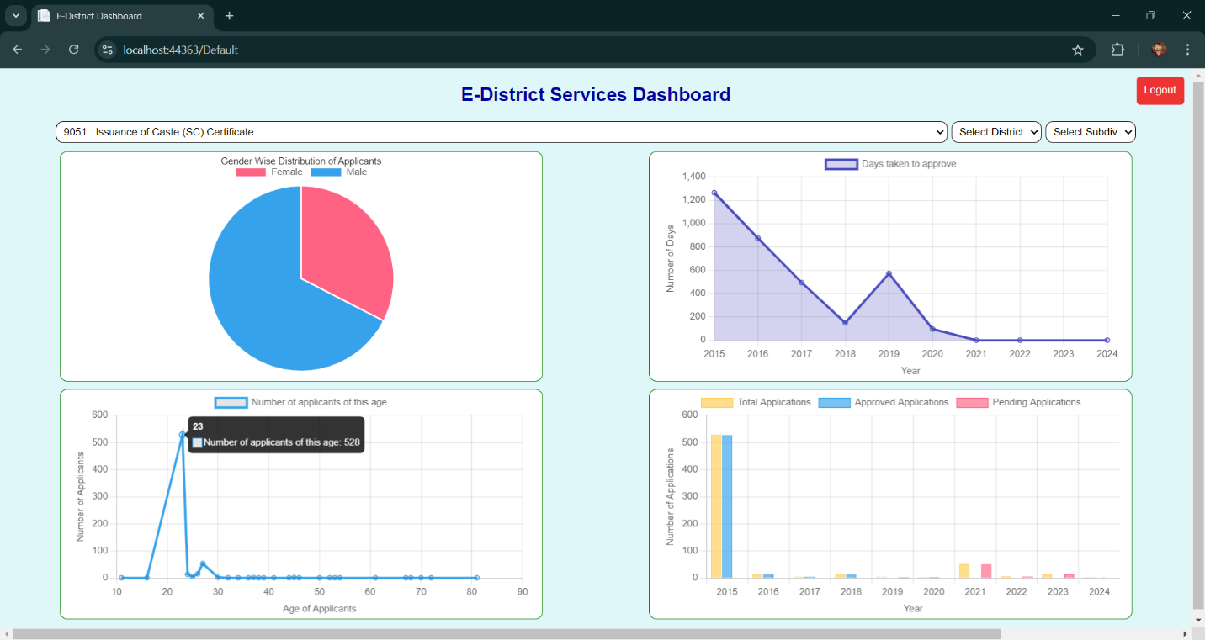

Figure 4: Performance of highest availed service

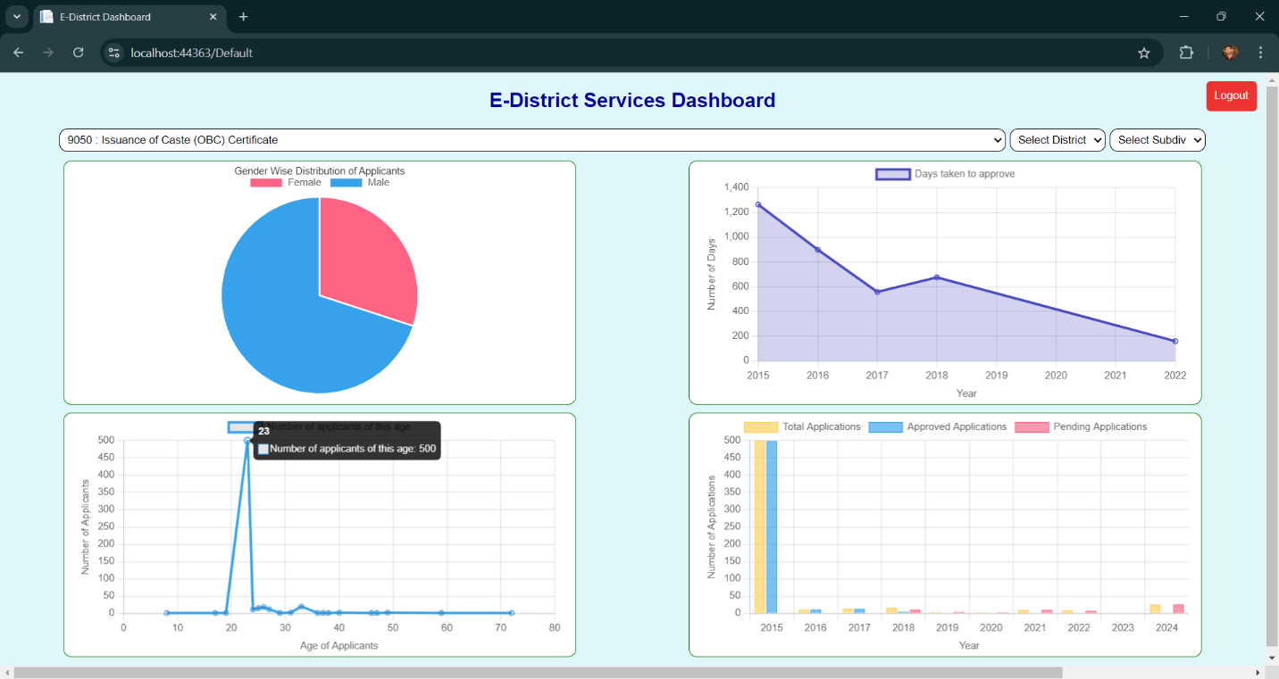

Figure 5: Performance of 2nd highest availed service

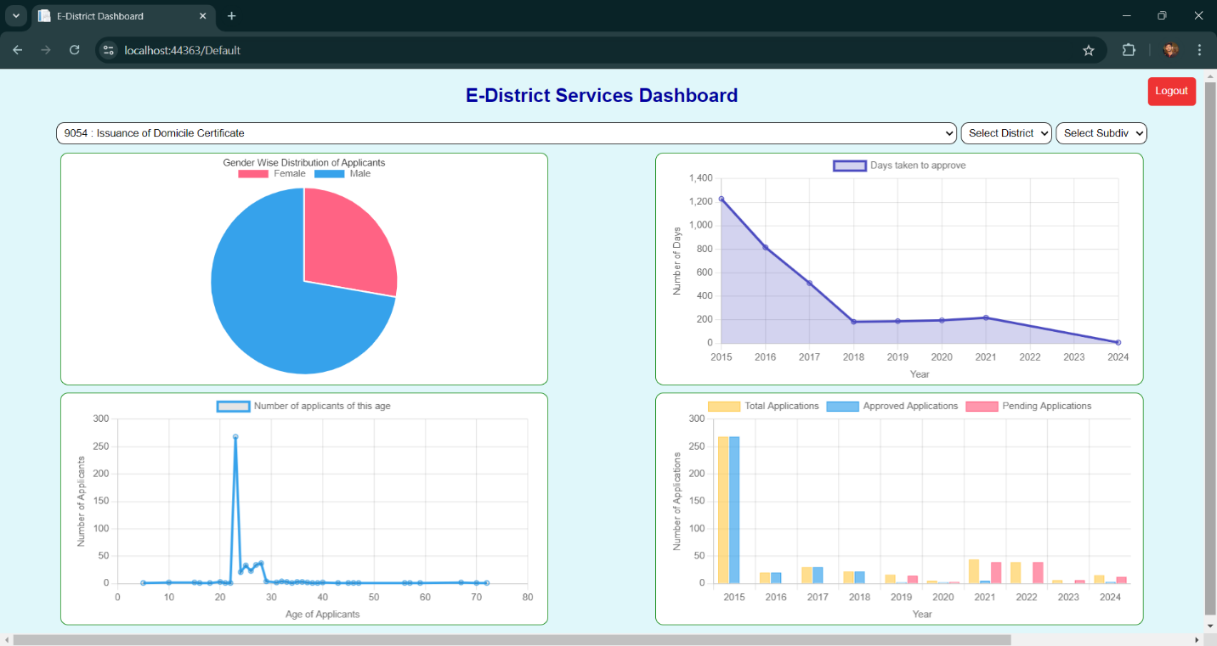

Figure 6: Performance of 3rd highest availed service

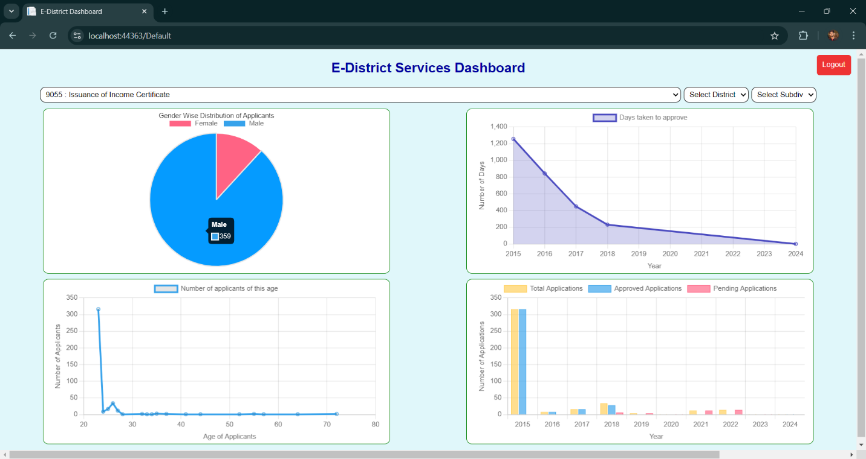

Figure 7: Performance of 4th highest availed service

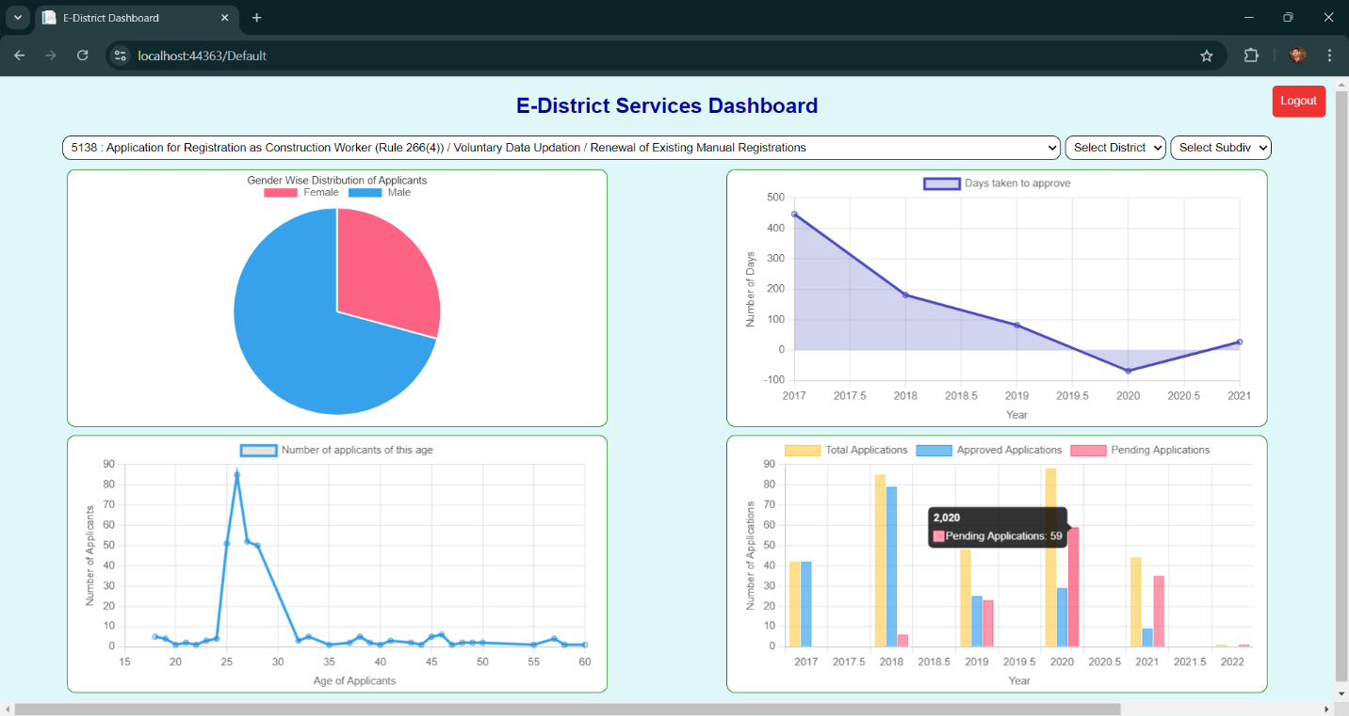

Figure 8: Performance of 5th highest availed service