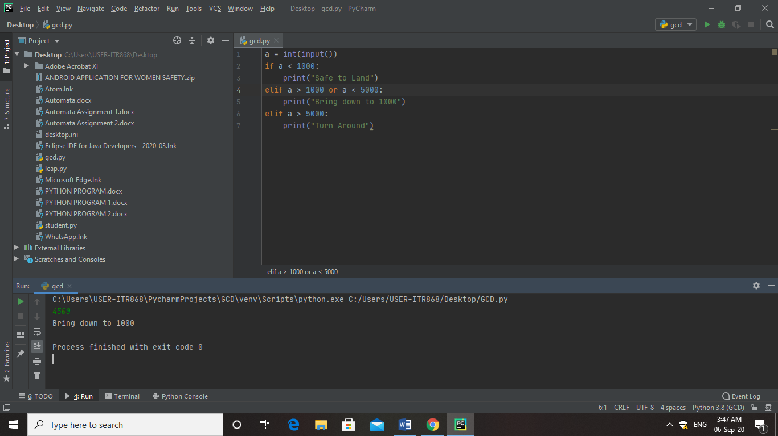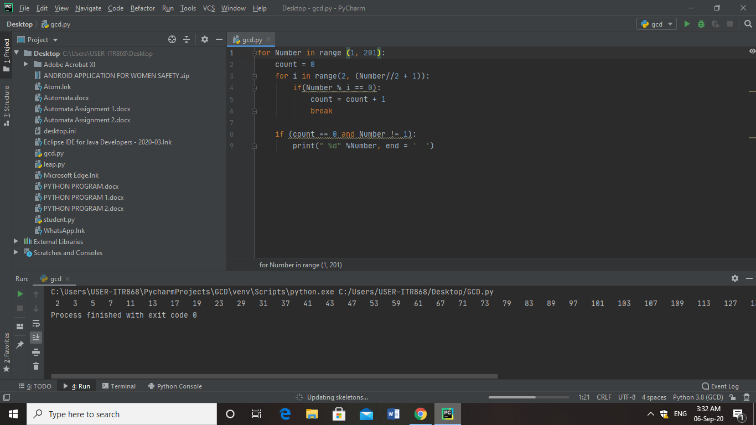

***IF ELSE PYTHON PROGRAM***

***FOR LOOP PYTHON PROGRAM***