**INTRODUCTION:**

The project's goal is to notify a consumer about the MOVIE TICKET BOOKING SYTEM so that they can purchase tickets. The project was created with the goal of making the process as simple and quick as possible. The user can book tickets, cancel tickets, and view all booking records using the system.

**FEATURES:**

1.booking tickets  
2.cancel tickets  
3.change ticket price(only admin)  
4.view all booking records

**HIGH LEVEL REQUIREMENTS:**

1.User shall be able to login to the system  
2.User shall be able to purchase a ticket  
3.User shall be able to cancel a ticket  
4.User shall be able to view the reserved seats

**LOW LEVEL REQUIREMENTS:**

**HVL1:**

1.User shall be able to login to the system with correct login details  
2.User need to book a ticket in a user entry mode  
3.If appropriate login details are not entered a message is displayed-"wrong password"

**HVL2:**

1.Displaying the movies available  
2.Admin can change the price for the movie

**HVL4:**

1.If user specifies seat number which is booked ,message appears that the seat is unavailable

Swot analysis:

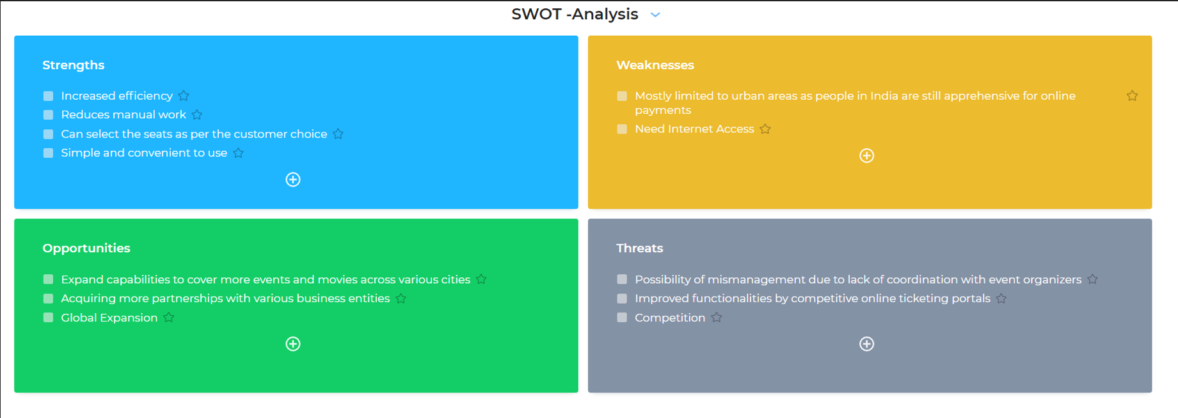

**4W'S AND 1H:**

**WHO**

Theater

**WHAT**

To bulid a system to book ticket, cancel ticket, view reserverd seats,change price of ticket(only admin)

**WHEN**

When user wants to carry out the tasks quickly and this reduces manual work and saves time

**WHERE**

This issue is in all parts of the world in theater where there is a lot of booking, cancellation of tickets happening in all the time

**HOW**

By creating a system which will provide all the functionalities required ,the booking of, cancelling of the tickets and other actions will be take more time and system needs more workers for these actions