 

**Placement Empowerment Program**

***Cloud Computing and DevOps Centre***

**Set up a VIRTUAL MACHINE on a cloud VM:** Launch a Virtual Machine and SSH into it.

Name: Kirubalini S I Department : IT



**Introduction**

Cloud computing has revolutionized the way IT infrastructure is managed, offering scalable and cost-effective solutions. One of the fundamental services provided by cloud platforms like AWS, Azure, and Google Cloud Platform (GCP) is the ability to deploy Virtual Machines (VMs). These VMs allow users to run applications, test environments, or host services without the need for physical hardware.

**Overview**

In this guide, we will walk through the process of setting up a free-tier virtual machine on a cloud platform. You will learn how to:

1.Create a cloud account (AWS, Azure, or GCP).

2.Deploy a Linux-based virtual machine using the cloud provider’s interface.

3.Connect to the VM securely using SSH.

4.Verify the connection and ensure the VM is operational.

5.Each cloud provider offers a free-tier that allows users to create a basic VM without incurring charges, making this a great way to get hands-on experience with cloud computing

**Objective**

By the end of this guide, you will be able to:

Create a cloud account with AWS, Azure, or GCP.

Launch a virtual machine using a free-tier eligible instance.

Configure networking and security settings to allow remote access.

Use SSH to connect to the VM securely.

Verify system functionality and execute basic commands.

**Importance**

Setting up a Virtual Machine (VM) in the cloud, specifically in Azure, offers numerous benefits and is crucial for various scenarios in today's technology landscape. Here's a breakdown of the importance:

**1. Flexibility and Scalability:**

* On-demand resources: Azure VMs allow you to provision computing resources as needed. You can easily scale up (increase resources) or scale down (decrease resources) based on your workload demands, ensuring you only pay for what you use.
* Variety of configurations: Azure offers a wide range of VM sizes and configurations, allowing you to choose the right fit for your specific needs, whether it's for compute-intensive tasks, memory-intensive applications, or general-purpose workloads.

**2. Cost Efficiency:**

* Pay-as-you-go model: With Azure VMs, you avoid the upfront costs of purchasing and maintaining physical hardware. You only pay for the compute time you consume, making it a cost-effective solution, especially for fluctuating workloads or short-term projects.
* Reduced operational costs: You don't have to worry about the physical infrastructure, power, cooling, or maintenance associated with on-premises servers. Azure handles these aspects, reducing your operational overhead.

**3. Enhanced Security:**

* Isolation: VMs provide a secure and isolated environment for your applications and data. If one VM is compromised, it doesn't affect other VMs or the underlying infrastructure.
* Built-in security features: Azure offers various security features like network security groups, access control, and encryption to protect your VMs and data from unauthorized access and threats.

**4. Development and Testing:**

* Isolated environments: VMs provide a safe space for developers to build, test, and debug applications without affecting production systems.
* Rapid provisioning: You can quickly spin up new VMs with different configurations for testing purposes, accelerating the development cycle.

**5. Disaster Recovery and Business Continuity:**

* Replication and backup: Azure VMs can be easily replicated and backed up to other Azure regions, ensuring business continuity in case of a disaster or outage.
* Quick recovery: In the event of a failure, you can quickly restore your VMs and applications from backups, minimizing downtime and data loss.

**6. Hybrid Cloud Scenarios:**

* Seamless integration: Azure VMs can be integrated with your on-premises infrastructure to create a hybrid cloud environment. This allows you to extend your existing data center to the cloud and leverage the benefits of both environments.

**7. Wide Range of Use Cases:**

* Application hosting: You can host various applications, from web servers to enterprise applications, on Azure VMs.
* Data analytics and machine learning: Azure VMs can be used for data processing, analysis, and machine learning tasks, especially with GPU-enabled instances.
* Dev/Test environments: VMs are ideal for creating development and testing environments for software projects.
* Backup and disaster recovery: VMs can be used for backing up critical data and applications and for disaster recovery purposes.

**Step-by-Step Overview**

**Step 1:**

Open the Azure portal.

[Home - Microsoft Azure](https://portal.azure.com/#home)

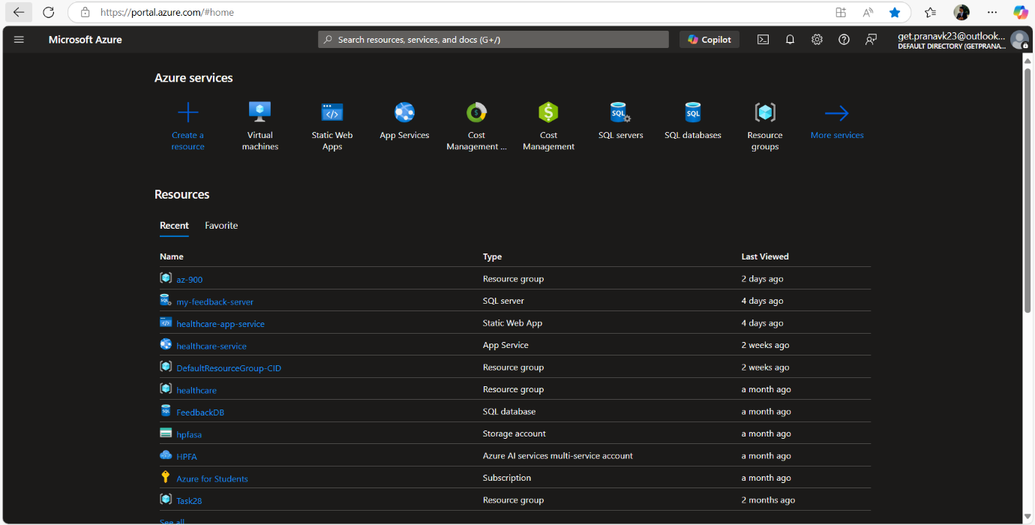

**Step 2:**

Navigate to Virtual Machines in menu bar [Located in top left corner of home] (or) you can search Virtual machines in Search bar. 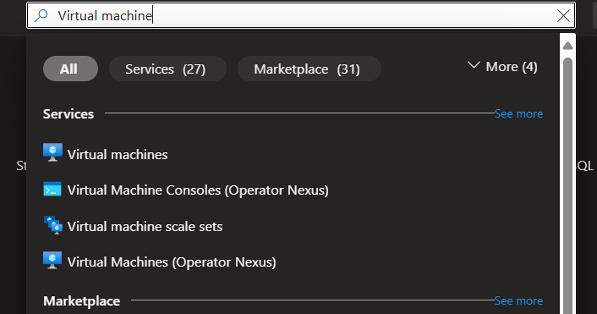

**Step 3**:

Select Azure Virtual Machine.

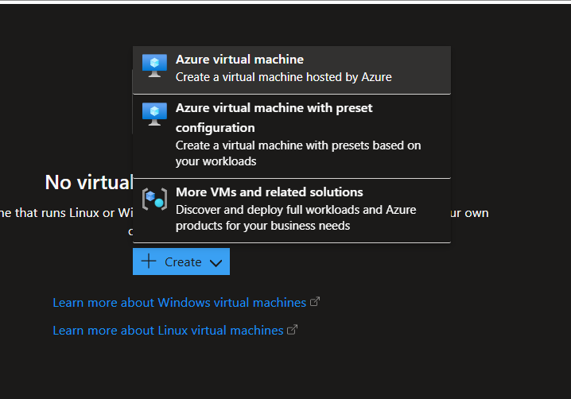

**Step 4:**

Resource Group: you can create a new one or select the existing one. [ your choice ], Virtual Machine name, Region, Image, Size,

In administrator account : enter Username, password and Confirm Password.

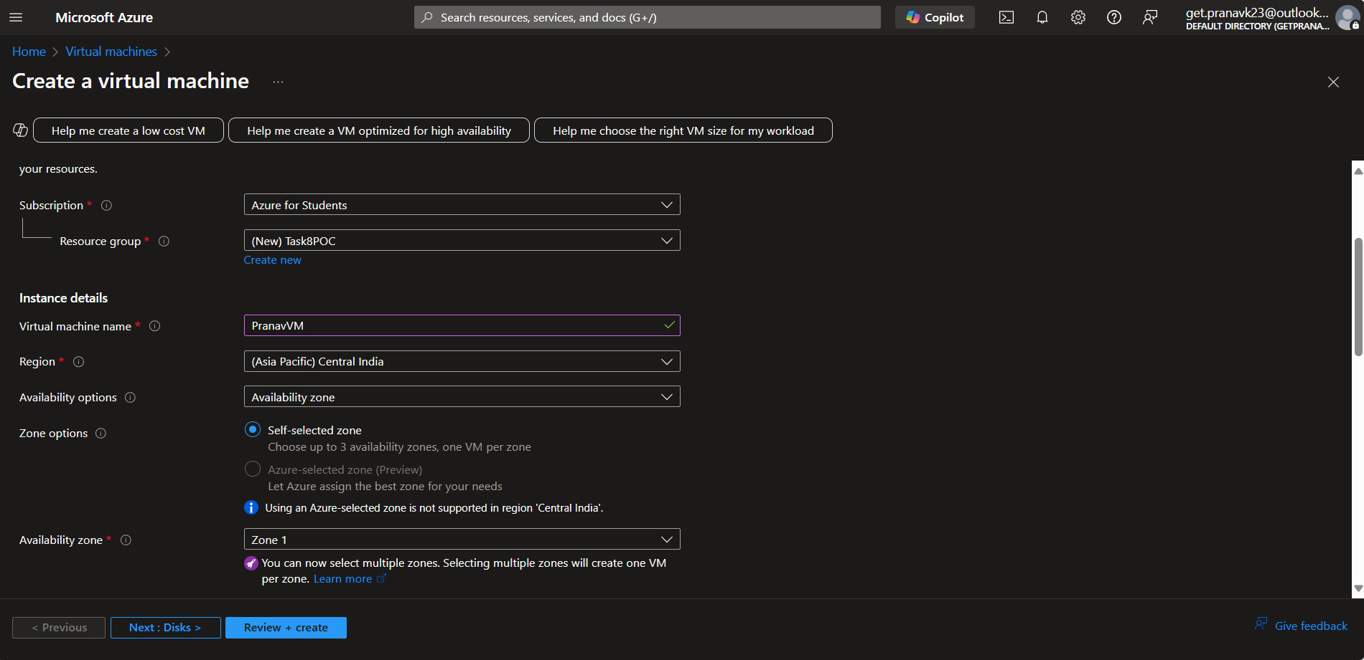

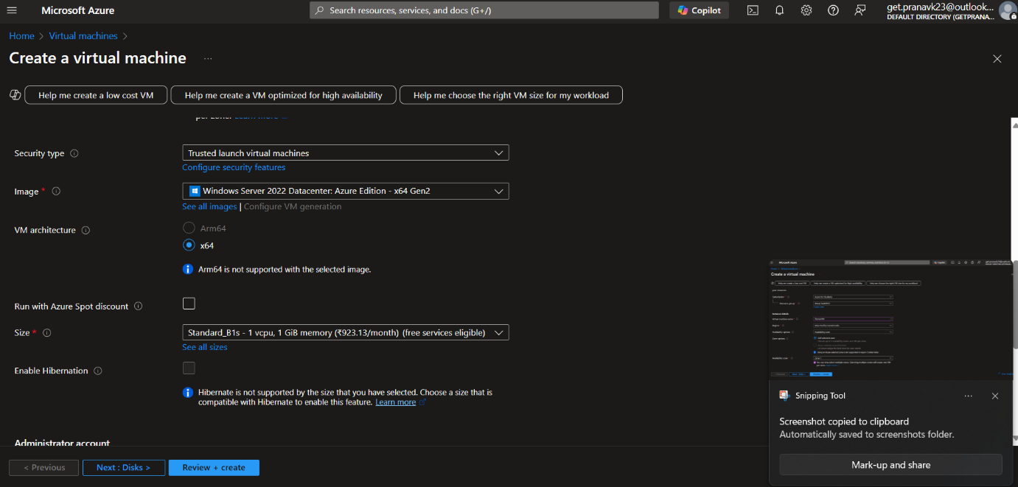

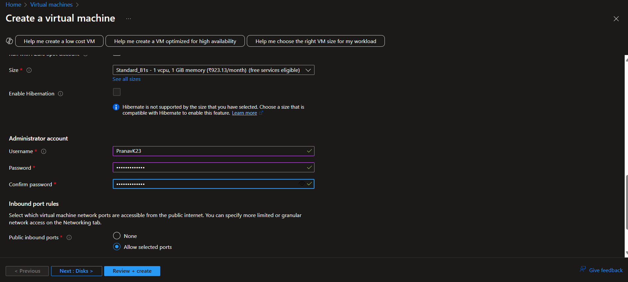

**Step 5:**

Move on to Disk and select Standard SSD.

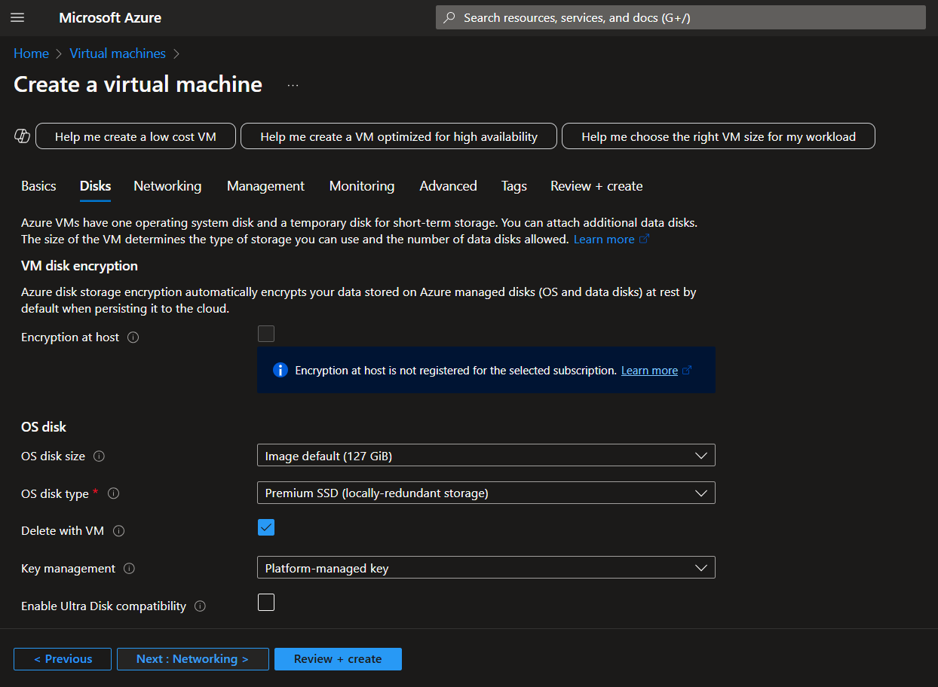

**Step 6:**

Click on "REVIEW + CREATE". once reviewed, click on "CREATE" to create the Virtual Machin.

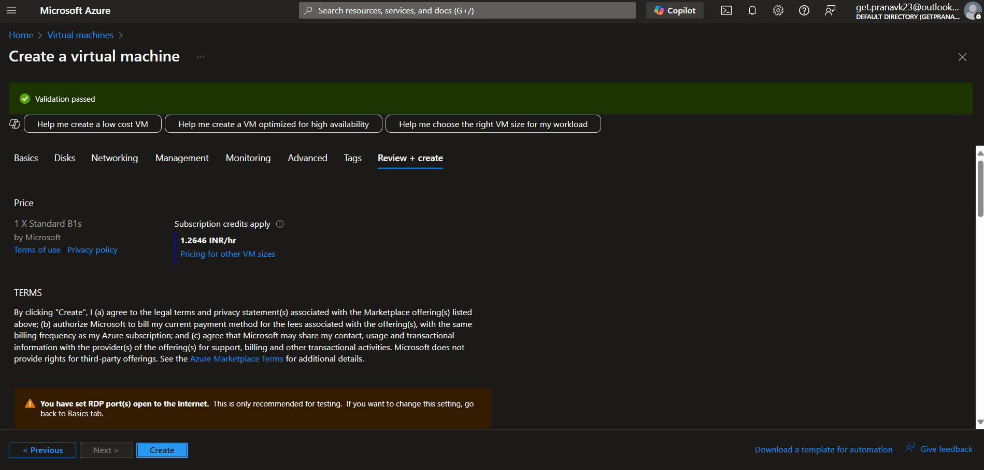

**Step 7:**

Once deployment is complete, you can click on go to resource to view the Virtual Machine.

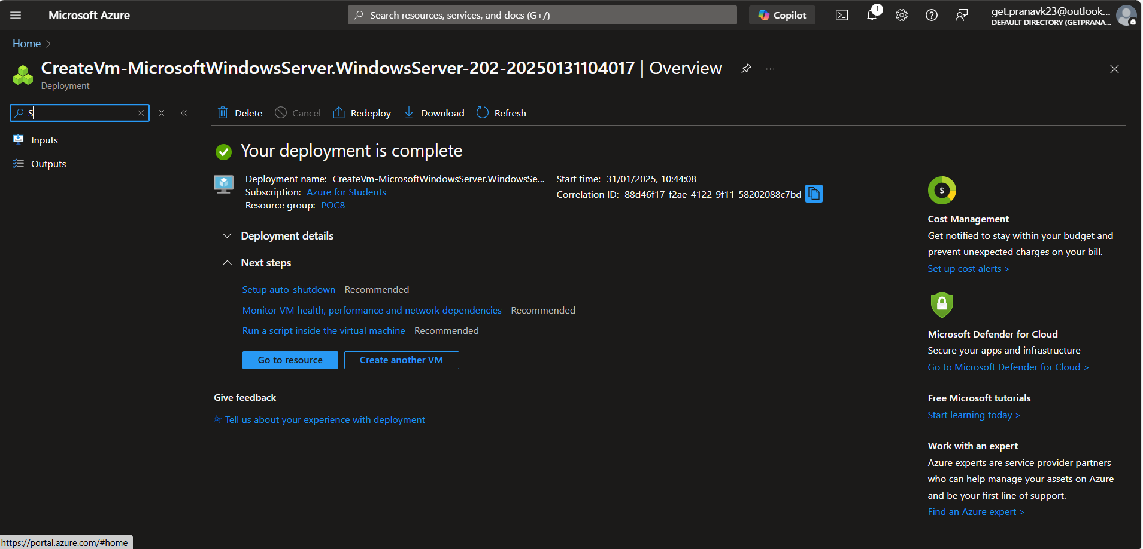

**Expected Outcome**

The outcome of setting up a virtual machine (VM) in the cloud can be summarized as follows:

**On-demand computing resources:** You gain access to scalable computing resources (CPU, memory, storage) that you can provision and deprovision as needed, avoiding the need to invest in and maintain physical hardware.

**Flexibility and scalability:** You can easily resize your VM's resources (e.g., increase RAM or storage) as your needs change. You can also easily spin up multiple VMs if required.

**Cost-effectiveness:** Cloud VMs often operate on a pay-as-you-go model, allowing you to pay only for the resources you consume. This can be more cost-effective than owning and maintaining physical servers, especially for fluctuating workloads.

**Increased agility:** Setting up a VM in the cloud is typically much faster than procuring and setting up physical hardware. This allows you to quickly deploy applications and services.

**Improved availability and reliability:** Cloud providers typically offer redundant infrastructure and features like automatic backups and disaster recovery, which can improve the availability and reliability of your applications.

**Accessibility:** You can access your cloud VM from anywhere with an internet connection, making it convenient for remote work and collaboration.

**Simplified management:** Cloud providers often offer tools and services to simplify the management of your VMs, such as monitoring, logging, and patching.

**Testing and development environment:** Cloud VMs provide an ideal environment for testing and developing applications, as you can easily create and destroy VMs as needed.

**Disaster recovery:** VMs can be easily replicated or backed up, making them a good solution for disaster recovery planning.