

Placement Empowerment Program
Cloud Computing and DevOps Centre

Write a Shell Script to Monitor Logs: Create a script that monitors server logs for errors and alerts you

Name: Kirubalini S I Department: IT



Introduction and Overview
In system administration, monitoring log files is a crucial task to ensure the health and stability of a server. Logs provide detailed insights into the performance of services, errors, and potential security issues. A shell script that monitors log files can help automate the process of identifying errors, providing real-time alerts, and even taking actions such as sending notifications to system administrators or triggering corrective measures.
The idea behind the script is to continuously or periodically scan specific log files (such as /var/log/syslog, /var/log/auth.log, or custom application logs) for error patterns, warning messages, or any other predefined criteria. If an error is found, the script can notify the administrator via email, push notifications, or system alerts.

Objective

Automate Log Monitoring: Set up a shell script that scans logs at defined intervals or continuously.

Error Detection: Look for specific error patterns such as "error," "failure," "critical," or any custom-defined keywords.

Alert Mechanism: Notify the system administrator when errors or warnings are detected. This can be done via email, SMS, or logs.

Scalability: The script can be extended to monitor multiple log files or even integrated with log management systems.

Importance
1. Real-Time Issue Detection
- Early Warning System: Logs often contain error messages, warnings, or information about performance issues that can lead to larger problems if not addressed promptly. By using a shell script, you can automate the detection of these errors and receive immediate alerts, giving you a head start in resolving the issue before it impacts the users or the system’s functionality.
- Prevent Downtime: Timely error detection can prevent critical failures from escalating into system downtime, allowing you to act before the issue affects services, websites, or applications that depend on the server.
2. Automation of Log Monitoring
- Consistency and Reliability: Manual log monitoring is prone to human error, particularly in busy environments where numerous logs need to be checked across multiple servers. A shell script can automatically monitor logs at regular intervals, reducing the risk of missing crucial information.
- Reduced Workload: Instead of checking logs manually or setting up complex third-party monitoring solutions, a simple shell script can be customized to check log files and alert administrators without human intervention.
3. Proactive Management
- Early Problem Detection: Logs are often the first place where problems like system failures, security breaches, and application bugs are recorded. A shell script can proactively detect these issues and alert you to address them before they have significant negative effects.
- Reduced System Downtime: Detecting issues early allows you to address them quickly, often preventing prolonged outages or system failures. This leads to more reliable systems and services with minimal disruption to users or customers.
4. Improved Security
- Security Monitoring: Logs also capture security-related events, such as failed login attempts, unauthorized access attempts, and unusual behavior that could indicate a security breach. By monitoring security logs, the script can alert you about potential threats, enabling you to take action promptly (e.g., blocking an IP address or investigating suspicious activity).
- Compliance and Audit: Many industries require strict log monitoring and auditing as part of their compliance standards (e.g., HIPAA, GDPR). A shell script that automatically alerts you to any security or operational issues can help ensure that you meet regulatory requirements and maintain an audit trail for future review.
5. Reduced Human Error
- Minimized Mistakes: Manually checking logs can result in overlooked issues, especially in high-traffic or complex environments with numerous log files. A script performs the same task every time, ensuring consistency in error detection and minimizing the chance of human oversight.
- Less Stress on System Admins: System administrators can avoid the burden of constant log checks, allowing them to focus on other critical tasks while the script runs in the background and alerts them only when necessary.
6. Faster Response Time
- Instant Alerts: A shell script can be programmed to send notifications via email, text message, or other alert mechanisms as soon as an error is detected in a log. This enables faster response times from system administrators, allowing them to address problems quickly without needing to manually check log files.
- Customizable Alerts: Depending on the script’s configuration, it can prioritize different types of errors, ensuring that the most critical issues are addressed first. For example, a server crash or database failure may trigger a high-priority alert, while minor warnings might trigger a lower-priority notification.
7. Simplified Troubleshooting
- Context for Diagnosing Problems: Logs provide essential information to help troubleshoot and resolve problems. A script that alerts you to errors gives you immediate insight into the issues, such as specific error messages or failing components, making it easier to diagnose the root cause and fix it quickly.
- Automated Log Aggregation: In environments where multiple logs need to be monitored across various systems, the script can gather and compile this data into a central location, improving your ability to correlate issues and track recurring problems over time.
8. Cost-Effective and Resource-Efficient
- Low Overhead: Shell scripts are lightweight, easy to implement, and don’t require the setup or maintenance of complex software tools. This makes them an affordable solution for small to medium-sized environments.
- No Third-Party Dependencies: You don’t have to rely on expensive third-party monitoring solutions, which can sometimes require ongoing costs or complicated integrations. With a shell script, you have a flexible and scalable solution built right into the server environment.

9. Scalability and Flexibility
- Customizable for Various Needs: A shell script can be tailored to meet your specific needs—whether it’s monitoring a single log file or handling multiple logs across a cluster of servers. As your infrastructure grows, you can easily update the script to monitor additional servers or log files.
- Integration with Other Tools: The script can be integrated with other automation tools or logging platforms, enabling advanced workflows such as generating reports, creating detailed dashboards, or automatically triggering system processes in response to alerts.
Step-by-Step Overview
Step1:
Create a Folder called logs for Your Logs and Script

Step 2 :
Open Notepad and Add the following sample text to it and Save the
file as mylogfile.log inside the logs folder
Step 3 :
Open Notepad and Type the following PowerShell script into it and
Set the $LogFilePath address to the mylogfile.log which you saved in
logs folder. Save the file as monitor_logs.ps1 inside the same logs
folder.

Step 4 :
Click the Windows Key and Search for Windows PowerShell and
click Run as Administrator.
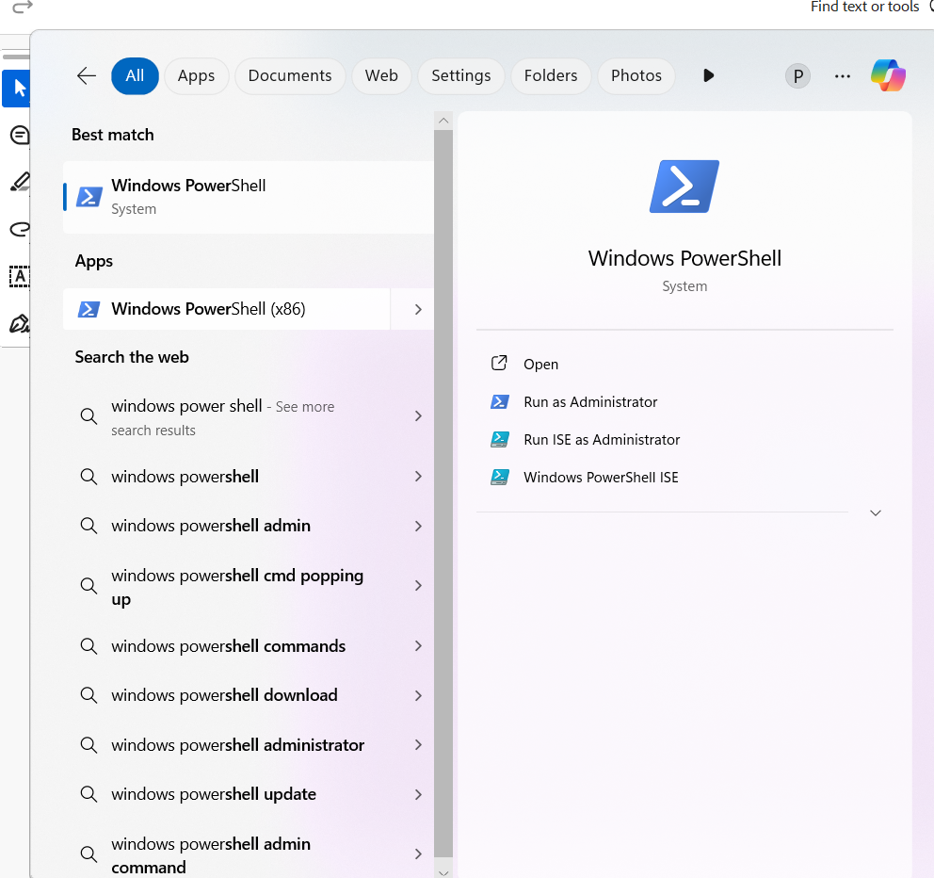
Step 5 :
Run the following command to allow script execution:
Set-Execution Policy -Scope Current User -Execution Policy
Remote Signed
When prompted, type Y and press Enter.
Step 6 :
Navigate to the logs folder and

Run the script:
.\monitor_logs.ps1


Step 7 :
Open mylogfile.log in Notepad and Add a new line with the word
"error" and Save the file.

Step 8 :
Check PowerShell — you should see an alert like:
ALERT: Keyword 'error' found in log: error: A new issue
occurred!

Expected Outcome
- Automatic Log Checking: The script automatically monitors log files for errors, removing the need for manual checking.
- Instant Alerts: The script sends immediate notifications (via email, SMS, or other methods) whenever an error is detected in the logs.
- Faster Problem Resolution: By detecting issues early, the script helps you address problems quickly before they escalate.
- Reduced Downtime: Early detection of issues leads to quicker fixes, reducing the time your server is down or affected by errors.
- Better Security: The script can help spot security issues, such as unauthorized login attempts, by alerting you when unusual activity is detected.
- Less Manual Work: System administrators don’t have to manually check logs constantly, saving time and effort.
- Improved System Health: Regular monitoring helps maintain system stability and performance by catching issues early.
These outcomes lead to more efficient and effective system management with less downtime and fewer missed problems.

