1)Create a Stored Procedure that takes employee id as IN parameter and updated salary as OUT parameter.Then update the salary of the employee

Code:

DELIMITER $$

CREATE PROCEDURE UpdateEmployeeSalary(IN emp_id INT,IN new_salary DECIMAL(10,2),OUT updated_salary DECIMAL(10,2))

BEGIN

UPDATE employee

SET salary = new_salary

WHERE employeeId = emp_id;

SELECT salary INTO updated_salary

FROM employee

WHERE employeeId = emp_id;

END $$

DELIMITER;

select * from employee;

SET @updated_salary = 0;

CALL UpdateEmployeeSalary(101, 5000.00, @updated_salary);

SELECT @updated_salary AS UpdatedSalary;

Output :

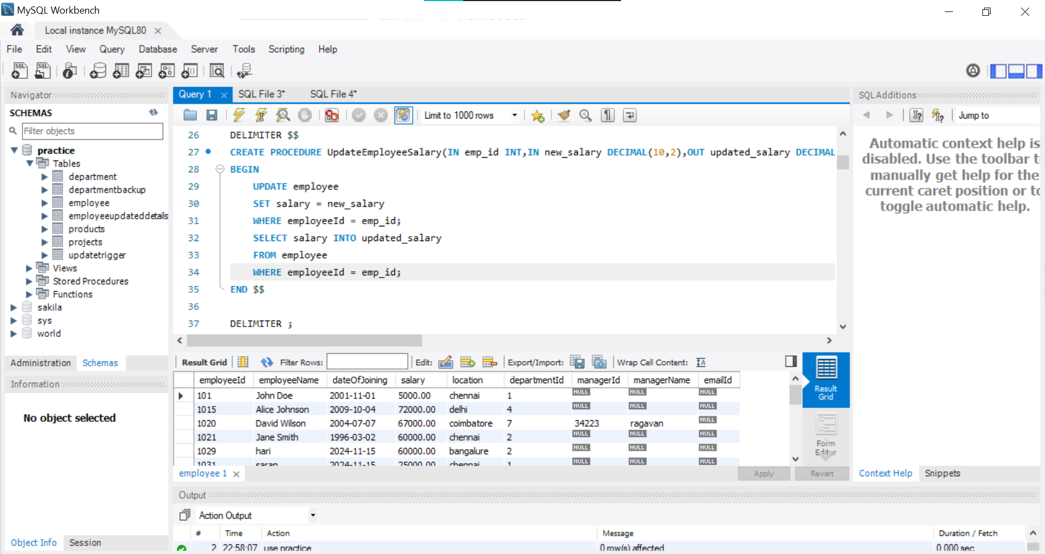

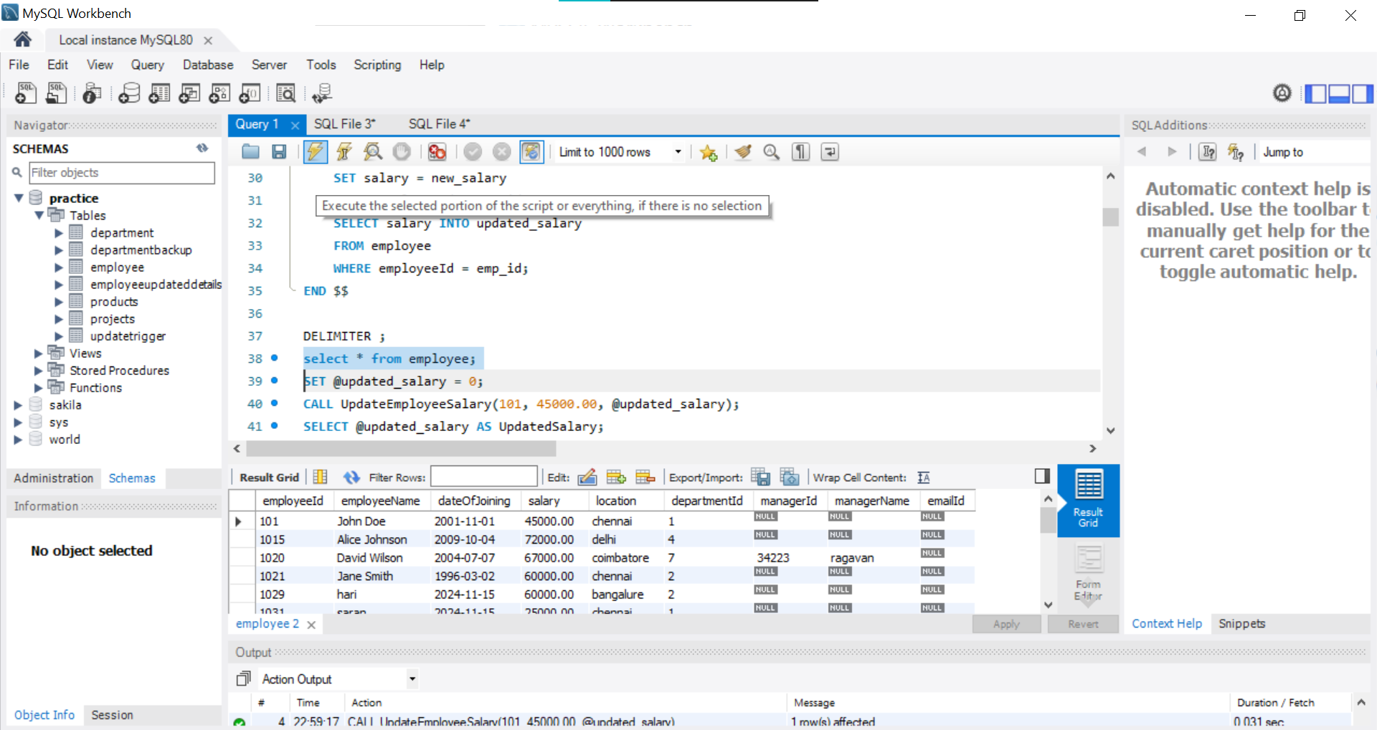

3)Create a view to display the employeeId,departmentname of all employees in "TN"

and "TA" departments who joined in 2022

Code:

DELIMITER $$

CREATE VIEW EmployeeDepartments2022 AS

SELECT e.employeeId,e.employeeName,e.dateOfJoining, d.departmentName

FROM employee e

JOIN department d ON e.departmentId = d.departmentId

WHERE (d.departmentName = 'HR' OR d.departmentName = 'Finance')

AND YEAR(e.dateOfJoining) = 2024;

$$ DELIMITER ;

SELECT * FROM EmployeeDepartments2022;

Output :

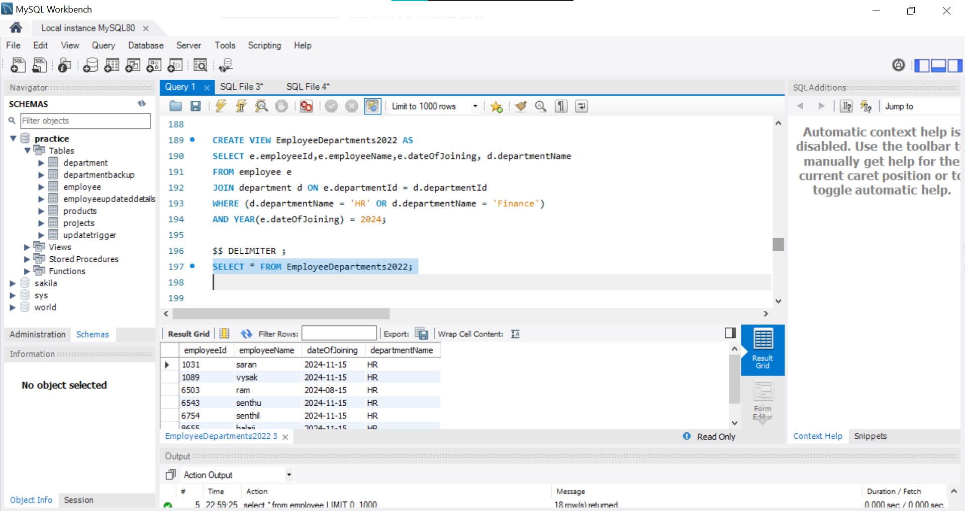

4)Create a trigger that fire After insertion in the employee table by updating the

count in the department

Code:

Before Trigger :

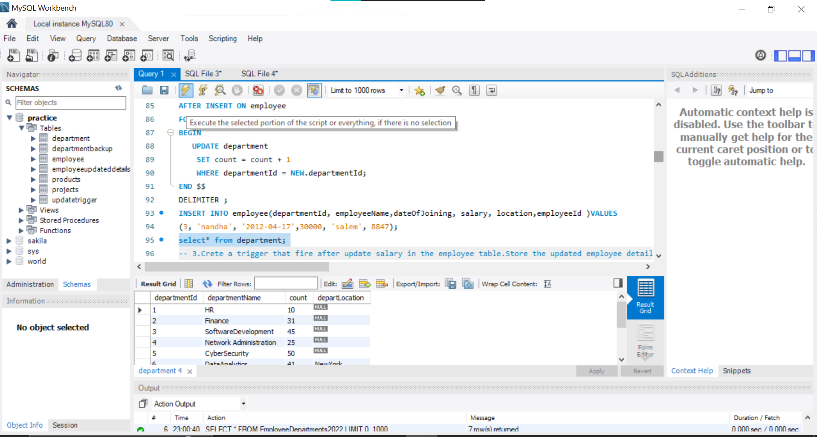

After Trigger:

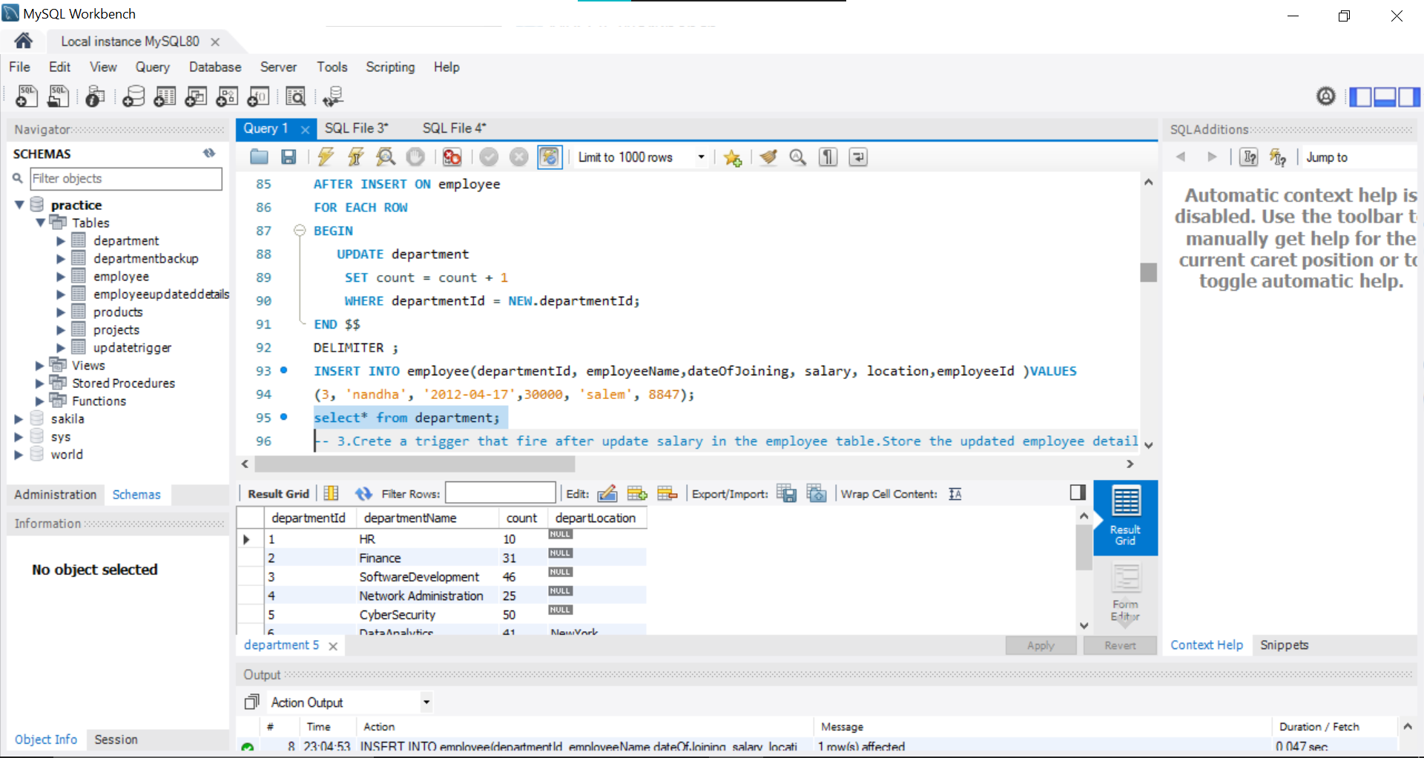

5)Crete a trigger that fire after update salary in the employee table.Store the updated

employee details in another table

Code :

CREATE TABLE employeeupdatedDetails (

employeeId INT,

oldSalary DECIMAL(10, 2),

newSalary DECIMAL(10, 2),

FOREIGN KEY (employeeId) REFERENCES employee(employeeId)

);

DELIMITER $$

CREATE TRIGGER salaryUpdate

AFTER UPDATE ON employee

FOR EACH ROW

BEGIN

IF OLD.salary <> NEW.salary THEN

INSERT INTO employeeupdatedDetails (employeeId, oldSalary, newSalary)

VALUES (NEW.employeeId, OLD.salary, NEW.salary);

END IF;

END $$

DELIMITER ;

update employee set salary=65000.00 where departmentId=9;

select * from employeeupdatedDetails;

Output:

