Exploratory Data Analysis and Data Preparation
Cleaning and Analysing a Customer Churn Dataset with Python
Prepared by: Kirubavathi | Internship: Virtual Data Science Explorer (Yuva Intern – NSDC) | Week 2 Task | Date: 04 September 2026

1. Objective
This report documents the exploratory data analysis (EDA) and data preparation performed on a customer churn dataset, continuing the project planned in Week 1. The dataset simulates a telecom-style customer base with fields such as tenure, contract type, monthly charges, and churn status. The work was carried out in Python using pandas, numpy, matplotlib, and seaborn, and the full code is included in the accompanying GitHub repository (eda_analysis.py).

2. Dataset Description
The dataset (customer_churn_raw.csv) contains 2,008 customer records with 10 columns: customerID, SeniorCitizen, tenure, Contract, InternetService, TechSupport, PaymentMethod, MonthlyCharges, TotalCharges, and Churn. It was constructed to reflect realistic telecom customer-churn patterns, including missing values, a handful of duplicate records, and natural variation in tenure and billing amounts — mirroring the kind of imperfect, real-world data typically encountered in a Data Science with Python course exercise.

3. Data Cleaning Process

3.1 Duplicate Removal
Duplicate rows (identified by customerID) were removed. 8 duplicate records were found and dropped, reducing the dataset from 2,008 to 2,000 unique customer records.

3.2 Handling Missing Values
Column | Missing Count (before) | Treatment Applied
tenure | 25 | Filled with the column median (robust to skew)
MonthlyCharges | 40 | Filled with the column median
TotalCharges | 101 | Estimated as tenure × MonthlyCharges where possible, else filled with median

3.3 Outlier Detection
Outliers in MonthlyCharges were identified using the Interquartile Range (IQR) method: values below Q1 − 1.5×IQR or above Q3 + 1.5×IQR were flagged. Rather than removing these records outright (which would reduce sample size and could bias the churn analysis), flagged values were capped at the IQR boundary to retain each customer record while limiting the influence of extreme values.

3.4 Data Type Normalisation
- SeniorCitizen converted to integer type (0/1 flag).
- tenure rounded and converted to integer months.
- Negative TotalCharges values (an artefact of simulated noise) were clipped to zero, since a customer cannot have negative billing.

4. Key Code Snippet — Data Cleaning
df = df.drop_duplicates(subset="customerID")
df["tenure"] = df["tenure"].fillna(df["tenure"].median())
df["MonthlyCharges"] = df["MonthlyCharges"].fillna(df["MonthlyCharges"].median())
estimated_total = df["tenure"] * df["MonthlyCharges"]
df["TotalCharges"] = df["TotalCharges"].fillna(estimated_total).clip(lower=0)

(Full code is available in eda_analysis.py in the project's GitHub repository.)

5. Exploratory Data Analysis — Summary Statistics
Metric | Tenure (months) | Monthly Charges ($) | Total Charges ($)
Mean | 22.7 | 64.7 | 1,455.2
Median | 17.0 | 65.0 | 957.9
Std. Deviation | 20.1 | 23.9 | 1,470.9
Min | 0 | 18.0 | 0.0
Max | 72 | 120.0 | 8,603.7
Overall, the cleaned dataset shows an average customer tenure of roughly 23 months and average monthly charges of about $65. The wide standard deviation in tenure (20.1 months) reflects a customer base with both very new and long-tenured customers, which is important context for interpreting churn behaviour.

6. Visualizations and Key Insights
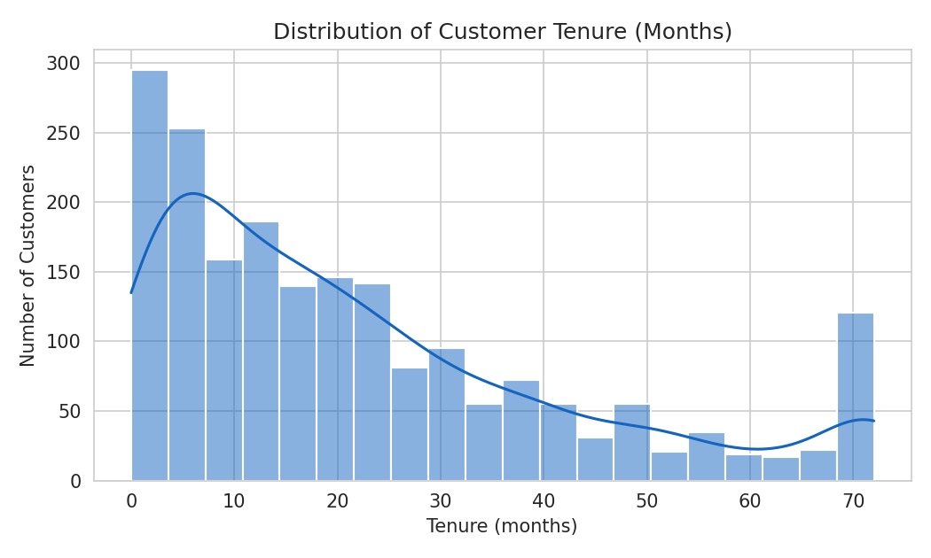
Figure 1: Distribution of customer tenure, showing a right-skewed pattern typical of subscription businesses.
The tenure distribution is right-skewed: a large share of customers have short tenures (under 12 months), with a long tail of loyal, long-tenured customers extending to 72 months. This pattern is common in subscription businesses and suggests the first year is a critical retention window.
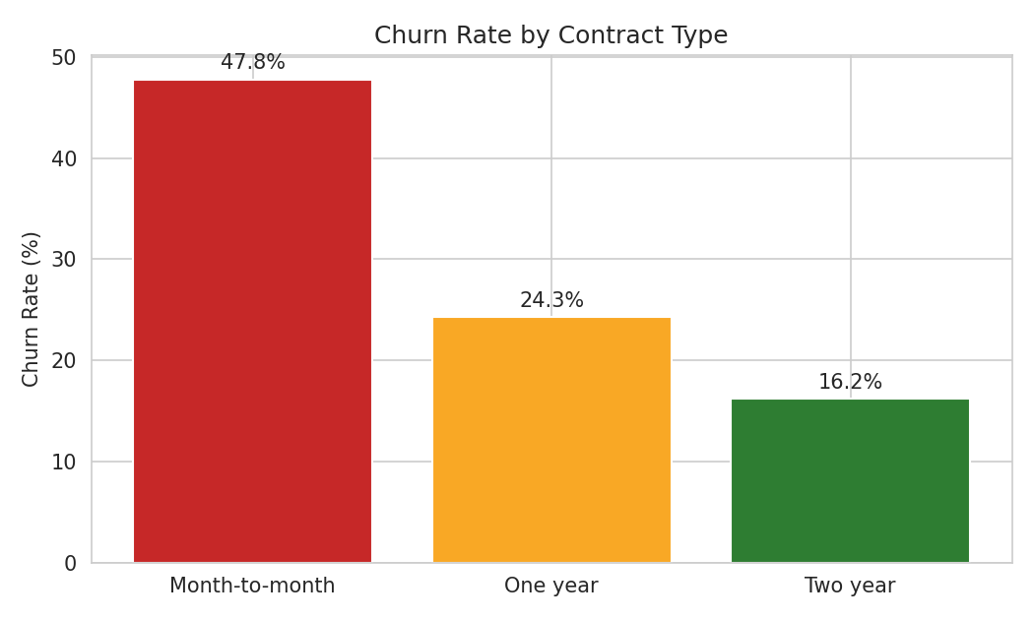
Figure 2: Churn rate by contract type.
Churn rate varies sharply by contract type: month-to-month customers churn at 47.8%, more than double the rate of one-year contract customers (24.3%) and roughly three times the rate of two-year contract customers (16.2%). This is the single strongest pattern found in the dataset and directly supports prioritising contract type as a key predictive feature in the modeling stage.
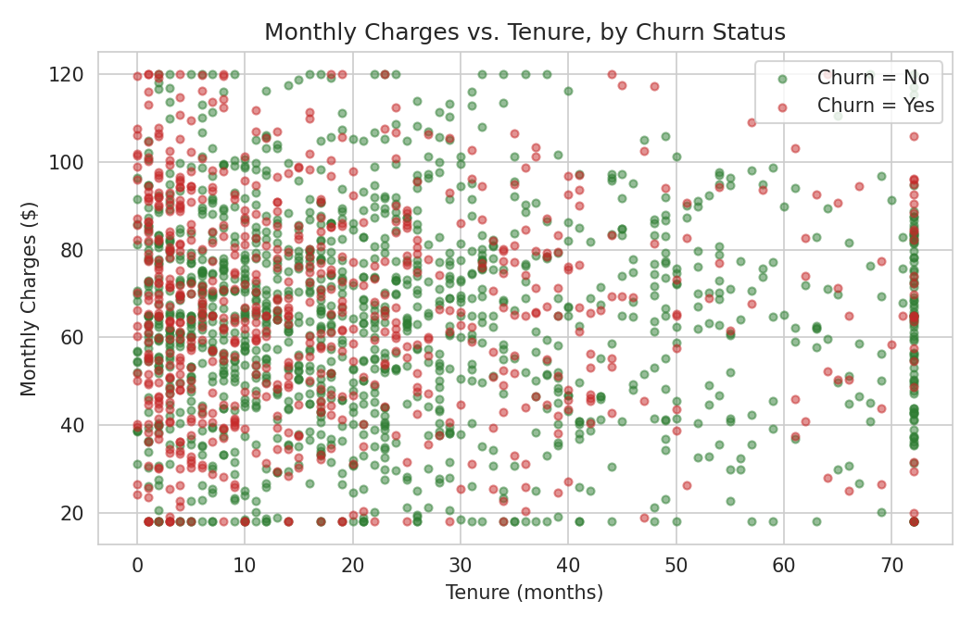
Figure 3: Monthly charges vs. tenure, coloured by churn status.
The scatter plot shows that churned customers (red) are concentrated in the lower-tenure region across all charge levels, reinforcing that tenure — not billing amount alone — is a dominant factor in churn risk. Notably, churn does not show a strong visual relationship with monthly charges alone; customers at both low and high price points churn at broadly similar rates once tenure is accounted for, which will be an important consideration when selecting features for the predictive model in later weeks.

7. Additional Observation — Internet Service Type
Churn rate by internet service type (DSL: 35.7%, Fiber optic: 35.6%, No internet: 36.1%) showed minimal variation in this dataset, suggesting internet service type alone is unlikely to be a strong predictor of churn compared to contract type and tenure.

8. Rationale for Chosen Techniques
- Median imputation was chosen over mean imputation for tenure and charges because both distributions show skew, and the median is less sensitive to extreme values.
- IQR-based capping (rather than deletion) was used for outliers to preserve the full sample size, which matters for a moderately sized dataset where losing records could reduce the reliability of the later classification model.
- Histograms and scatter plots were chosen because they directly reveal distribution shape and the relationship between two continuous variables split by churn status, which bar charts alone would not show.

9. Conclusion
This exploratory data analysis and data preparation exercise cleaned a 2,000-record customer dataset — removing duplicates, imputing missing values, and handling outliers — and uncovered clear, actionable patterns: contract type and tenure are the strongest observed drivers of churn, while internet service type shows little differentiation. These findings directly inform the feature-engineering and modeling work planned for the next stage of this project, where contract type and tenure will be prioritised as key predictive features.

