Section one software engineering

Name Kirubel Teka Zewdie

ID ATR/4407/11

Assignment one

1.History of the internet

History of the internet started with the starting of interconnecting networks. In 1950’s computer science was an emerging discipline which considered time sharing with the help of making wide area networks. A person by the name Paul Baran proposed a distributed network based on data in message blocks in early 1960’s and another person named Donald Davies came up with packet switching in 1965.

In the early times data networking was made through ARPANET, Merit Network and CYCLADES. In the 1980’s NSF funded national super computing centers provided inter-connectivity in 1986 and it was at in the time period between 1989-90 where world wide web came linking hypertext documents into an information system accessible from any node on the network. The internet we know today is the result of connection of computers that provide wide variety of information through hypertext documents and make the people informed about literally everything.

2.

1. **Reddit.com** is not as intelligent and well informed and it has relatively high level of languages and communication skills used the overall design of the web is fantastic and registered users post links and and text-based posts which makes it a user generated content website.As of July 2019, Reddit ranks as the No 5 most visited website in the U.S.
2. **IMDb.com** is an online database of information which is related to movies,television programs,home videos,video games and streaming content online and registered members can write reviews, edit the site and vote on ratings.
3. **Stackoverflow.com** is a question and answer website for programmers and professional developers.It was launched on September 15, 2008.Stackoverflow only accepts questions related to programming on a specific problem and in April 2009 Stack Exchange implemented a policy of timed suspension in order to curtail users who either show No effort to learn or engage in disruptive behaviour.
4. **Bloomberg.com** is a privately held financial software ,data and media company founded on october 1, 1981 in New York, United States.Bloomberg also includes wire service known as bloomberg news the company renamed itself Bloomberg L.P. within a few years.
5. **nbcnews.com** is a news television website of the American broadcast television network NBC.It was founded in February 21, 1940 still serving to this day overall it is a one of the best webstes for finding information about what is going on in the world.

3.

**Facebook.com** is a type of social network website for communication of people all around the world and it actually had little changes in the years of its early times.

Facebook in 2000 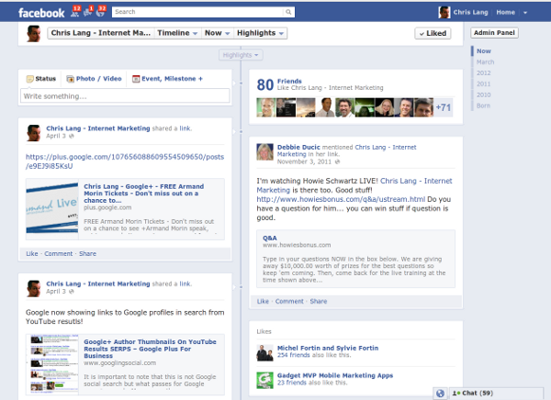

Facebook in 2020 had a cleaner and easy view on the layout compared to the facebook in 2000.

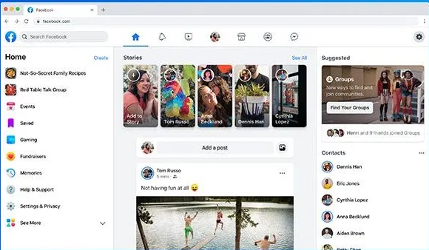

**CNN.com** is an American news website which is a big source of information and we can see its changes in the years of early times up to now.

.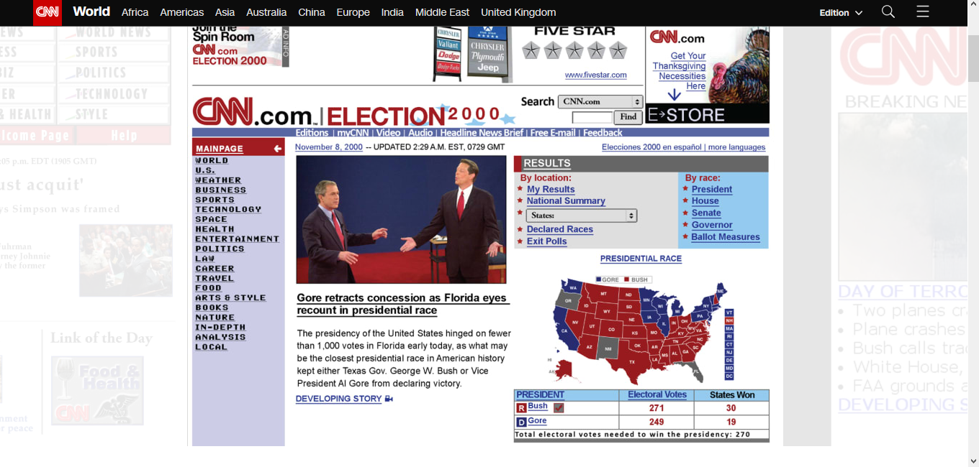

These is what CNN website looked like in 2000. Even tough it was long ago it had pretty remarkable page layout and was easy for the eyes of the users to navigate what they are looking for.

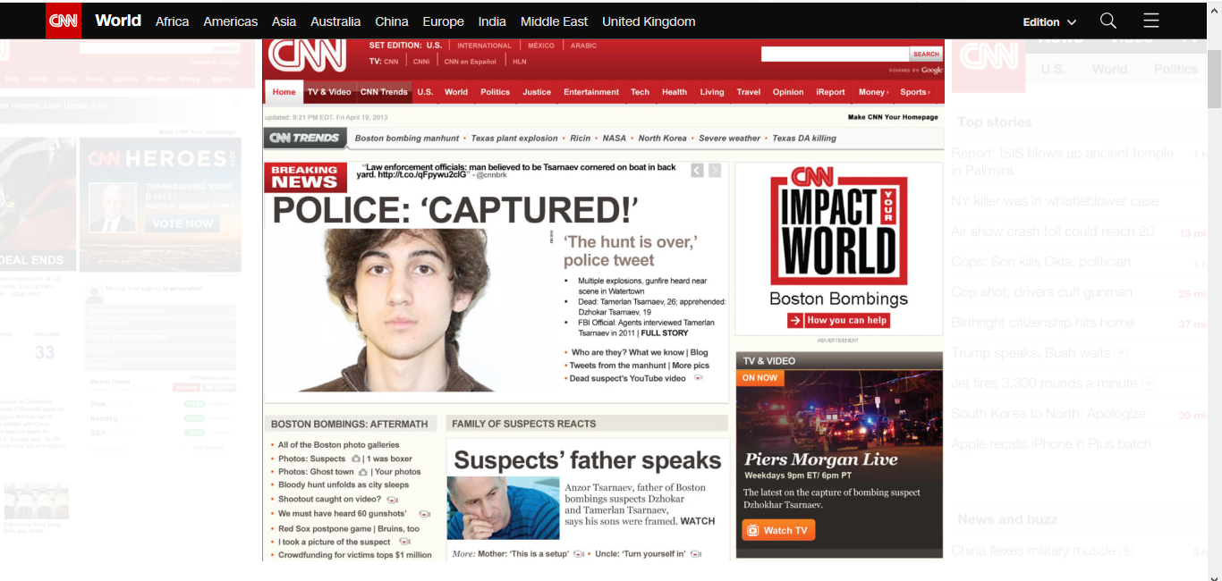

This is the current look of CNN website with lot of improvements.

**foxsports.com** is a news broadcasting websites that informs the world of the current sports news.

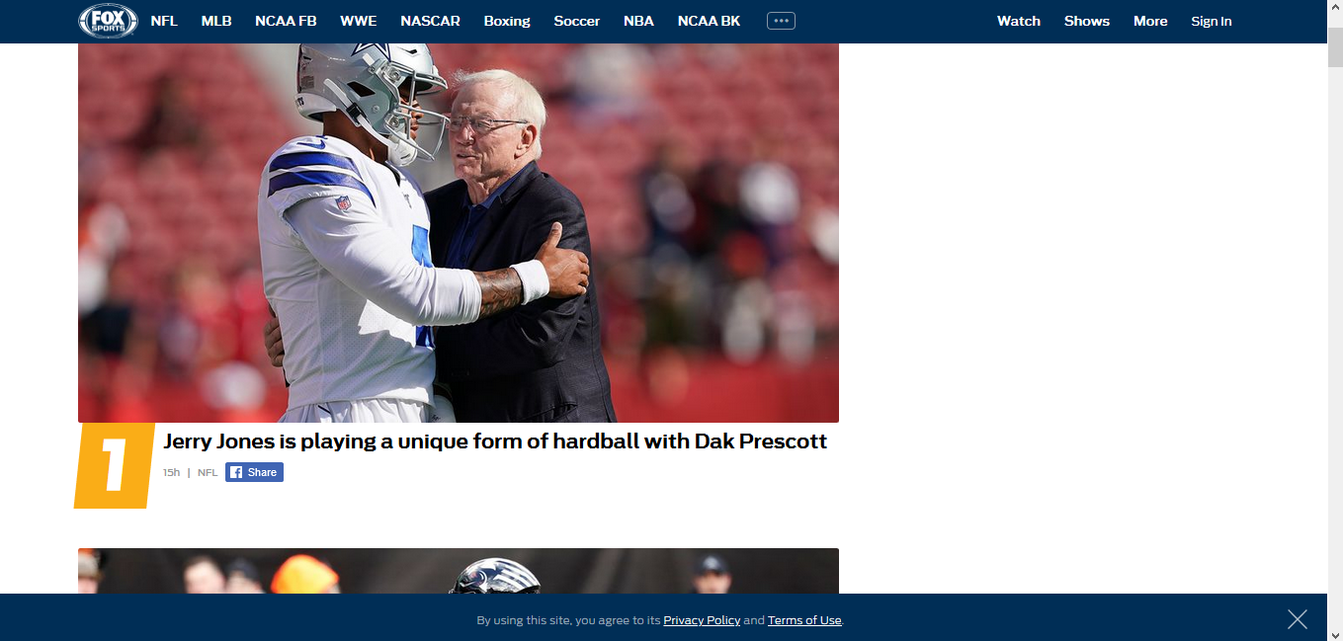

Foxsports looks like this with easy and attractive layout.

**Wordpress.com** is the king of bogging on the internet where people blog about different varieties of topics and you are the one who will host the wordpress software and the wordpress interface looks as below 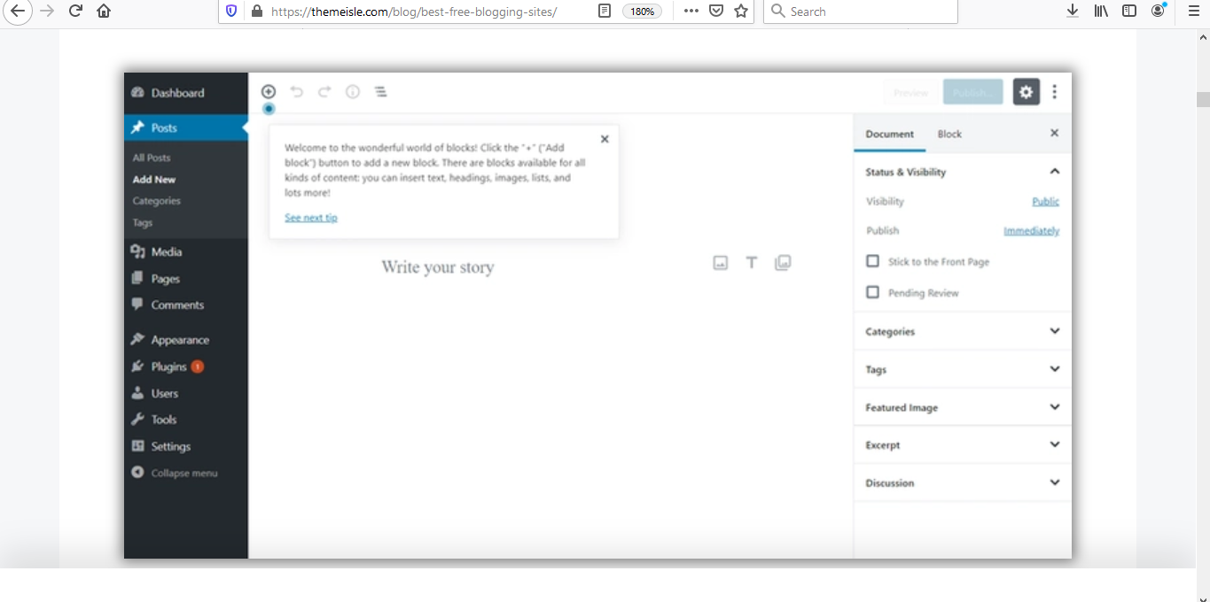

5.

The guidelines for evaluating a website are

1. **Authority** defines the person or entity who is responsible for the contents on the website and it should be clear who posted the website by providing contact information such as phone number or email address.
2. **Purpose** the purpose is the overall intention of the website which clearly defines for the goal of the website.In evaluating the purpose of a website these are questions that should come up in our heads

*Does the content support the purpose of the website

*Is the information intended for a specific set of audience

*Is the site organized and focused

*Are the outside links appropriate for the site

1. **Coverage** what topics are covered in depth on the site which can be valued with the following points.

*Are the topics explored in depth

*compare the value of the information contained in the website with another similar website

*Do the links go to outside sites rather than its own

1. **Currency** represents how current the information presented in the website is which can be evaluated by when the last revision was made on the post.
2. **Objectivity** explains the site having no bias such as intention for advertising unrelated contents that the user may not want.
3. **Accuracy** is evaluated based on the reliability and comparability of the website with same topics

Let us see two website from news

CNN.com and nbcnews.com

Looking at both sites information seems to be clearly stated and we can easily understand the purpose and accuracy of the wesites both cover information in a good way but when it comes to CNN it weighs more in content with varieties of media and people interaction with the news reporters and the contents covered are with much depth compared to nbcnews therefore we can be safe to say that interms of coverage CNN is better but in the other criteria both websites play comparable and outstanding work.