# Swiggy Restaurant Analysis Project Documentation

## 1. Introduction

The objective of this project is to analyze Swiggy's restaurant data to extract meaningful insights and provide actionable recommendations. Using Power BI, the data was cleaned, transformed, and visualized to understand the performance of restaurants, customer preferences, delivery times, and various other metrics that can help Swiggy make informed business decisions.

## 2. Data Overview

The dataset includes various details such as city, area, restaurant name, price, average ratings, total ratings, food type, and delivery time. These features were crucial in understanding the dynamics of restaurant performance and customer behavior.

## 3. Data Cleaning and Transformation

Before analysis, the dataset underwent cleaning and transformation in Power BI. This involved:  
- Handling missing values and correcting data types.  
- Removing duplicates to ensure accuracy.  
- Creating new columns such as 'Price Range' and 'Rating Category' to facilitate analysis.  
- The dataset was then prepared for visualization by ensuring consistency and reliability of data entries.

## 4. Methodology

The analysis was divided into several tasks using Power BI for visualizations. Each task was aimed at extracting specific insights:  
1. Top 10 Areas with Most Restaurants  
2. Most Popular Food Types in Each City  
3. Top Rated Swiggy Restaurants (Percentage)  
4. Correlation of Factors Affecting Average Rating  
5. Delivery Time Analysis  
6. City-wise Restaurant Count  
7. Price Analysis  
8. Delivery Time Breakdown  
9. Cuisine Variety Analysis  
10. Area-wise Restaurant Count within Cities  
11. Correlation Analysis of Ratings, Price, and Delivery Time  
12. Customer Feedback Analysis  
13. Geographical Mapping of Restaurant Locations  
14. Providing Actionable Recommendations based on the insights.

## 5. Visualizations and Insights

Below are the key insights derived from each visualization:

### 5.1 Top 10 Areas with Most Restaurants

The bar chart shows that Rohini, Chembur, and Kothrud are the top areas with the most restaurants. This suggests high market activity in these areas, indicating that Swiggy should focus marketing and partnership efforts here.

### 5.2 Most Popular Food Types in Each City

The pie chart reveals that North Indian and Indian cuisines are the most popular food types across multiple cities. Swiggy can use this insight to expand listings and promotions for these popular cuisines to meet customer demand.

### 5.3 Top Rated Swiggy Restaurants (Percentage)

The donut chart shows that 54.19% of restaurants are rated as 'Excellent', while 38.18% are 'Good'. Only 7.63% fall under the 'Poor' category. This suggests that the majority of restaurants offer good quality services, but Swiggy should work with the lower-rated ones to improve their offerings.

### 5.4 Delivery Time Analysis

The column chart indicates that a majority (6.1K) of the restaurants fall into the 'Slow' delivery time category. This suggests a need for logistical improvement to enhance delivery speed, which can directly impact customer satisfaction.

### 5.5 Price Analysis

The price analysis reveals that 56.56% of restaurants fall under the 'Low' price range, while 31.75% are 'Medium' and 11.69% are 'High'. This segmentation provides Swiggy with an opportunity to market based on different customer segments—affordable options vs. premium dining experiences.

### 5.6 Customer Feedback Analysis

The feedback analysis shows that most customer ratings fall into the 'Good' category. Swiggy should leverage this feedback to maintain the quality of services and address issues related to restaurants in the 'Poor' category to further improve customer satisfaction.

### 5.7 Correlation Analysis

The scatter chart analyzing the correlation between price, delivery time, and ratings indicates that higher-priced restaurants tend to receive better ratings. This can guide Swiggy in positioning premium restaurants more effectively.

### 5.8. Geographical Mapping of Restaurant Locations

The Mapping provide a geographical view of where Swiggy’s restaurant partners are located, helping identify regions with strong coverage and areas for expansion.

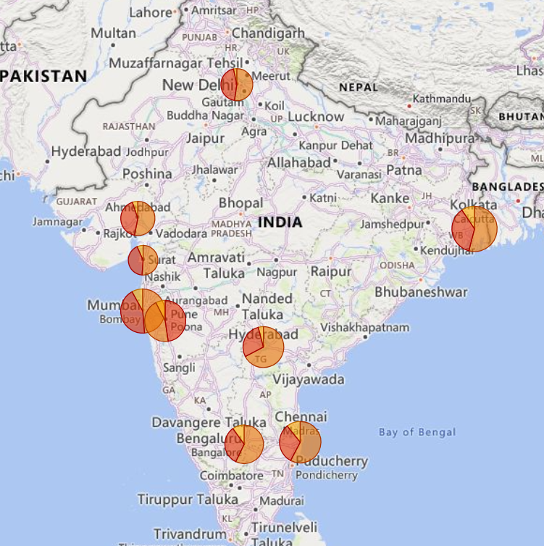

## 6. Recommendations

Based on the insights from the analysis, the following recommendations are proposed:  
1. Focus marketing efforts in high-density areas like Rohini, Chembur, and Kothrud.  
2. Expand restaurant listings for popular cuisines such as North Indian and Indian across all cities.  
3. Improve logistics in areas with slow delivery times to enhance customer experience.  
4. Collaborate with restaurants in the 'Poor' rating category to identify challenges and support improvements.  
5. Segment marketing strategies based on price range to target both premium and value-conscious customers.

## 7. Conclusion

The Swiggy Restaurant Analysis project has successfully identified key areas, customer preferences, and operational challenges using Power BI. By implementing the recommendations provided, Swiggy can optimize its operations, enhance customer satisfaction, and expand its market presence effectively.