**Inheritence**

**Task**   
You are given two classes, *Person* and *Student*, where *Person* is the base class and *Student* is the derived class. Completed code for *Person* and a declaration for *Student* are provided for you in the editor. Observe that *Student* inherits all the properties of *Person*.

Complete the *Student* class by writing the following:

* A *Student* class constructor, which has  parameters:
  1. A string, .
  2. A string, .
  3. An integer, .
  4. An integer array (or vector) of test scores, .
* A *char calculate()* method that calculates a Student object's average and returns the grade character representative of their calculated average:

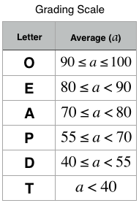

**Input Format**

The locked stub code in your editor calls your *Student* class constructor and passes it the necessary arguments. It also calls the *calculate* method (which takes no arguments).

*You are not responsible for reading the following input from stdin:*   
The first line contains , , and , respectively. The second line contains the number of test scores. The third line of space-separated integers describes .

**Constraints**

**Output Format**

*This is handled by the locked stub code in your editor.* Your output will be correct if your *Student* class constructor and *calculate()* method are properly implemented.

**Sample Input**

Heraldo Memelli 8135627

2

100 80

**Sample Output**

Name: Memelli, Heraldo

ID: 8135627

Grade: O

**Explanation**

This student had  scores to average:  and . The student's average grade is . An average grade of  corresponds to the letter grade , so our *calculate()* method should return the character'O'.