**InsightStream: Navigate the News Landscape (React Application)**

**Introduction**

**Project Title: InsightStream News App**

**Team Members:**

* S K Kiruthikaa(Team head) – kiruthikaasunder1@gmail.com
* B K Mokksha(Team Member)mokksha12@gmail.com
* S Bhuvaneshwari(Team Member)bhuvaneshwaribhuvaneshwari66@gmail.com
* C.Kavi priya(Team Member)kavijan2005@gmail.com

**Project Overview**

**Purpose**

* InsightStream is a revolutionary web application designed to redefine how people discover and consume news. With an intuitive interface, dynamic search, and a vast range of news categories, InsightStream offers an innovative approach to staying informed.

**Features**

* Access global news from various API sources.
* Dynamic search for personalized news retrieval.
* Visual news exploration with curated image galleries.
* Intuitive design ensuring seamless navigation.
* Advanced search feature for tailored content discovery.

**Architecture**

**Component Structure**

* **Navbar Component**: Contains the navigation menu.
* **Hero Component**: Displays trending news and search bar.
* **Category Components**: Showcases news under different categories.
* **Search Component**: Allows users to search articles by keywords.
* **News List Component**: Displays news articles retrieved from APIs.
* **Article Page Component**: Redirects to a detailed news page.

**State Management**

* **Context API** is used for global state management to handle user preferences and API data.

**Routing**

* React Router is used to manage navigation between different sections, including home, category pages, and article details.

**Setup Instructions**

**Prerequisites**

* **Node.js & npm**: Required for package management and running the development server.
* **React.js**: JavaScript library for building the user interface.
* **Git**: Version control system for tracking changes.
* **Development Environment**: Visual Studio Code (recommended) or any preferred IDE.

**Installation**

1. Clone the repository:
2. git clone [repository_link]
3. Navigate to the project directory:
4. cd news-app-react
5. Install dependencies:
6. npm install
7. Start the development server:
8. npm start
9. Open http://localhost:3000 in a browser to access the application.

**Folder Structure**

news-app-react/

│── src/

│ ├── components/ # Reusable components

│ ├── pages/ # Different page layouts

│ ├── context/ # Context API state management

│ ├── styles/ # Styling files (CSS)

│ ├── App.js # Main App component

│ ├── index.js # Entry point

│── public/

│── package.json

│── README.md

**Running the Application**

Run the following command to start the app:

npm start

**Component Documentation**

**Key Components**

* **Navbar**: Displays the navigation menu.
* **Hero Section**: Highlights trending news and search functionality.
* **Category Pages**: Displays articles related to specific categories.
* **Article Page**: Shows the full content of a selected news article.

**Reusable Components**

* **NewsCard**: Used to display individual news articles.
* **SearchBox**: Used for searching news articles.

**State Management**

**Global State**

* Managed using **Context API** to store and update user preferences and API responses.

**Local State**

* Managed using React’s **useState** and **useEffect** hooks to handle dynamic UI updates.

**User Interface**

* **CSS Framework**: Bootstrap or Tailwind CSS for styling.
* **Theming**: Custom CSS for consistent branding and user experience.

**Testing**

**Testing Strategy**

* **Unit Testing**: Using Jest and React Testing Library for component validation.
* **Integration Testing**: Testing API integration and user interactions.

**Screenshots or Demo**

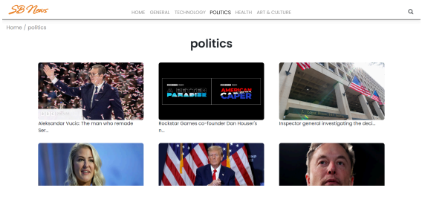

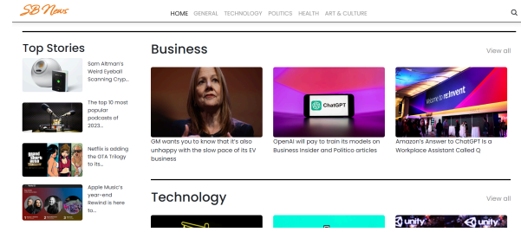

**Demo**

https://drive.google.com/file/d/1rTPQTu8SUo-KSjYdBHO-OQmPCntBUhC7/view?usp=drive_link

**Known Issues**

* Redux for global state management, as it efficiently handles large-scale state management, improves performance with centralized data storage, and simplifies state updates compared to Context API or Recoil.

**Future Enhancements**

* Add user authentication for personalized news feeds.
* Implement dark mode for better readability.
* Enhance API integration for more diverse news sources.