**MEASURE ENERGY CONSUMPTION**

PHASE 1

**Problem Statement:**

The measurement of energy consumption is critical in understanding and optimizing energy usage in various sectors, including manufacturing sites, homes, commercial buildings, and transportation. However, the manual collection and analysis of energy consumption data can be time-consuming and error-prone. Therefore, there is a need for an automated approach to collect, analyze and visualize energy consumption data for better decision-making.

**Phase 1: Problem Definition and Design Thinking**

**Problem Definition:**

The problem at hand is to create an automated system that measures energy consumption, analyzes the data, and provides visualizations for informed decision-making. This solution aims to enhance efficiency, accuracy, and ease of understanding in managing energy consumption across various sectors.

**Design Thinking:**

**1. Data Source:**

We are choosing a dataset from kaggle this dataset contains information related to electricity load and power consumption in various regions, possibly within the PJM (PJM Interconnection) electric grid system in the United States. Here's a brief interpretation of some of the column names:

**COMED_MW:** Likely electricity load data for the Commonwealth Edison (COMED) service area.

**DAYTON_MW:** Likely electricity load data for the Dayton Power and Light (DAYTON) service area.

**DEOK_MW:** Likely electricity load data for the Duke Energy Ohio and Kentucky (DEOK) service area.

**DUQ_MW:** Likely electricity load data for the Duquesne Light (DUQ) service area.

**EKPC_MW:** Likely electricity load data for the East Kentucky Power Cooperative (EKPC) service area.

**FE_MW:** Likely electricity load data for the FirstEnergy (FE) service area.

**NI_MW:** Likely electricity load data for the Northern Indiana (NI) service area.

**PJM_Load_MW:** Likely the aggregated electricity load data for the entire PJM Interconnection region.

**AEP, PJME, PJMW:** These abbreviations likely refer to other specific regions or utilities within the PJM system.

**Dataset Link:**[**https://www.kaggle.com/datasets/robikscube/hourly-energy-consumption**](https://www.kaggle.com/datasets/robikscube/hourly-energy-consumption)

**2.Data Preprocessing:**

Clean, transform, and prepare the dataset for analysis.

**Handling Missing Values:** Address missing data by either removing or filling missing values.

**Data Transformation:** Convert date-time columns to a consistent format and scale numerical features.

**Outlier Detection:** Identify and handle outliers using statistical methods.

**Data Splitting:** Split data into training, validation, and test sets if building models.

**Quality Assurance:** Ensure data cleanliness and accuracy throughout the process.

**3. Feature Extraction:**

Feature extraction involves selecting and transforming relevant information from the dataset to create new features that are more informative for analysis or modeling. For the energy consumption dataset you mentioned, some feature extraction ideas include:

**Time-Based Features:**  Extract day of the week, month, or year from the datetime column.

**Statistical Aggregates:** Compute statistical aggregates for each region, such as mean, median, standard deviation, or percentiles, to summarize energy consumption patterns.

**Seasonal Trends:** Create features to represent seasonal variations, such as temperature data if available, to account for weather-related energy consumption patterns.

**Correlations:** Compute correlations between energy consumption in different regions to identify regions with similar or opposite trends.

**Frequency Domain Features:** Apply Fourier or wavelet transforms to reveal periodic patterns in the data.

**4. Model Development:**

Certainly, here's a concise step-by-step guide for developing a Linear Regression model for energy consumption prediction:

**Data Preparation:** Clean and preprocess the dataset.

**Data Splitting:** Split data into training and testing sets.

**Feature Selection:** Choose relevant features.

**Model Selection:** Choose Linear Regression for prediction.

**Model Training:** Train the Linear Regression model.

**Model Evaluation:** Assess model performance using metrics like MAE, MSE, RMSE, and R-squared.

**Visualization:** Visualize predictions vs. actual values.

**Interpretation:** Analyze coefficients for feature impact.

**Fine-Tuning:** Optimize the model as needed.

**Deployment and Monitoring:** Deploy for predictions and monitor over time.

**Communication:** Share results and recommendations with stakeholders.

**5.Visualization:**

Certainly, here are five types of concise visualizations for presenting energy consumption trends and insights:

**Time Series Plot:** Show long-term consumption trends and seasonality.

**Residual Plot:** Display model errors to identify patterns.

**Feature Importance Plot:** Highlight the impact of each feature on consumption.

**Histogram of Residuals:** Check the distribution of model errors.

**Regression Line Plot:** Visualize the linear relationship between a key feature and consumption.

**6. Automation:**

Certainly, here's a concise overview of automating data collection, analysis, and visualization:

**Data Collection:** Automate data retrieval from online sources.

**Data Analysis:** Develop scripts for preprocessing, modeling, and analysis.

**Visualization:** Create automated chart and graph generation.

**Integration:** Combine data collection, analysis, and visualization into a single workflow.

**Scheduled Execution:** Set up automatic execution at defined intervals.

**Error Handling:** Implement error checks and logging for reliability.

**Continuous Improvement:** Regularly update and optimize the automation process.

**PHASE 2**

Predicting energy consumption using machine learning involves using historical data on energy usage along with other relevant features to build a model that can make accurate predictions. The following steps outline the process:

1. Data Collection and Preparation:
   * Gather historical data on energy consumption. This can include information like date, time, weather conditions, building type, number of occupants, etc.
   * Clean the data to remove any outliers or missing values.
   * Preprocess the data, which may involve normalization, scaling, or encoding categorical variables.
2. Feature Selection:
   * Identify which features (independent variables) are most relevant for predicting energy consumption. This may involve using domain knowledge or employing feature selection techniques.
3. Splitting the Data:
   * Divide the dataset into training and testing sets. The training set will be used to train the model, while the testing set will be used to evaluate its performance.
4. Choosing a Model:
   * Select a suitable machine learning algorithm for regression tasks. Common choices include Linear Regression, Random Forest, Support Vector Machines, Neural Networks, etc.
5. Model Training:
   * Train the chosen model on the training data. During training, the model learns the relationships between the features and the target variable (energy consumption).
6. Model Evaluation:
   * Use the testing set to evaluate the model's performance. Common metrics for regression tasks include Mean Absolute Error (MAE), Mean Squared Error (MSE), and R-squared (R²) score.
7. Hyperparameter Tuning (Optional):
   * Fine-tune the model's hyperparameters to improve performance. Techniques like grid search or random search can be used.
8. Model Deployment:
   * Once the model performs satisfactorily, deploy it in a real-world setting. This could be as part of an application or integrated into an existing system.

9.Monitoring and Maintenance:

* + Continuously monitor the model's performance in the production environment. If the model's performance degrades over time, it may need retraining or adjustment.

10.Predicting Energy Consumption:

* To predict future energy consumption, feed new data (e.g., current weather conditions, occupancy, etc.) into the trained model.

**Phase 3**

ai-phase3-1

November 1, 2023

[1]:

**import pandas as pd import numpy as np**

**import matplotlib.pyplot as plt import seaborn as sns**

**import datetime**

[2]:

df = pd.read_csv("PJME_hourly.csv")

[3]:

df.head()

1. : Datetime PJME_MW

0 2002-12-31 01:00:00 26498.0

1 2002-12-31 02:00:00 25147.0

2 2002-12-31 03:00:00 24574.0

3 2002-12-31 04:00:00 24393.0

4 2002-12-31 05:00:00 24860.0

[4]:

df.tail()

1. : Datetime PJME_MW

145361 2018-01-01 20:00:00 44284.0

145362 2018-01-01 21:00:00 43751.0

145363 2018-01-01 22:00:00 42402.0

145364 2018-01-01 23:00:00 40164.0

145365 2018-01-02 00:00:00 38608.0

[11]:

df.describe()

|  |  |  |
| --- | --- | --- |
| [11]: |  | PJME_MW |
|  | count | 145366.000000 |
|  | mean | 32080.222831 |
|  | std | 6464.012166 |
|  | min | 14544.000000 |
|  | 25% | 27573.000000 |
|  | 50% | 31421.000000 |
|  | 75% | 35650.000000 |

max 62009.000000

**1 Data Preprocessing**

[5]:

df.set_index("Datetime", inplace=**True**)

[6]:

df.head()

[6]: PJME_MW

Datetime

2002-12-31 01:00:00 26498.0

2002-12-31 02:00:00 25147.0

2002-12-31 03:00:00 24574.0

2002-12-31 04:00:00 24393.0

2002-12-31 05:00:00 24860.0

[7]:

df.index

[7]: Index(['2002-12-31 01:00:00', '2002-12-31 02:00:00', '2002-12-31 03:00:00',

'2002-12-31 04:00:00', '2002-12-31 05:00:00', '2002-12-31 06:00:00',

'2002-12-31 07:00:00', '2002-12-31 08:00:00', '2002-12-31 09:00:00',

'2002-12-31 10:00:00',

…

'2018-01-01 15:00:00', '2018-01-01 16:00:00', '2018-01-01 17:00:00',

'2018-01-01 18:00:00', '2018-01-01 19:00:00', '2018-01-01 20:00:00',

'2018-01-01 21:00:00', '2018-01-01 22:00:00', '2018-01-01 23:00:00',

'2018-01-02 00:00:00'],

dtype='object', name='Datetime', length=145366)

[8]:

pd.to_datetime(df.index)

[8]: DatetimeIndex(['2002-12-31 01:00:00', '2002-12-31 02:00:00',

'2002-12-31 03:00:00', '2002-12-31 04:00:00',

'2002-12-31 05:00:00', '2002-12-31 06:00:00',

'2002-12-31 07:00:00', '2002-12-31 08:00:00',

'2002-12-31 09:00:00', '2002-12-31 10:00:00',

…

'2018-01-01 15:00:00', '2018-01-01 16:00:00',

'2018-01-01 17:00:00', '2018-01-01 18:00:00',

'2018-01-01 19:00:00', '2018-01-01 20:00:00',

'2018-01-01 21:00:00', '2018-01-01 22:00:00',

'2018-01-01 23:00:00', '2018-01-02 00:00:00'],

dtype='datetime64[ns]', name='Datetime', length=145366, freq=None)

[9]:

df.index = pd.to_datetime(df.index)

[10]:

df.plot(title="PJME Energy use in MegaWatts", figsize=(20, 8),

style=".", color=sns.color_palette()[0])

plt.show()

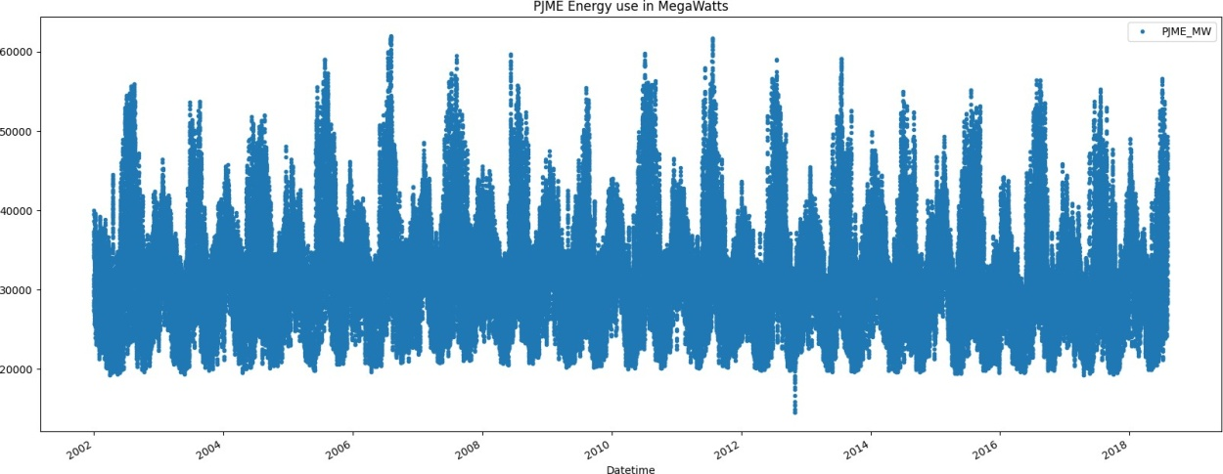

Phase 4

ai-phase4-1

[1]:

**import pandas as pd import numpy as np**

**import matplotlib.pyplot as plt import seaborn as sns**

**import datetime**

[2]:

df = pd.read_csv("PJME_hourly.csv")

[3]:

df.head()

1. : Datetime PJME_MW

0 2002-12-31 01:00:00 26498.0

1 2002-12-31 02:00:00 25147.0

2 2002-12-31 03:00:00 24574.0

3 2002-12-31 04:00:00 24393.0

4 2002-12-31 05:00:00 24860.0

1. :

df.tail()

1. : Datetime PJME_MW

145361 2018-01-01 20:00:00 44284.0

145362 2018-01-01 21:00:00 43751.0

145363 2018-01-01 22:00:00 42402.0

145364 2018-01-01 23:00:00 40164.0

145365 2018-01-02 00:00:00 38608.0

1. :

df.describe()

|  |  |  |
| --- | --- | --- |
| [5]: |  | PJME_MW |
|  | count | 145366.000000 |
|  | mean | 32080.222831 |
|  | std | 6464.012166 |
|  | min | 14544.000000 |
|  | 25% | 27573.000000 |
|  | 50% | 31421.000000 |
|  | 75% | 35650.000000 |

max 62009.000000

# 1 Data Preprocessing

1. :

df.set_index("Datetime", inplace=**True**)

1. :

df.head()

1. : PJME_MW

Datetime

2002-12-31 01:00:00 26498.0

2002-12-31 02:00:00 25147.0

2002-12-31 03:00:00 24574.0

2002-12-31 04:00:00 24393.0

2002-12-31 05:00:00 24860.0

1. :

df.index

1. : Index(['2002-12-31 01:00:00', '2002-12-31 02:00:00', '2002-12-31 03:00:00',

'2002-12-31 04:00:00', '2002-12-31 05:00:00', '2002-12-31 06:00:00',

'2002-12-31 07:00:00', '2002-12-31 08:00:00', '2002-12-31 09:00:00',

'2002-12-31 10:00:00',

…

'2018-01-01 15:00:00', '2018-01-01 16:00:00', '2018-01-01 17:00:00',

'2018-01-01 18:00:00', '2018-01-01 19:00:00', '2018-01-01 20:00:00',

'2018-01-01 21:00:00', '2018-01-01 22:00:00', '2018-01-01 23:00:00',

'2018-01-02 00:00:00'],

dtype='object', name='Datetime', length=145366)

1. :

pd.to_datetime(df.index)

1. : DatetimeIndex(['2002-12-31 01:00:00', '2002-12-31 02:00:00',

'2002-12-31 03:00:00', '2002-12-31 04:00:00',

'2002-12-31 05:00:00', '2002-12-31 06:00:00',

'2002-12-31 07:00:00', '2002-12-31 08:00:00',

'2002-12-31 09:00:00', '2002-12-31 10:00:00',

…

'2018-01-01 15:00:00', '2018-01-01 16:00:00',

'2018-01-01 17:00:00', '2018-01-01 18:00:00',

'2018-01-01 19:00:00', '2018-01-01 20:00:00',

'2018-01-01 21:00:00', '2018-01-01 22:00:00',

'2018-01-01 23:00:00', '2018-01-02 00:00:00'],

dtype='datetime64[ns]', name='Datetime', length=145366, freq=None)

1. :

df.index = pd.to_datetime(df.index)

1. :

df.plot(title="PJME Energy use in MegaWatts", figsize=(20, 8),

style=".", color=sns.color_palette()[0])

plt.show()

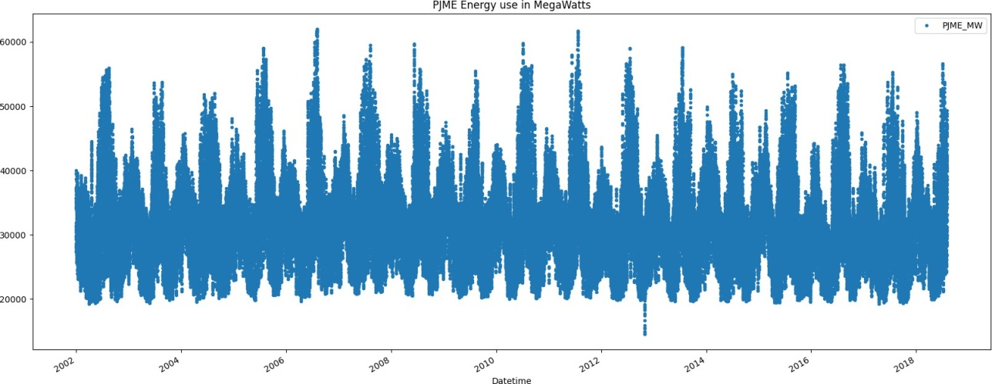

1. :

# Train and test split

1. :

x = df[df.index < "01-01-2015"] y = df[df.index >= "01-01-2015"]

fig, ax = plt.subplots(figsize=(20,8))

x.plot(ax=ax, label = "train set", title="Train/Test Split") y.plot(ax=ax, label = "test set")

ax.axvline("01-01-2015", color="black", ls="--") ax.legend(["Train Set", "Test Set"])

plt.show()

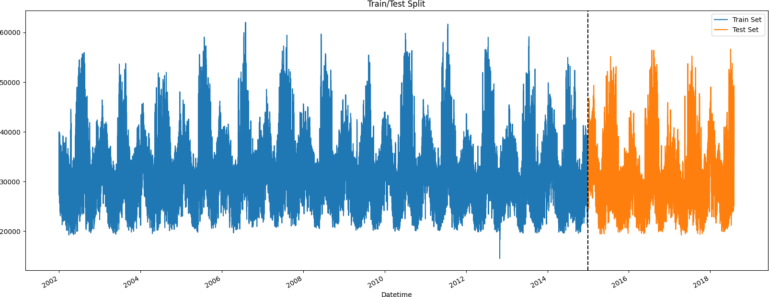

1. :

# Feature creation

1. : PJME_MW hour day_of_week

df["hour"] = df.index.hour df["day_of_week"] = df.index.day_of_week df.head()

|  |  |  |
| --- | --- | --- |
| Datetime |  | |
| 2002-12-31 01:00:00 26498.0 | 1 | 1 |
| 2002-12-31 02:00:00 25147.0 | 2 | 1 |
| 2002-12-31 03:00:00 24574.0 | 3 | 1 |
| 2002-12-31 04:00:00 24393.0 | 4 | 1 |
| 2002-12-31 05:00:00 24860.0 | 5 | 1 |

1. :

df["quarter"] = df.index.quarter df["month"] = df.index.month df["year"] = df.index.year

df["day_of_year"] = df.index.day_of_year

1. :

df.head()

1. : PJME_MW hour day_of_week quarter month year \

|  |  |  |  |  |
| --- | --- | --- | --- | --- |
| Datetime |  | | | |
| 2002-12-31 01:00:00 26498.0 | 1 | 1 | 4 | 12 2002 |
| 2002-12-31 02:00:00 25147.0 | 2 | 1 | 4 | 12 2002 |
| 2002-12-31 03:00:00 24574.0 | 3 | 1 | 4 | 12 2002 |
| 2002-12-31 04:00:00 24393.0 | 4 | 1 | 4 | 12 2002 |
| 2002-12-31 05:00:00 24860.0 | 5 | 1 | 4 | 12 2002 |

Datetime

day_of_year

1. :

train = df[df.index < "01-01-2015"] test = df[df.index >= "01-01-2015"]

2002-12-31 01:00:00 365

2002-12-31 02:00:00 365

2002-12-31 03:00:00 365

2002-12-31 04:00:00 365

2002-12-31 05:00:00 365

1. :

x_train = train.drop("PJME_MW", axis=1) x_test = test.drop("PJME_MW", axis=1) y_train = train["PJME_MW"]

y_test = test["PJME_MW"]

1. :

**from xgboost import** XGBRegressor

**from sklearn.metrics import** mean_squared_error

model = XGBRegressor(n_estimators=1000, learning_rate=0.01,␣

𝗌early_stopping_rounds=50)

model.fit(x_train, y_train,

eval_set=[(x_train, y_train) ,(x_test, y_test)], verbose=100)

# Model

|  |  |  |
| --- | --- | --- |
| [0] | validation_0-rmse:6407.35736 | validation_1-rmse:6479.81619 |
| [100] | validation_0-rmse:3911.97994 | validation_1-rmse:4312.03224 |
| [200] | validation_0-rmse:3244.38509 | validation_1-rmse:3864.56545 |
| [300] | validation_0-rmse:2996.08999 | validation_1-rmse:3748.76687 |
| [400] | validation_0-rmse:2830.28024 | validation_1-rmse:3744.93340 |
| [417] | validation_0-rmse:2801.66222 | validation_1-rmse:3749.26089 |

1. : XGBRegressor(base_score=None, booster=None, callbacks=None, colsample_bylevel=None, colsample_bynode=None, colsample_bytree=None, device=None, early_stopping_rounds=50, enable_categorical=False, eval_metric=None, feature_types=None, gamma=None, grow_policy=None, importance_type=None, interaction_constraints=None, learning_rate=0.01, max_bin=None, max_cat_threshold=None, max_cat_to_onehot=None, max_delta_step=None, max_depth=None, max_leaves=None, min_child_weight=None, missing=nan, monotone_constraints=None, multi_strategy=None, n_estimators=1000, n_jobs=None, num_parallel_tree=None, random_state=None, …)
2. :

importance_df = pd.DataFrame(data=model.feature_importances_, index=model.

𝗌feature_names_in_, columns=["Importance"]) importance_df.sort_values("Importance")

# Feature Importance

|  |  |  |
| --- | --- | --- |
| [20]: |  | Importance |
|  | year | 0.023824 |
|  | quarter | 0.028881 |
|  | day_of_year | 0.118251 |
|  | day_of_week | 0.162005 |
|  | month | 0.203161 |
|  | hour | 0.463878 |

1. :

importance_df.sort_values("Importance").plot(kind="barh", title="Feature␣

𝗌Importance")

plt.show()

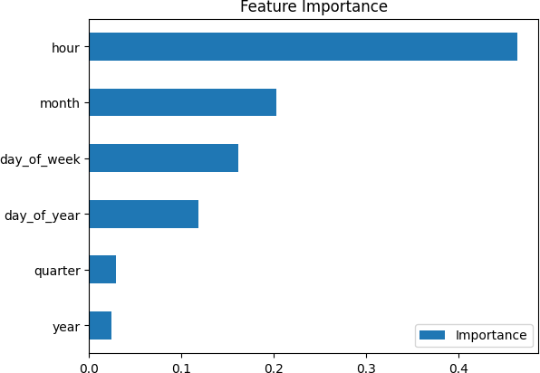

1. :
2. :

# Prediction on testset

test["Prediction"] = model.predict(x_test)

<ipython-input-22-8b14319b119b>:1: SettingWithCopyWarning:

A value is trying to be set on a copy of a slice from a DataFrame. Try using .loc[row_indexer,col_indexer] = value instead

See the caveats in the documentation: https://pandas.pydata.org/pandas- docs/stable/user_guide/indexing.html#returning-a-view-versus-a-copy

test["Prediction"] = model.predict(x_test)

df = df.merge(test["Prediction"], how="left", left_index=**True**, right_index=**True**) df.head()

[23]:

|  |  |  |  |  |  |  |  |  |
| --- | --- | --- | --- | --- | --- | --- | --- | --- |
| PJME_MW hour day_of_week quarter | | | | | | month | year | \ |
| Datetime 2002-01-01 | 01:00:00 | 30393.0 | 1 | 1 | 1 | 1 | 2002 | |
| 2002-01-01 | 02:00:00 | 29265.0 | 2 | 1 | 1 | 1 | 2002 | |
| 2002-01-01 | 03:00:00 | 28357.0 | 3 | 1 | 1 | 1 | 2002 | |
| 2002-01-01 | 04:00:00 | 27899.0 | 4 | 1 | 1 | 1 | 2002 | |
| 2002-01-01 | 05:00:00 | 28057.0 | 5 | 1 | 1 | 1 | 2002 | |
| Datetime |  | day_of_year | Prediction | | | | | |
| 2002-01-01 | 01:00:00 | 1 | NaN | | | | | |
| 2002-01-01 | 02:00:00 | 1 | NaN | | | | | |
| 2002-01-01 | 03:00:00 | 1 | NaN | | | | | |
| 2002-01-01 | 04:00:00 | 1 | NaN | | | | | |
| 2002-01-01 | 05:00:00 | 1 | NaN | | | | | |

1. :

ax = df["PJME_MW"].plot(figsize=(20,8)) df["Prediction"].plot(ax=ax, style=".") plt.legend(["Truth Data","Prediction"]) plt.title("Raw Data and Prediction") plt.show()

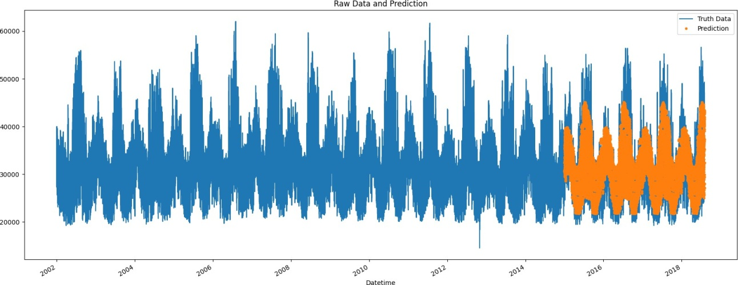

1. :

model.score(x_test, y_test)

[25]: 0.6635635163510866

1. :

score = np.sqrt(mean_squared_error(test["PJME_MW"], test["Prediction"])) print(f"RMSE score on test set:**{**score**:**0.2f**}**")

RMSE score on test set:3741.03

**Advantages:**

Measuring energy consumption using Artificial Intelligence (AI) offers several advantages, as it leverages the power of advanced algorithms and machine learning to improve accuracy, efficiency, and decision-making in energy management. Here are some of the key advantages of using AI for energy consumption measurement:

1. **Increased Accuracy**: AI can process vast amounts of data with high precision, resulting in more accurate measurements of energy consumption. It can detect subtle patterns, anomalies, and variations that might be missed by traditional methods.
2. **Real-time Monitoring**: AI systems can provide real-time energy consumption data, allowing for immediate response to changes and issues. This enables better control over energy usage and helps identify opportunities for optimization.
3. **Predictive Analytics**: AI can use historical data and predictive modeling to forecast future energy consumption patterns. This capability helps organizations plan for peak loads, manage energy demand, and reduce costs through proactive measures.
4. **Anomaly Detection**: AI can identify anomalies or irregularities in energy consumption patterns. This can be crucial for detecting equipment malfunctions, leaks, or unauthorized usage, preventing energy waste and potential safety hazards.
5. **Energy Efficiency Optimization**: AI can analyze energy consumption data to identify areas where energy can be saved or optimized. It can recommend adjustments, such as setting optimal thermostat levels or scheduling equipment operation during off-peak hours.
6. **Load Balancing**: AI can help balance energy loads in real-time, ensuring that energy is distributed efficiently across a system. This is particularly important in large-scale operations and smart grid management.
7. **Energy Cost Reduction**: By optimizing energy consumption and demand, AI systems can help reduce energy costs for businesses and households. This can lead to substantial financial savings in the long run.
8. **Environmental Impact**: AI-driven energy management can contribute to reducing greenhouse gas emissions by optimizing energy usage, which aligns with sustainability and environmental goals.
9. **Integration with IoT Devices**: AI can be integrated with Internet of Things (IoT) devices and sensors to gather data from various sources, providing a holistic view of energy consumption. This interconnected approach enhances decision-making capabilities.
10. **Scalability**: AI solutions are scalable and adaptable to different types and sizes of operations, making them suitable for a wide range of applications, from small residential settings to industrial facilities.
11. **Continuous Learning**: AI systems can continuously learn and adapt to changing energy consumption patterns, making them more effective over time. They can adapt to seasonal variations, changes in occupancy, and shifts in energy prices.
12. **Remote Monitoring**: AI-enabled energy monitoring systems can be accessed and managed remotely, offering convenience and flexibility in energy management, even for distributed or geographically dispersed facilities.
13. **Data Insights**: AI can provide valuable insights and visualizations of energy consumption data, making it easier for users to understand and act on the information.

In summary, leveraging AI for measuring energy consumption can lead to more precise, efficient, and proactive energy management. It enables organizations and individuals to optimize their energy usage, reduce costs, and contribute to sustainability and environmental goals.

**Disadvantages:**

While using Artificial Intelligence (AI) for measuring energy consumption offers several advantages, it also comes with certain disadvantages and challenges that should be considered:

1. **Cost of Implementation**: Implementing AI-driven energy measurement systems can be expensive. The initial investment in hardware, software, and expertise required for deployment can be a barrier, particularly for small businesses and residential users.
2. **Complexity**: AI systems are complex and may require specialized knowledge for setup and maintenance. This can pose a challenge for users who are not familiar with AI technology.
3. **Data Privacy and Security**: AI systems that collect and analyze energy consumption data can be vulnerable to data breaches and privacy concerns. Protecting sensitive energy data is crucial, and AI systems need to have robust security measures in place.
4. **Data Accuracy**: While AI can improve accuracy, it is not immune to errors. Inaccurate data input or flawed algorithms can lead to incorrect measurements and recommendations.
5. **Dependence on Data Quality**: AI systems heavily rely on the quality and consistency of the data they receive. If the data is incomplete, outdated, or erroneous, it can negatively impact the AI's performance.
6. **Energy Consumption Variability**: Some energy consumption patterns may be inherently variable and challenging to predict accurately, particularly in settings with irregular usage or fluctuating conditions.
7. **Integration Challenges**: Integrating AI into existing infrastructure and systems can be complex and may require significant adjustments and upgrades. Compatibility issues can arise.
8. **Energy-Specific Expertise**: Effective use of AI for energy measurement often requires specialized knowledge of both energy systems and AI technologies. Finding qualified personnel with this dual expertise can be challenging.
9. **Scalability**: While AI is scalable, scaling up AI solutions to accommodate a large number of energy-consuming devices or facilities can be complex and may require substantial resources.
10. **Energy Management Disruption**: Implementing AI solutions may disrupt existing energy management practices and processes. Organizations may face resistance from employees and stakeholders who are accustomed to traditional methods.
11. **Energy Ownership and Control**: When AI systems are used for residential energy measurement, concerns can arise about data ownership, control, and potential privacy infringements by the entity providing the AI service.
12. **Energy Optimization Trade-offs**: Optimization recommendations from AI may sometimes conflict with other operational goals, such as comfort or production efficiency, which can create a challenge in decision-making.
13. **Regulatory Compliance**: Depending on the jurisdiction, AI-driven energy measurement may need to comply with specific regulations and standards, which can introduce additional complexities and costs.
14. **Maintenance and Upkeep**: AI systems require ongoing maintenance and updates to remain effective. This maintenance can be resource-intensive, both in terms of time and money.

It's important to recognize that the advantages of using AI for energy measurement often outweigh the disadvantages, especially in terms of efficiency and cost savings. However, addressing these challenges and concerns is crucial to ensure that AI-based energy measurement solutions are deployed effectively and ethically.

**Conclusion:**

Measuring energy consumption using Artificial Intelligence (AI) offers numerous advantages, including increased accuracy, real-time monitoring, predictive analytics, and energy cost reduction. AI can help optimize energy usage, reduce environmental impact, and provide valuable insights into energy consumption patterns. However, there are also several disadvantages to consider, such as the initial cost of implementation, complexity, data privacy and security concerns, and the need for specialized expertise.

Despite these challenges, the benefits of AI-driven energy measurement often outweigh the drawbacks, particularly in terms of improved efficiency, cost savings, and sustainability. To harness the full potential of AI in energy measurement, organizations and individuals should carefully plan their implementation, ensure data security and privacy, and remain adaptable to changing energy consumption patterns. With the right strategies in place, AI can play a pivotal role in achieving more sustainable and efficient energy management in a rapidly evolving world.